LCpl David A. Brown

USMC 1981 - 1984

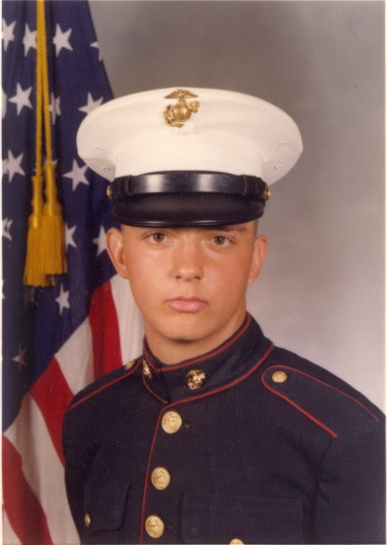

Camp Pendleton, CA 1st Marine Division the 1st Battalion 9th Marines H&S Co. Communications Platoon - Tactical Air Control Party (TACP), June 1983 to Dec. 1984; WestPac 83-84 Okinawa, 35th MAU Battalion Landing Team (BLT) A. Co. 1st Battalion 9th Marines (TACP - 1st wave 2nd Amtrak) USS Fresno (LST 1182) practice beach landing in the Philippines (Sept. 83) and a canceled deployment to Beirut, Lebanon; Korea DMZ (TACP Bear Hunt Sept. - Nov. 83), Tactical Air Control Party (TACP) certified Feb. 3, 1984; Panama Canal in June 1984.

Updated: 31st MAU Subic Bay, Philippines 3rd Marine Division HQ 31st MAU Comm Plt, Oct. 1982 to April 1983, WestPac 82-83 on the USS Belleau Wood (LHA-3). Shellback crossing the equator at 119.05.2 deg on Oct. 16, 1982; Perth, Australia (Exercise Valiant Usher - Oct. 1982), the Pfc representative in the 1982 Marine Corps Ball in Freemantle, Australia; a practice beach landing for Berbera, Somalia in Diego Garcia, Indian Ocean (1st wave 3rd LCM - Nov. 10, 1982); Berbera, Somalia in Nov. 1982 for Operation Jade Tiger a USA presence in Somalia (1st wave 1st LCM); Wahabi Sands, Oman Dec. 1982 (Exercise Golden Lion aka Exercise Jade Tiger); Strait of Hormuz, Arabian Sea in Dec. 1982 including conducting surveillance off the coast of Iran during a battle in the Iran/Iraq war. Singapore and then returned to the Philippines on Dec. 31st 1982 during a time of heightened NPA guerrilla warfare. -- WestPac 1983 a cross-deck to the USS New Orleans (LPH-11), Korea in Feb. 1983 (Exercise Team Spirit 83), Hong Kong, Okinawa, Philippines and in April 1983 returned to 7th Comm Bn in Camp Hansen, Okinawa.

Camp Hansen Okinawa, Japan 3rd Marine Division 7th Communication Battalion, Communications Platoon May 1982 to May 1983.

MCCES School at 29 Palms, CA for Field Radio Operator Course (FROC) MOS 2531.

Boot camp at MCRD San Diego Ca, in M Co. Platoon 3101 Nov. 10, 1981 - Jan. 29, 1982.

LCpl David Anson Brown USMC 1981 – 1984.
- Capt. John Brown Documents pdf
- David A. Brown USMC pdf
- David A. Brown USMC Timeline here
- David A. Brown USMC Bio here
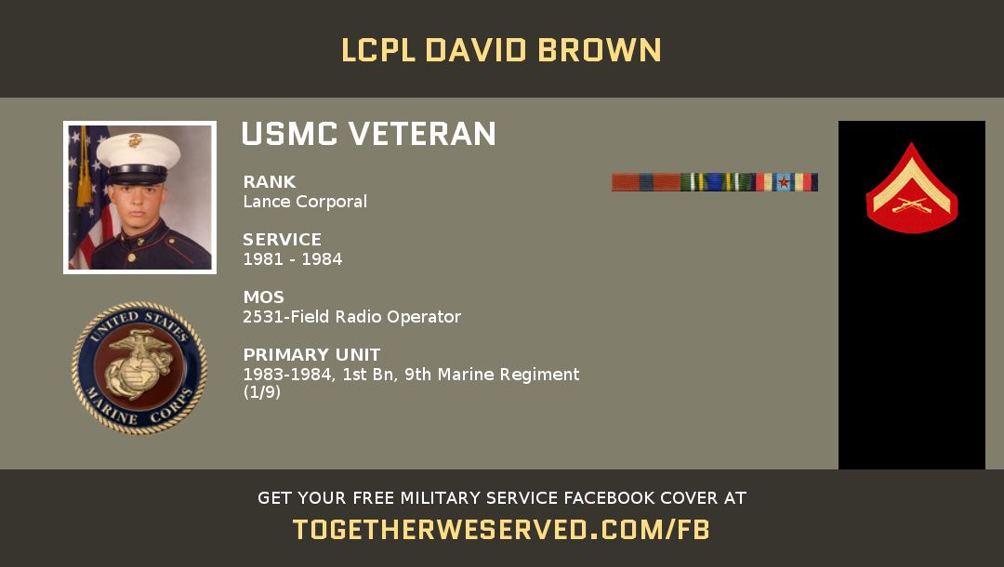
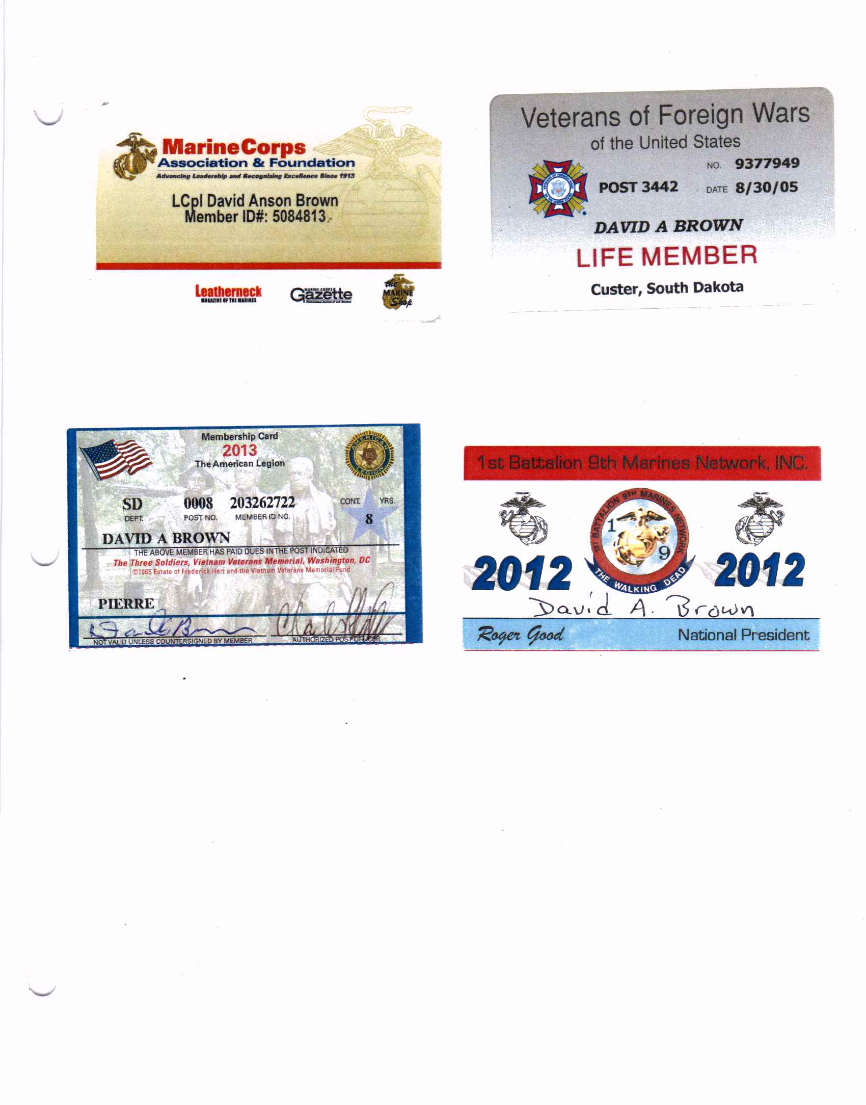

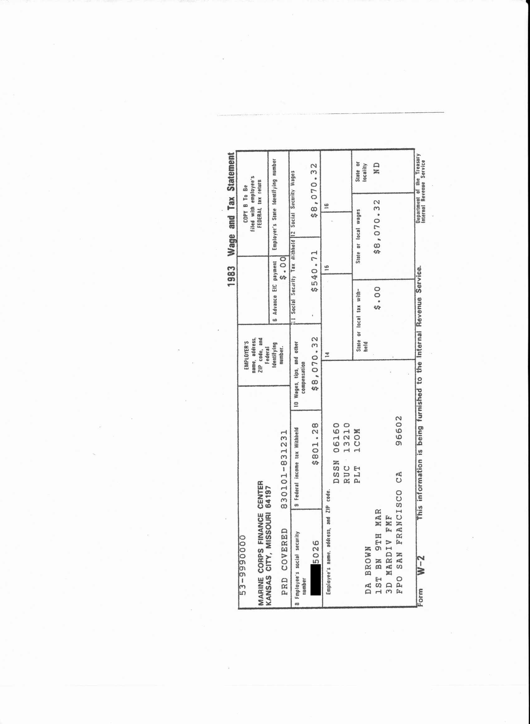

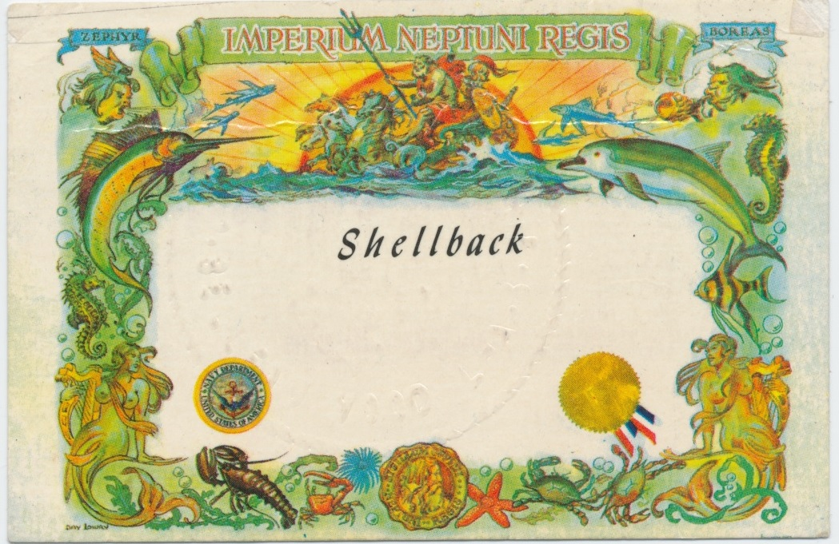

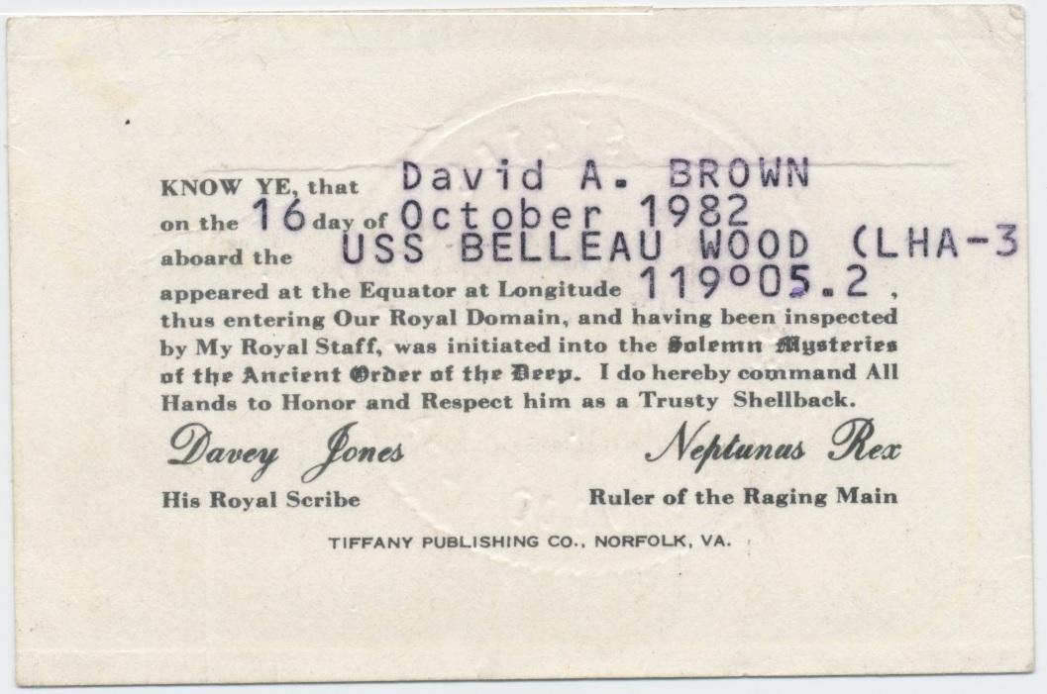

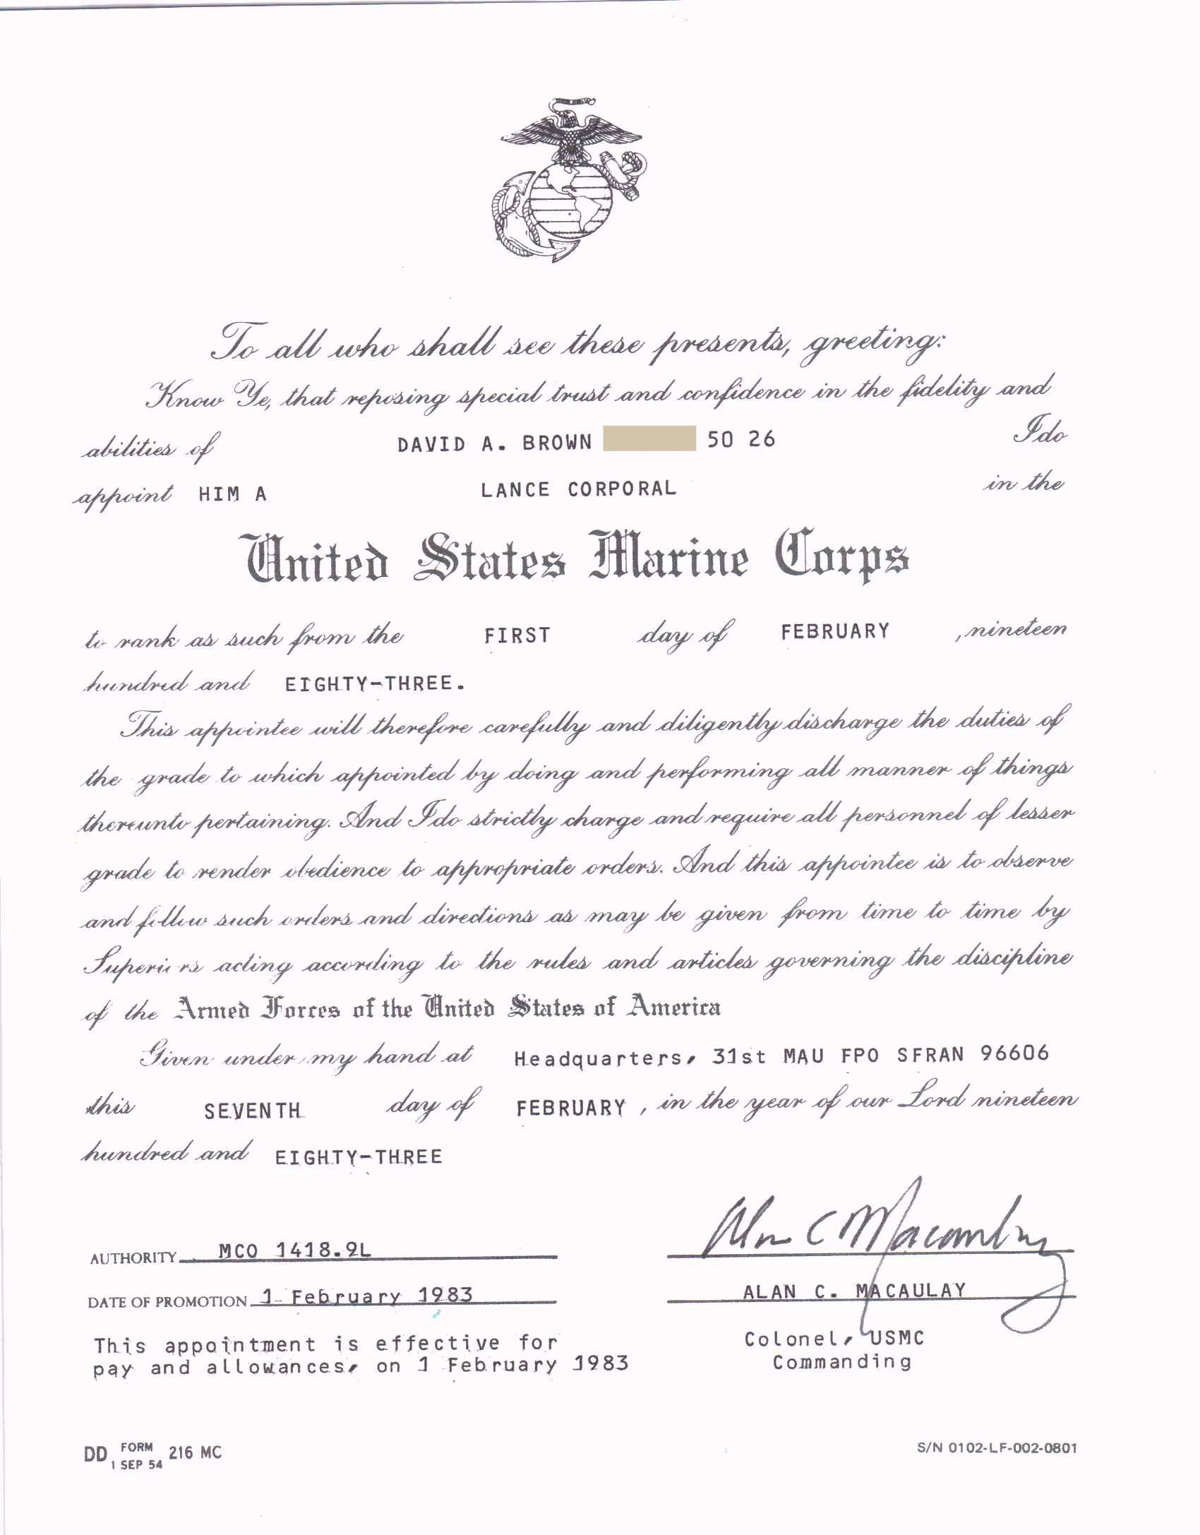
May 21, 2015
Thinking about my fellow Jade Tiger Veterans
May 21st is my original rotation (RTD) date from my first overseas tour (including Operation Jade Tiger). I was moved-up 1 flight and actually returned to the USA on May 11, 1983 from Okinawa but always remember May 21st as my RTD date.
Also thinking about the Veterans from other "Jade Tiger" like military operations
WW II (1943) Exercise Tiger at Slapton Sans in Devonshire, England
Exercise Tiger, or Operation Tiger, was the code name for one in a series of large-scale rehearsals for the D-Day invasion of Normandy, which took place on Slapton Sands or Slapton Beach in Devon. Coordination and communication problems resulted in friendly fire deaths during the exercise, and an Allied convoy positioning itself for the landing was attacked by E-boats of Nazi Germany's Kriegsmarine, resulting in the deaths of 946 American servicemen. The incident was under the strictest secrecy at the time due to the impending invasion, and was only nominally reported afterward; as a result it has been called "forgotten". – Wikipedia.com

Lebanon crisis (1958) Operation Blue Bat

Vietnam (1967) Battle of Two July – Operation Buffalo, 1st Bn 9th Marines "The Walking Dead"
Vietnam (1970) Battle of Fire Base Ripcord
Vietnam (1970) Operation Ivory Coast
Vietnam (1971) Battle of Fire Base Mary Ann

The Cold War (1970's) Operation Ivy Bells – awarded the Presidential Unit Citation
Iran Hostage Crisis (April 24, 1980) Operation Eagle Claw – staging base located at Masirah Island near Oman
*Somalia (1982 - November) Operation Jade Tiger – aka Exercise Jade Tiger
*Oman (1982 - December) Exercise Golden Lion – aka Exercise Jade Tiger

Afghanistan (2005) Operation Red Wings II
*events participated in by David A. Brown USMC 1981-1984
Note: much of the public information regarding these events appears to be either inaccurate or is missing altogether. When looking for information about these events you are going to need to read between the lines and keep looking until a more accurate picture emerges.

Westpac 82-83 surveillance of Iran and Iraq War commonly known as the oil “Tanker War”

Prior to deploying on Westpac 82-83 the ship the USS Belleau Wood (LHA-3) had maintenance work done and received upgrades. The LHA-3 was scheduled to receive the upgraded phalanx weapon system prior to the 82-83 deployment. A last minute (budget and time) decision canceled the phalanx weapon system upgrade in favor of a new surveillance system upgrade. The phalanx weapon system was later added prior to the next LHA-3 Westpac deployment of July 1984.

The new surveillance system upgrade for the first time allowed a US Navy ship to conduct full scale, high quality surveillance while underway. Previous to Westpac 82-83 a Navy ship would have to stop and shutdown most its operating systems and engines in order to conduct surveillance in a quiet mode aboard the ship i.e. the USS Liberty where the USS Liberty in 1967 when conducting surveillance had to shutdown all of their ships systems in order to eavesdrop with the electronic equipment they were using.

In December 1982 the USS Belleau Wood (LHA-3) conducted surveillance of a battle in the Iran and Iraq war while off the coast of Southern Iran near the Strait of Hormuz. The Ship the USS Belleau Wood (LHA-3) conducted both types of electronic surveillance both with all power systems on and the ship underway and by the previous procedures (i.e. USS Liberty 1967) of powering down most of the ships systems and remaining "dead" in the water while silently conducting surveillance. Both of the surveillance results were the same quality with the new surveillance equipment. Since Westpac 82-83 a US Navy ship can now conduct high quality surveillance while underway and maneuvering under power without having to shutdown and remain still and silent while conducting surveillance.

I was outside on one of the upper decks with a few of the LHA-3 Sailors talking about Somalia while some of the surveillance, particularly the quiet mode surveillance was taking place as the ship sat off the cost of Iran. We could see the bushes that grow only in Iran on the nearby shore of Iran and we looked for Iranian artillery fire though we didn't see any or we didn't see much. Previous US ships in that area had witnessed the huge artillery battles between Iraq and Iran especially at night. Later it was confirmed that the surveillance equipment had performed with better than expected results. Those surveillance tests were carried on for several years and multiple US Navy ships conducted similar tests in the same area.

Update December 2016: I hope this will be the last update for a while though I have made a commitment to truthfully and ACCURATELY present material and documents from our deployments. If something does come up that assists in documenting our deployments I’ll add it to my document. I think it is the responsibility of all Veterans to portray our military experiences as accurately as we possibly can. If in any of my material I need to make corrections or changes I will gladly make them.

David A. Brown
USMC 1981-1984

February 2014

Some of my lighter memories of WestPac 82-83.

1. Of course seeing and boarding the USS Belleau Wood (LHA 3) for the first time, in the Philippines for me – that ship was huge and all business.

2. When we departed the Philippines and on route to Perth, Australia we passed really close by the resort Island of Bali it was a foggy misty morning though clearing. I was up on deck and tourists (seemingly Americans) were laying on the beach just relaxing and waiting for the sun and suddenly they looked up and through the clearing fog there was this huge American Warship right in front of them. I don’t think they appreciated what the BW brought to the scenery and when they realized how long it would take for the slow moving ship to pass several tourists picked up their towels and headed off the beach with a no shortage of unkind words and gestures as they departed. It was really funny, mostly Americans but two different worlds colliding in the Far East.

3. Midrats for everyone after Australia and on route to Somalia was a great time while it lasted. The ship was trying to keep the Marines out of Midrat (Midnight) Mess but everyone would just say we were on duty and get in line. Midrats was basically an afterhours club with food and a great time and nothing worked to keep us extras out until someone got the idea to serve only the banger sausages that we got from Australia as Midrats and those things had a strange taste (like eating a dead body) that was inedible to those of us who hadn’t grownup eating them. That ended us extras from showing up and then more accurate lists were made of who needed to be there so we couldn't get in.

4. On our beach party day in Somalia (I was in the fourth and last group - 4th day) most of us myself included got sunburned from head to toe and I mean sunburned. When we got back to the ship that evening the BW brought in and handed out jars and jars of Noxzema skin cream for everyone to put on. The smell of Noxzema and sunburn was so strong for days I think it even went through the steel walls. It was years after that before I could even be in the same room with an open jar of Noxzema.

5. One of the best memories in my life is when we were getting back to the Philippines after the Arabian Sea and the Indian Ocean and the galley was completely closed. I walked in there to see if I could get some coffee and even that was secured and a couple of Sailors came out and told me that even the drinks are put away. The galley was clean and spotless like the deployment had never even happened. I said that they had really been working hard and that the place looked great and as we stood there a couple more Sailors and another Marine or two came up and it kind of dawned on all of us that we had made it through a really difficult deployment, not the first deployment for most of the group and everyone began to say that it was really something what we just went through.

David Anson Brown
Westpac 82-83, HQ Comm Plt 31st MAU

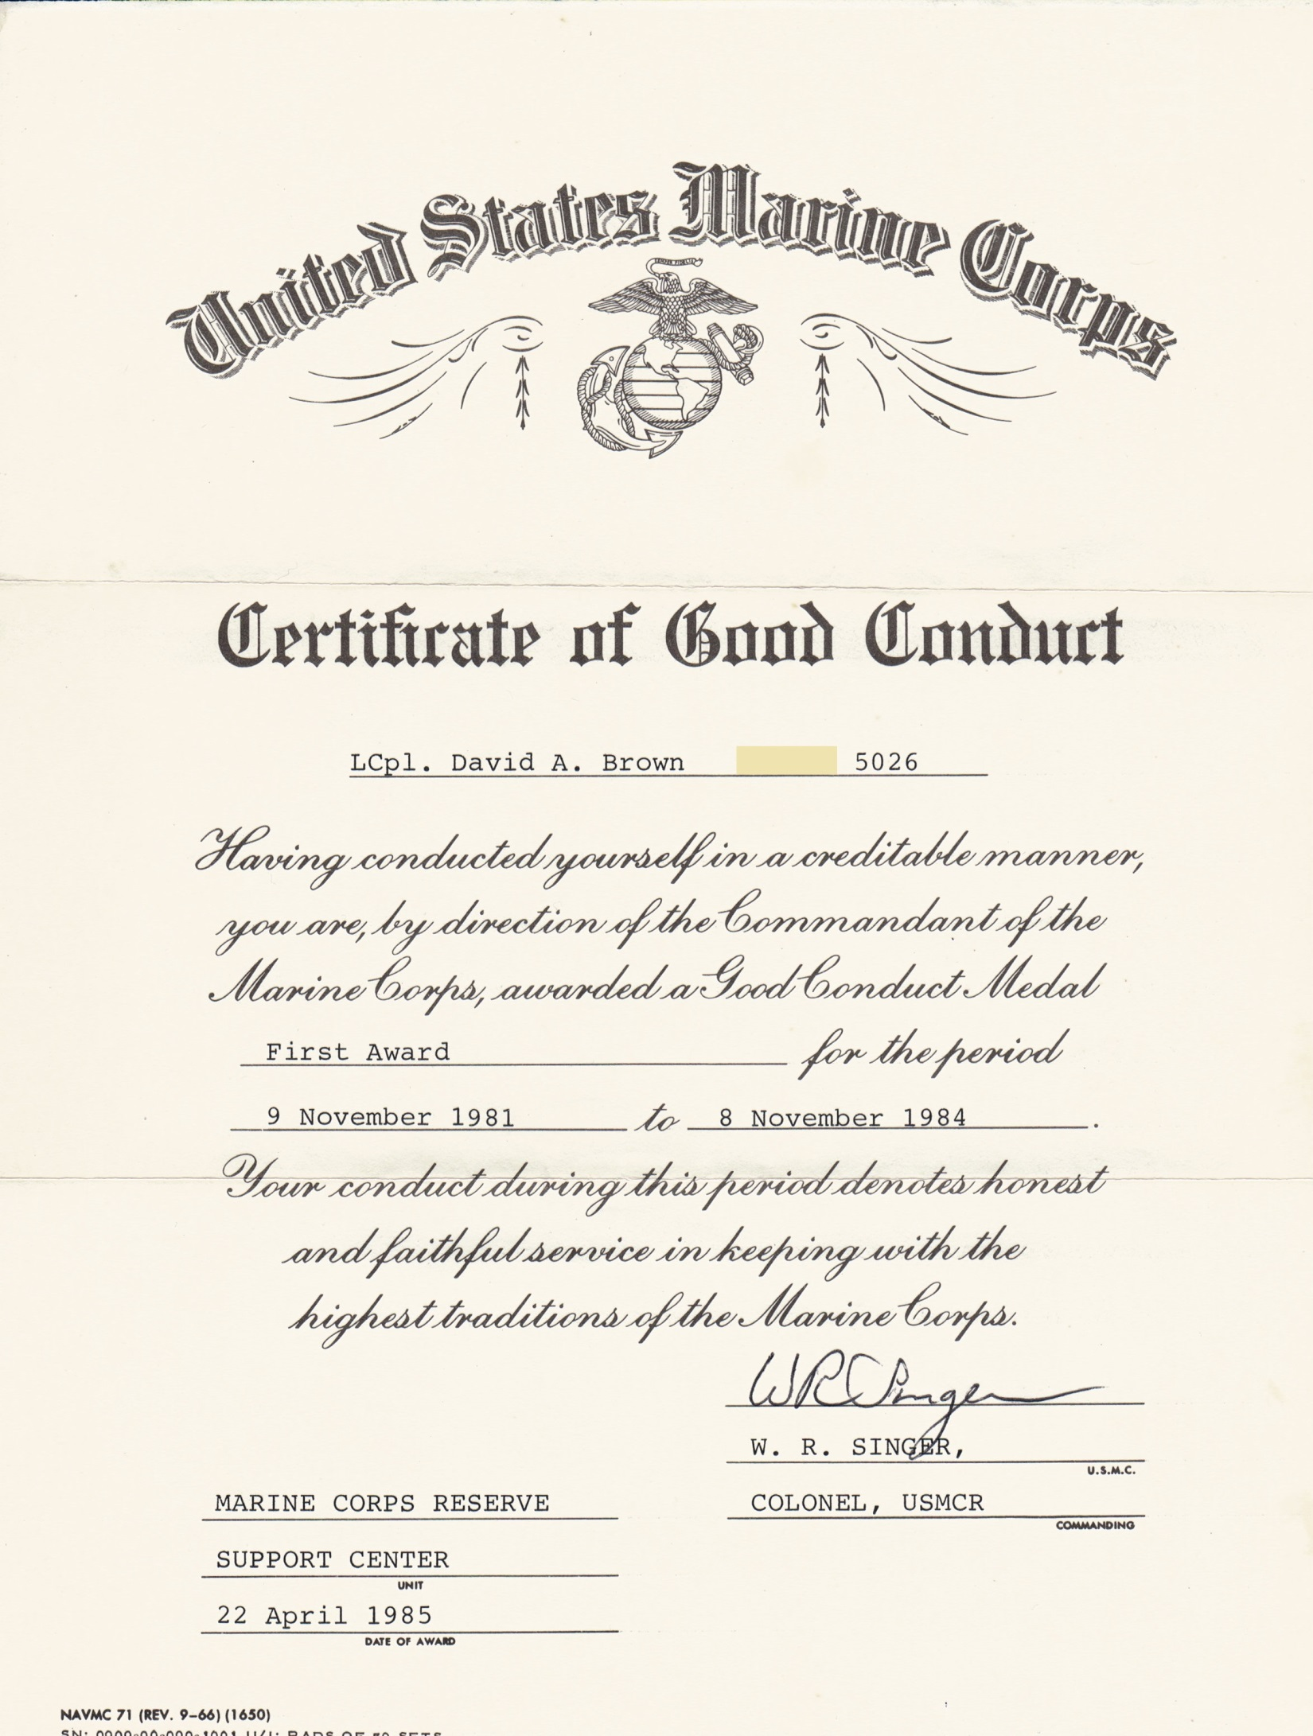
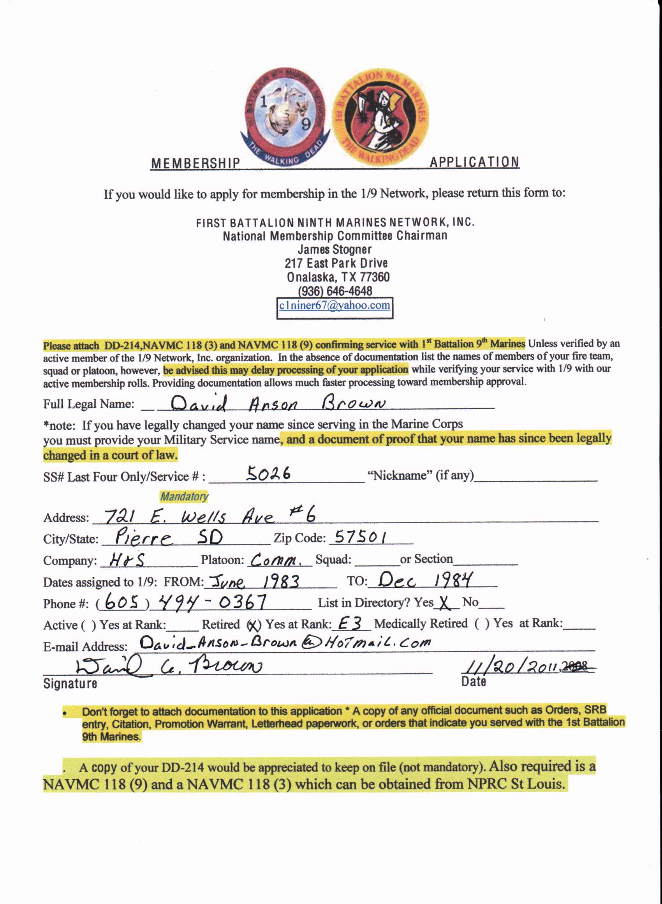
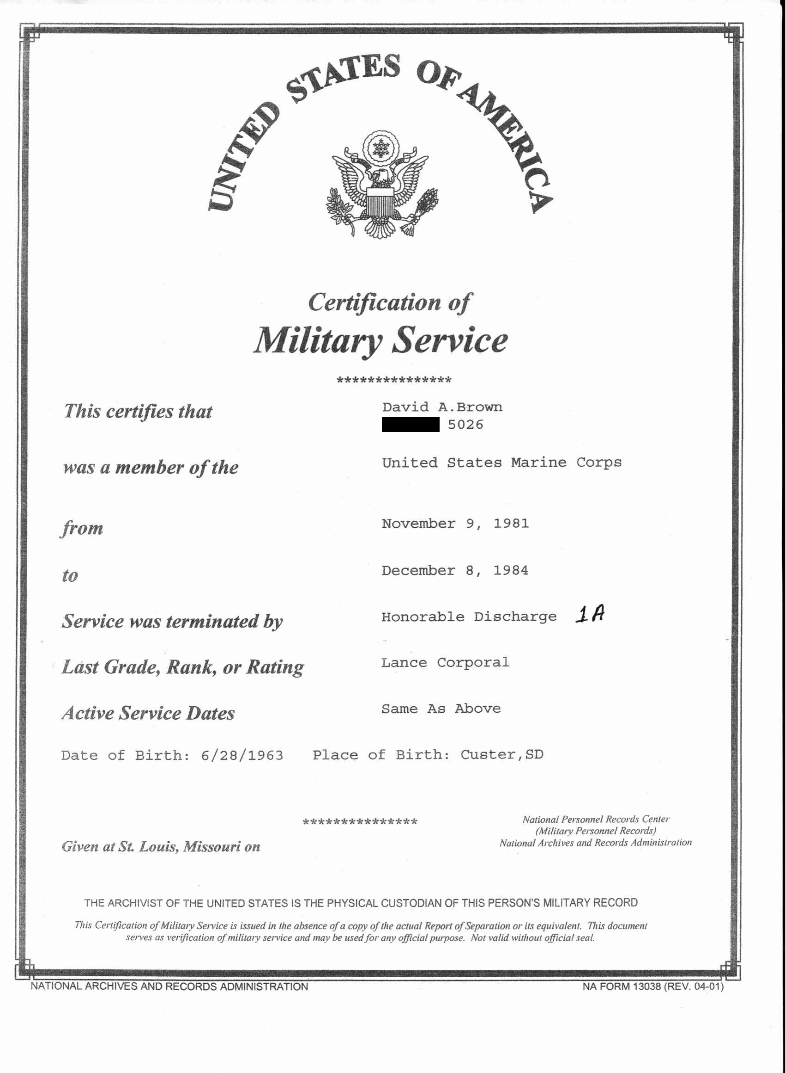
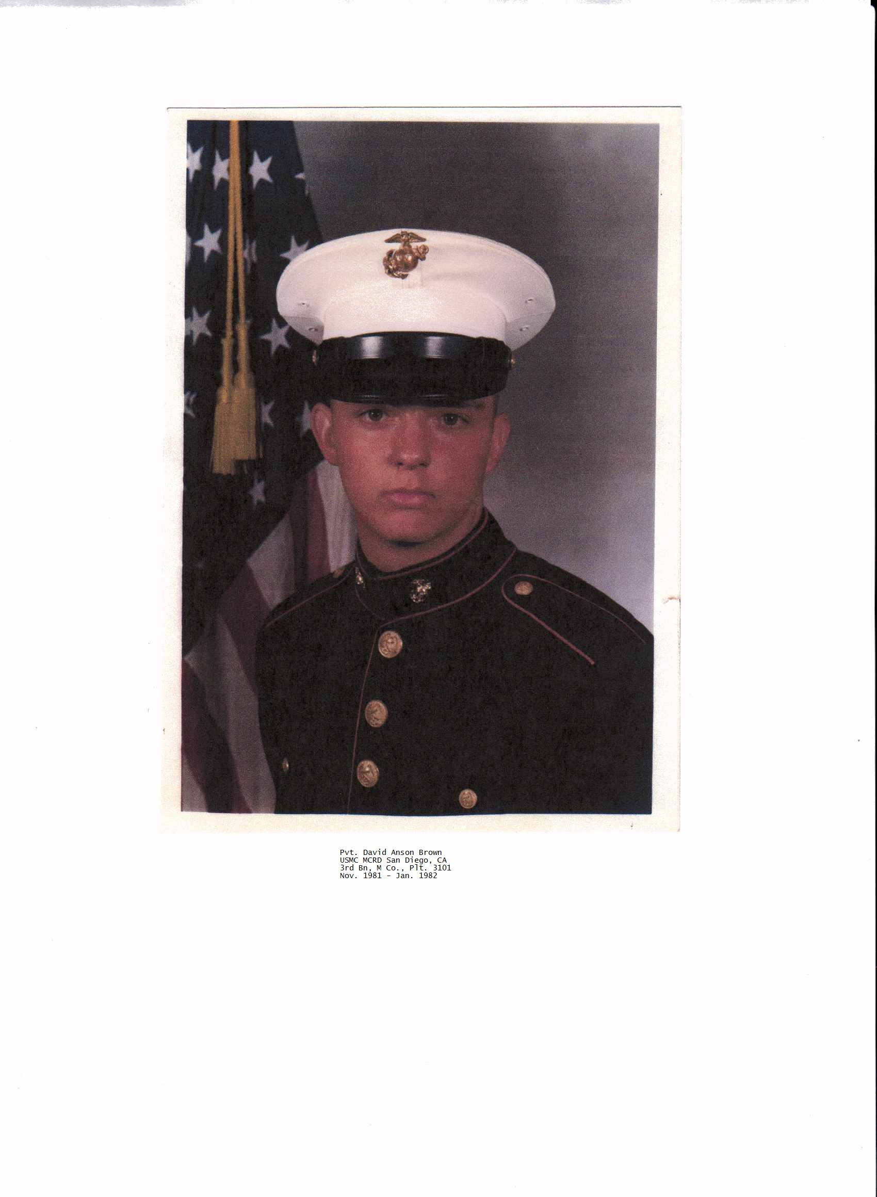
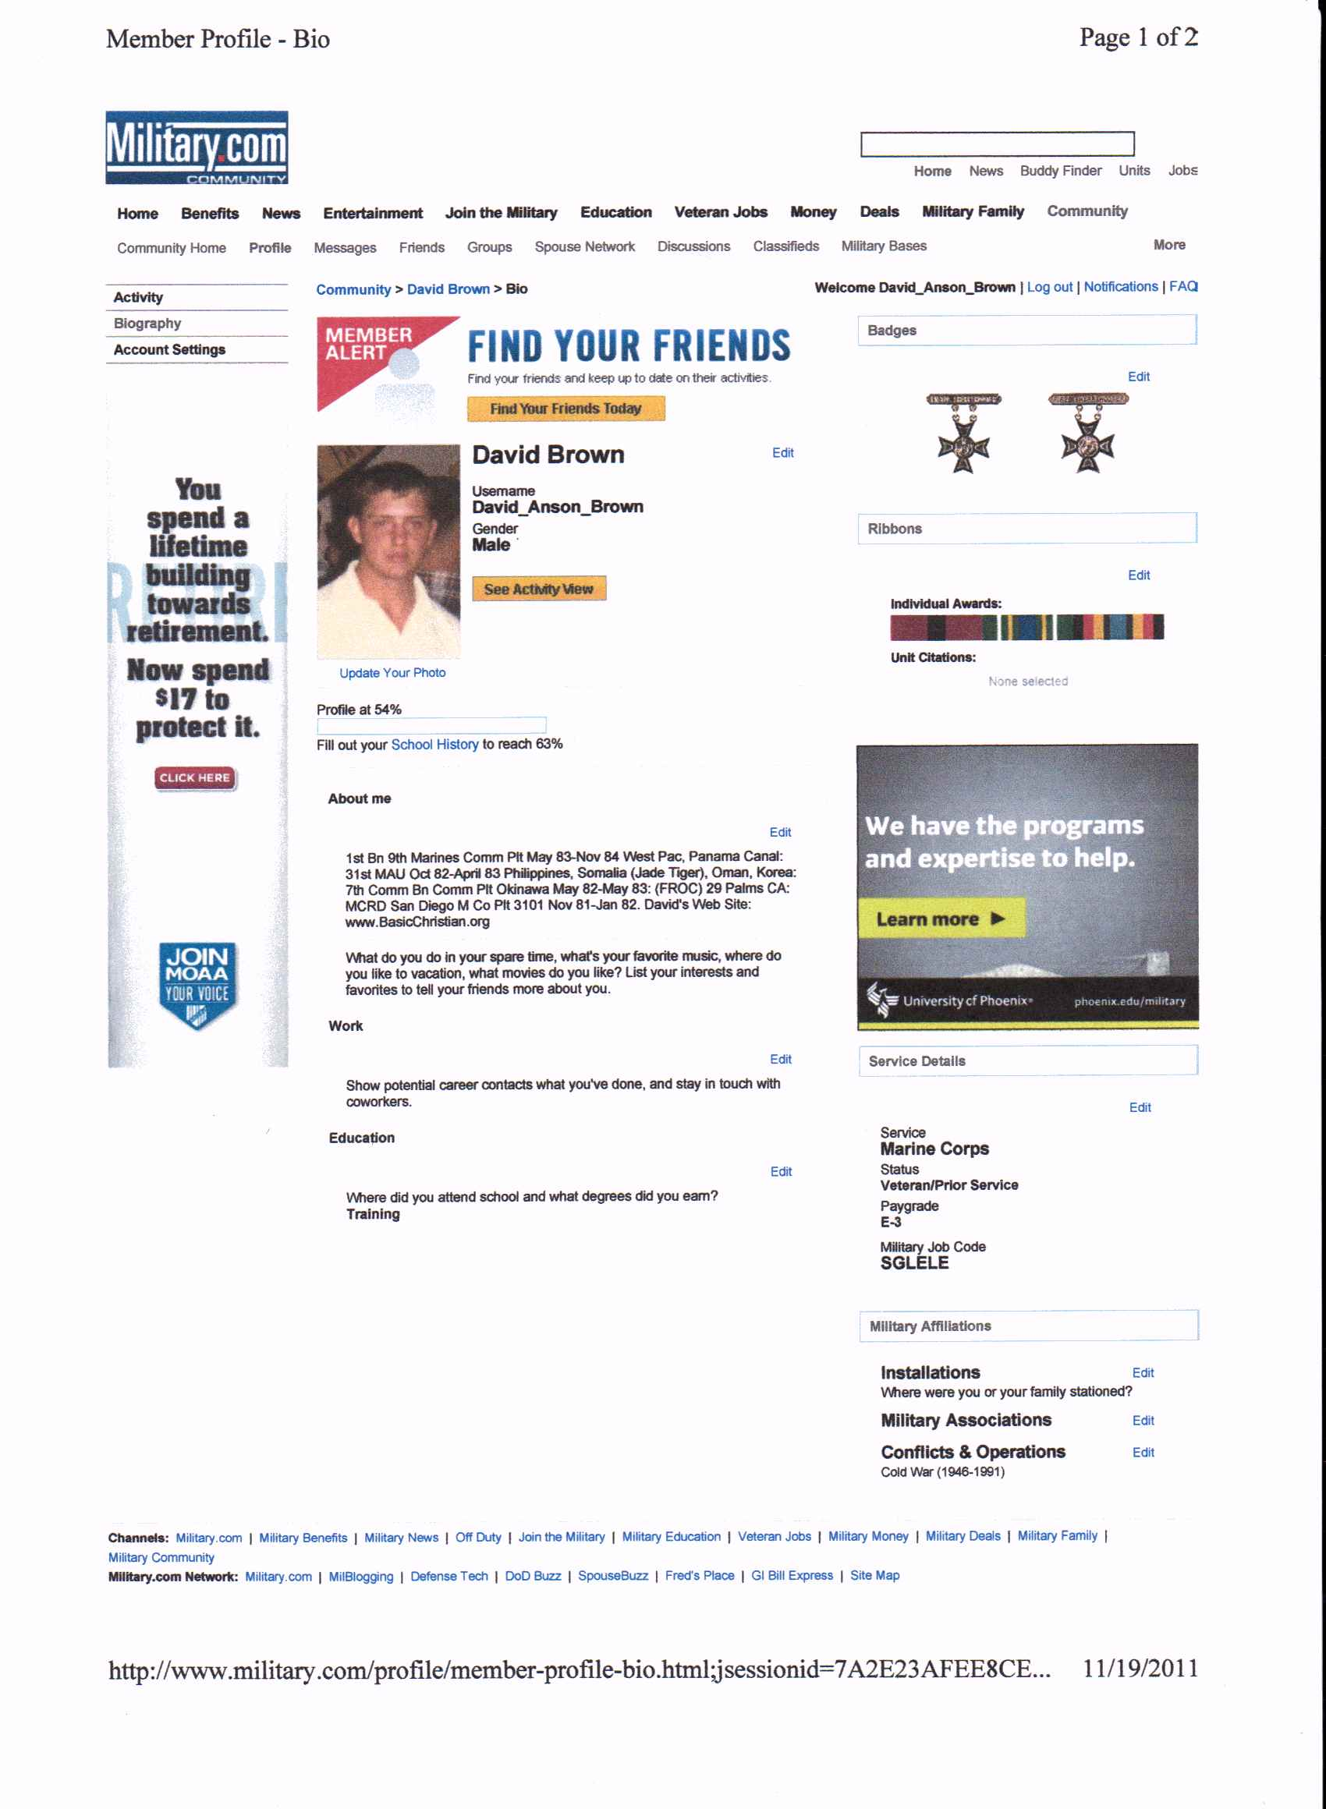
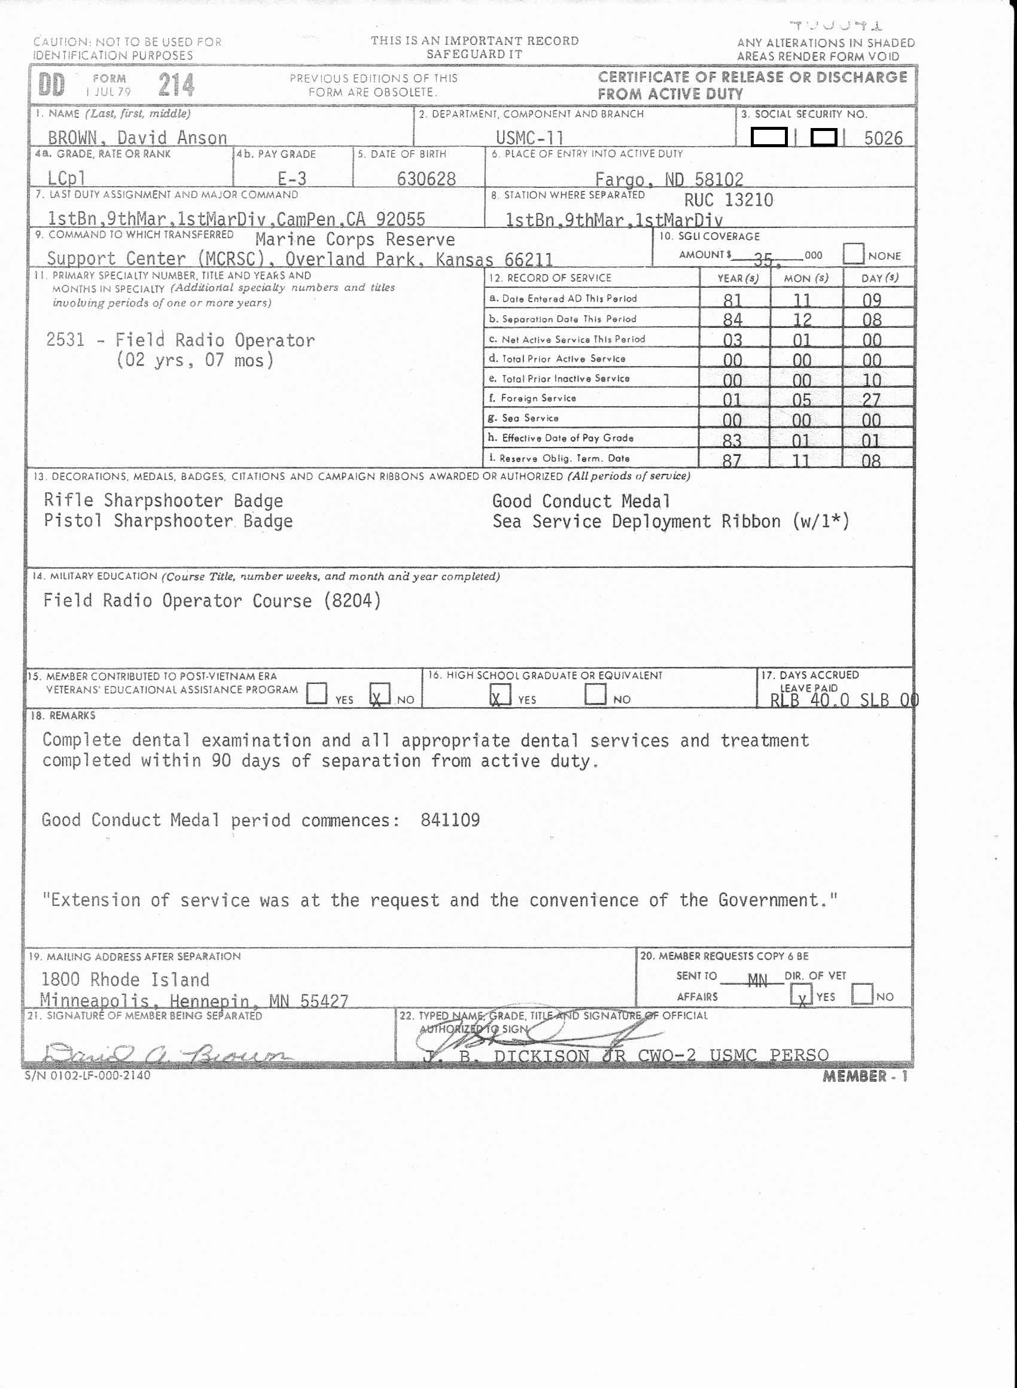
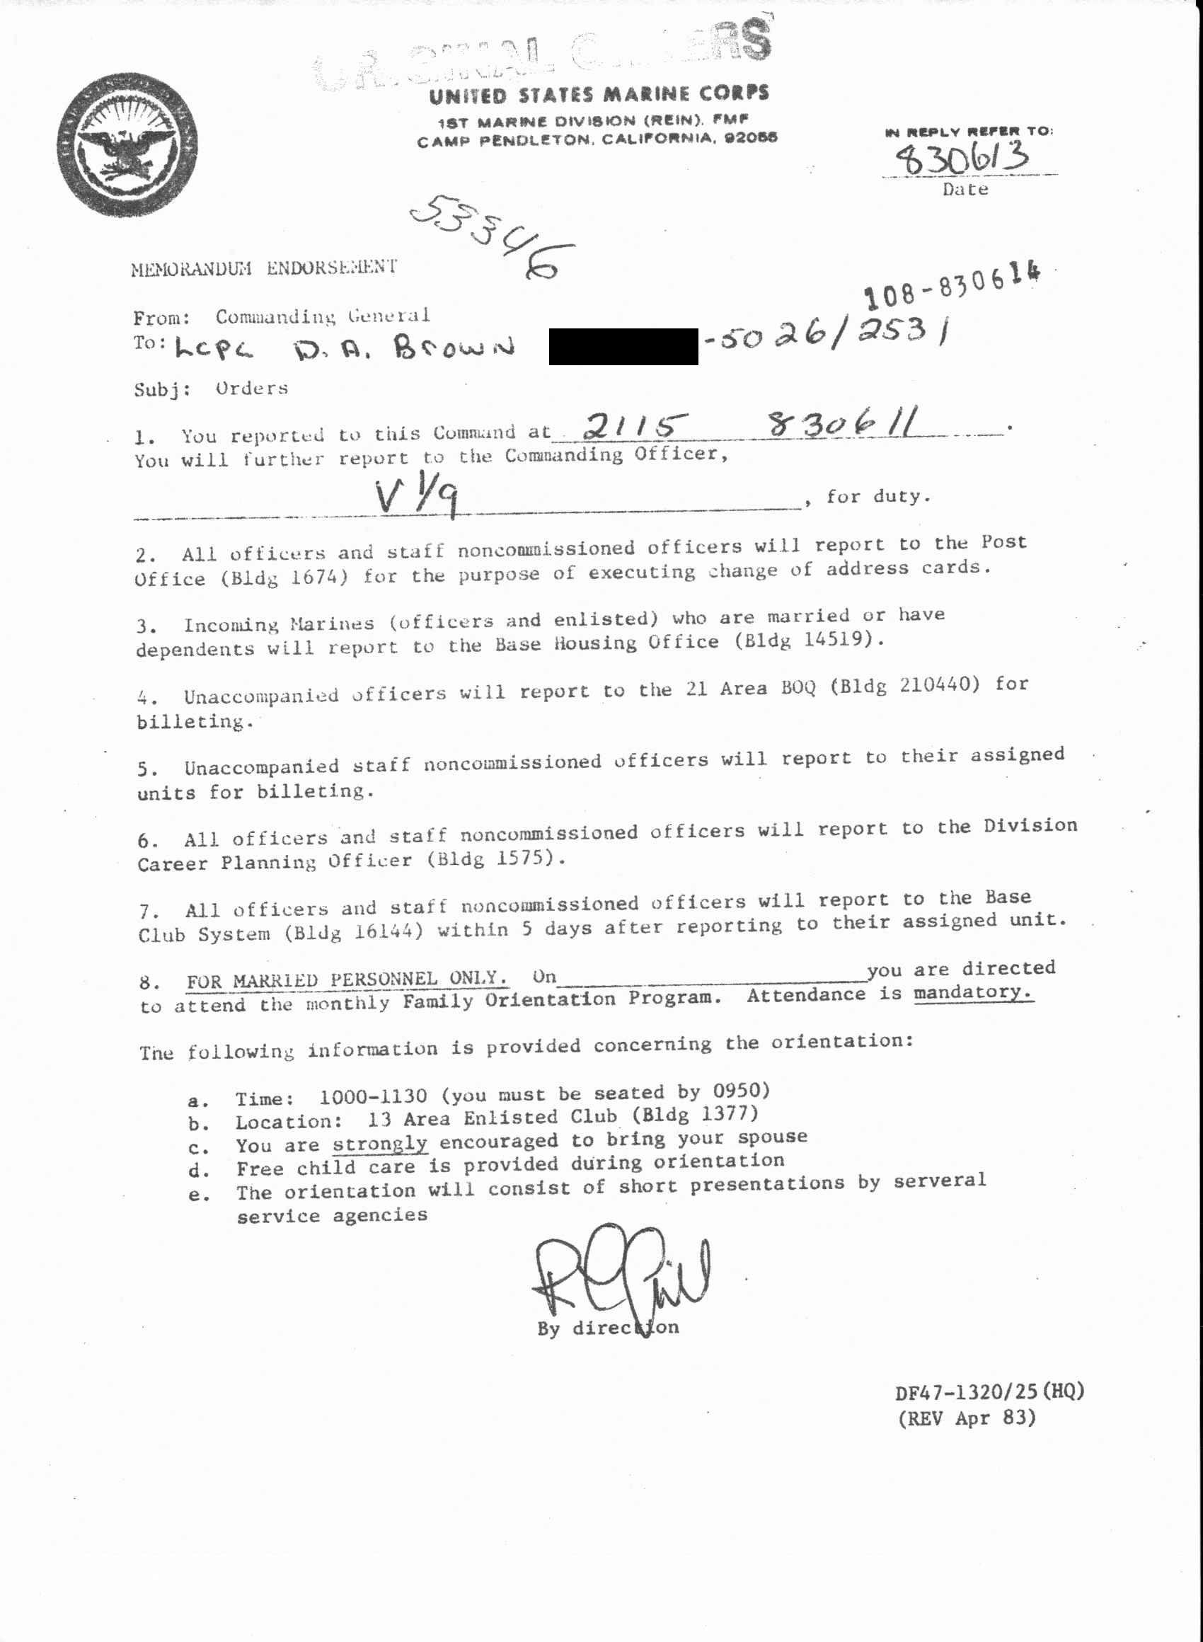
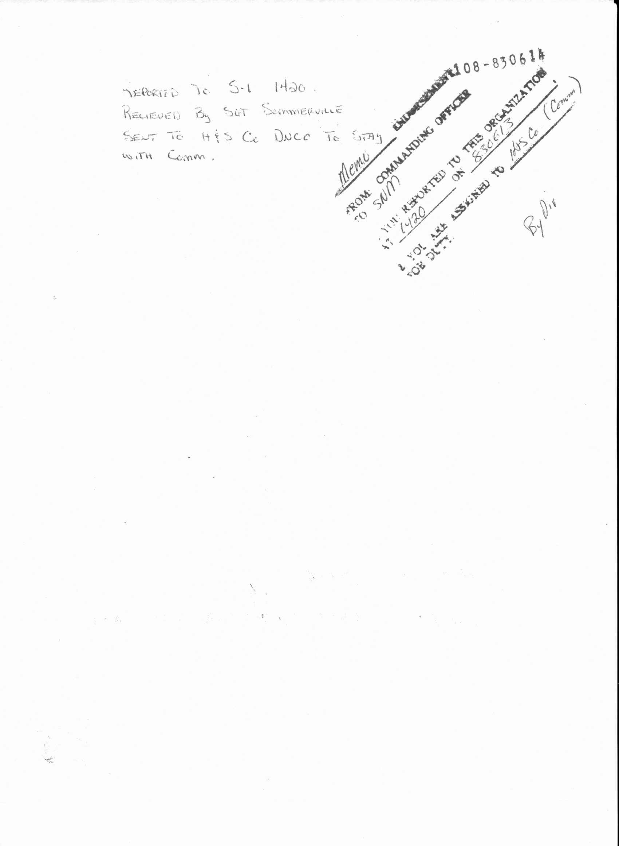
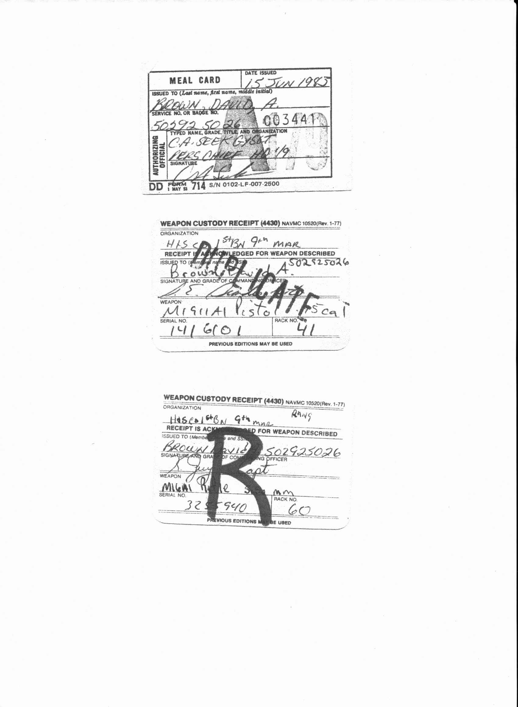
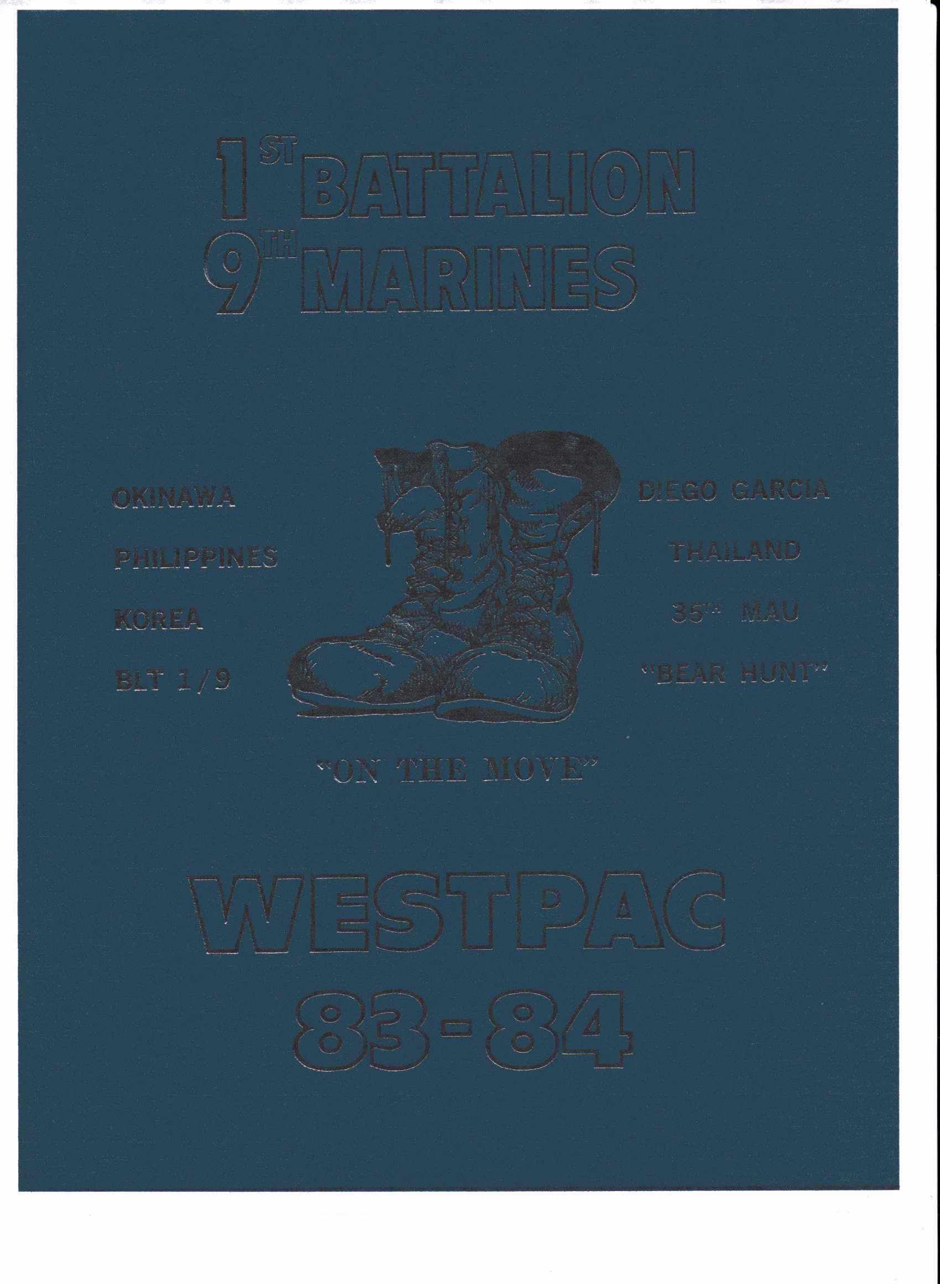
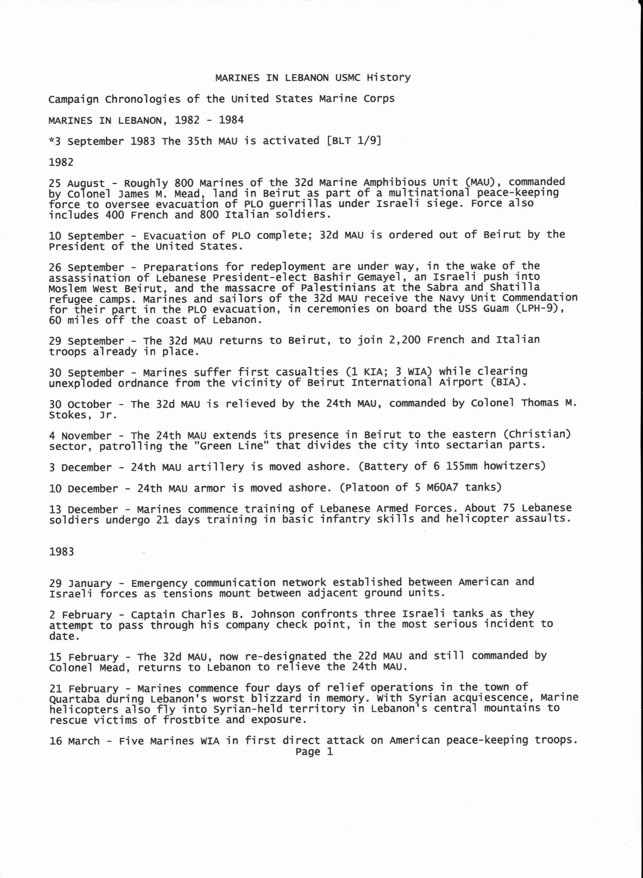
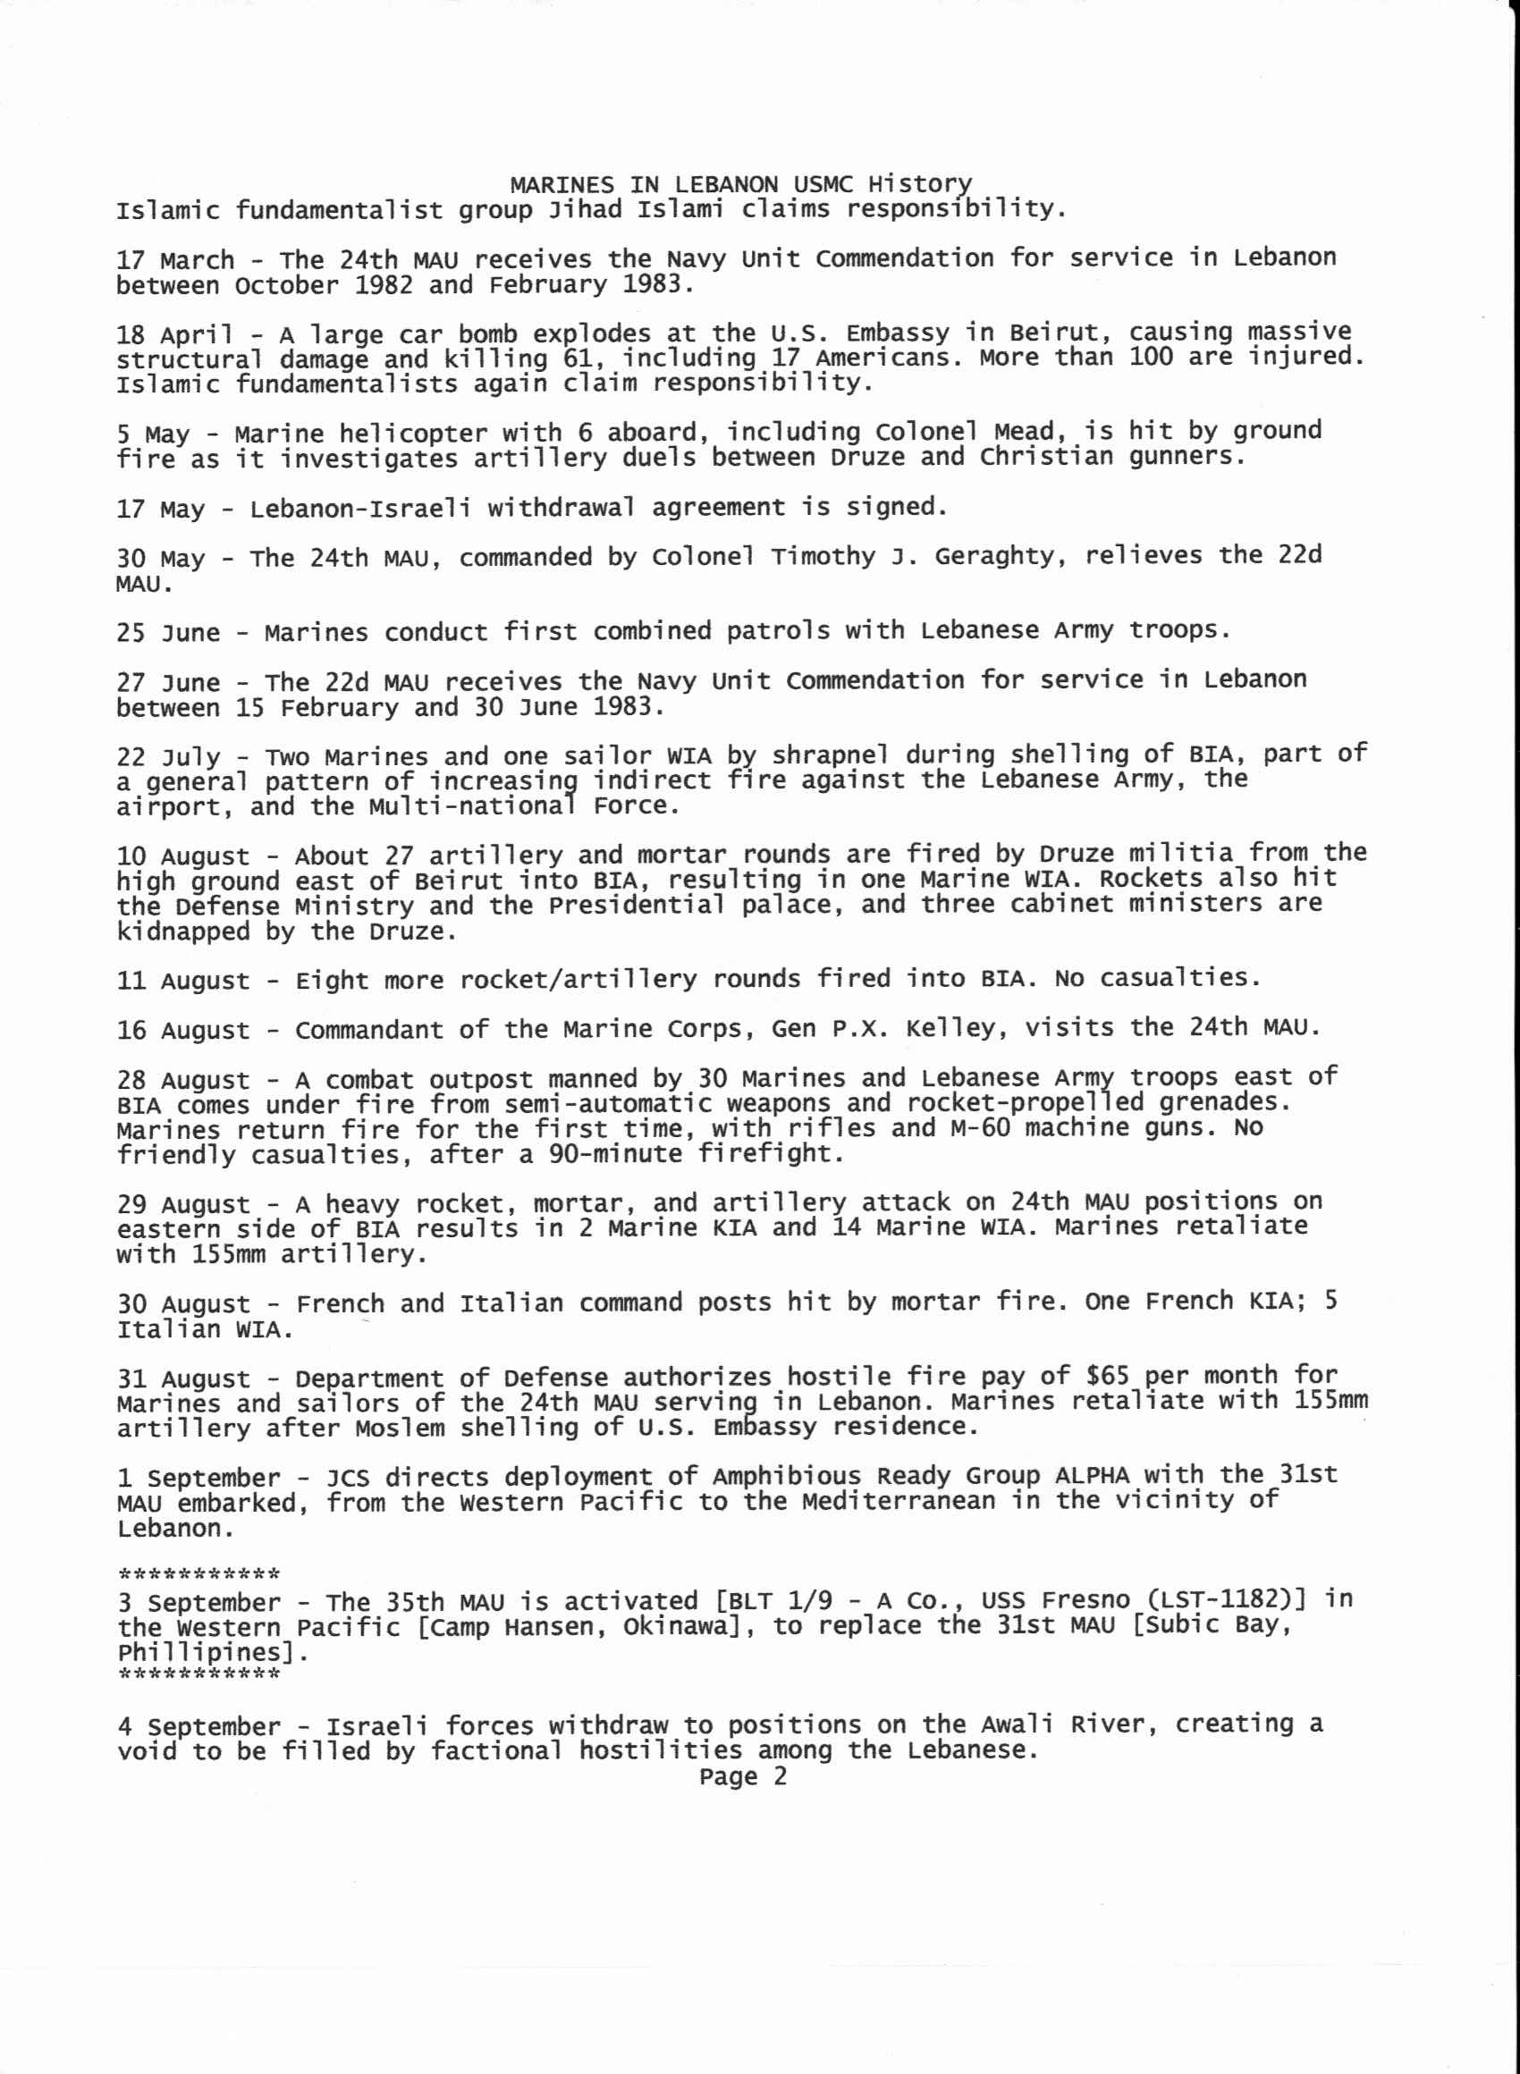
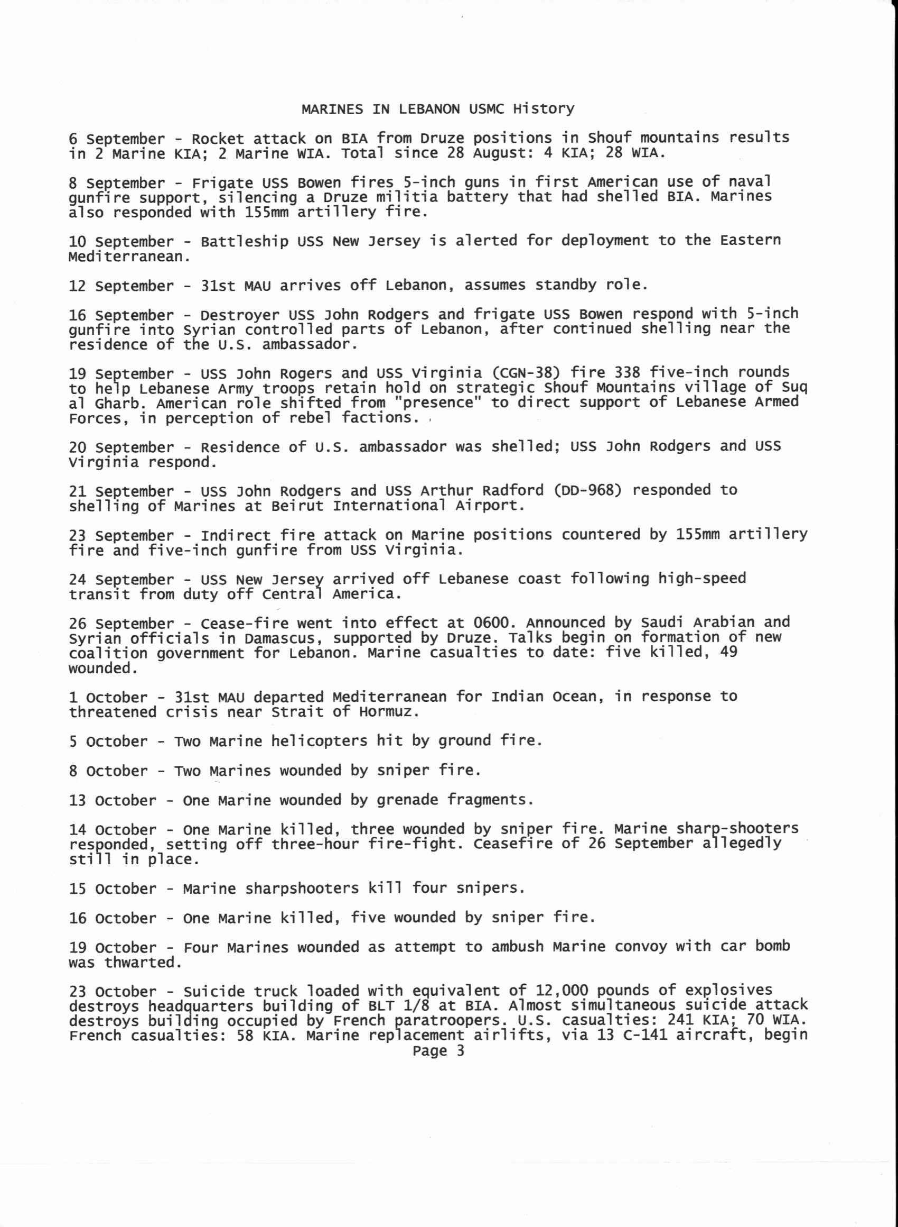
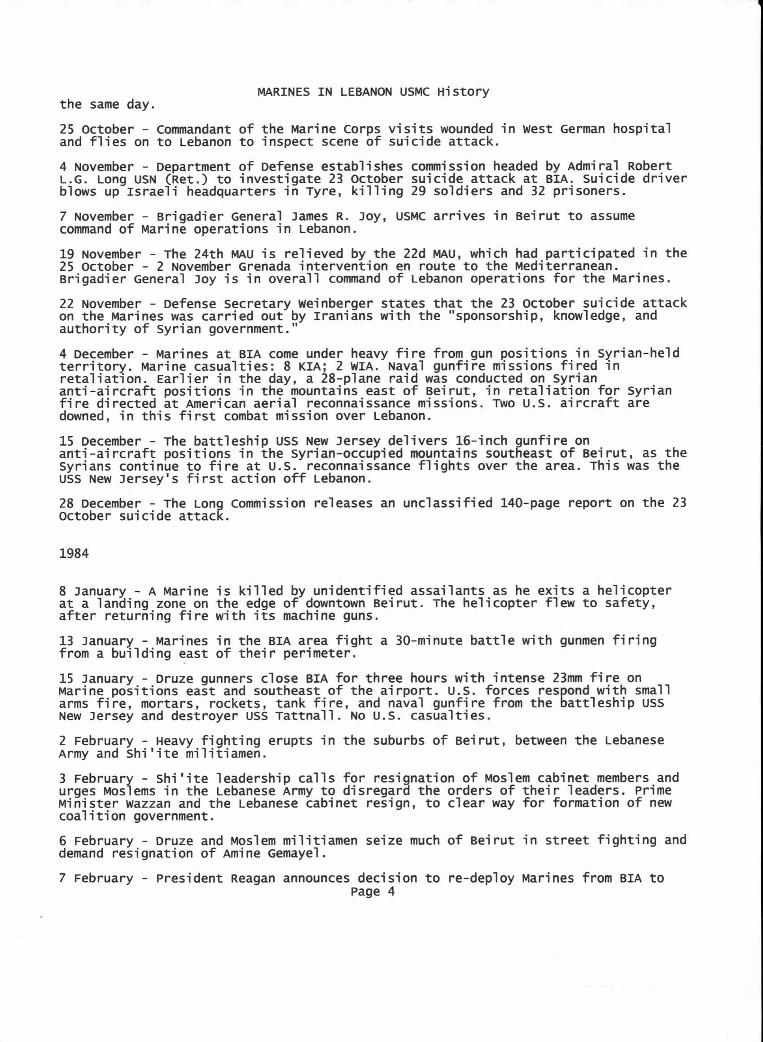
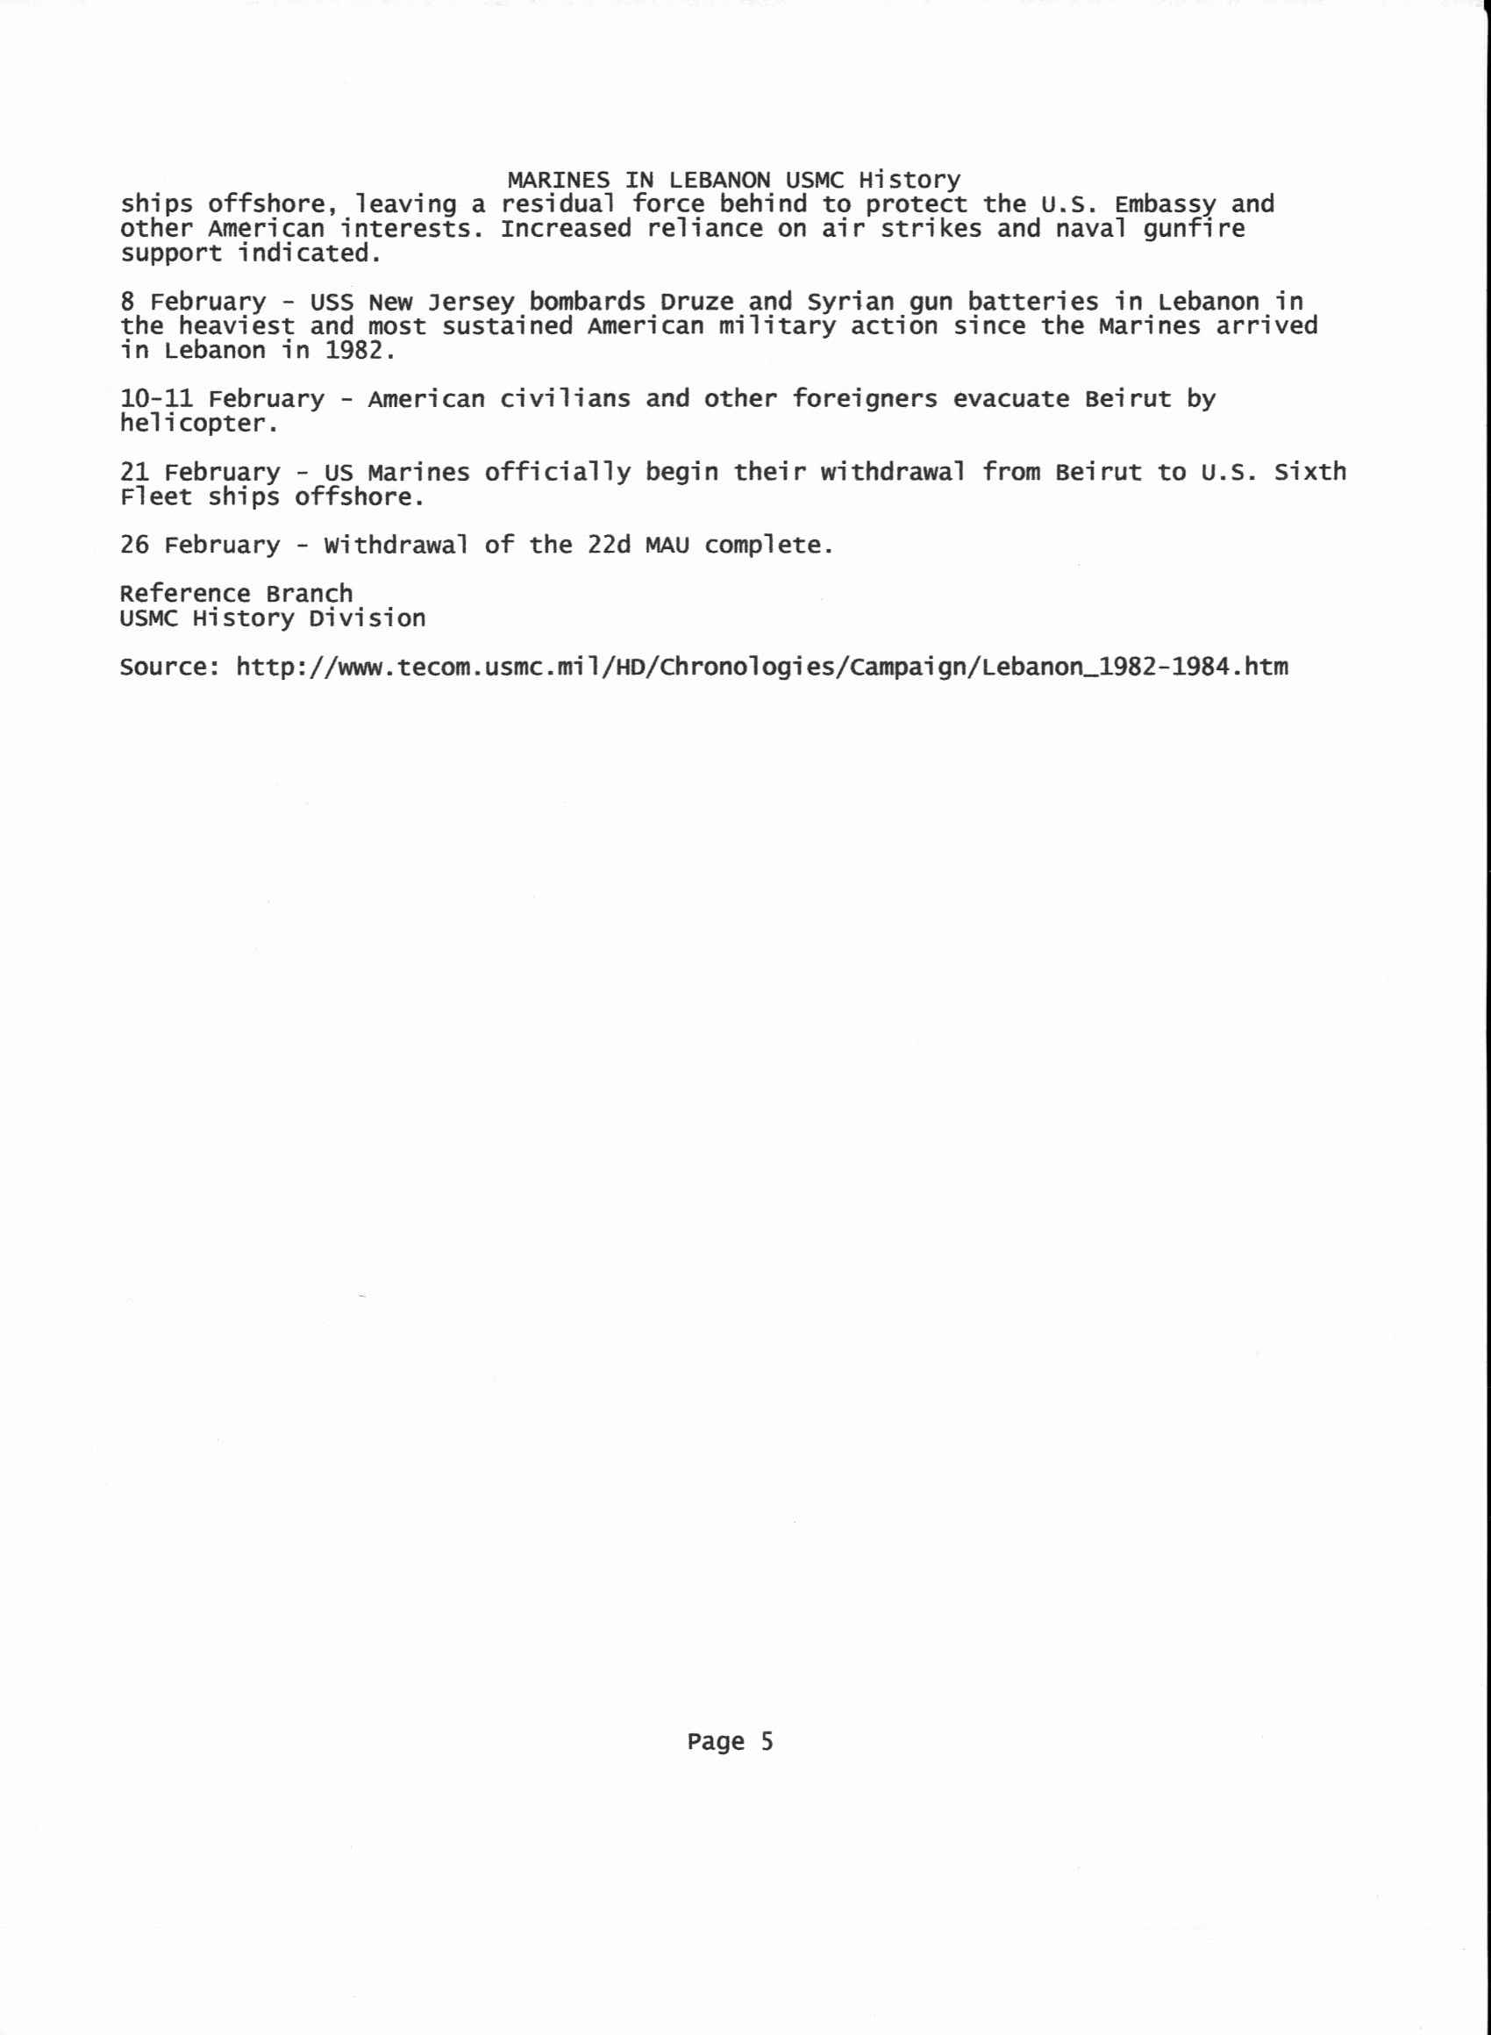
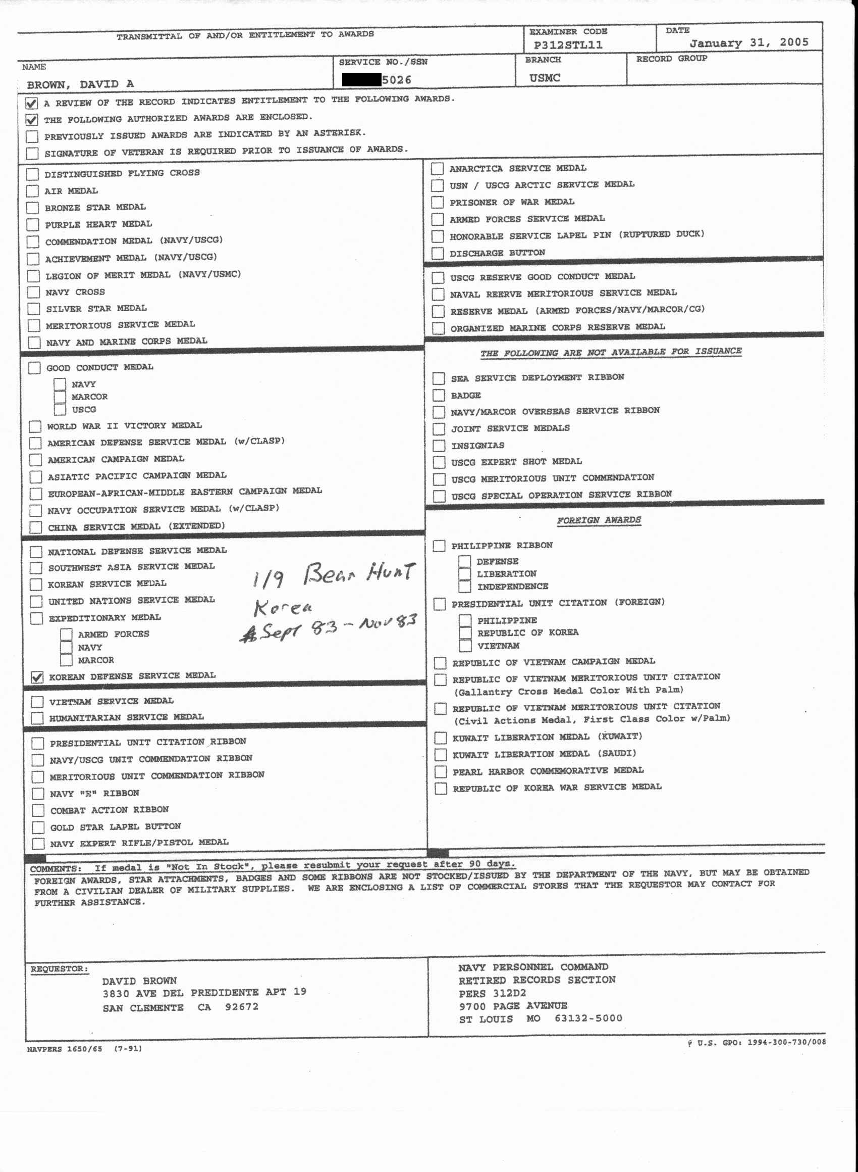
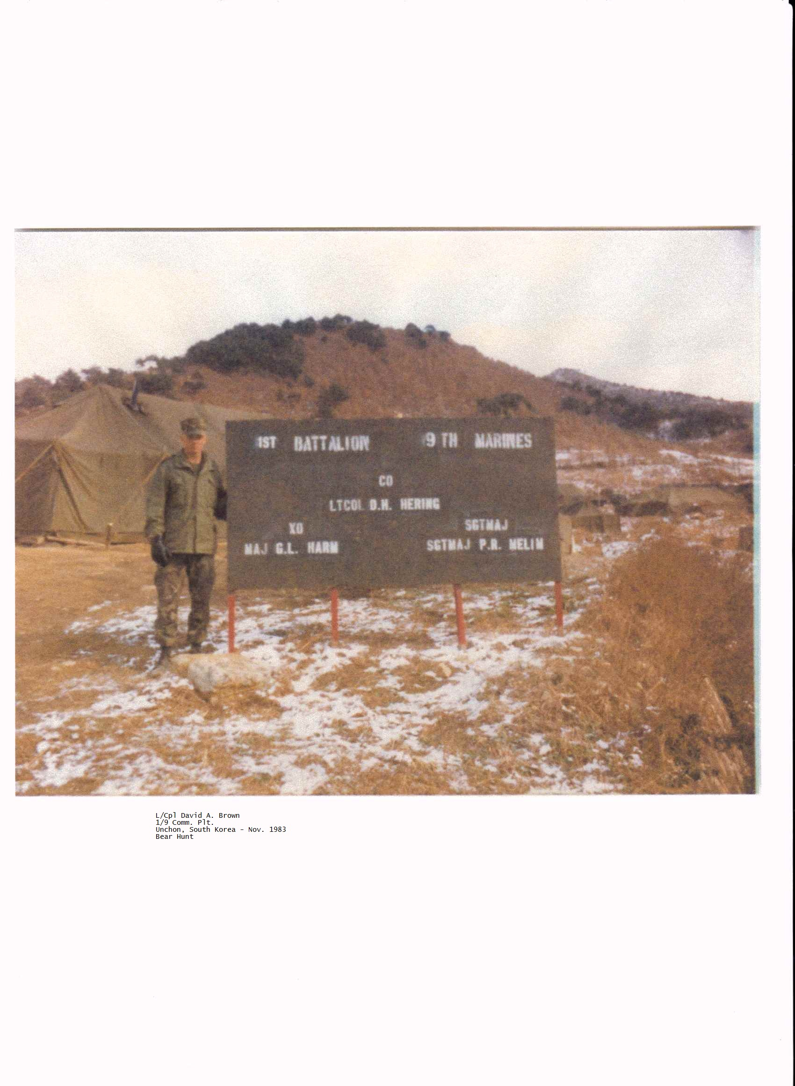
3rd Marine Division – Camp Hansen, Okinawa 83-84
1st Bn 9th Marines "The Walking Dead"
The Beirut Barracks Bombing (October 23, 1983, in Beirut, Lebanon)
In the attack on the building serving as a barracks for the 1st Battalion 8th Marines (Battalion Landing Team - BLT 1/8), the death toll was 241 American servicemen: 220 Marines, 18 sailors and three soldiers, making this incident the deadliest single-day death toll for the United States Marine Corps since World War II's Battle of Iwo Jima, the deadliest single-day death toll for the United States military since the first day of the Vietnam War's Tet Offensive, and the deadliest single attack on Americans overseas since World War II. Another 128 Americans were wounded in the blast. Thirteen later died of their injuries, and they are numbered among the total number who died. - wiki.com

1st Bn 9th Marines
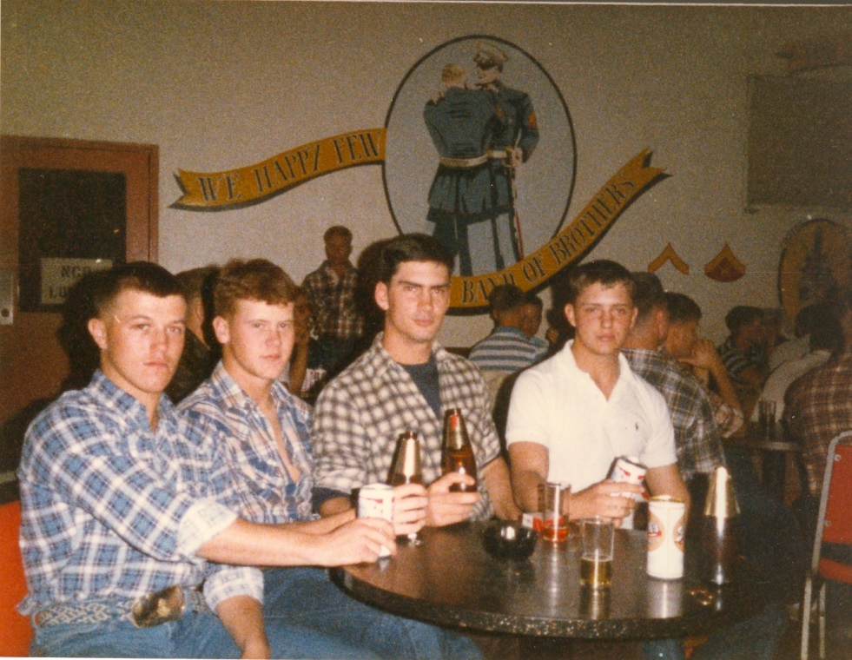
E-club at Camp Hansen, Okinawa
LCpl Chastine 1st Plt A Co., LCpl Tim Moudy, LCpl John Connelly, and LCpl David Anson Brown of 1/9 Comm Plt
October 23, 1983 most of 1/9 [A Co., C Co., WPNS Co. and H&S Co.] were on a hill in Korea [B Co. was in Diego Garcia]. When we arrived in Okinawa (about August 83) we were being bussed to Camp Hansen and our bus driver turned on a radio the news came on and it was about Lebanon and the escalation and increase of mortar attacks on the Marines in Beirut. The second plane bringing 1/9 to Okinawa was delayed a couple of days and once all of 1/9 was in place we started training [rifle range and nbc] then in September at about 2200 (10:00 pm) MP’s showed up and secured 1/9 to base while we were given extra equipment and the next day [for A Co. – I was one of three H&S Comm FAC (Forward Aircraft Control) radioman attached to A Co.] we loaded on ship at Red Beach just outside of Camp Hansen. After a practice landing and training in the Philippines our deployment to Beirut was canceled and we came back to Okinawa where we were still on standby for Beirut until the standby was canceled when we went to Korea for Bear Hunt.

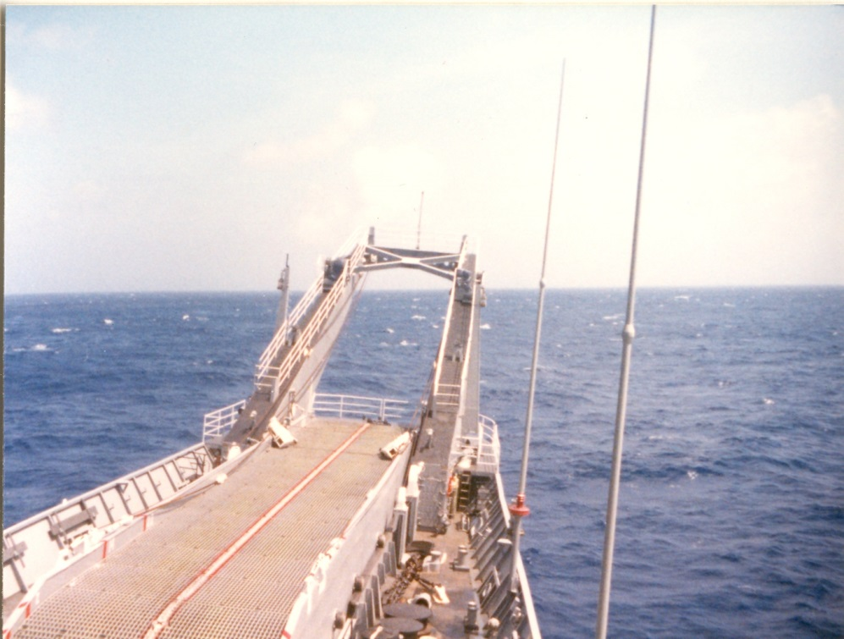
USS Fresno (LST 1182) on route to the Philippines - on the way back to Okinawa we took waves over the deck during a massive Typhoon storm that we encountered.

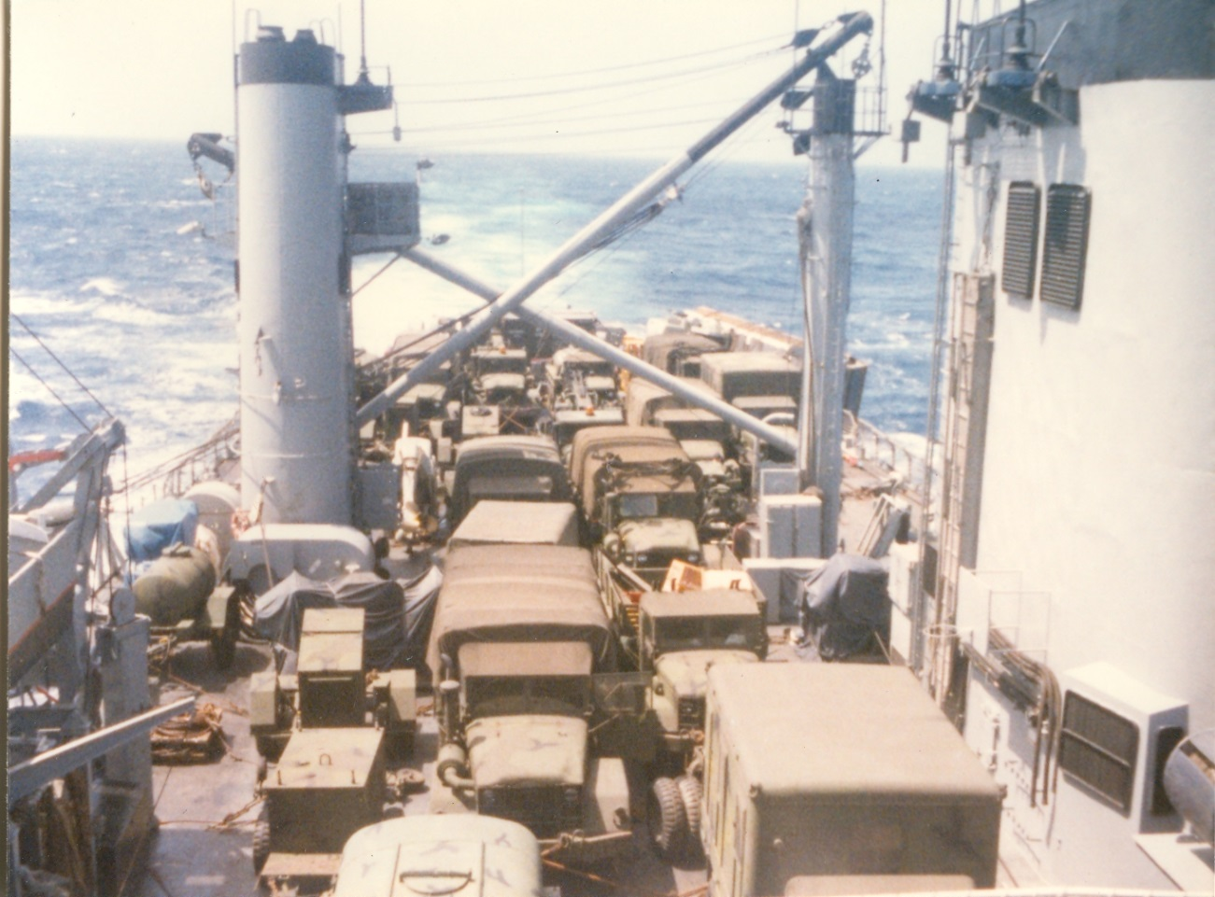
USS Fresno (LST 1182) BLT A Co. 1/9 on route to the Philippines
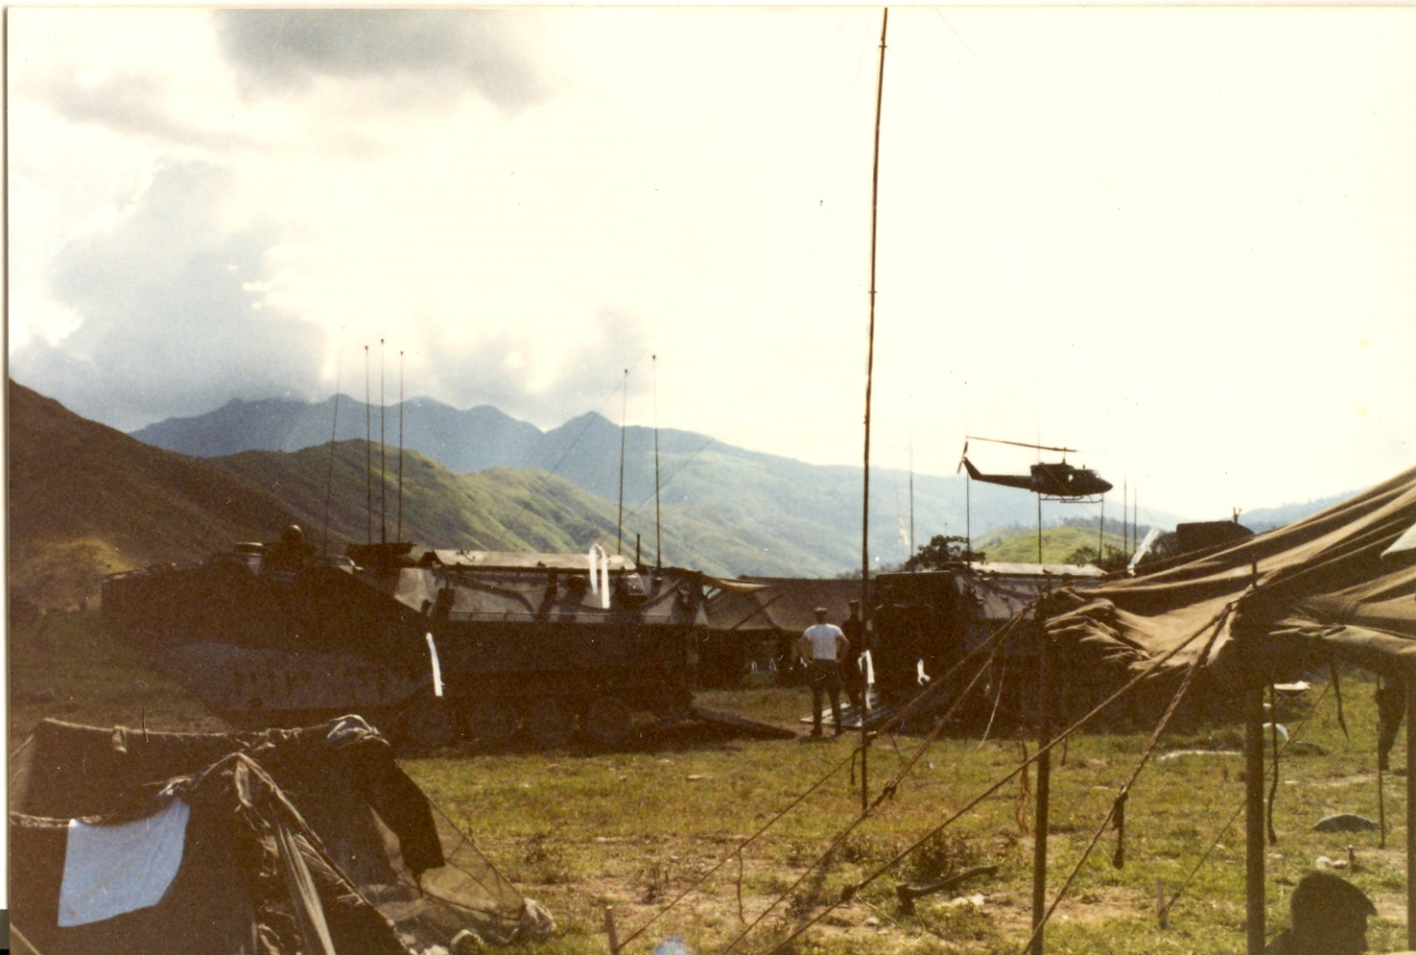
Ashore in the Philippines – Photo provided in Okinawa by LCpl D. Lucas (Oklahoma) 1/9 Comm Plt, B Co. Bn Radioman

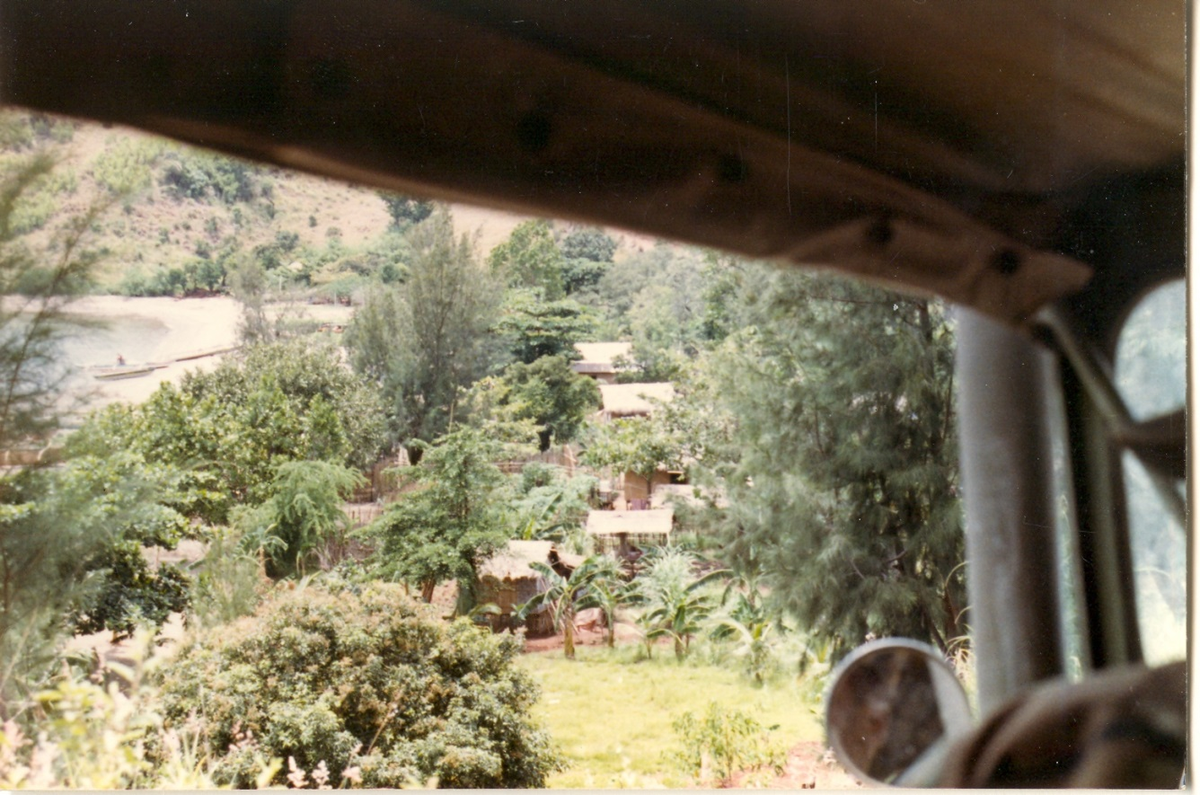
Philippine seaside village – Photo provided in Okinawa by LCpl D. Lucas (Oklahoma) 1/9 Comm Plt, B Co. Bn Radioman
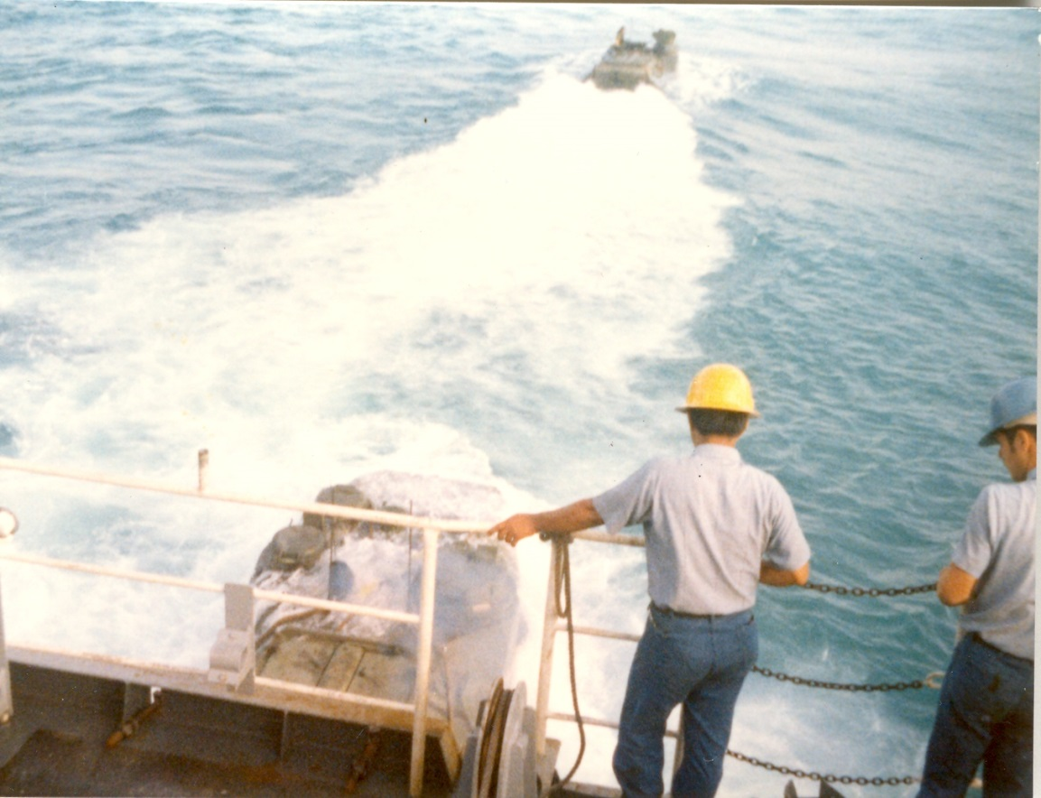
USS Fresno (LST 1182) return to Okinawa and the offloading of Amtracs in southern Okinawa.

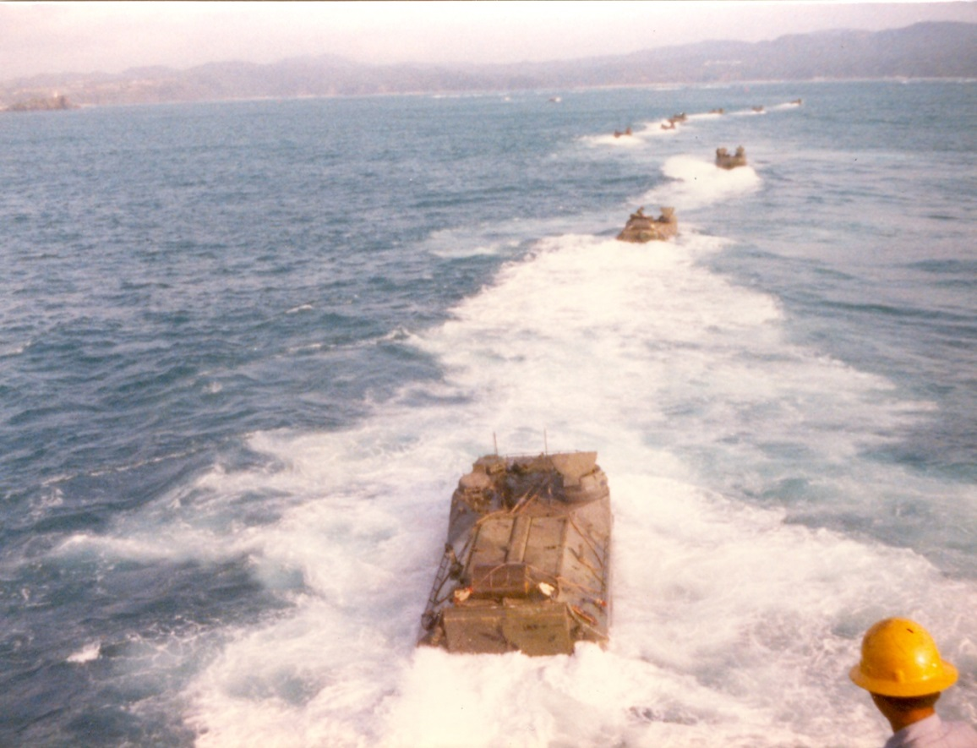
USS Fresno (LST 1182) offloading of the amtracs prior to returning A Co. further north to (Camp Hansen) Red Reach, Okinawa. In the Philippines practice landing I went ashore in the 1st wave 2nd amtrac.
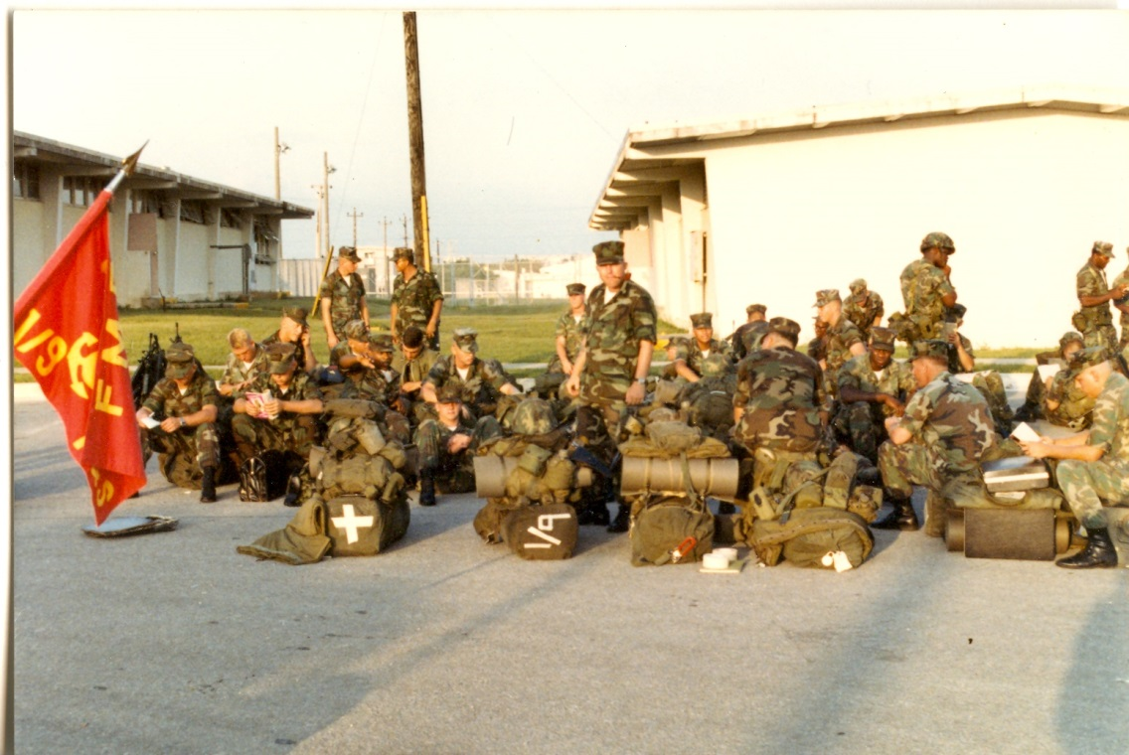
1st Bn 9th Marines Comm Plt – H&S Co, A Co., C Co. and WPNS Co. waiting to depart to Korea for “Bear Hunt”

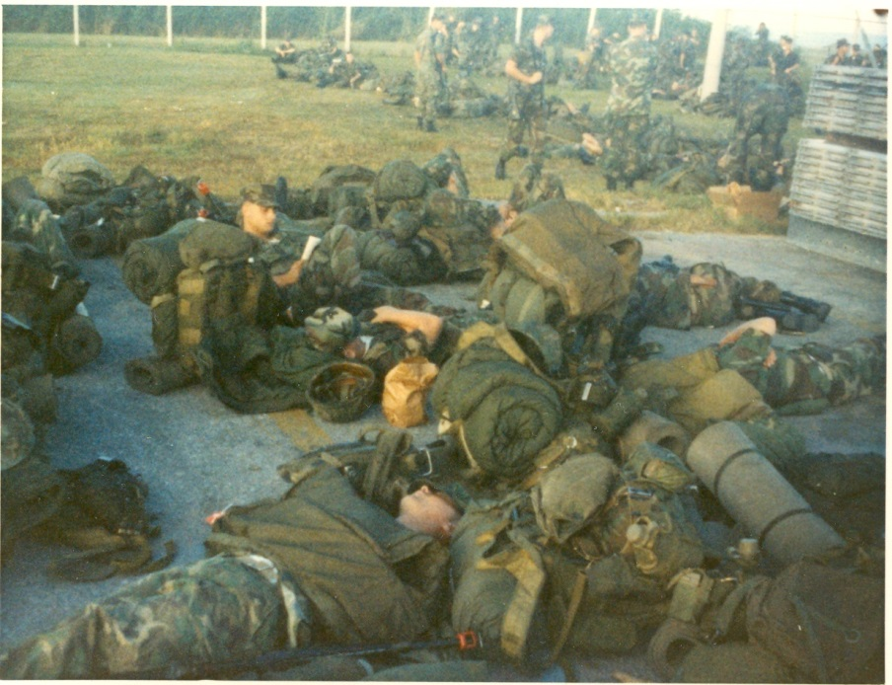
After being back for about 10 days from (35th MAU) the Philippines and then going to Korea.
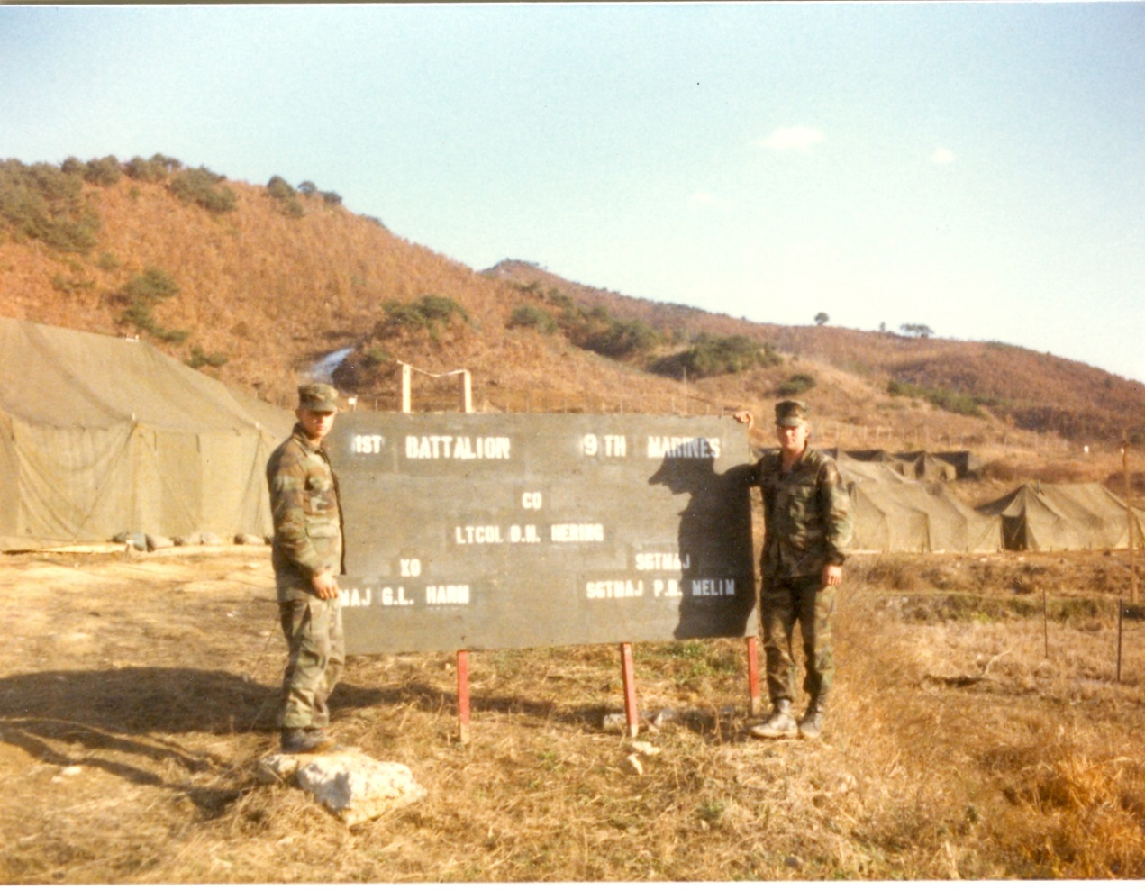
LCpl David Anson Brown – LCpl Bob Mills (Ohio) – 1/9 Com Plt
1st Bn 9th Marines – north of Unchon, Korea at the “Bear Hunt” Tent City approx. Sept – Nov 1983
When we arrived in Korea apparently there was a North Korea border massing taking place [involving over 140,000 North Korean soldiers] and 1/9 was sent to the DMZ to be a blocking force after about two weeks along the DMZ we went to the Bear Hunt tent city and then our time was extended in Korea to resume normal training in Korea.

Korea DMZ part of the famous “Iron Triangle” area
Upon arriving at our DMZ area 1/9 secured our area and then established two LZs for incoming helicopters.

Korea DMZ area 1983
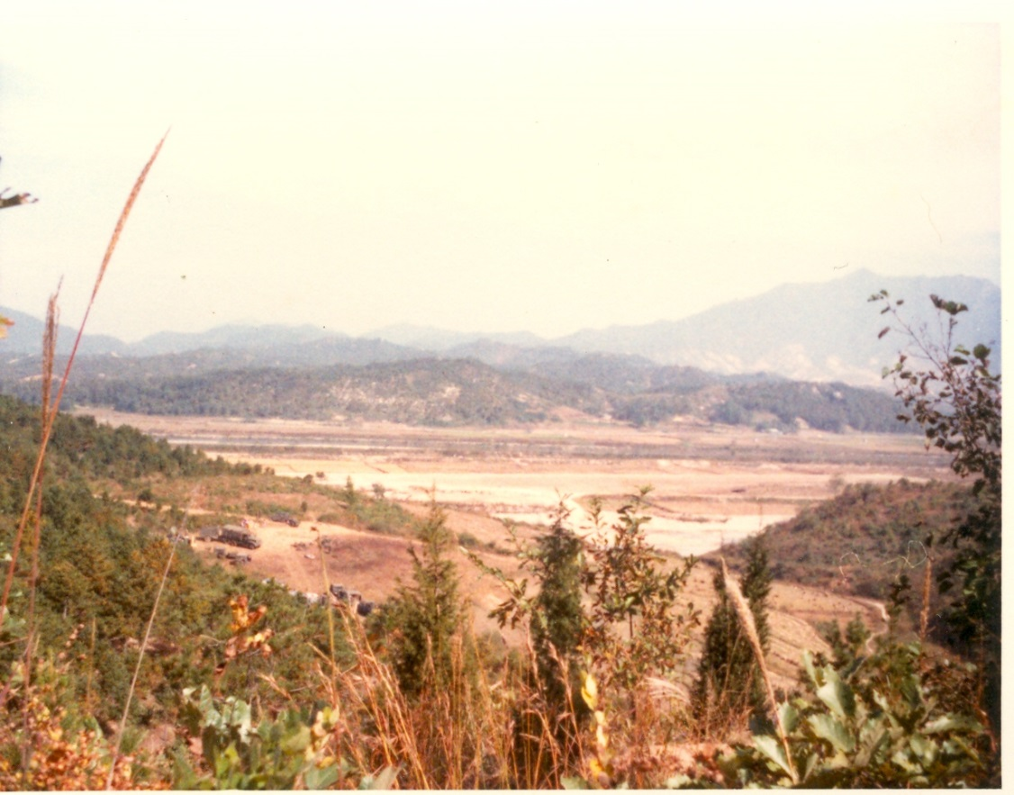
1st Bn 9th Marines in the famous Iron Triangle area the Korea DMZ the hills in the far background are in North Korea.

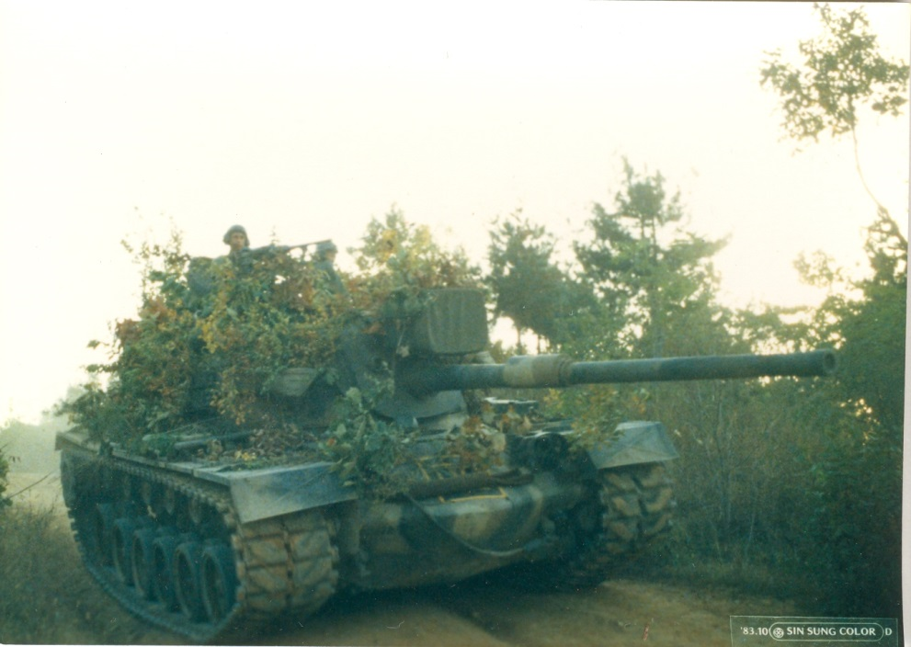
Army tanks being brought up several days after our arrival, on the road in the 1/9 area near the DMZ.

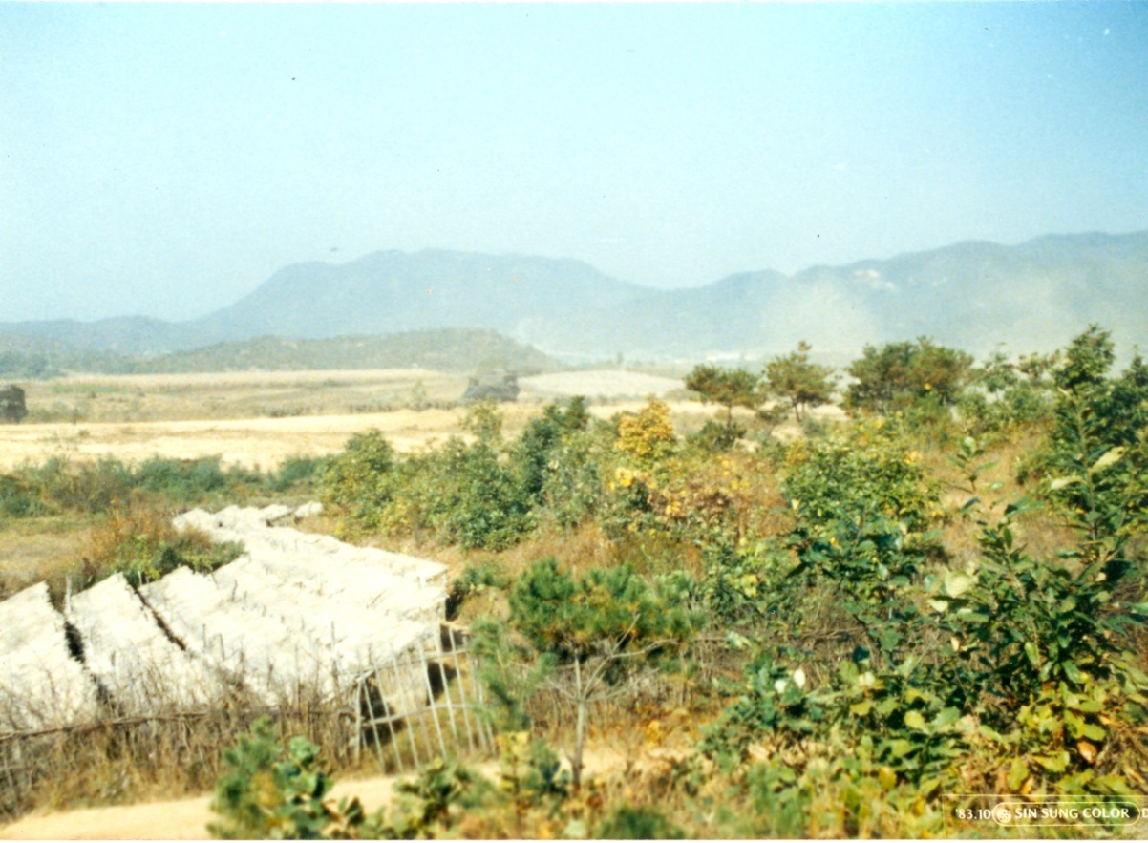
1st Bn 9th Marines area in the famous Iron Triangle of the Korea DMZ the hills in the background are in North Korea.
The thatched covers are used to cover the growing ginseng.

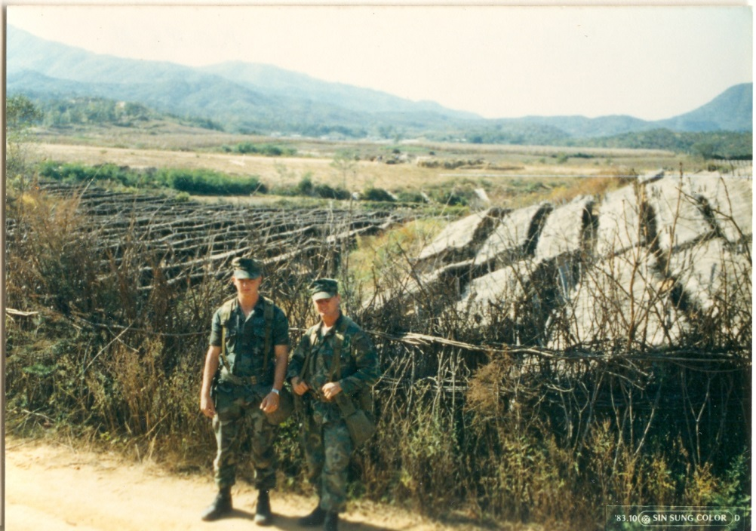
H&S Co. road guard duty on the road in front of the small ginseng farm.
LCpl David Anson Brown replacing LCpl Timothy Kach (Iowa) on road guard duty. We stood a lot of guard duty at that road while we were there, much of my duty was from about Midnight to 2 AM and then I would spend days with A Co.
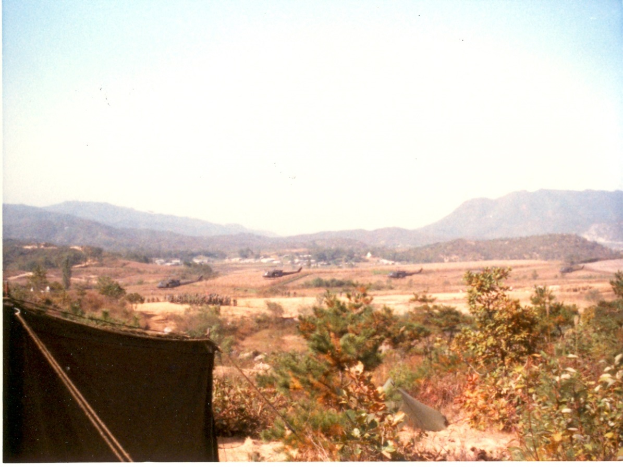
Marines of 1/9 C Co. training with the Korea ROK (Republic of Korea) Marines.
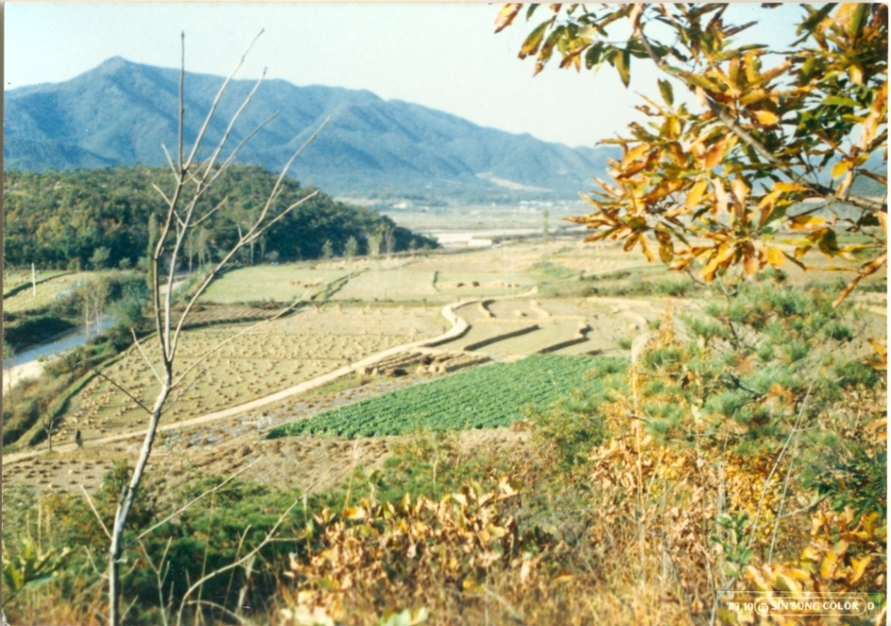
Marines of 1/9 A Co. patrolling and training on the road next to the DMZ.
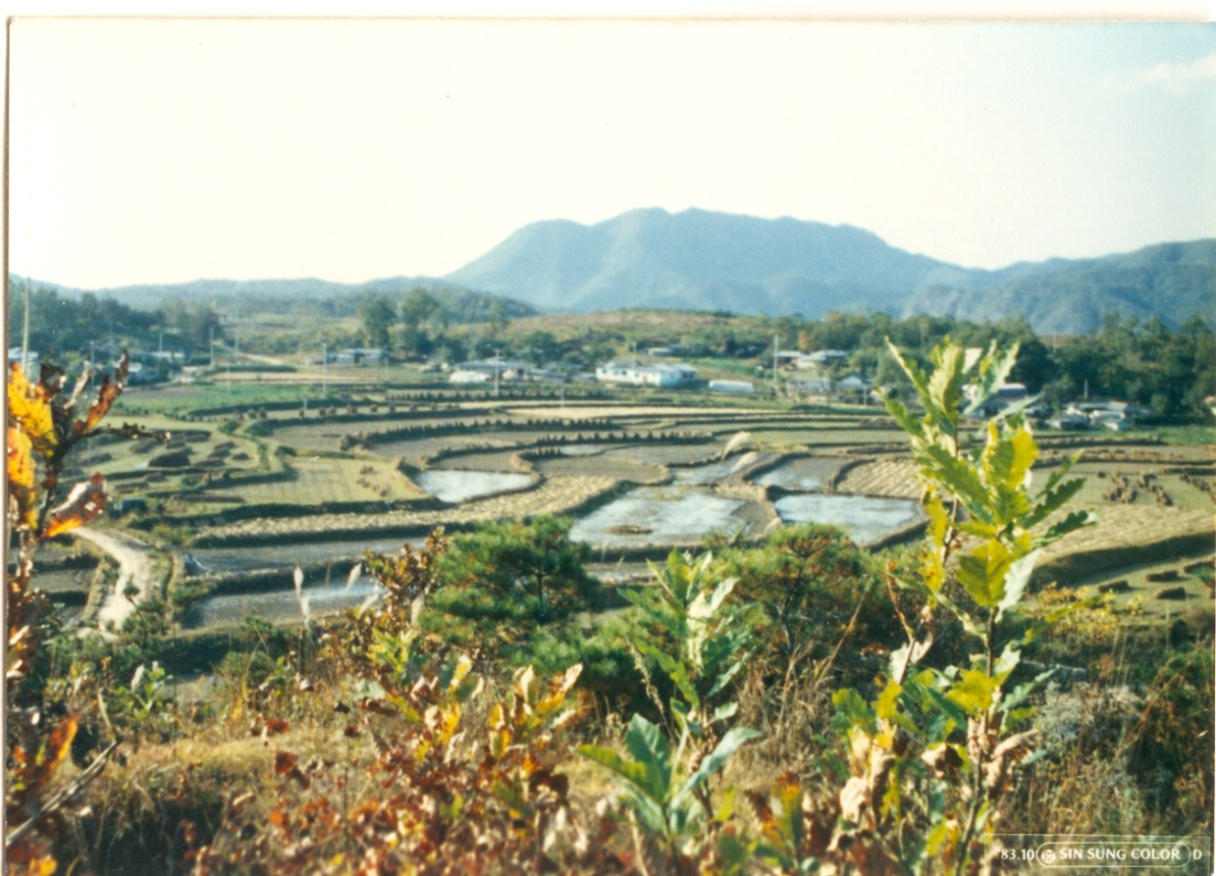
Along the DMZ area of Korea – flooded rice fields.

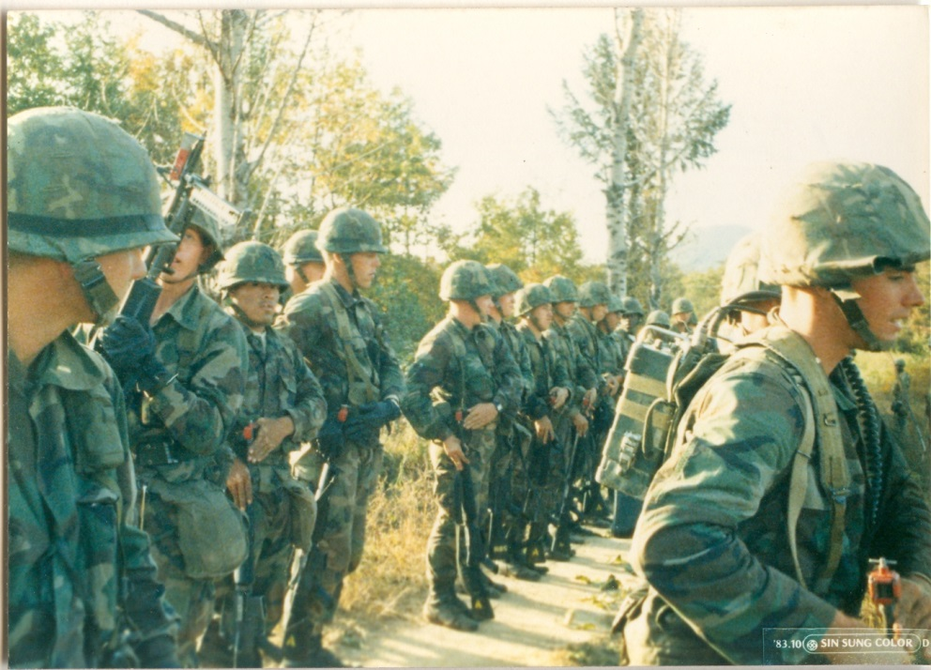
1st Bn 9th Marines A Co. located this unique spot, it looked like (Bridgeport) or places in the USA and we used this area a couple of times for assembly and as staging area. On this day A Co. and C Co. are training with the ROK Marines.
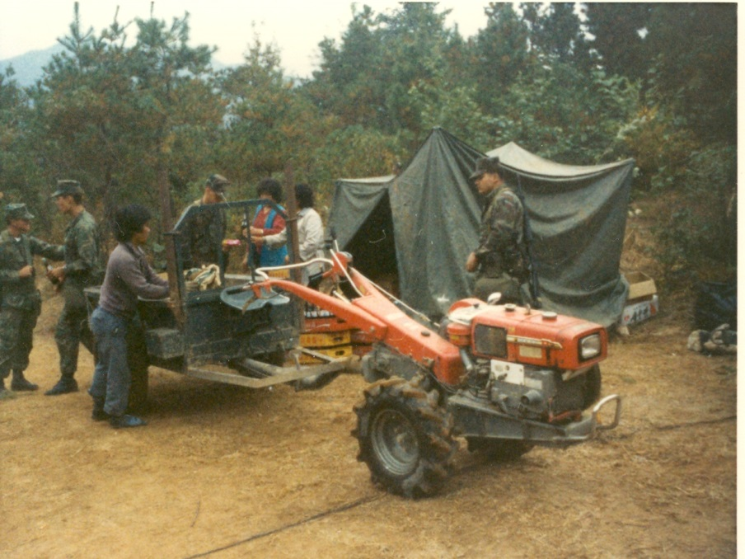
1st Bn 9th Marines Comm Plt’s area – a couple of Koreans are selling food, mostly noodles, to Marines.

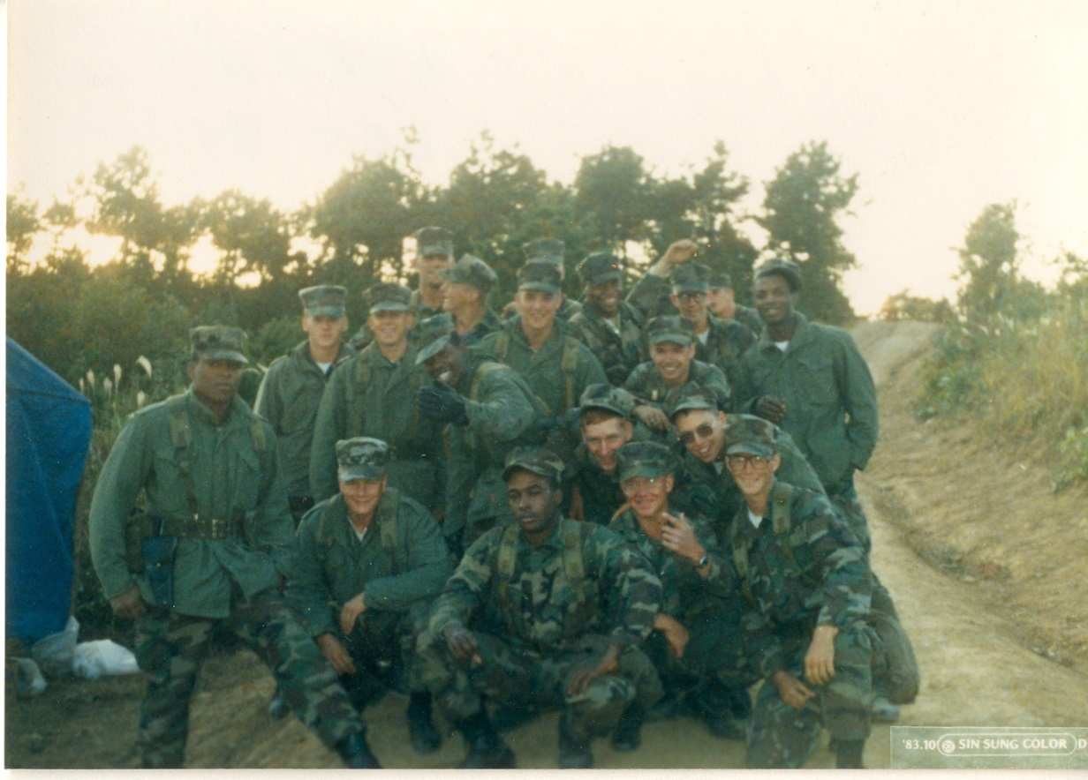
1st Bn 9th Marines Comm Plt not the full platoon.
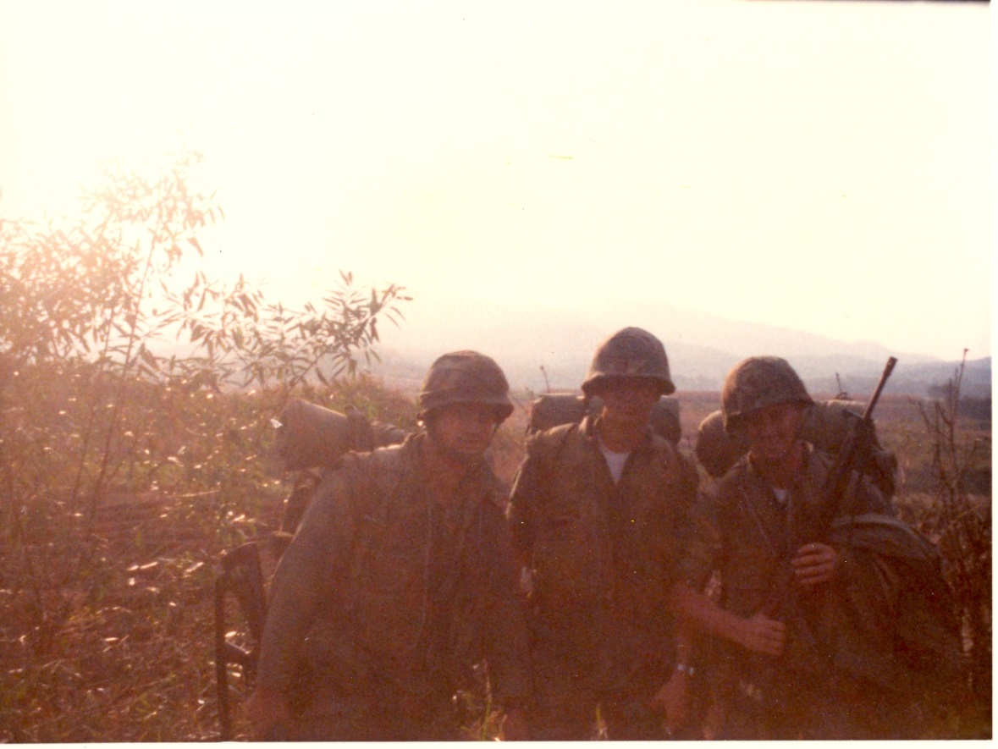
uncertain of who is on the left, LCpl David Anson Brown, LCpl Timothy Kach
Departing our DMZ area and forming up for a Battalion hike to the Bear Hunt Tent City.

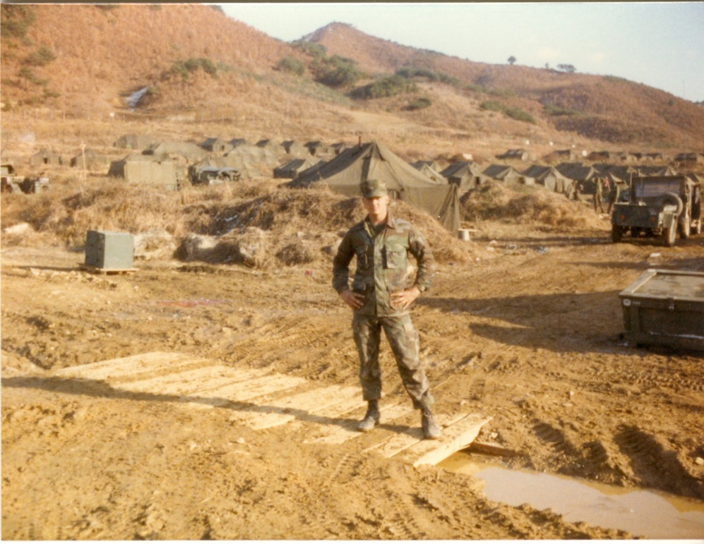
Later and much colder at Tent City – LCpl David Anson Brown.

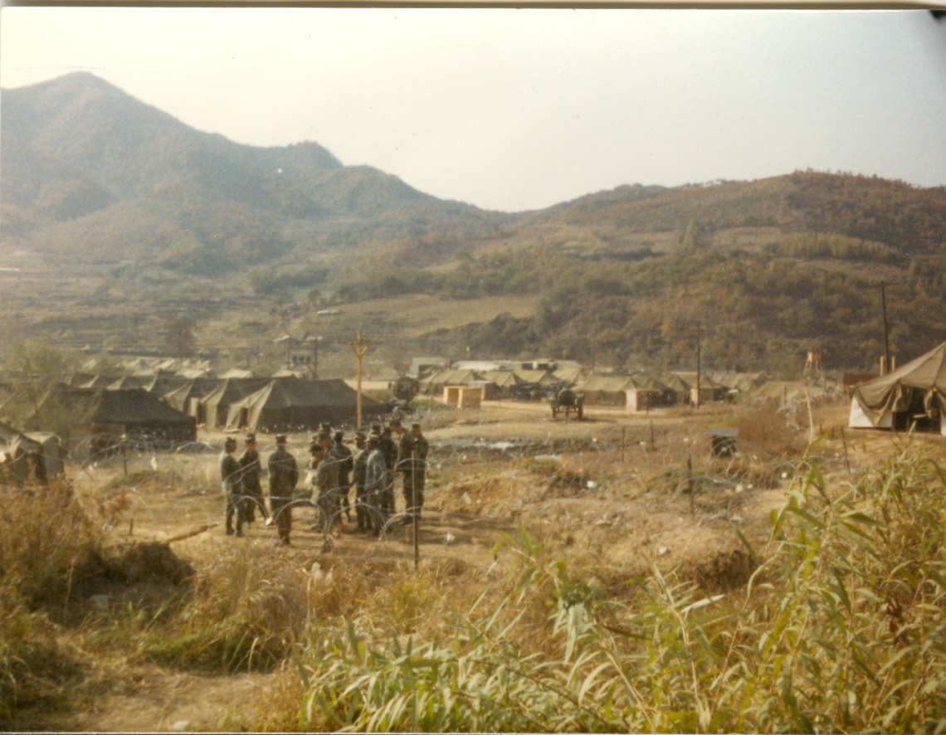
About October 1983 soon after our arrival at the “Bear Hunt” Tent City.

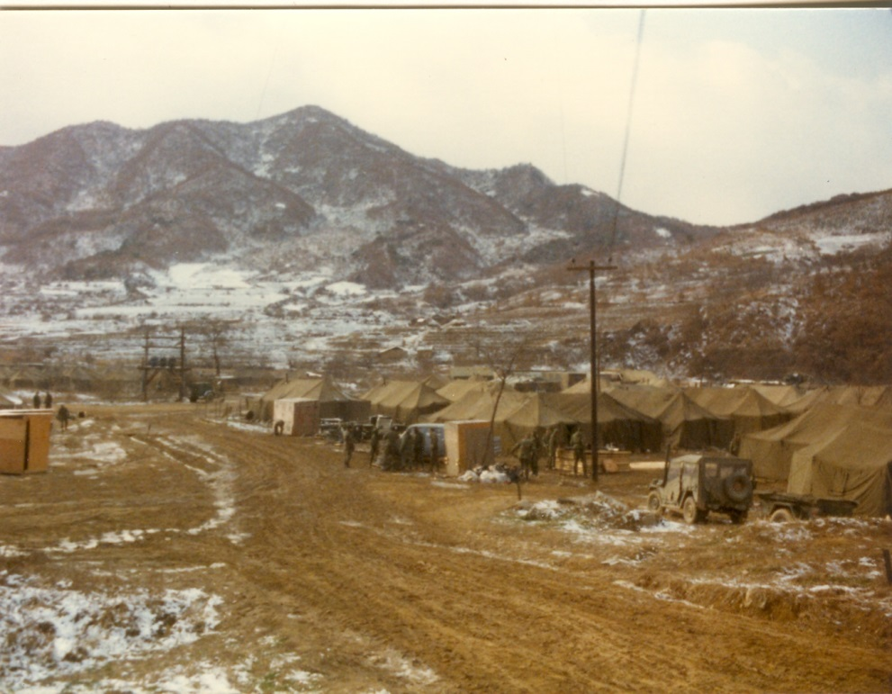
Finally snow and cold just before we left the Tent City for the last time as we departed from Korea.
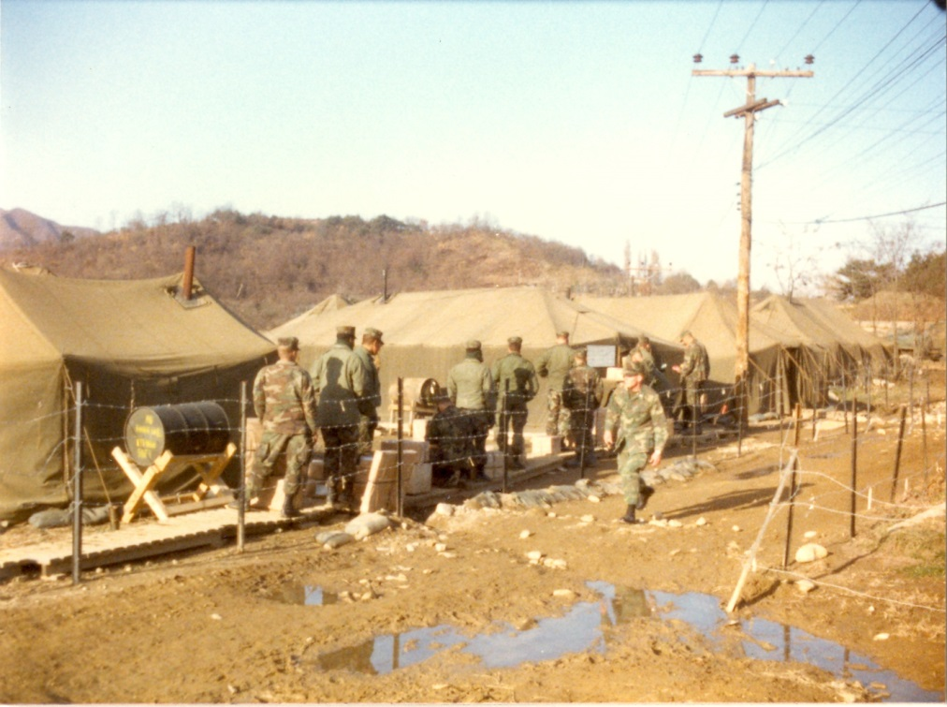
The chow hall tents at Bear Hunt Tent City – A Co. suffered an unforgettable bout of dysentery after eating there.

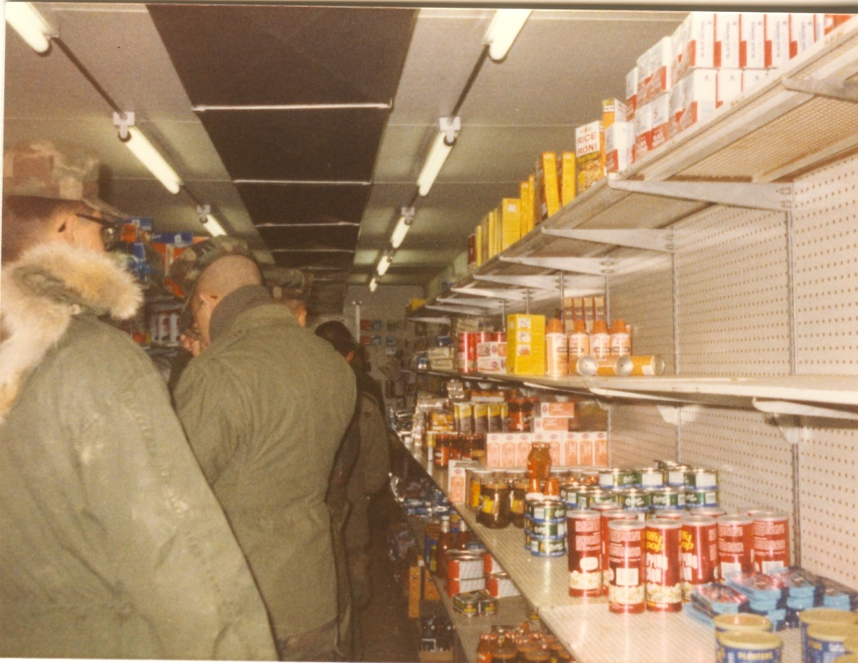
A trailer-store at “Bear Hunt” Tent City – National Guard troops and Marines shopping.

We had left the tent city and were trucked to a hill in Korea near a live fire range where we were staying and training. If I remember correctly things started to loosen up for 1/9 and we were getting some liberty in that we could get a pass and get trucked to a small village for a few hours of liberty, just walking around and buying stuff like souvenirs and popcorn shrimp.
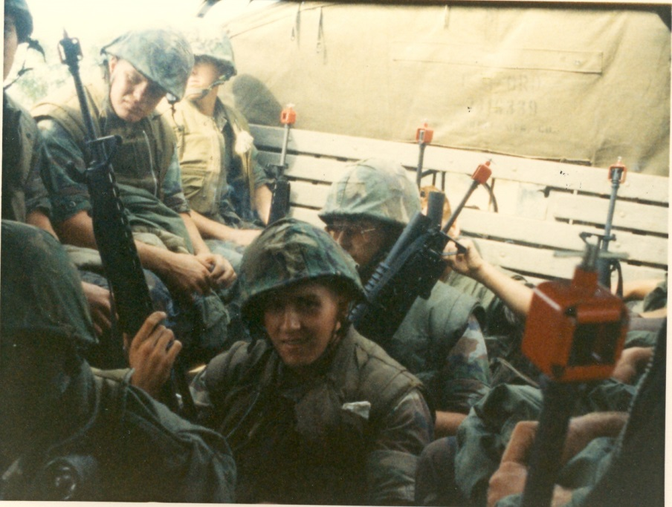
1/9 A Co. in the back of trucks for more training somewhere in Korea
Back on our hill there was a piece of a busted up pumpkin laying on the ground and I and another Marine were looking at it and briefly talking about Halloween and wondering if Halloween had already passed we said “it looks like someone was aware enough to get a pumpkin” because we were not sure of when Halloween was and had actually forgotten about holidays. We had just taken a couple steps away and were back to talking about training when a Marine came walking up to us looking really distressed and said that a large bomb had gone off in Beirut (possibly days earlier) [the Marine I had been talking to had several friends in 1/8 who were in Beirut at the time – I didn’t know anyone who was at Beirut at that moment] and because it was known that the other Marine had friends there the Marine was breaking the news to us the best he could and I said something like “well how bad could it be with one bomb” and he begin to say you don’t understand this was a really big bomb that hit a barracks and there are massive casualties and fatalities. At that moment word was spreading and some other Marines who also knew some of the 1/8 Marines came running to support their friend that I was talking to and with the other Marines there I went back to the other radiomen to try to find out more info and it was confirmed that all hell had broken loose in Beirut.
Shortly after that 1/9 got a few days liberty in Soul, Korea and a couple of us took a taxi onto a US Army base to do some shopping. The Army base was on complete lockdown and had sandbagged positions at the gates, there were some rumors that Korea could get hit as well. Apparently outsiders had not entered the base since the bombing and we came up there in a taxi and the first soldiers after seeing our ID cards waved the taxi onto the base and another soldier came running up and said don’t let that taxi on the base and in the confusion our Korean taxi driver said they can’t tell me not to drive on the base (his company had a contract) and started to drive forward anyhow and the soldier running up to the gate said shoot that taxi, shoot that taxi so machine guns, rifles and m203 barrels started coming into the open windows of our taxi and I was sitting in the back seat so I reached forward and put the taxi driver in a choke hold and he was barely able to say should I stop and I said only if you don’t want to get shot. The other Marine explained to the driver that the bomb blast in Beirut also had ramifications in Korea and after that the Army base pretty much opened back up for business as we saw several 1/9 Comm Plt Marines in the PX and asked if they had any trouble getting on base and they said none.
On that hill in Korea when we first heard the news about the Beirut bombing my first and only thought was that the Marines in Beirut were doing their job and doing it well. As the years have gone by and we are learning more about their impossible mission in Beirut, I can only say that I have even more respect and admiration for what those Marines accomplished in Beirut.

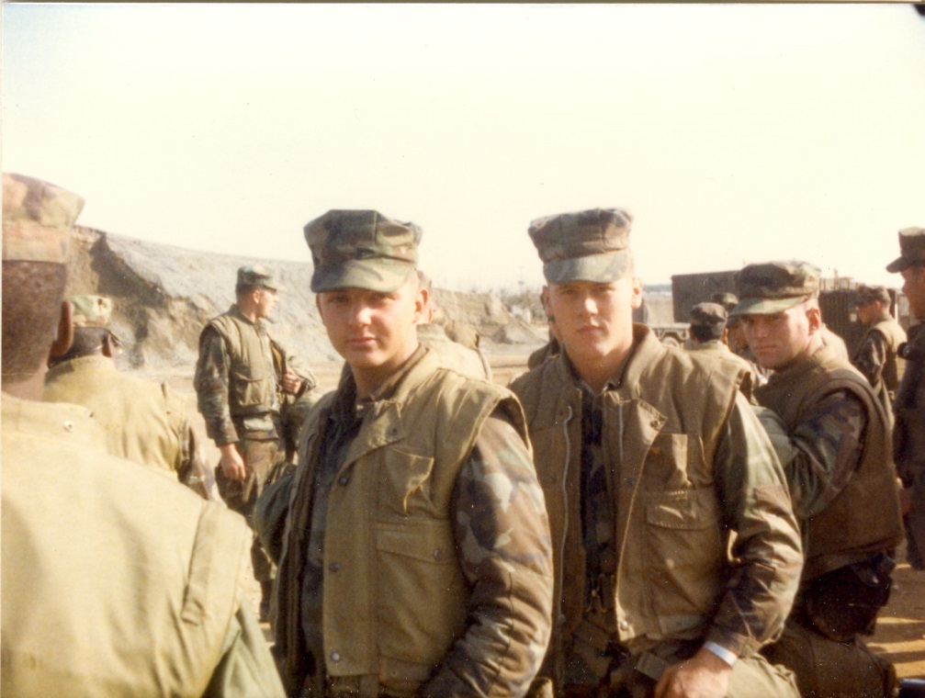
LCpl David Anson Brown, LCpl Timothy Moudy, and LCpl Bob Mills – Mills was the Bn Radioman for C Co.
About to depart Korea – 19/ about to eat a delivery of field mess.

Also somewhere around this area, possibly earlier that day or the day before (on Sunday) we held a field Church service and there was a picture of it taken. I saw a large picture of it on the Chaplin’s door back in Okinawa and I was in the picture, almost in the center of the picture, it would be a great picture to get a copy of.

Departing Korea – Osan Air Base
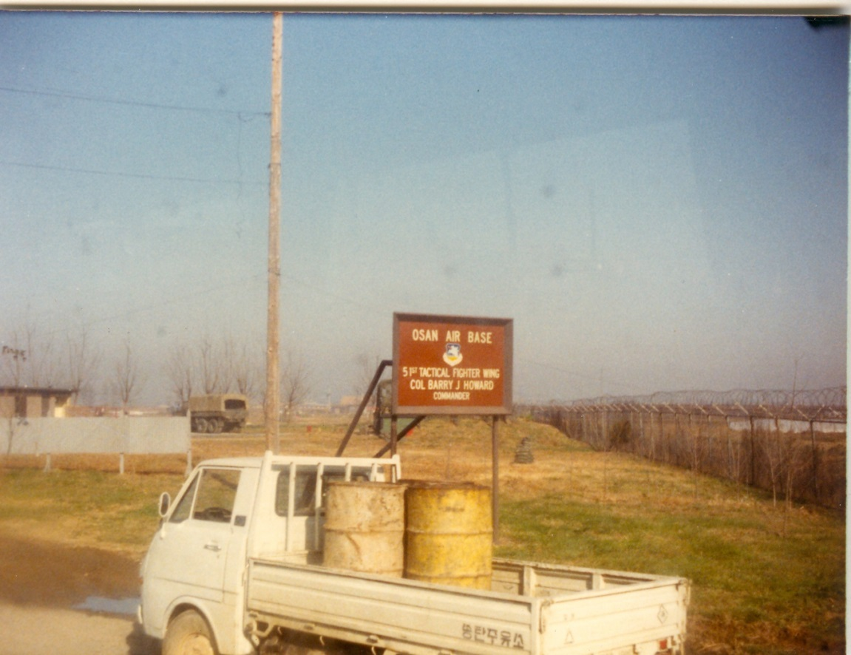
Arrival at Osan Air Base to depart Korea.

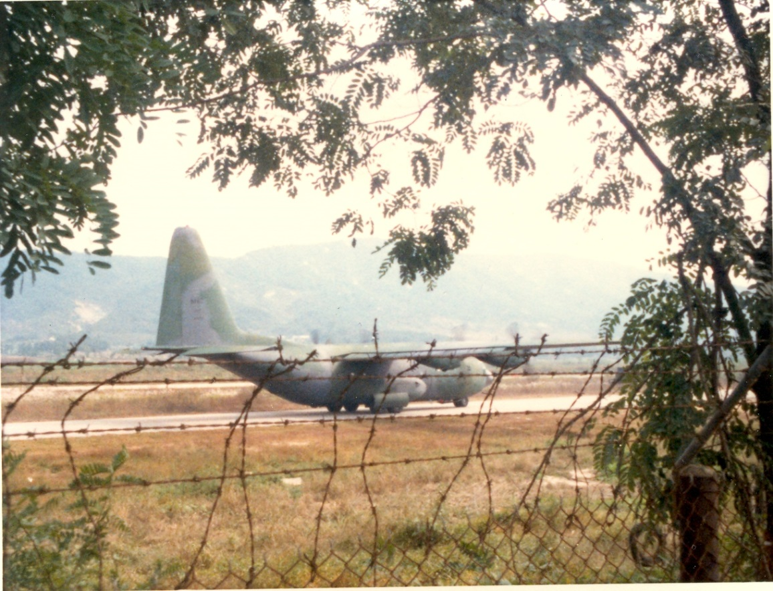
A C130 landing on the runway at Osan – part of 1/9 might have departed on this plane but I think we took a C147.

Back at Camp Hansen, Okinawa

Camp Hansen, Okinawa
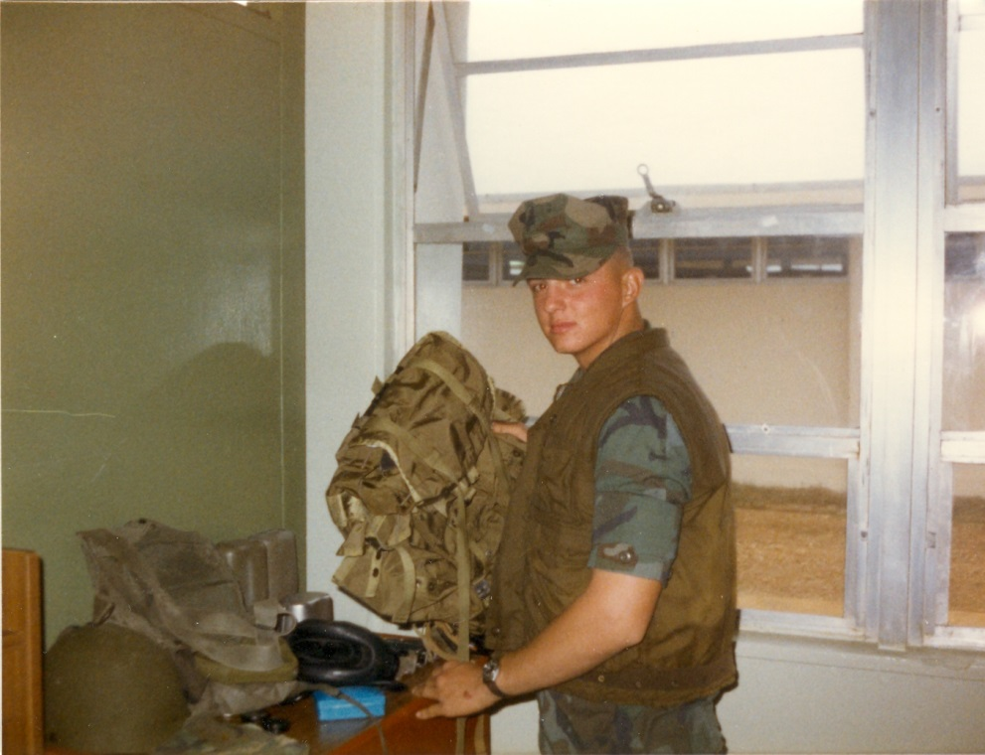
Camp Hansen, Okinawa - LCpl David Anson Brown getting equipment ready for inspection.
Then back in Okinawa the Companies of 1/9 went on several different missions and training exercises while I and several other Comm Plt Marines went to an excellent 3rd Marine Division school to learn more about calling in (FAC) airstrikes and because 1/9 left Okinawa soon after it had gotten back those of us going to FAC school got the added bonus of standing Battalion Guard duty for a couple of weeks until our FAC-TACP school started.

Note: these are just my memories from years later and some of the dates, locations and info may not be exactly correct. ~ David Anson Brown USMC (2531) LCpl 81-84

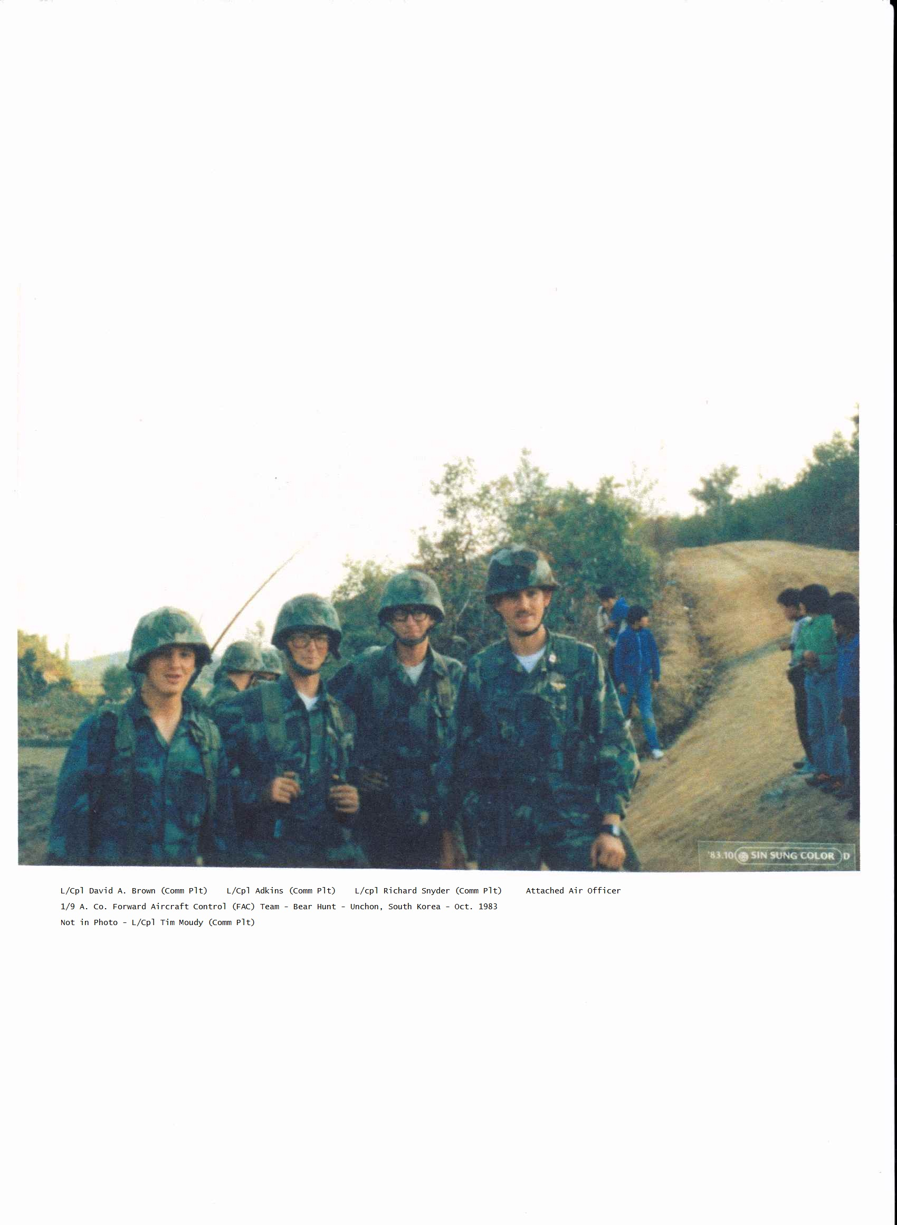
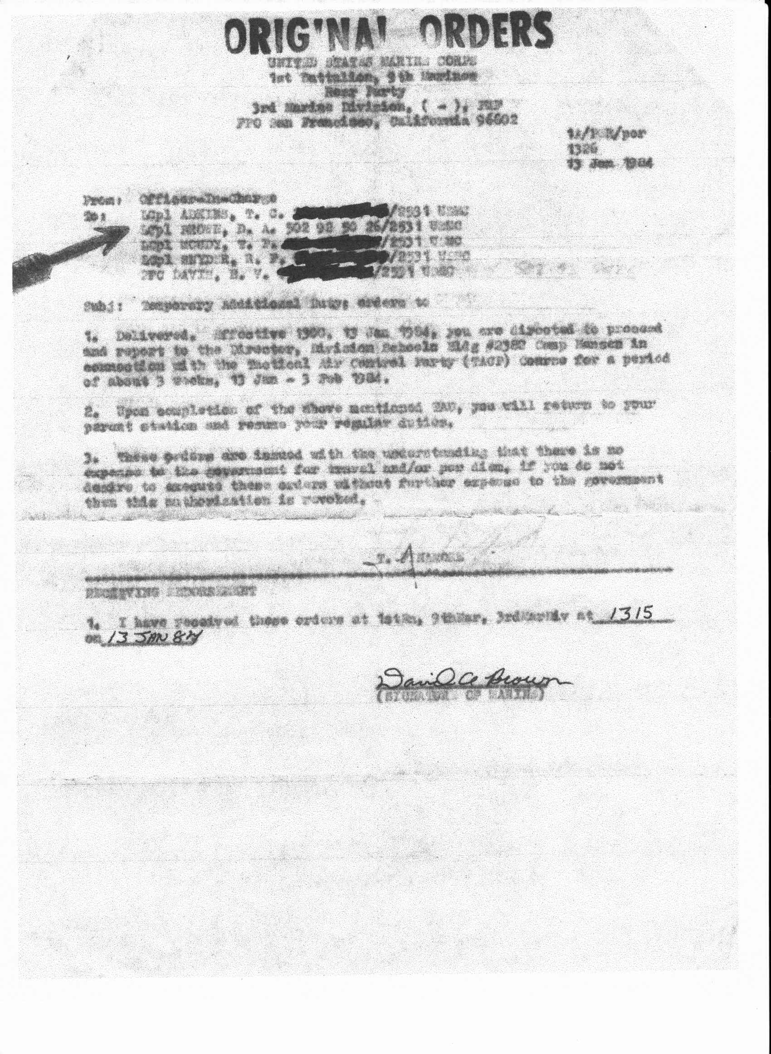
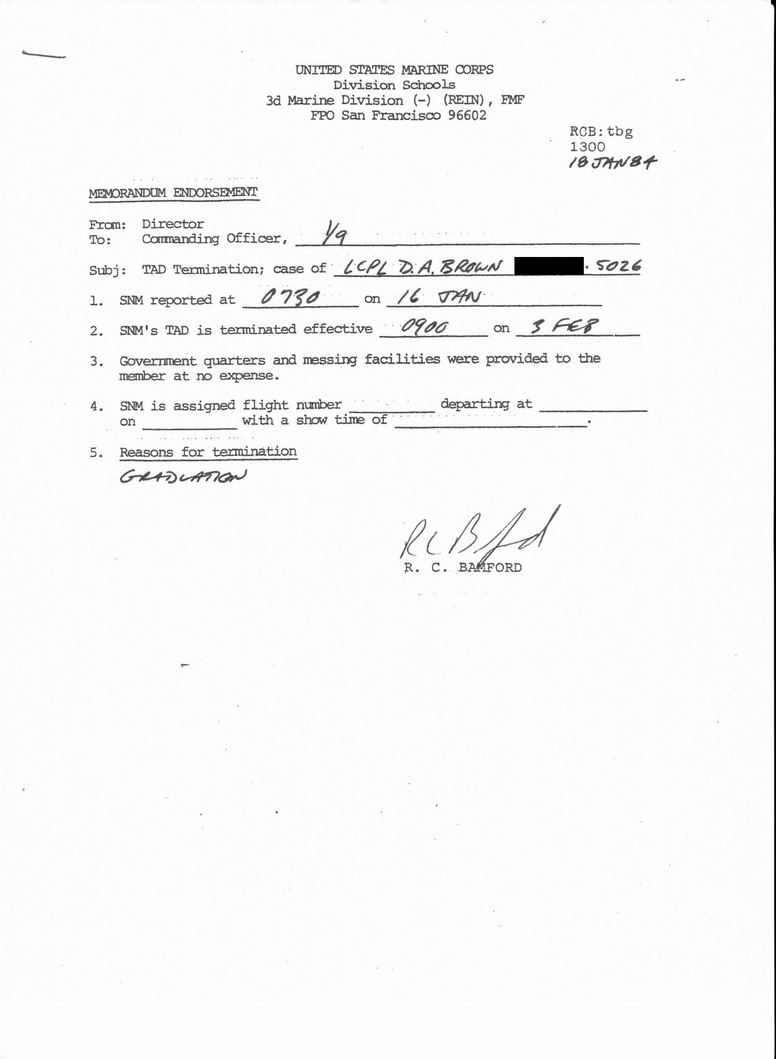
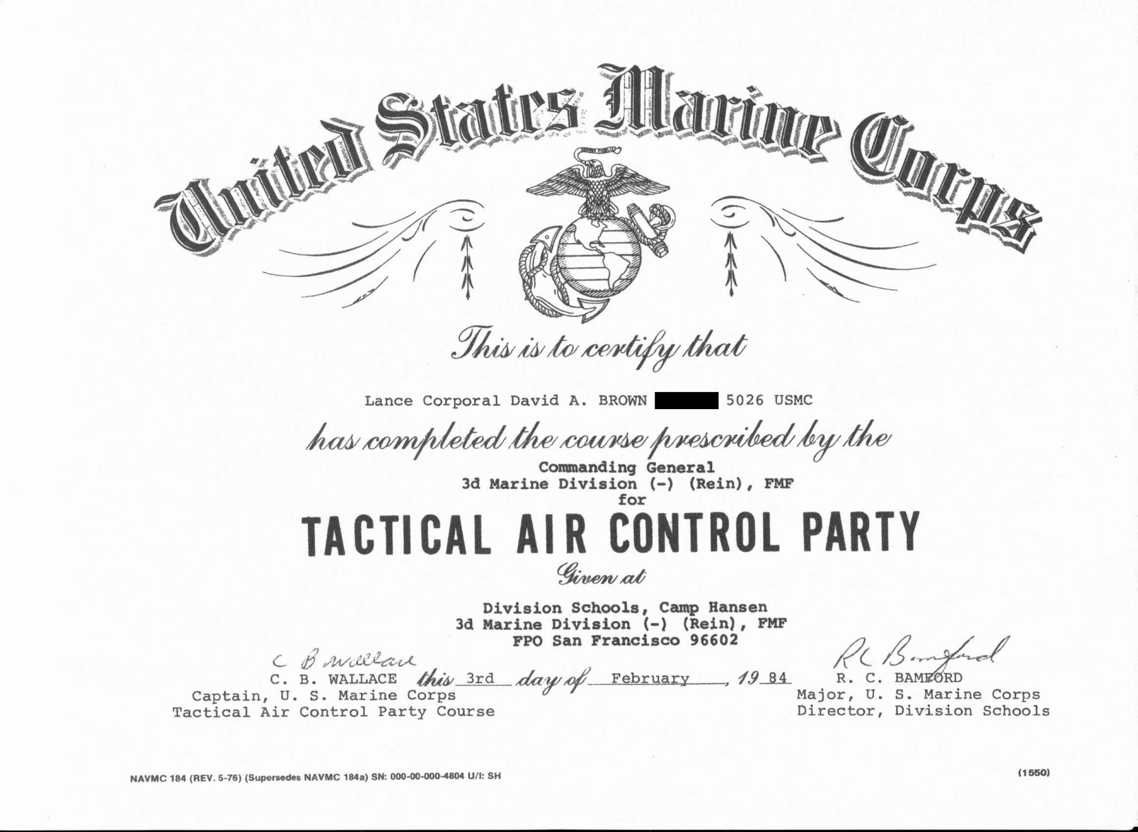

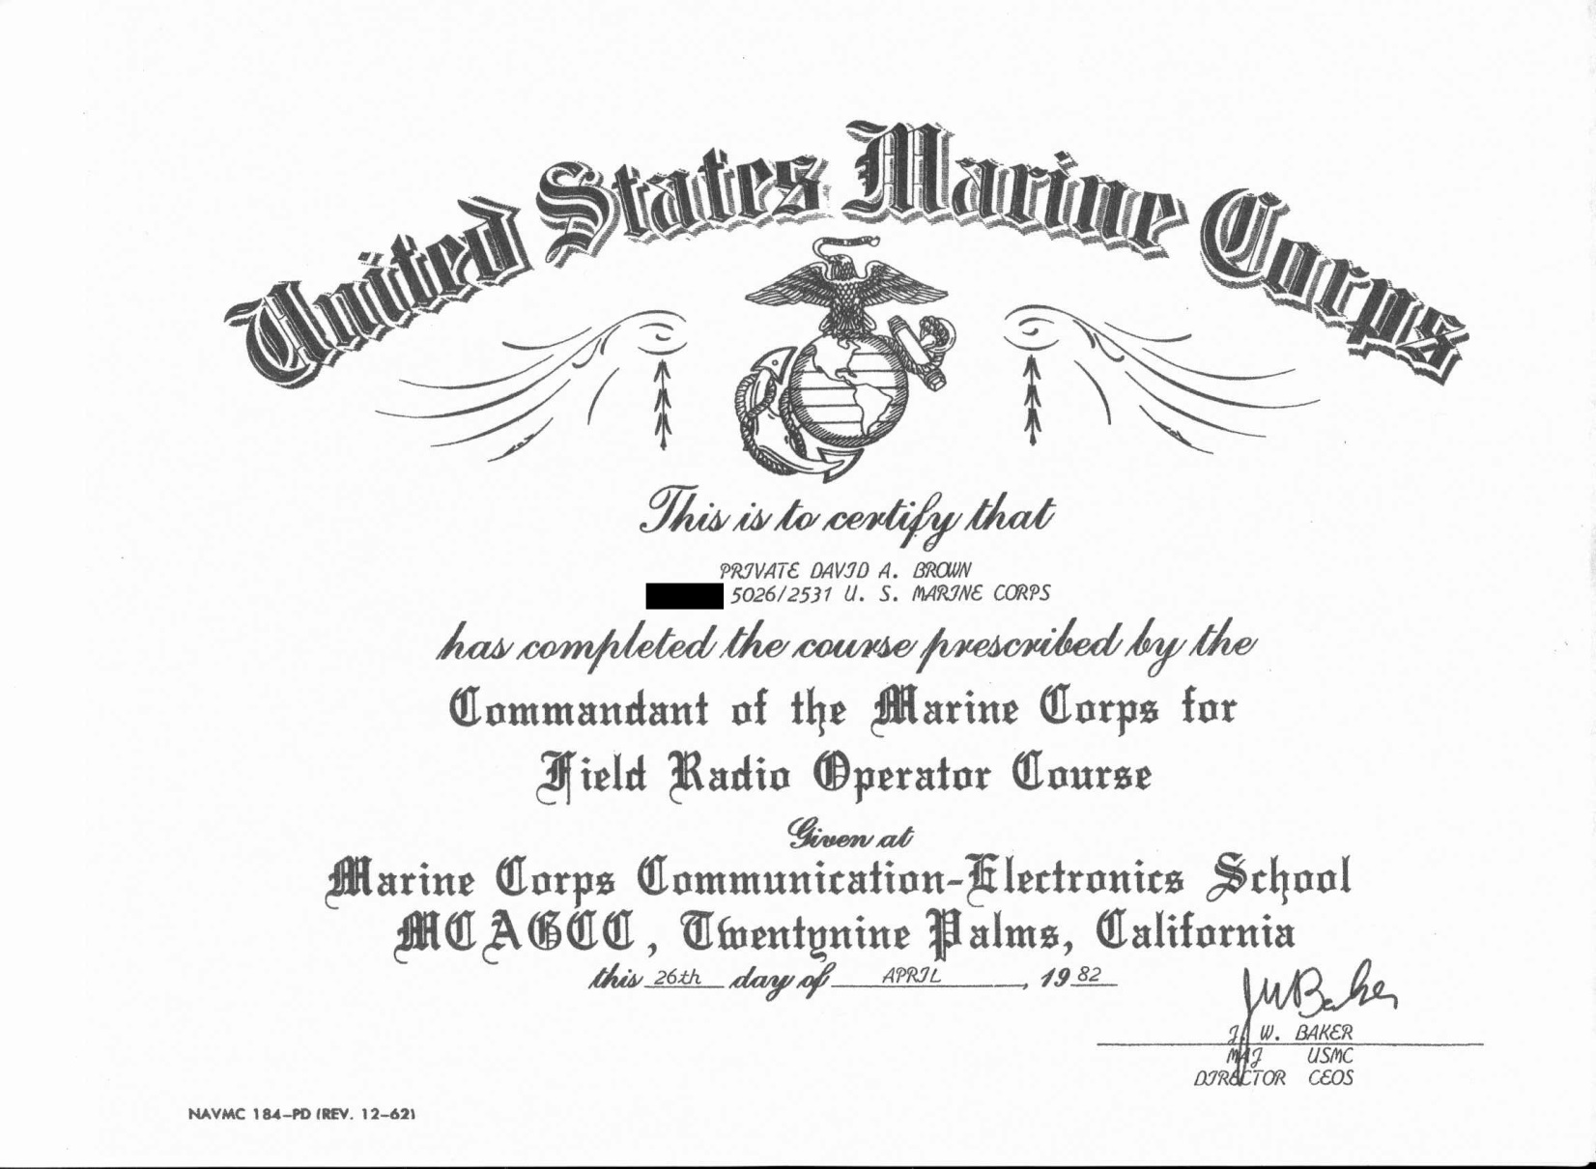

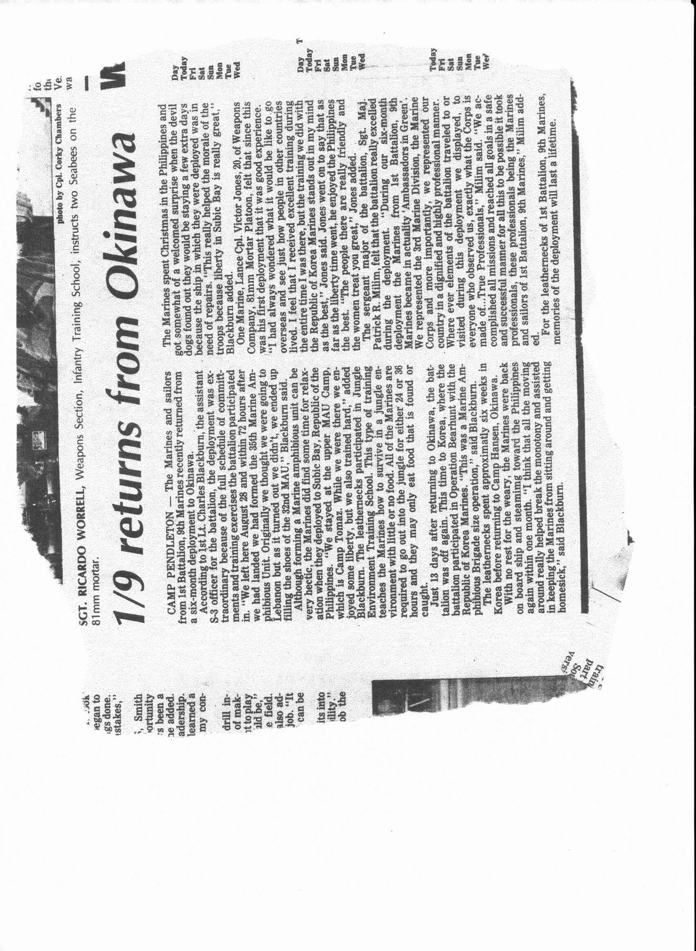
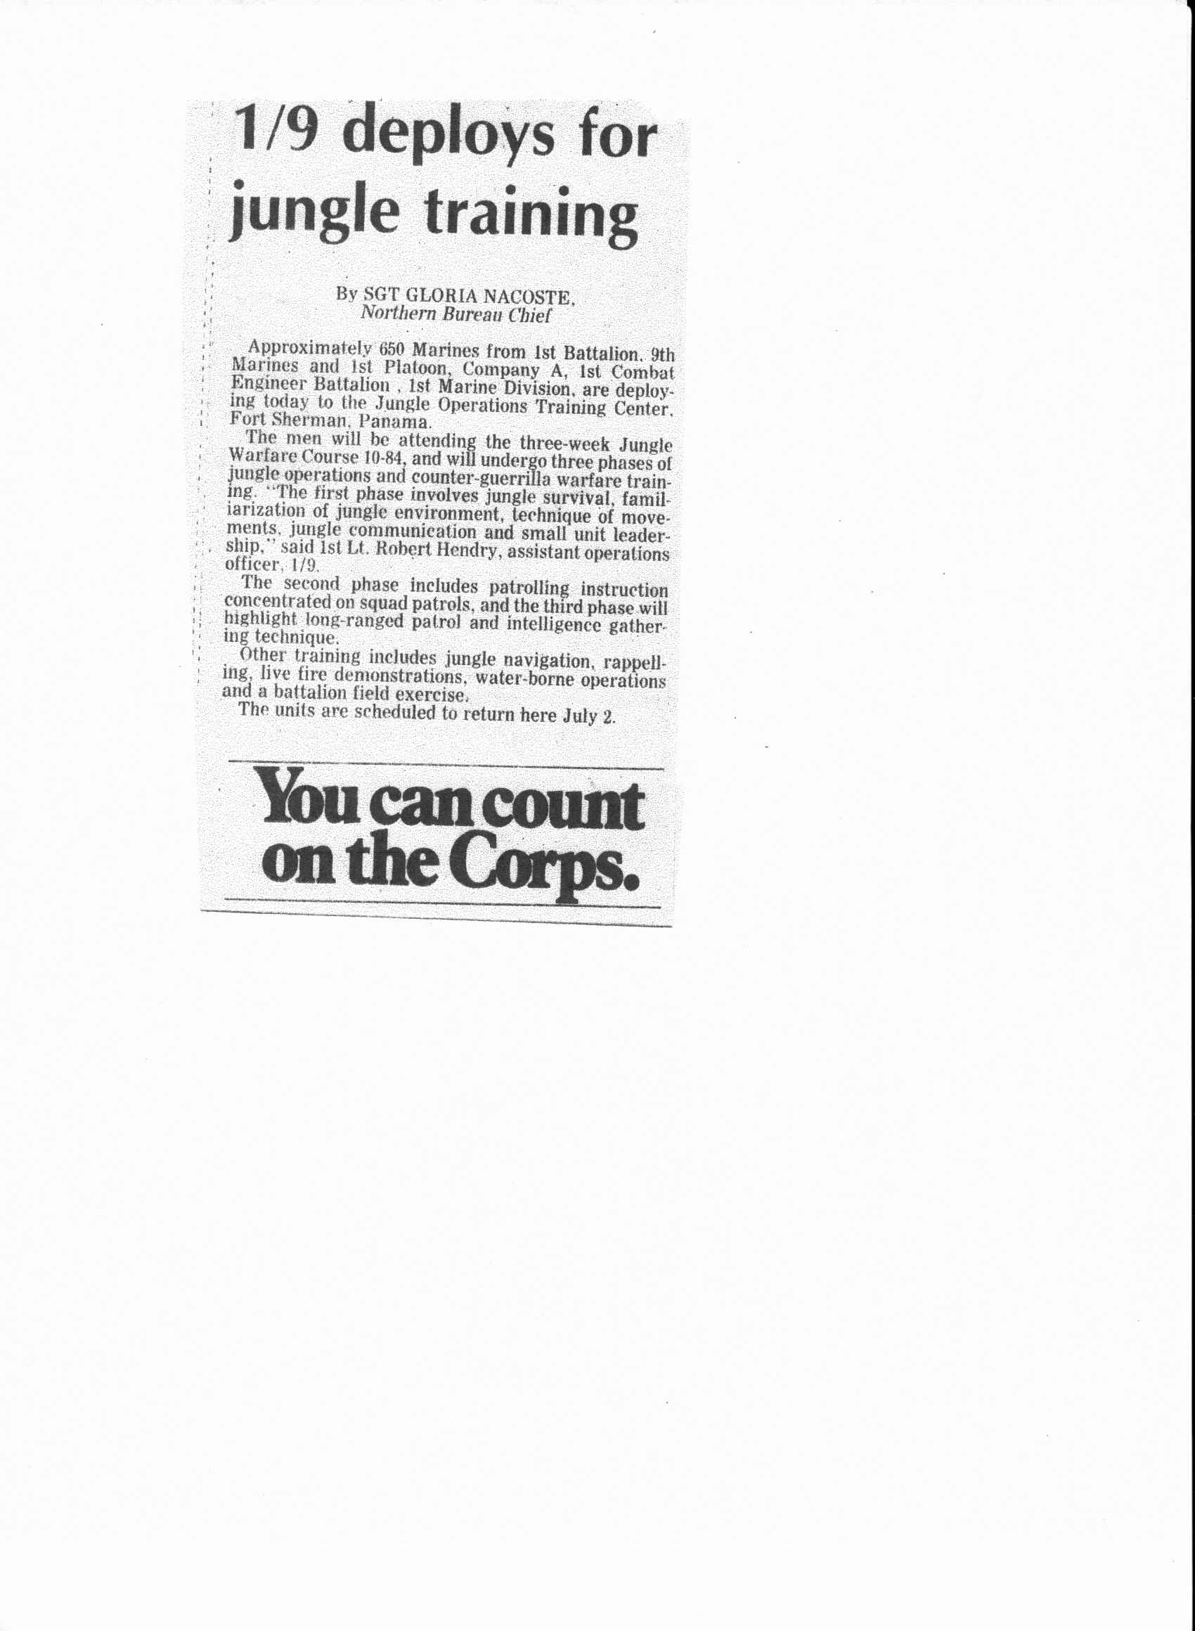
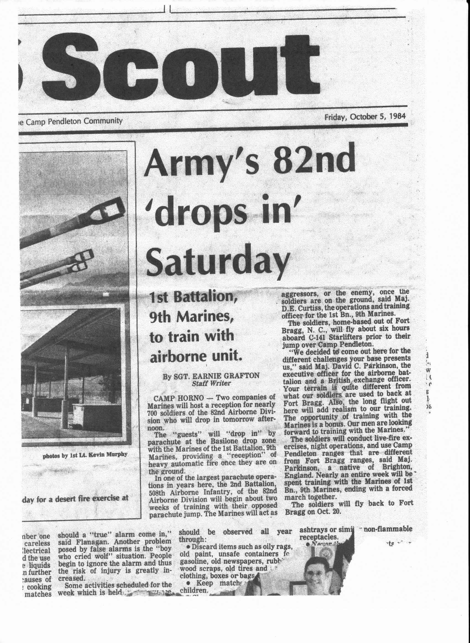
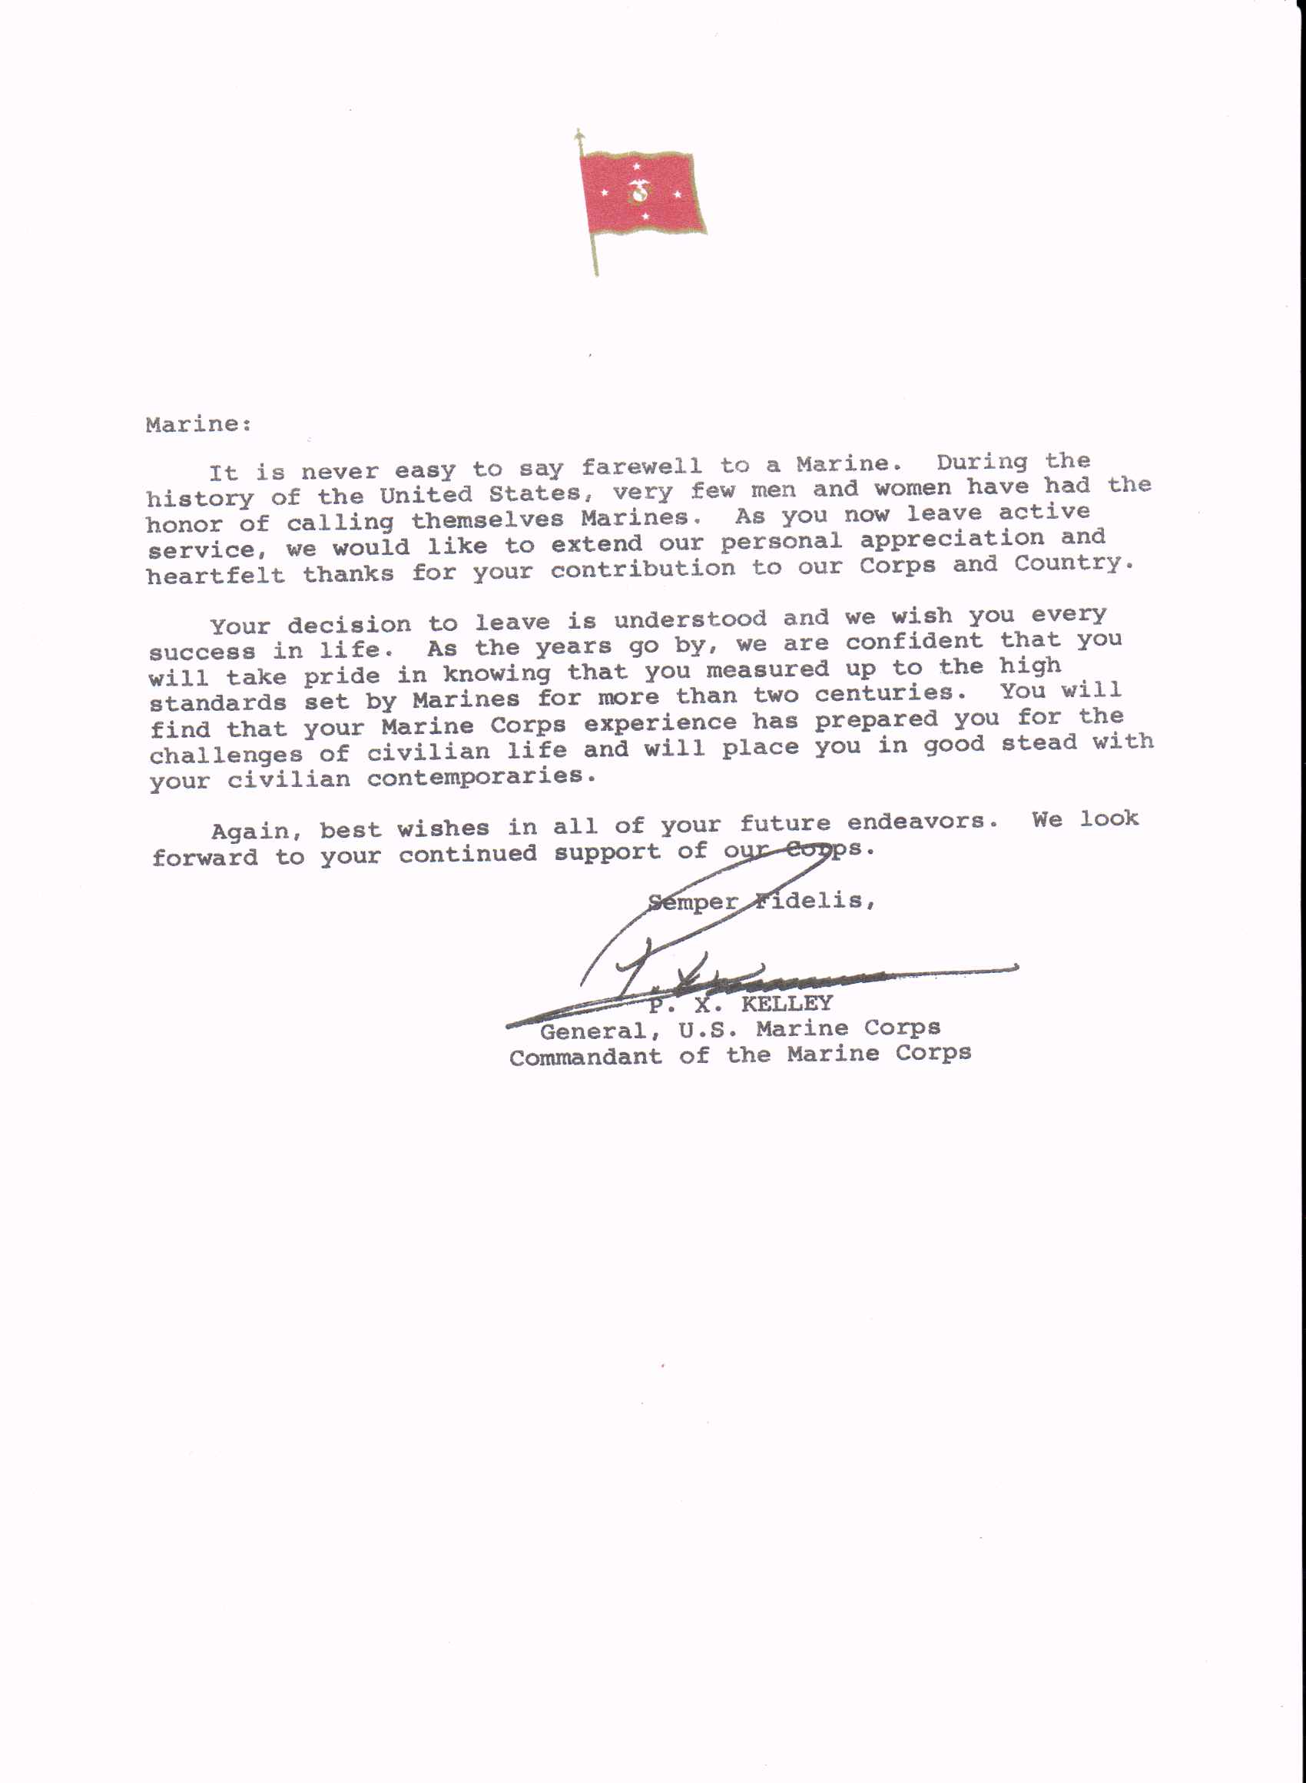
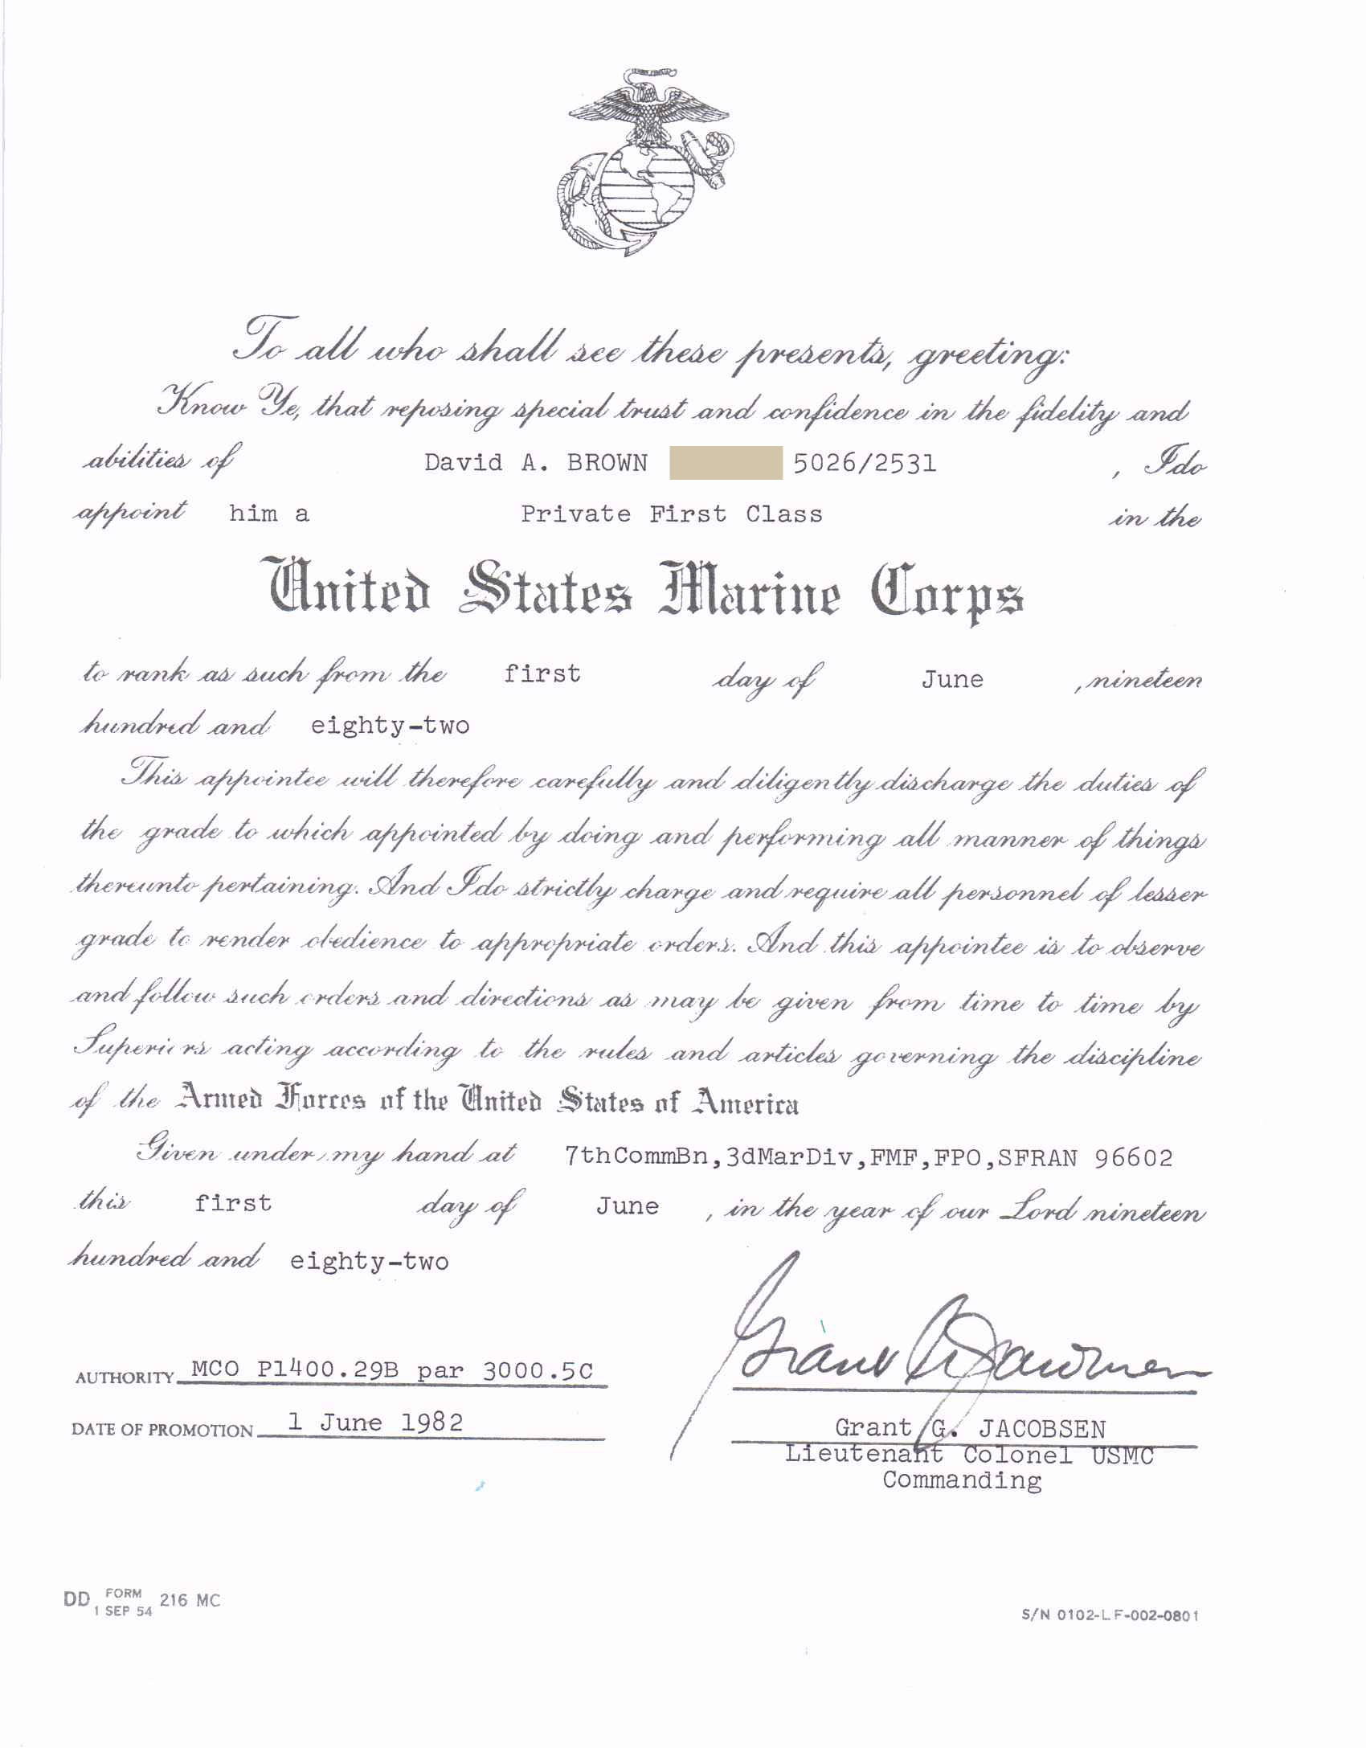
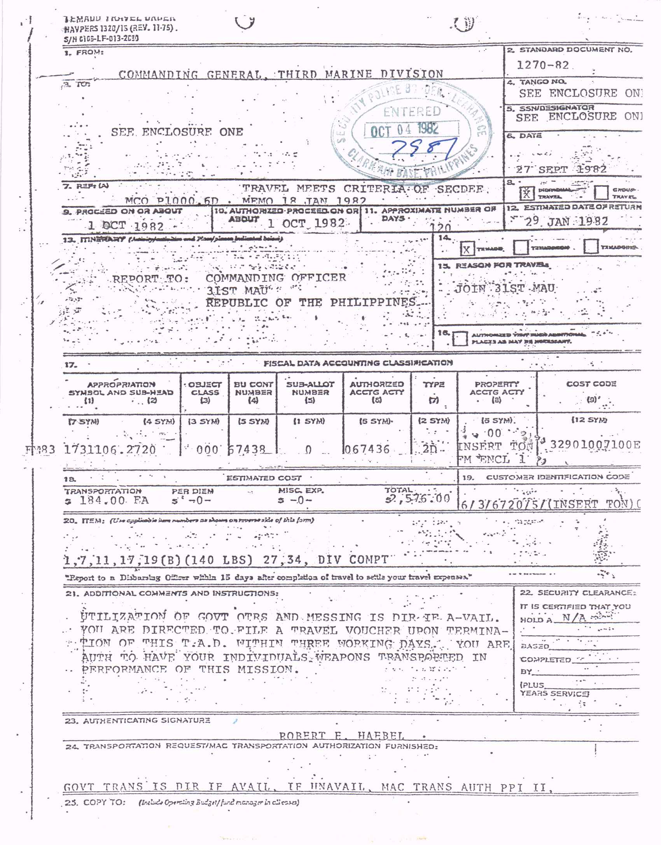

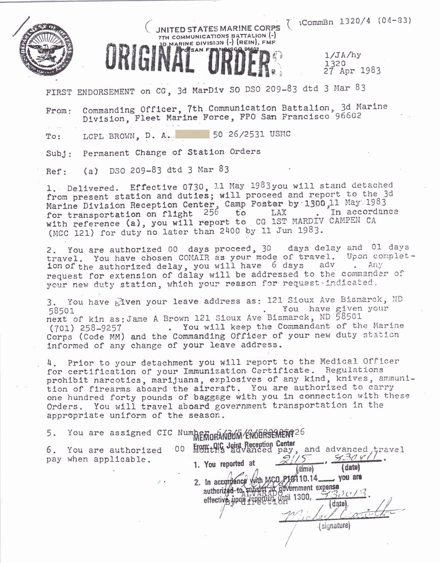

3rd Marine Division – Okinawa, Japan

7th Comm Bn, Okinawa
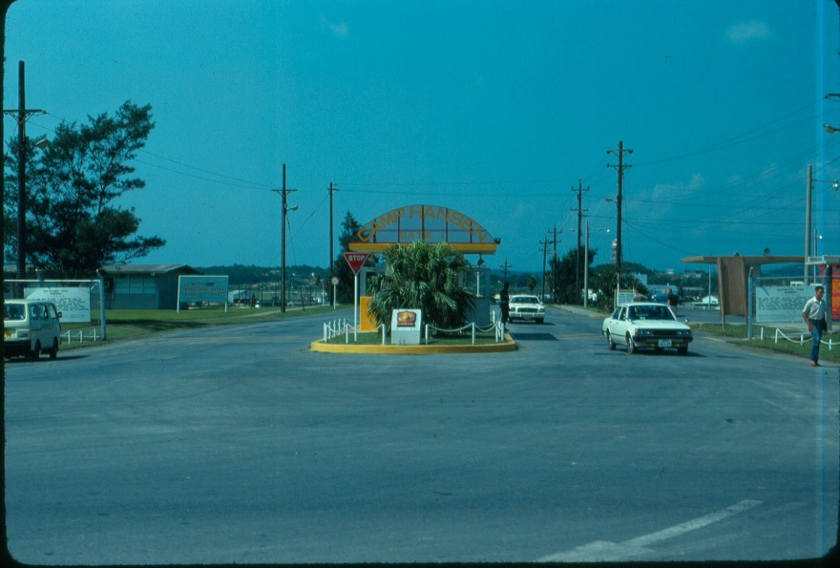
Camp Hansen, Okinawa – 7th Communication Battalion
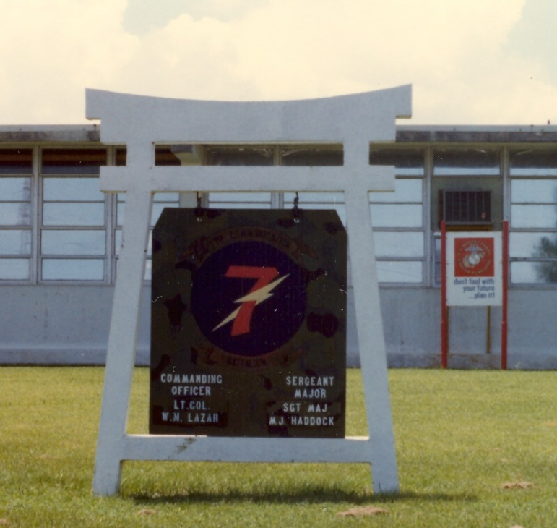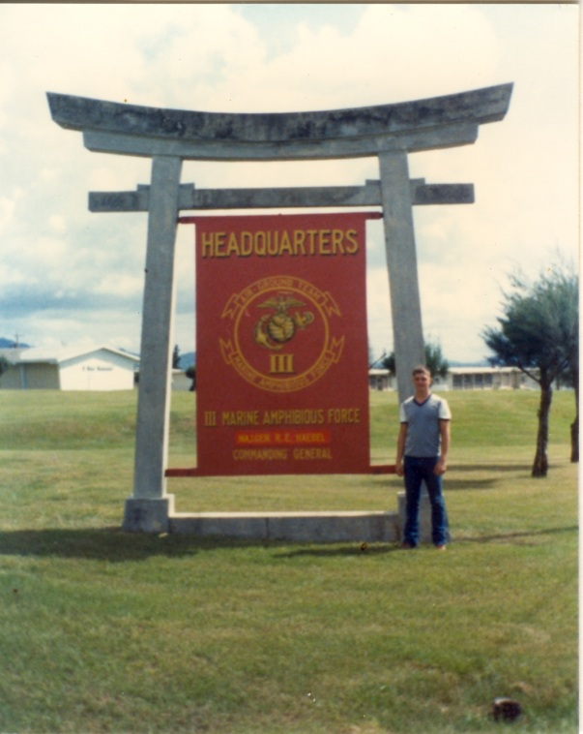
PFC David Anson Brown of 7th Comm Bn
Arrived on Okinawa about May 21, 1982 and was assigned to 7th Communication Bn, Communication Co, Communication PLT. On arrival was also assigned to mess duty at III MAF HQ Officers Mess Hall at Camp Courtney. I was 18 years old and a Pvt when I got to Okinawa and a month later when this photo was taken I was 19 years old and a PFC.

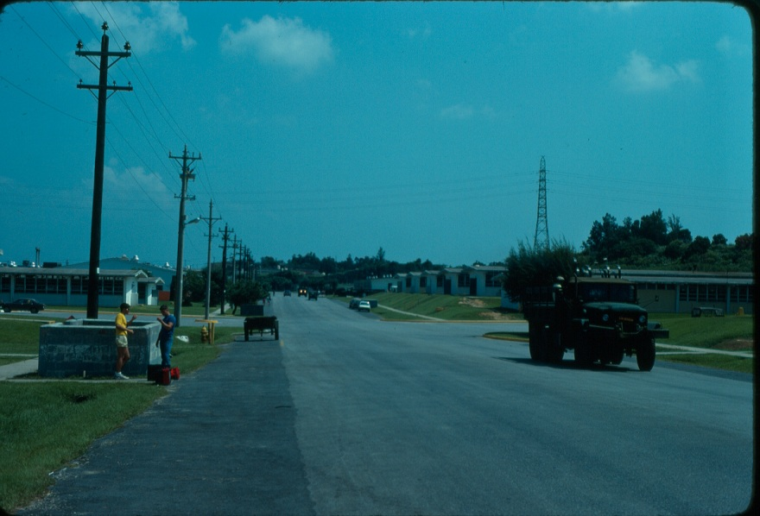
7th Communication Bn, Camp Hansen Okinawa
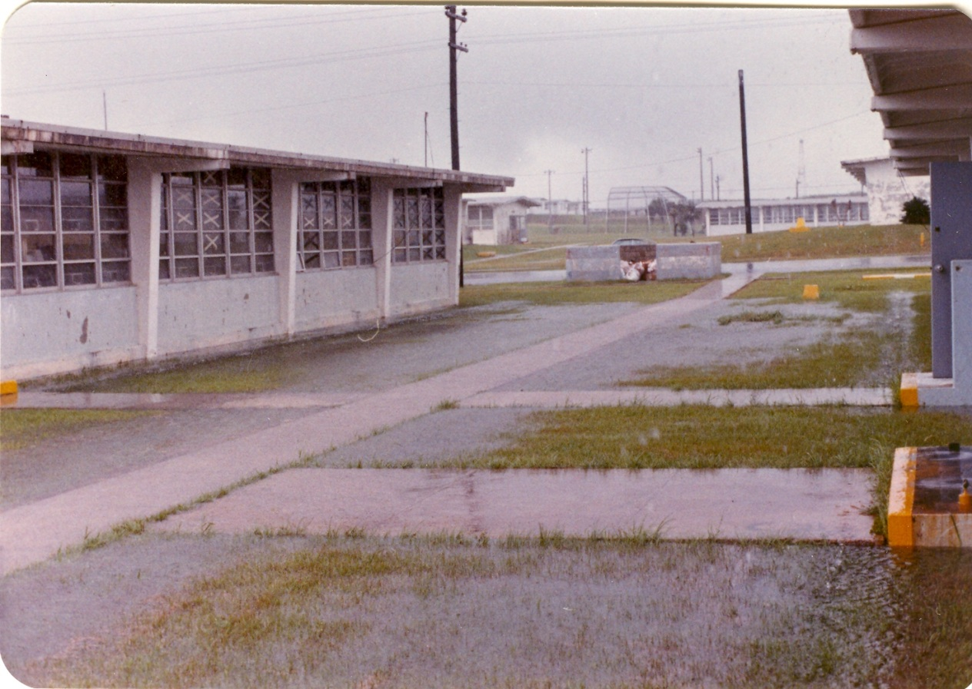
It could rain in Okinawa, parts of days often looked like this though this was a Typhoon downgraded to a Tropical Storm.
The X’s on the windows are tape in preparation for a pending Typhoon.
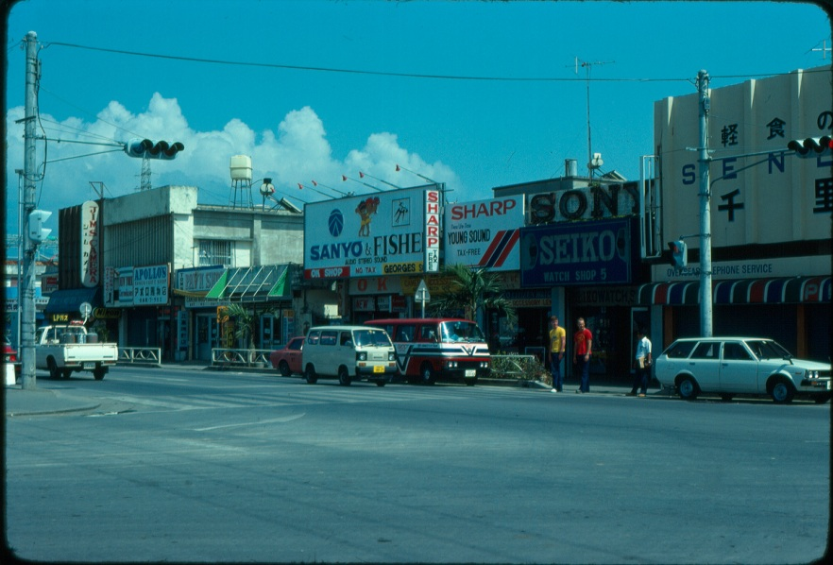
Kin Village the town just outside the Main Gate of Camp Hansen.
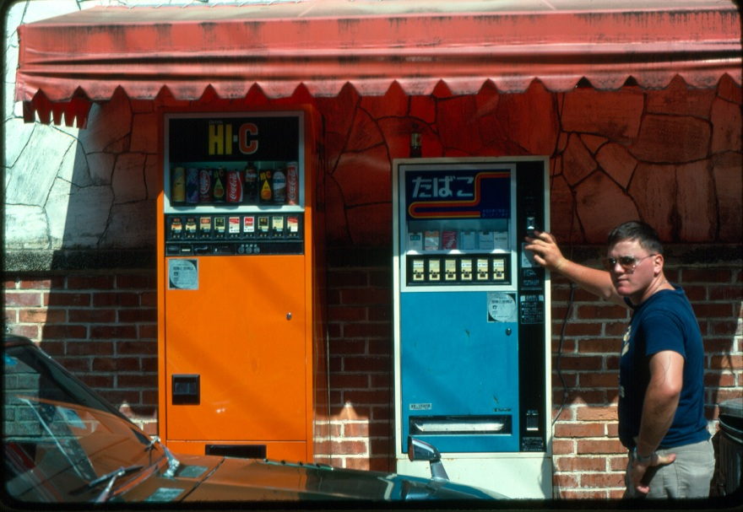
PFC Warden (Michigan)
From Communications School in 29 Palms, CA about 22 of us flew on the same flight to Okinawa [three of us from the same platoon in boot camp] most of the Comm Marines were assigned to the Artillery at 12th Marine Regiment – three of us were assigned to 7th Comm Bn including one Marine I went to boot camp with and PFC Warden.
While I was on ship PFC Warden was awarded Okinawa Marine of the Month or possibly of the Quarter.
Ocean Expo Park, Okinawa

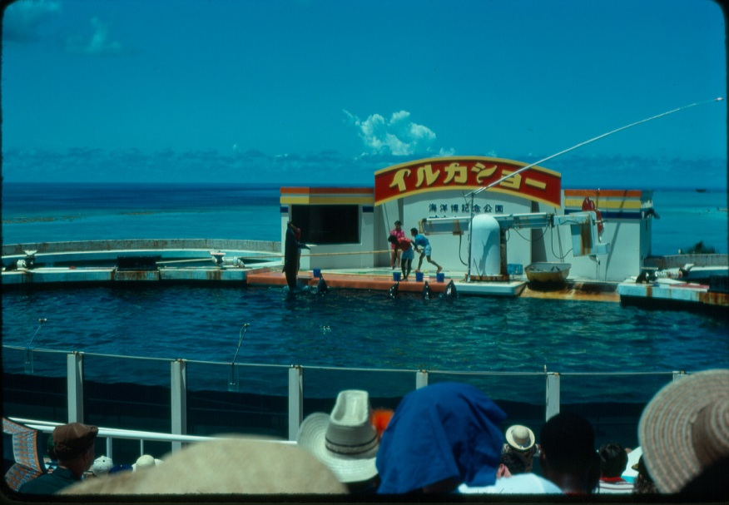

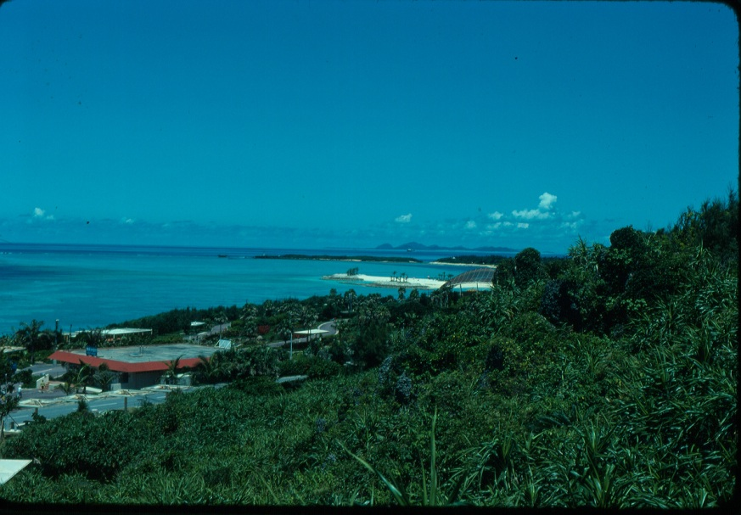

Ocean Expo Park, Okinawa - Continued

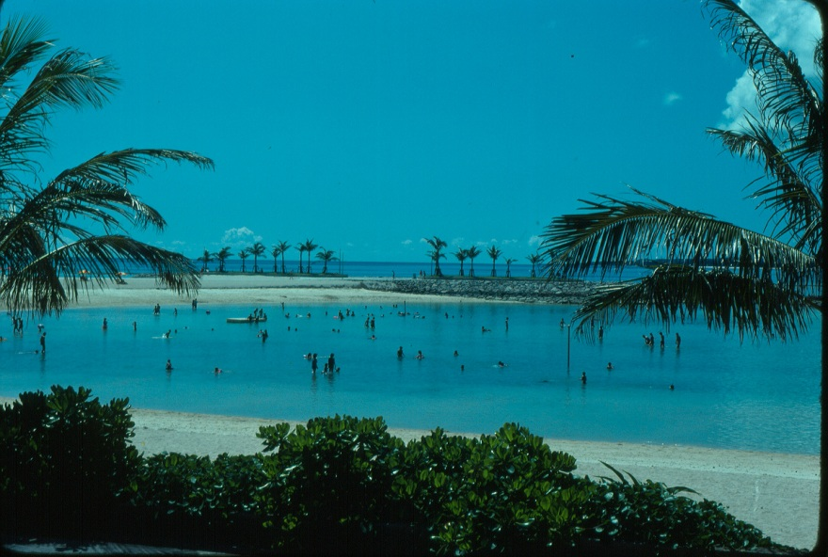

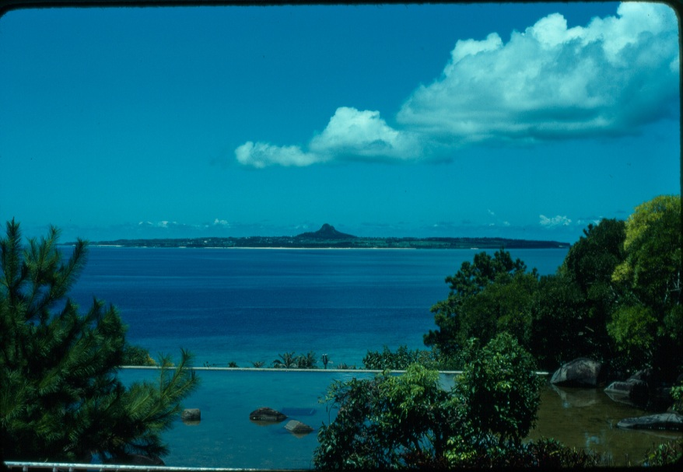
Arrival at 31st MAU in the Philippines - October 1982- West Pac 82-83

31st MAU Philippines
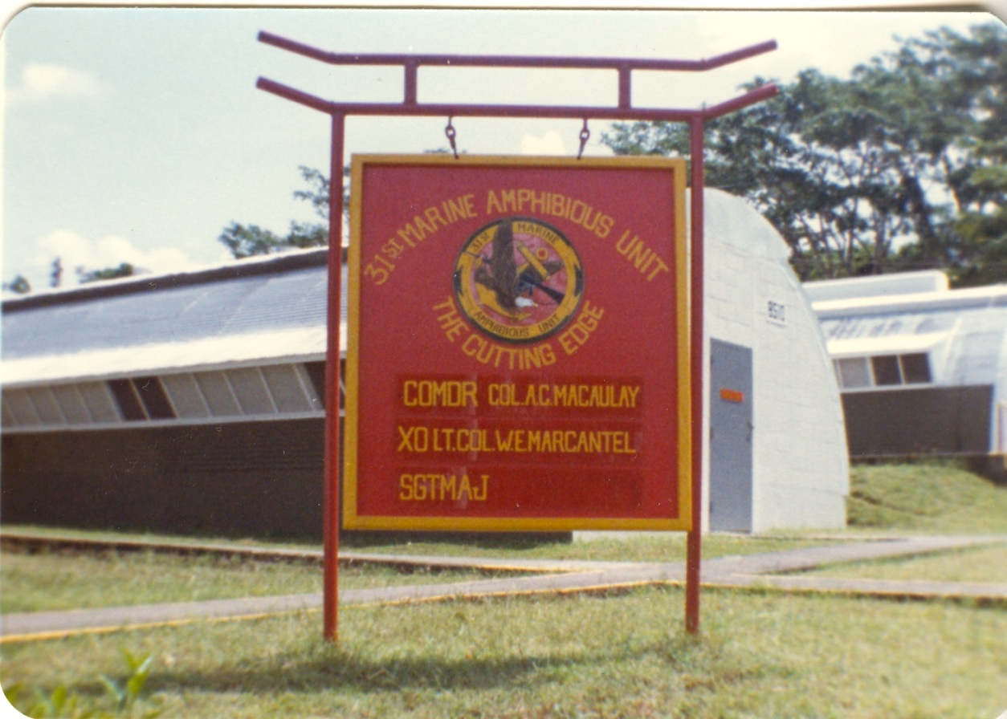
31st MAU Camp, located between Subic Bay Naval Base and Naval Air Station (NAS) Cubi Point in the Republic of Philippines October 1982.
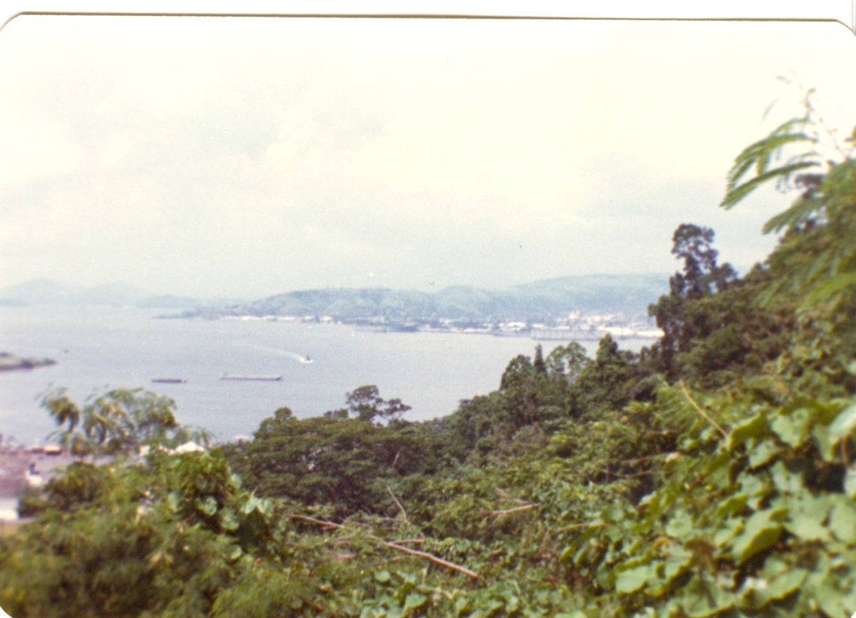
Looking from 31st MAU Camp down to Subic Bay Naval Base – USS Belleau Wood is docked in the center.

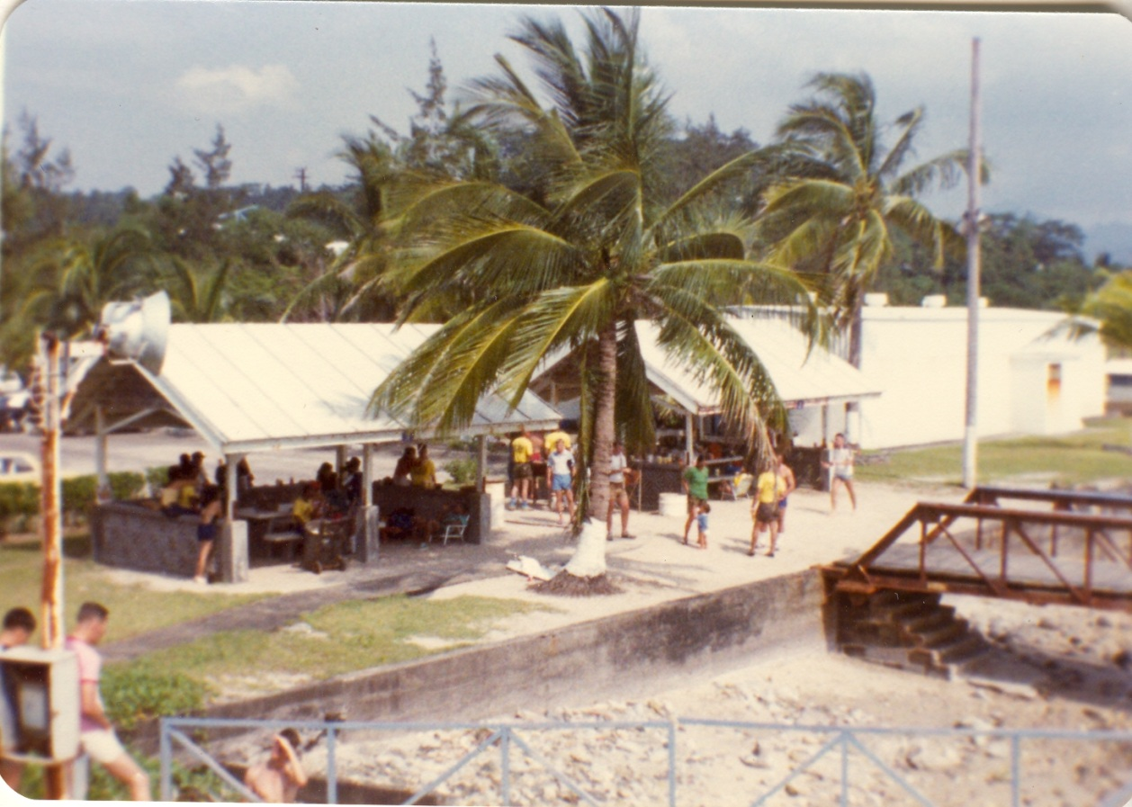
Subic Bay beach facilities.
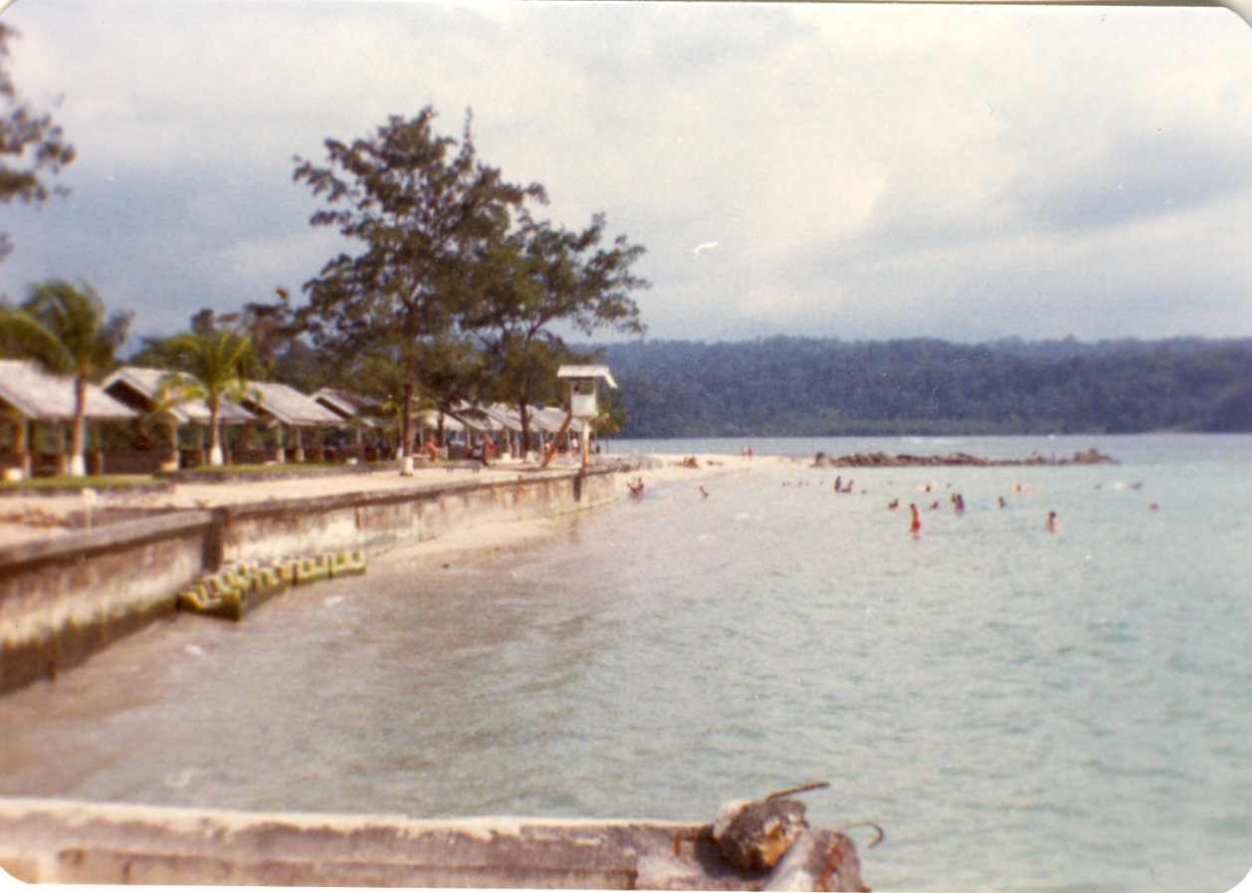
31st MAU beach party Subic Bay, October 1982.
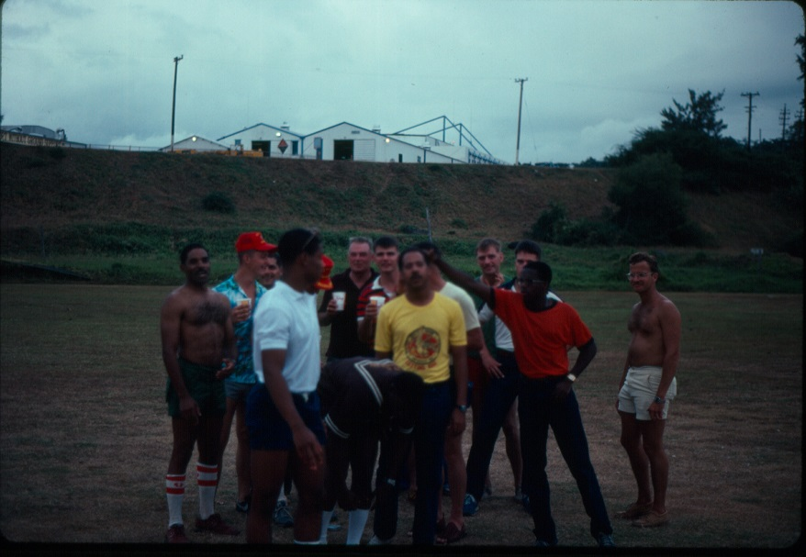
31st MAU beach party Subic Bay, October 1982. PFC David A. Brown 2nd on the left (blue shirt – red 31st MAU cover)
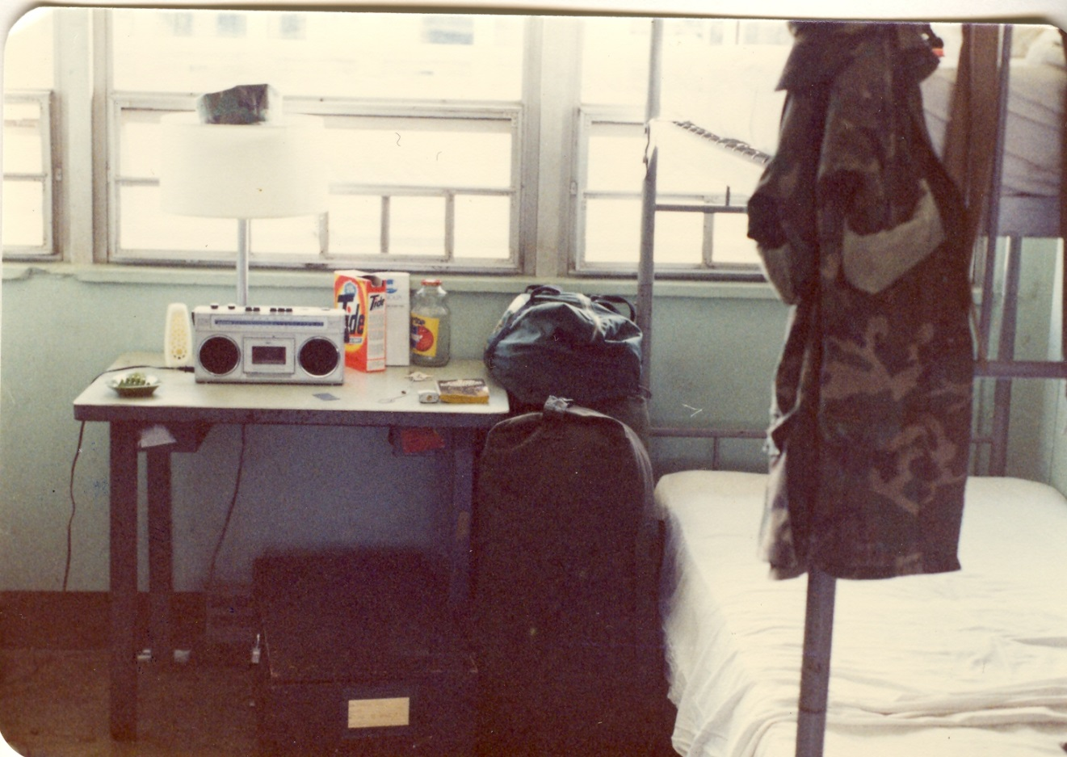
October 4, 1982 packed and ready to depart from 7th Communication Battalion in Camp Hansen, Okinawa. My lower bunk Marines were already sitting on it with my new cube mate it became a smoking card playing cube.
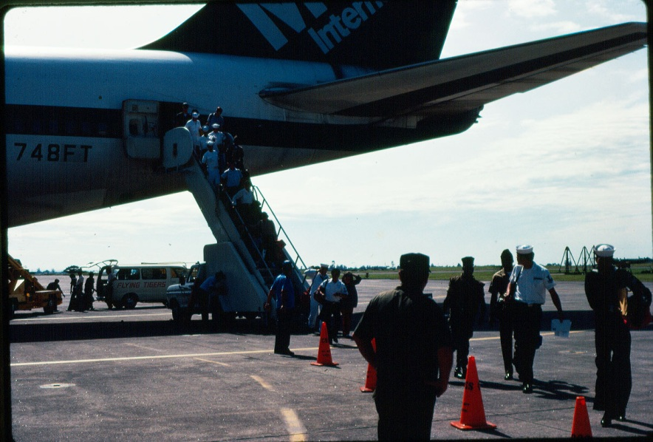
Actual arrival at Clark Air Base in the Philippines on October 4, 1982.
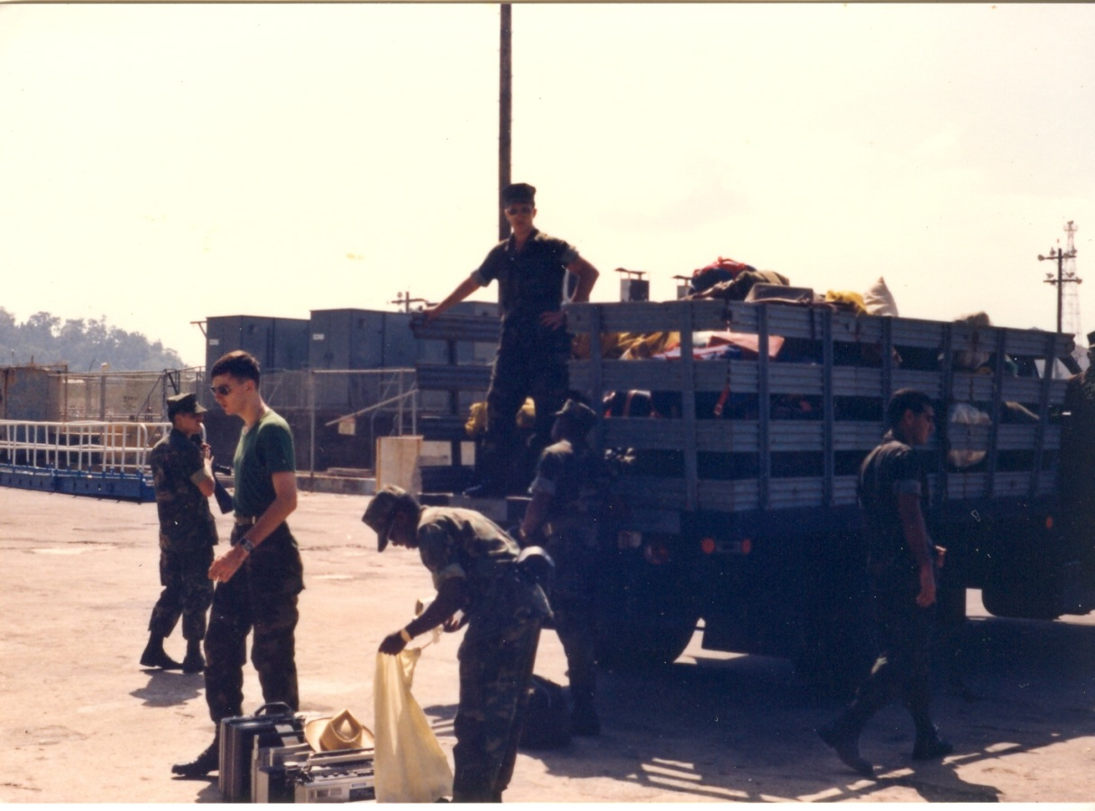
Marines of 31st MAU, Comm PLT transferring gear between ship and the MAU Camp – April 1983.
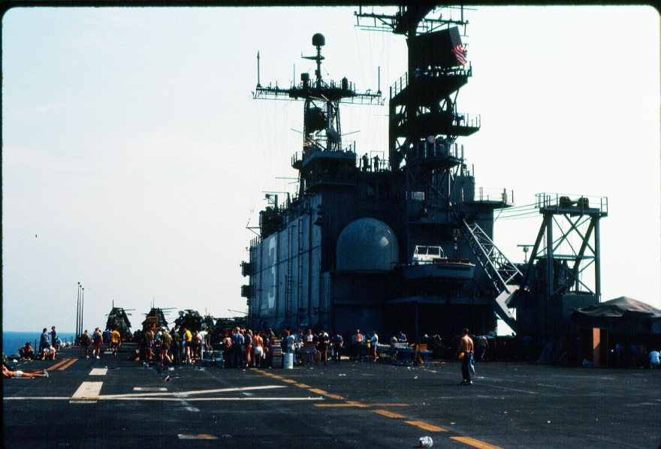
Deck Party USS Belleau Wood – probably nearing Hawaii - 31st MAU then cross-decked to the USS New Orleans.
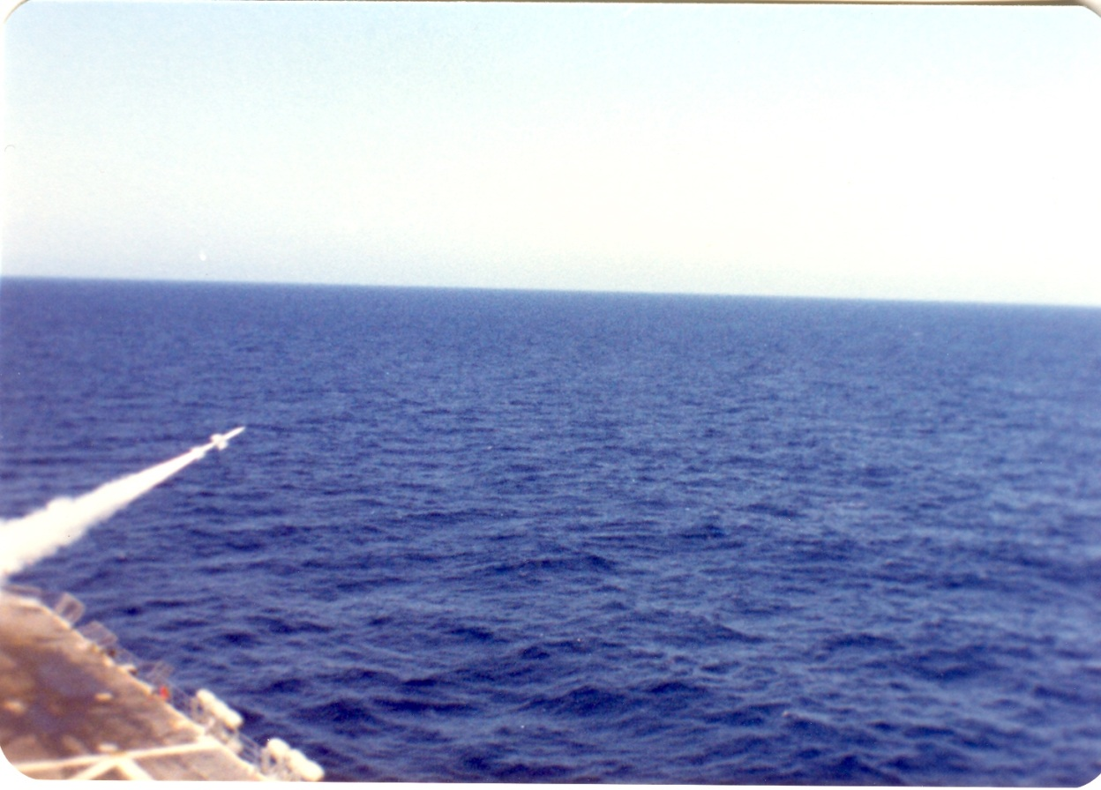
USS Belleau Wood (LHA 3) on route to Australia – Missile surface to air test fire exercise.

Exercise Valliant Usher in Australia and Marine Corps Birthday Ball in Perth, Australia 1982

31st MAU Australia
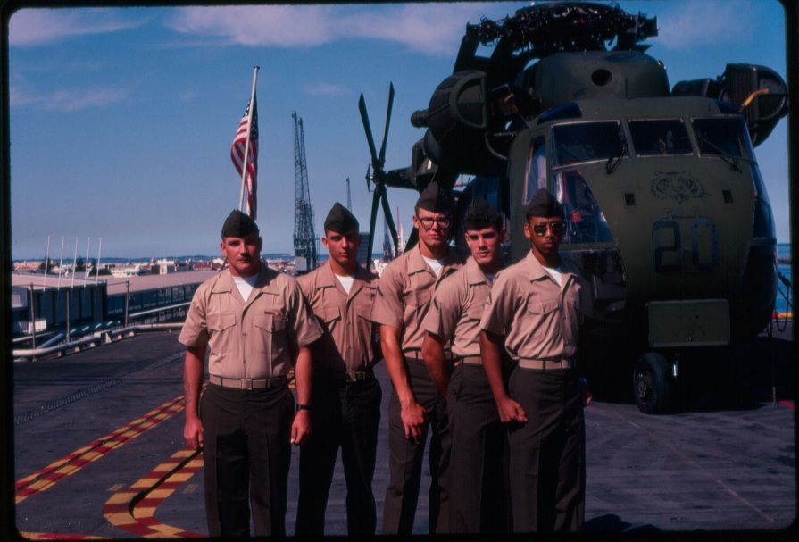
Arriving in Fremantle, Western Australia - Perth Australia – PFC Brown 2nd from left, LCpl Alvin Walker on the right.
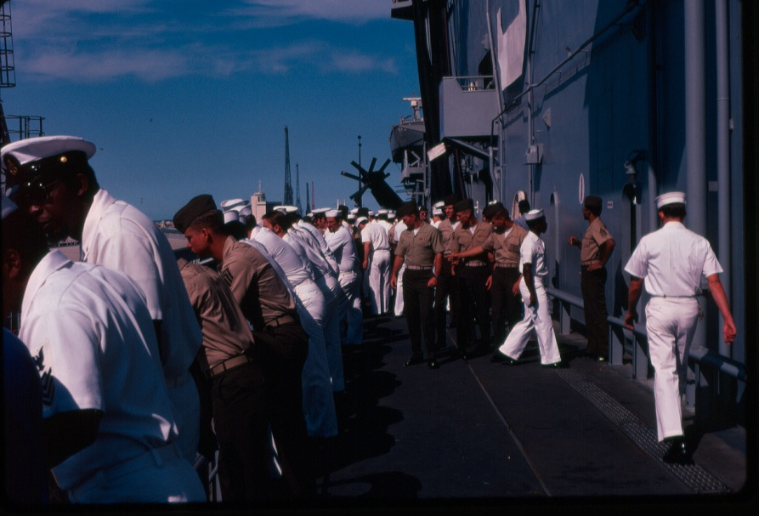
Marines of the 31st MAU, BLT 2/3 and Sailors aboard the USS Belleau Wood (LHA 3) arriving in Perth, Australia.

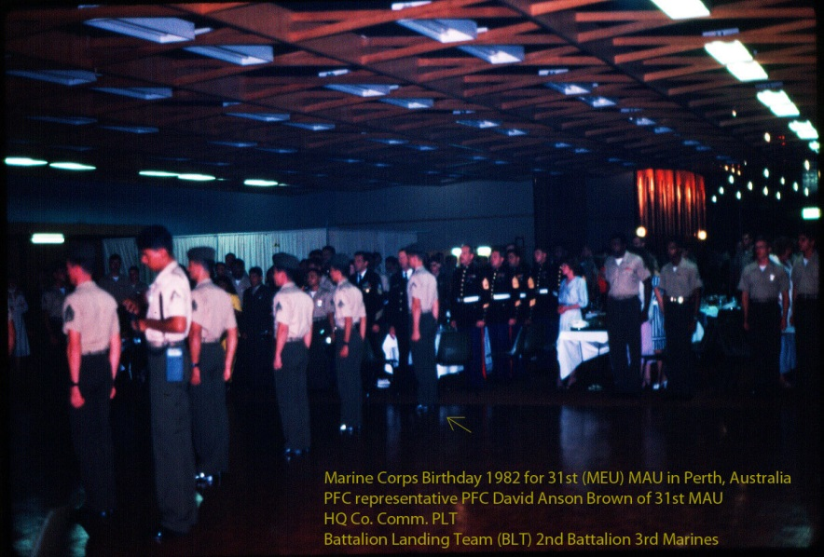
31st MAU’s Marine Corps 207th Birthday Ball in 1982 at Fremantle, Australia - PFC representative David A. Brown
Units: HQ 31st MAU, BLT 2/3, HMM 262, MSSG-37

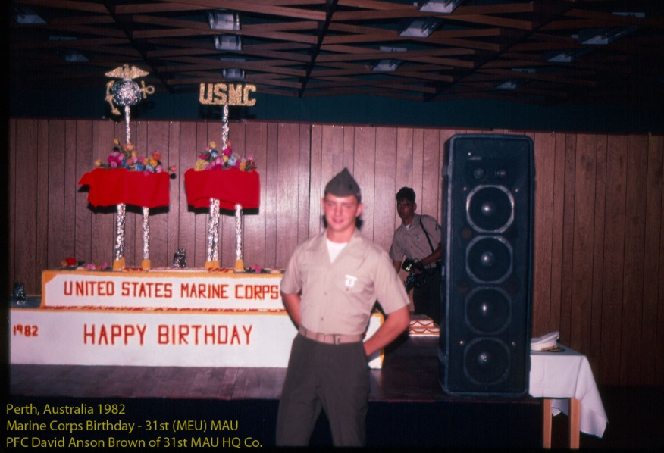
Marine Corps 207th Birthday Ball in 1982 at Fremantle, Australia - PFC David A. Brown HQ 31st MAU Comm Plt
Photo was taken immediately after the MCB ceremony just before I removed my cover for the evening.
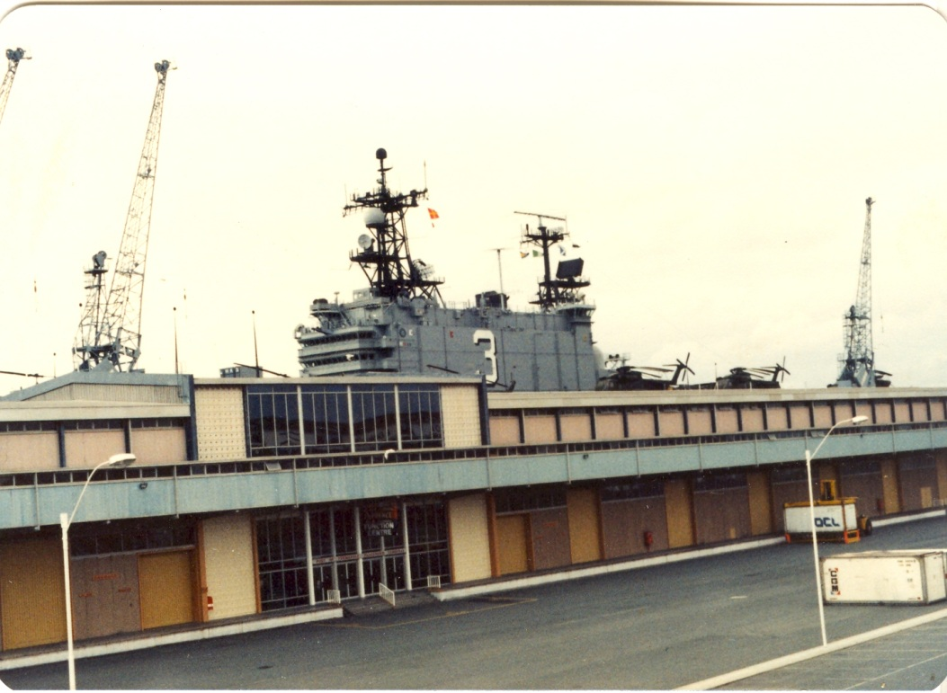
The USS Belleau Wood LHA 3 docked in Fremantle, Australia – The building and upstairs is where the Marine Corps Birthday Ball was held.
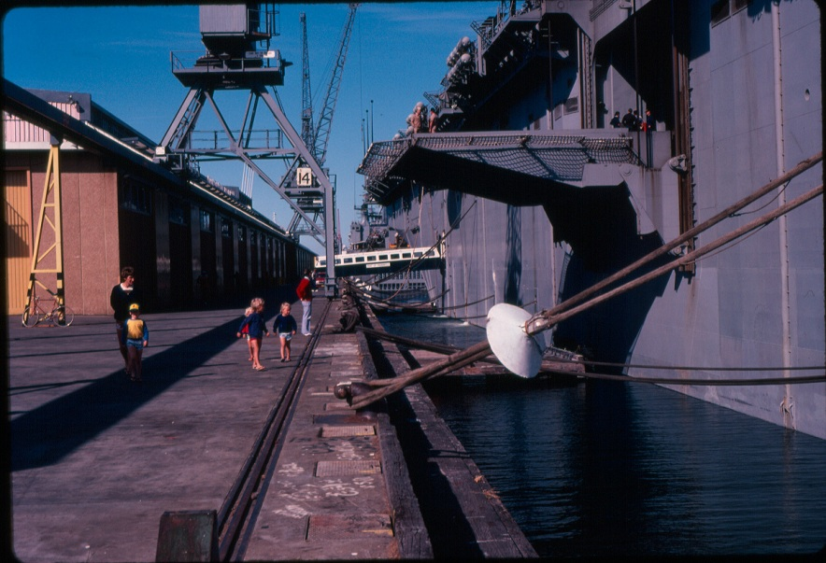
USS Belleau Wood – Visitors Day for local civilians in Perth, Australia.
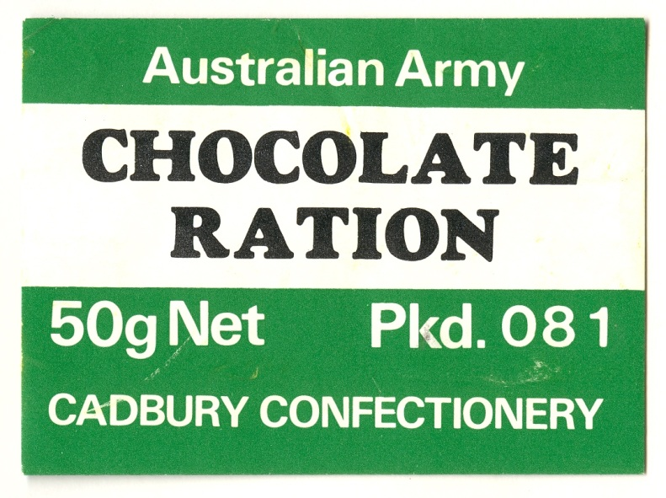
I stayed on ship (Shipside Communications) for Valliant Usher but managed an Australian C Ration package.

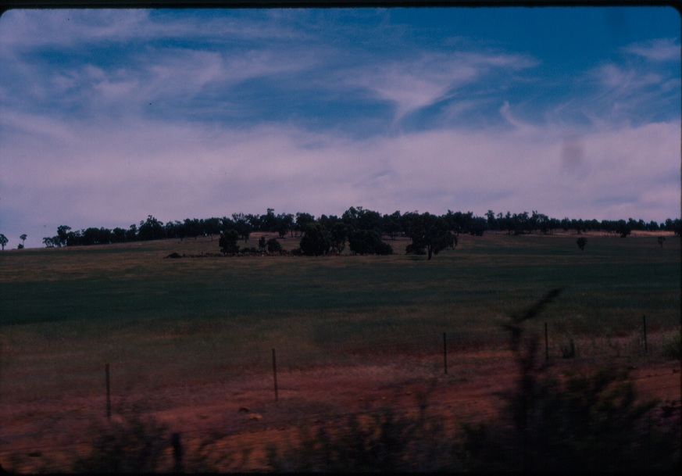
Liberty in Australia – Guided history tour bus ride and the Australian countryside.
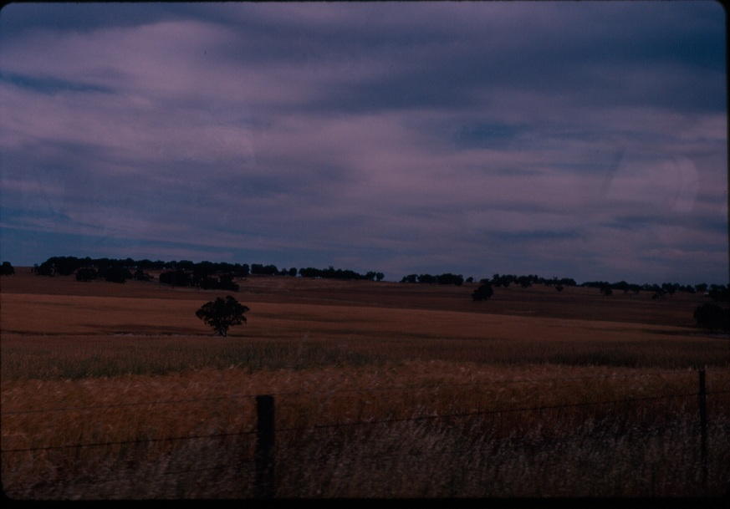

Diego Garcia, Indian Ocean

31st MAU about November 9-12, 1982 Diego Garcia, Indian Ocean

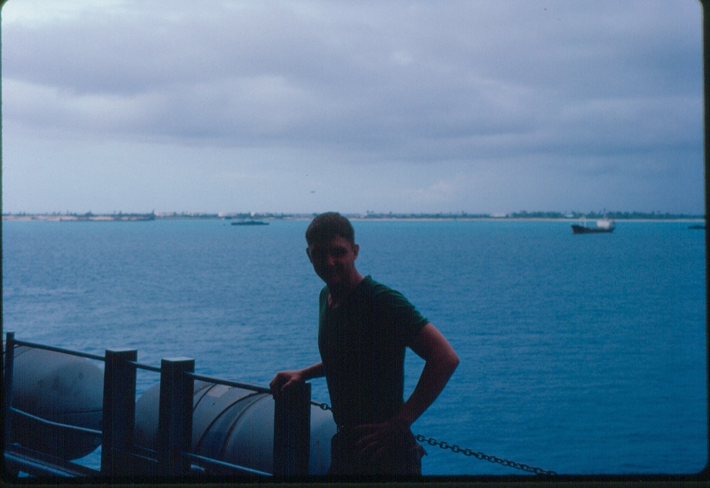

Pfc David Anson Brown 31st MAU about November 9, 1982 Diego Garcia, Indian Ocean

The 31st MAU on LHA-3 was in Diego Garcia in Nov. 1982 having left Perth Australia (Oct. 1982 - Exercise Valliant Usher 2 - Marine Corps Birthday Ball), to take on supplies for our departure to Berbera, Somalia (originally Exercise Jade Tiger it became Operation Jade Tiger when a security area was setup outside the town). In Dec. 1982 Wahiba Sands, Oman (originally Exercise Golden Lion it is now known as Exercise Jade Tiger) and the North Arabian sea the Strait of Hormuz/Iran the Iran/Iraq War (Oil Tanker War) surveillance. Departing to Singapore at the end of December and returning to the Philippines for New Year 1983.
I was on deck during ops while we were in Australia (Valiant Usher), taking on supplies in Diego Garcia, Indian Ocean, our arrival at Berbera, Somalia, later at Wahiba Sands, Oman and the Strait of Hormuz during surveillance off the Southern coast of Iran. I was a radioman in HQ Co. Comm Plt and at Diego Garcia a radioman for the MAU Executive Officer (XO) the second highest ranking Marine on the deployment. At Australia I was in the Marine Corps Ball ceremony and all of that gave me opportunity to both hear and see much of what was actually taking place on our Westpac 82-83 deployment.

Note: While we were in Berbera, Somalia and at Oman the news reported us as American Soldiers and that has led to much confusion because people don't know that it was Marines and Sailors that were there. Also the names of our Operations/Exercises have changed, some of the official photos of the deployment are mislabeled and the map of our deployment is slightly inaccurate.

31st MAU – Diego Garcia, Indian Ocean – November 1982
A practice beach landing, a beach party and the receiving of supplies for the upcoming Jade Tiger and Golden Lion
Note: PFC David Anson Brown was one of several radiomen for the MAU Command Staff participating in the landing.

31st MAU Diego Garcia
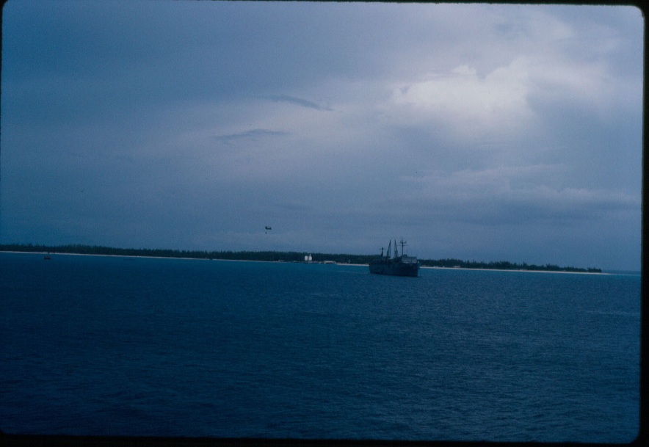
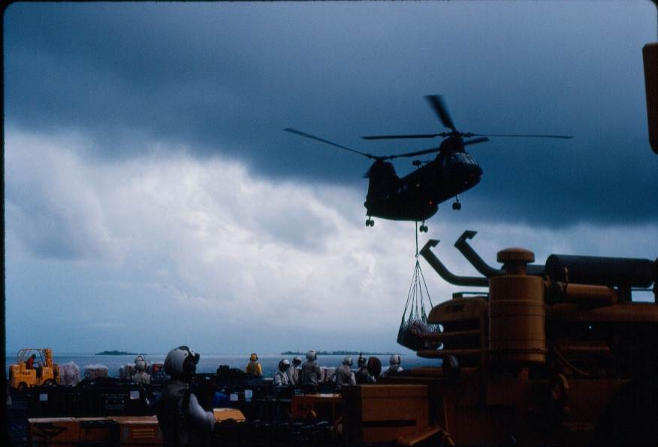
Helicopters delivering supplies to the USS Belleau Wood (LHA 3) at Diego Garcia, Indian Ocean.
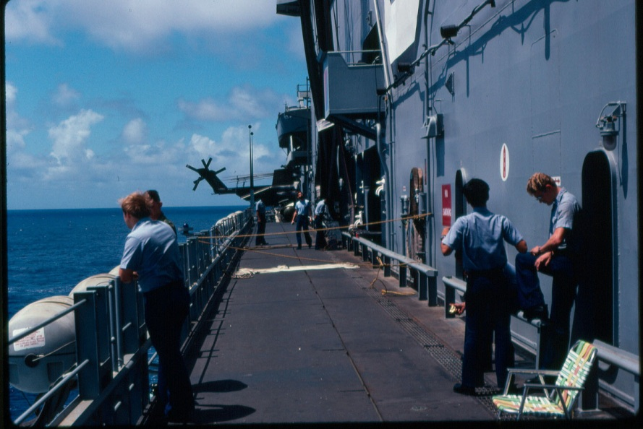
Navy ship repairs and viewing the events of Diego Garcia.
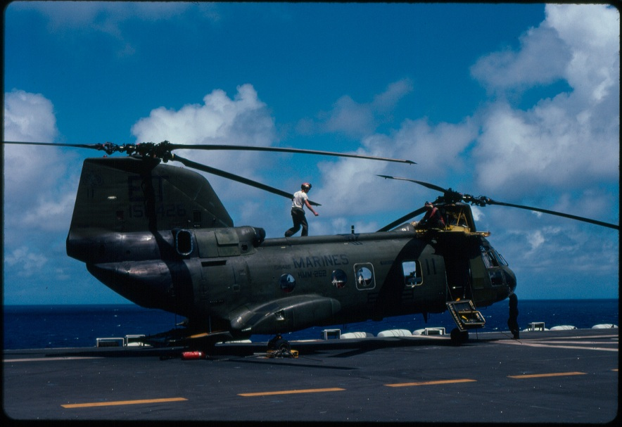
Helicopter maintenance and repairs.

31st MAU – USS Belleau Wood (LHA 3) - Jade Tiger - Berbera, Somalia

31st MAU Somalia
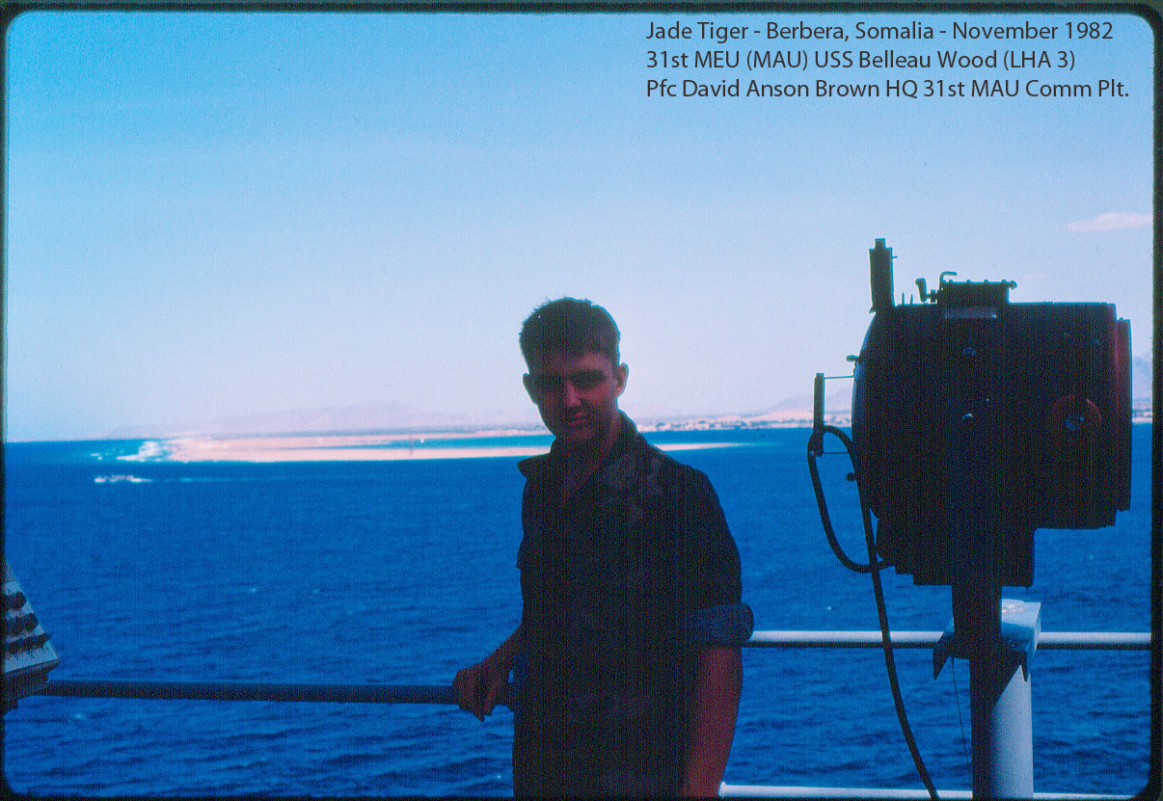
Arrival off the coast of Somalia – PFC David Anson Brown USMC
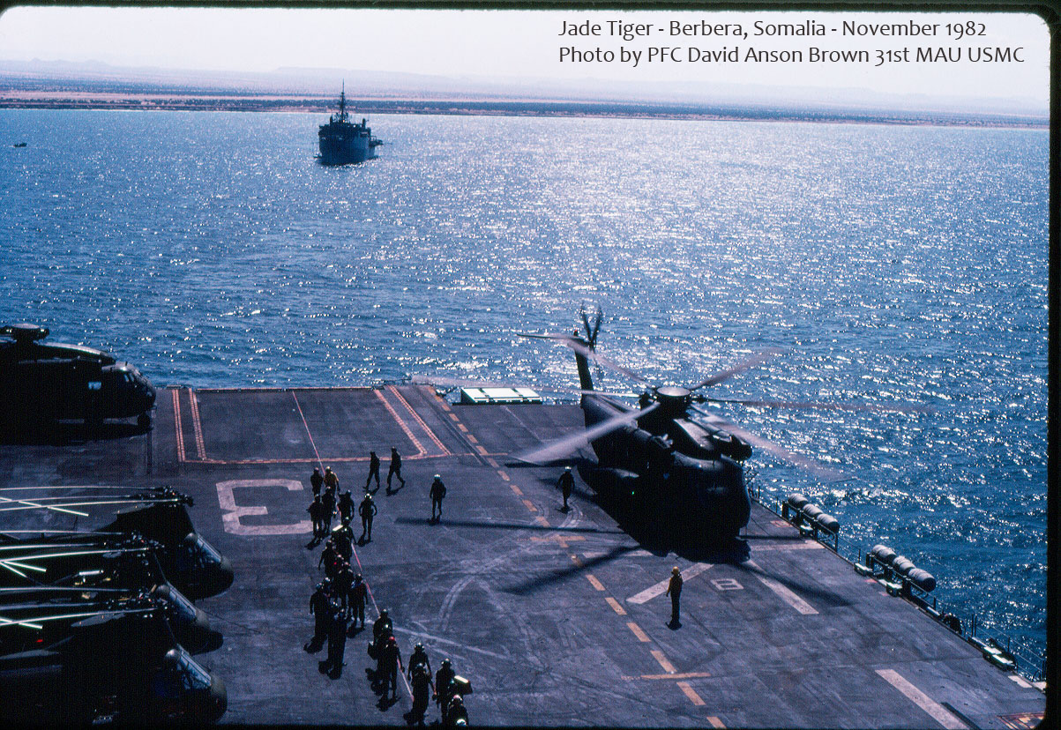
Recovery of a combined Marine Recon and Navy SEAL Team.

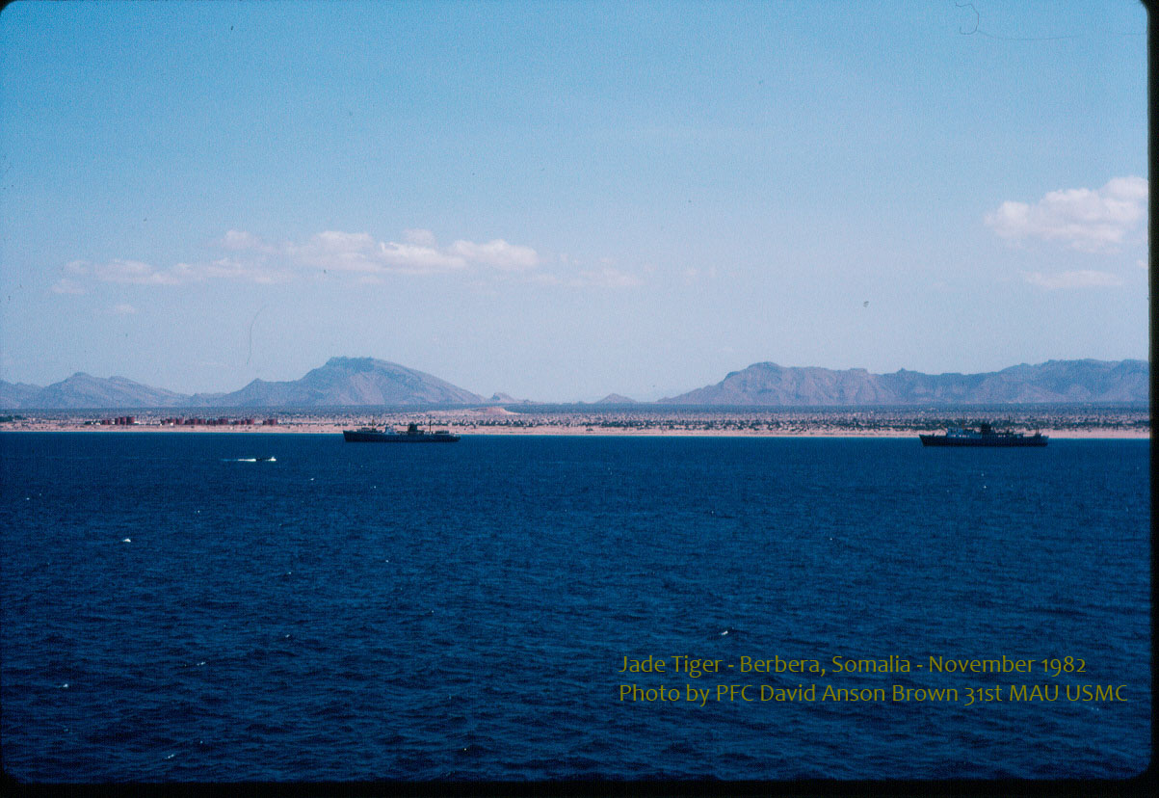

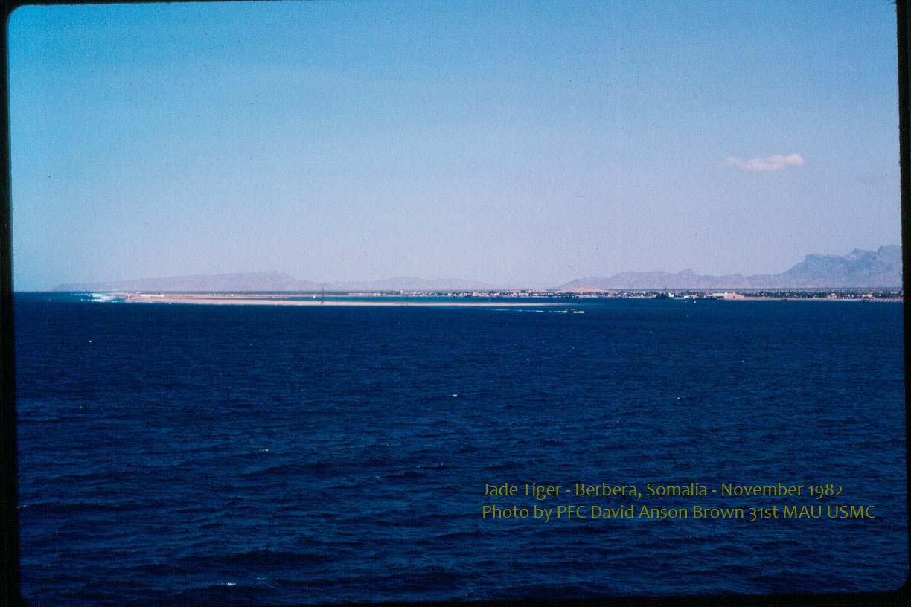

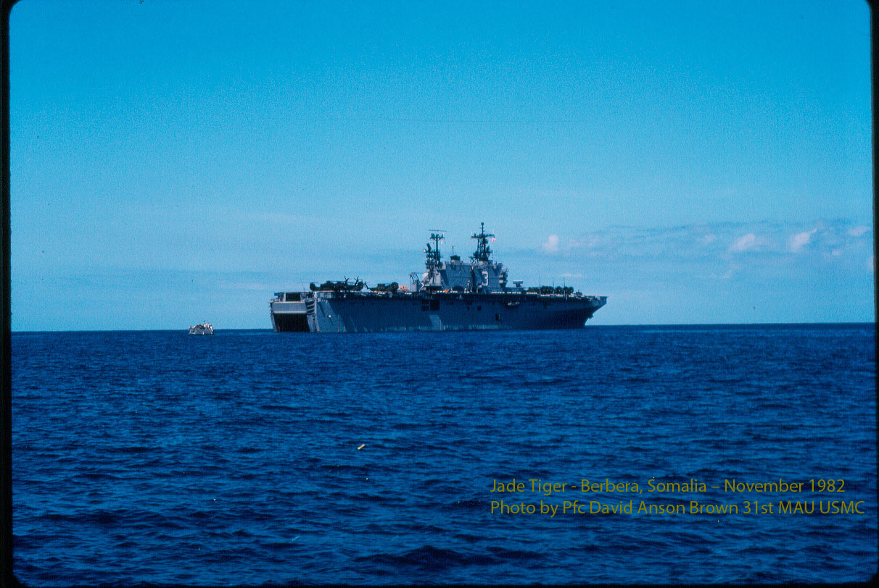

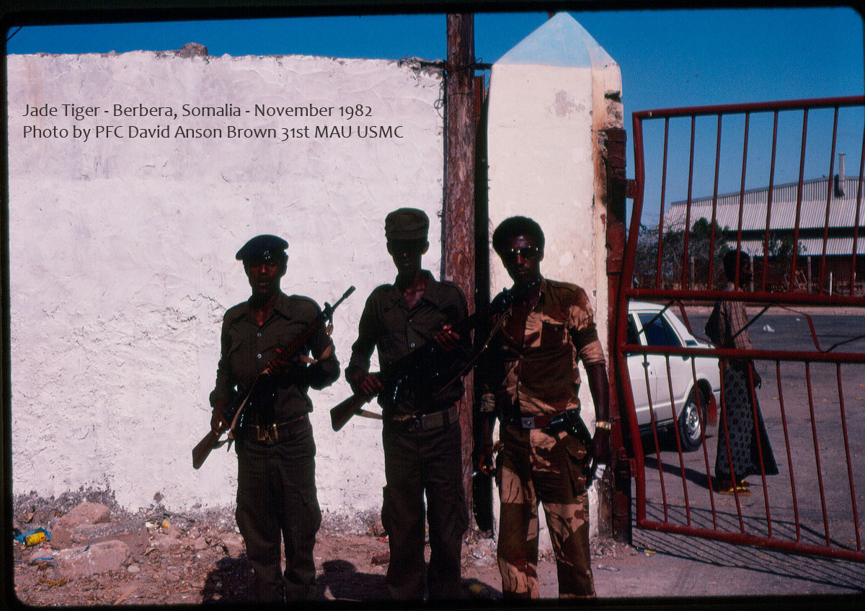
Note: most of the gates like this red one are dented and broken from Somali rebels ramming vehicles into them.
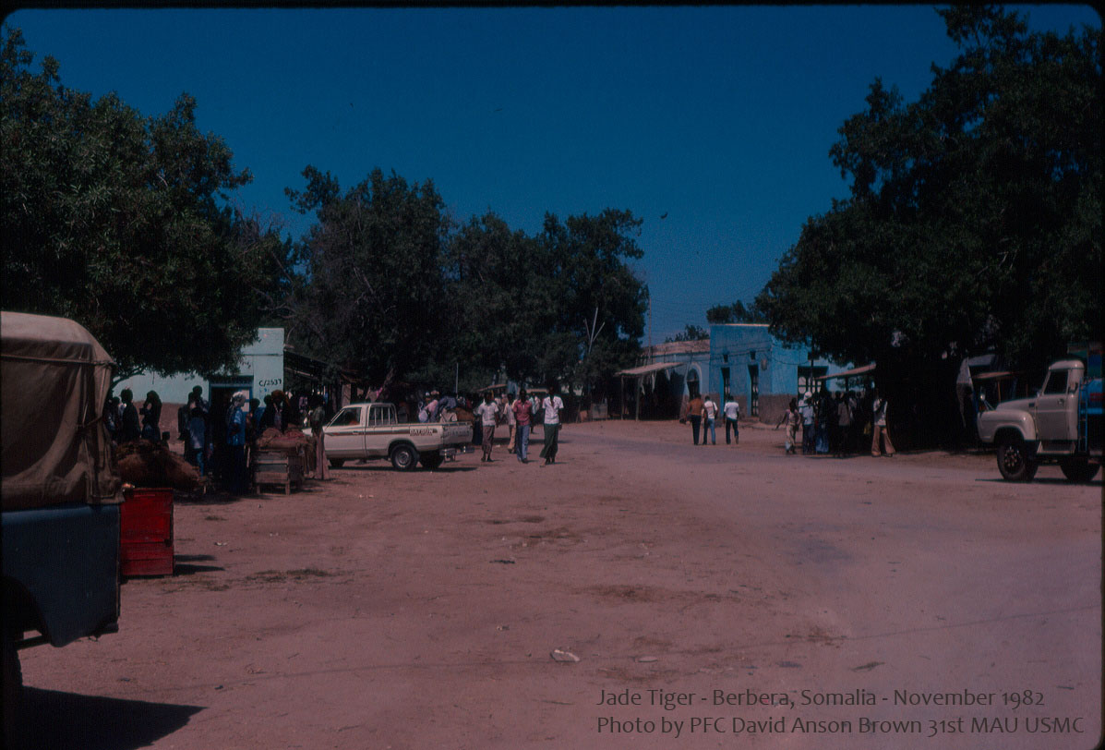

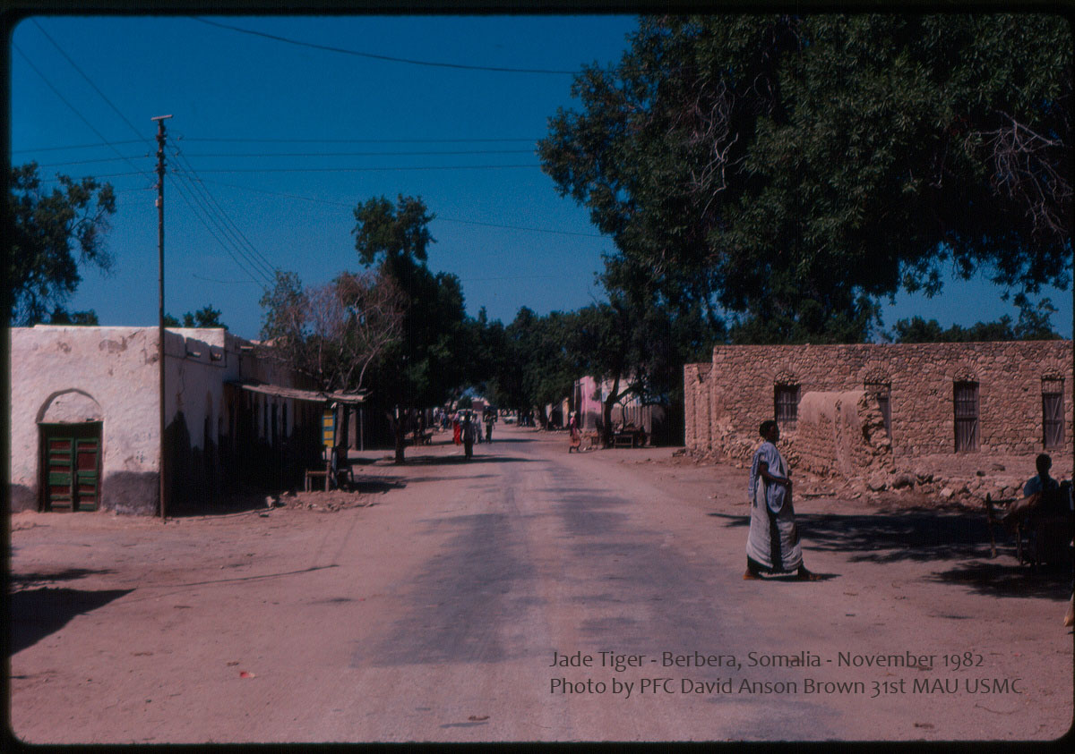
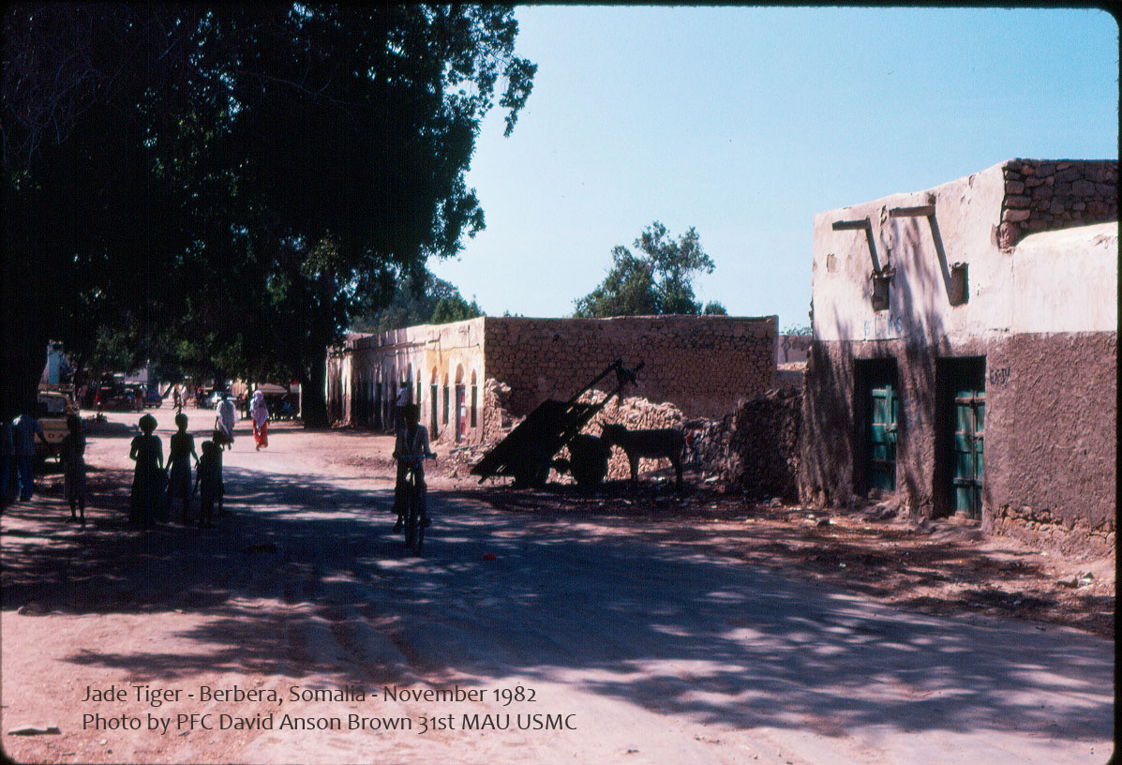

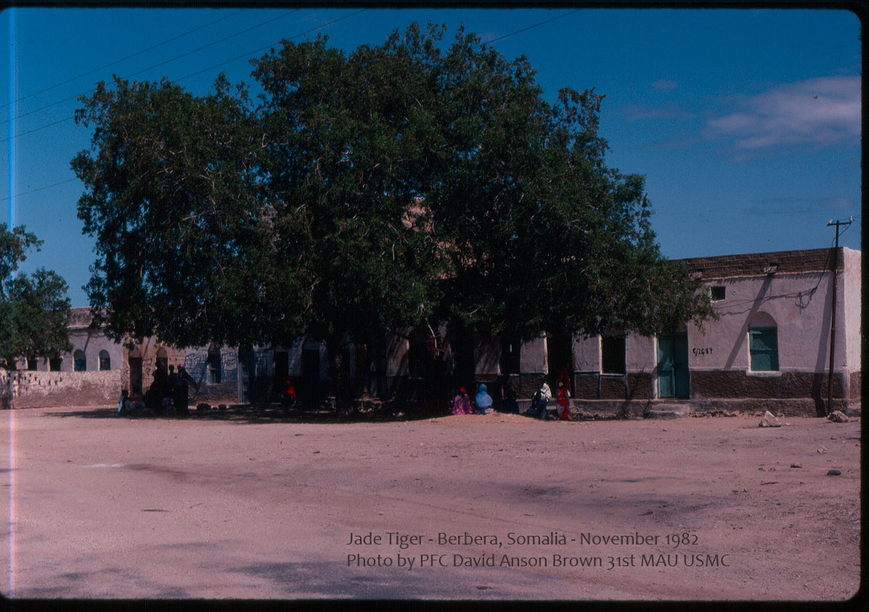

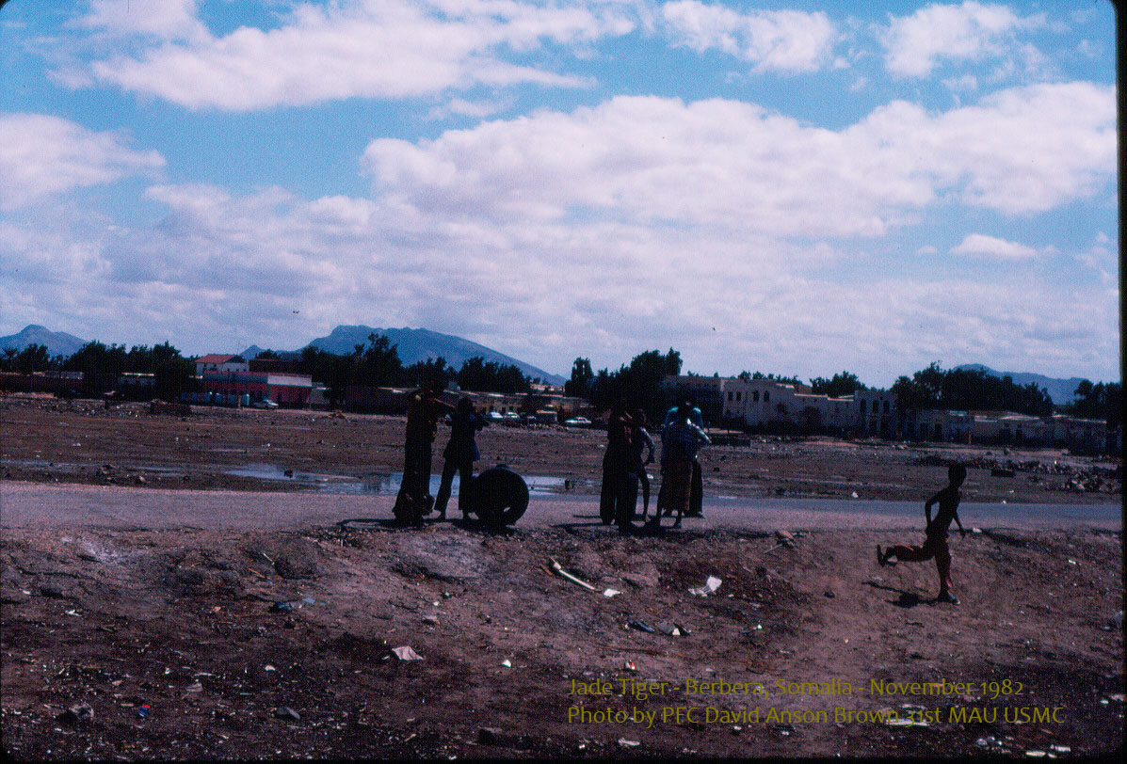

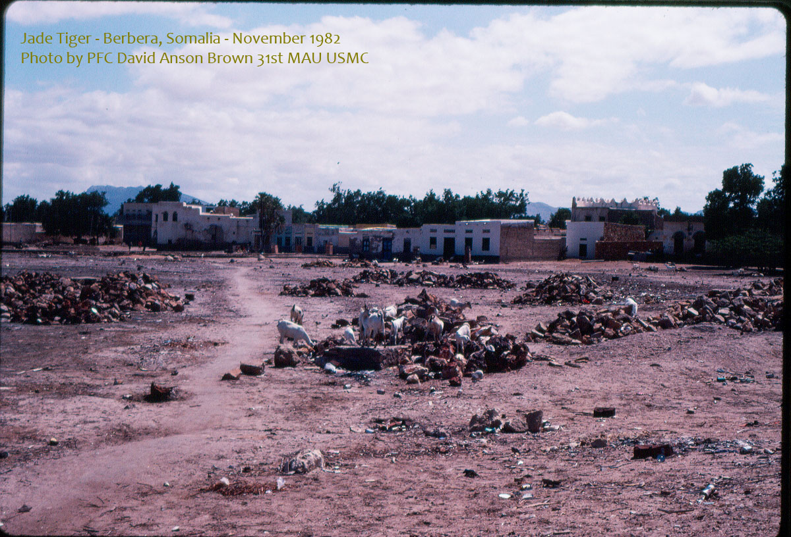
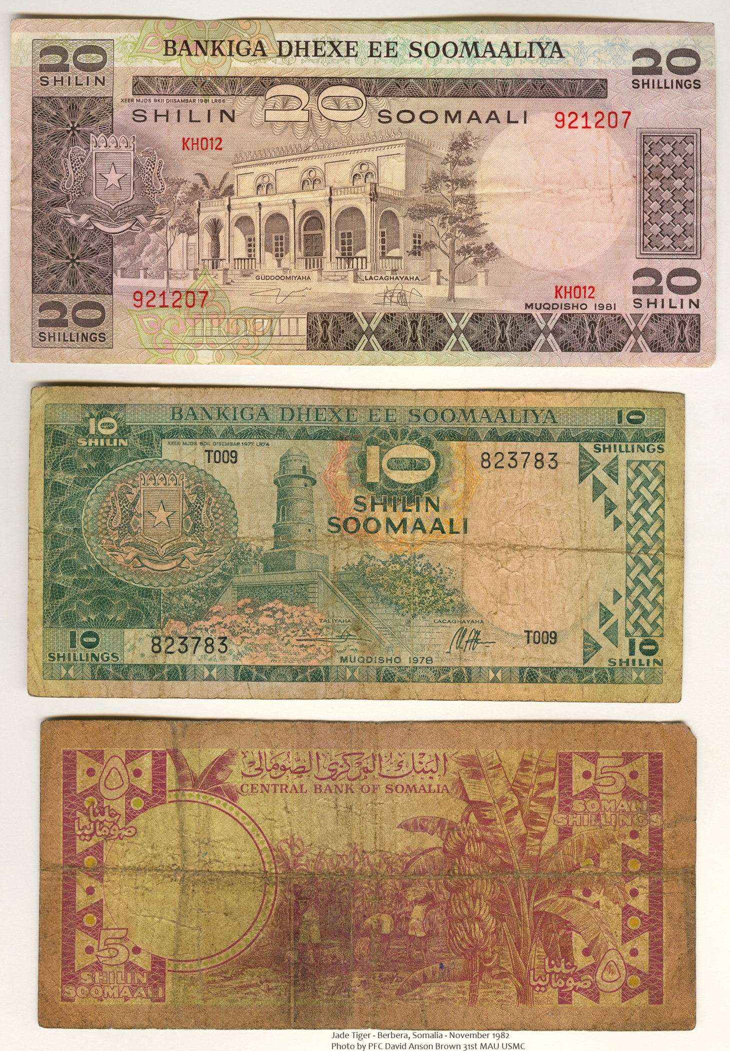

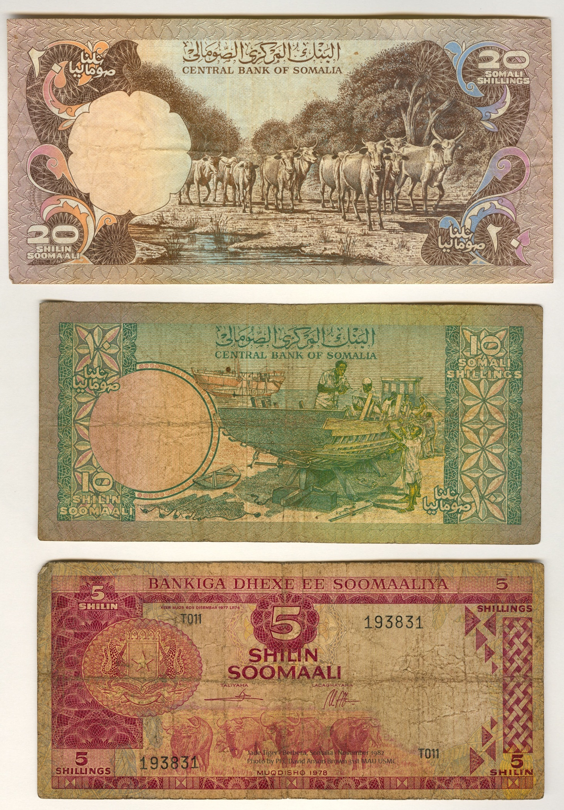
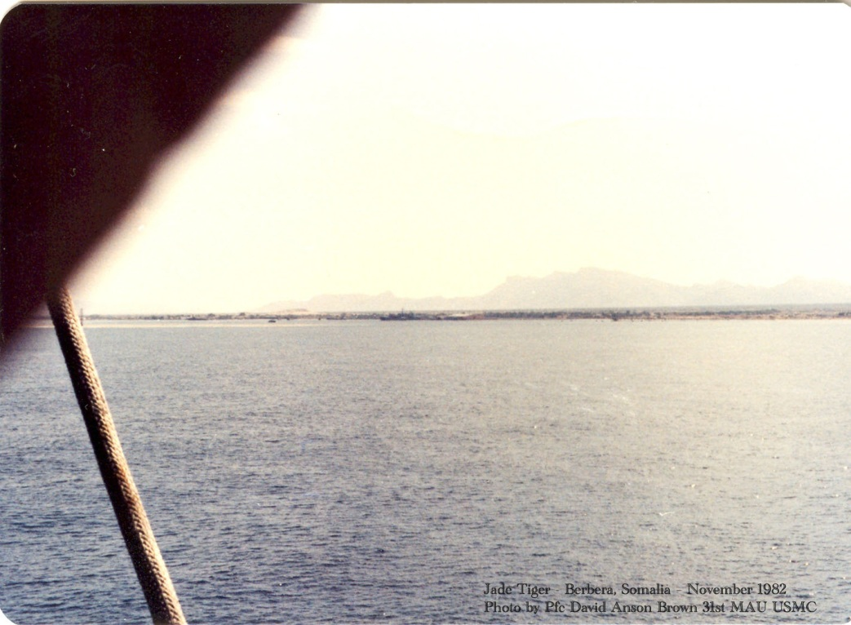

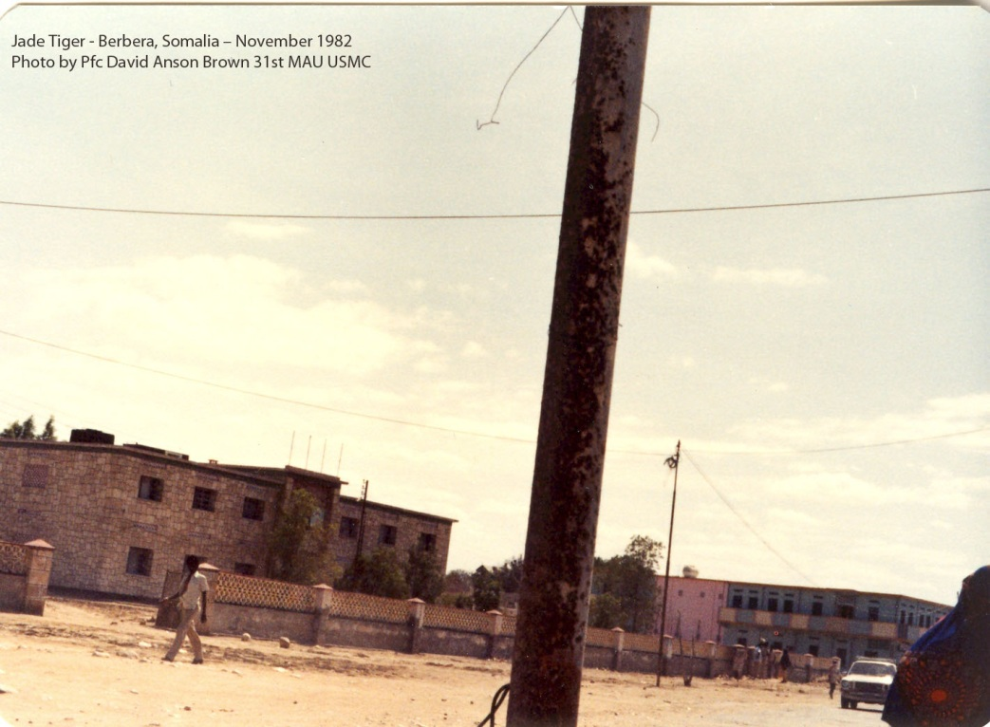
This photo is near the hospital in Berbera where a big effort was made by the 31st MAU to clean and improve the hospital facilities. I had duty on ship for a while that day and arrived at the hospital working party several hours later and was told to remain outside the building and provide a presence there.
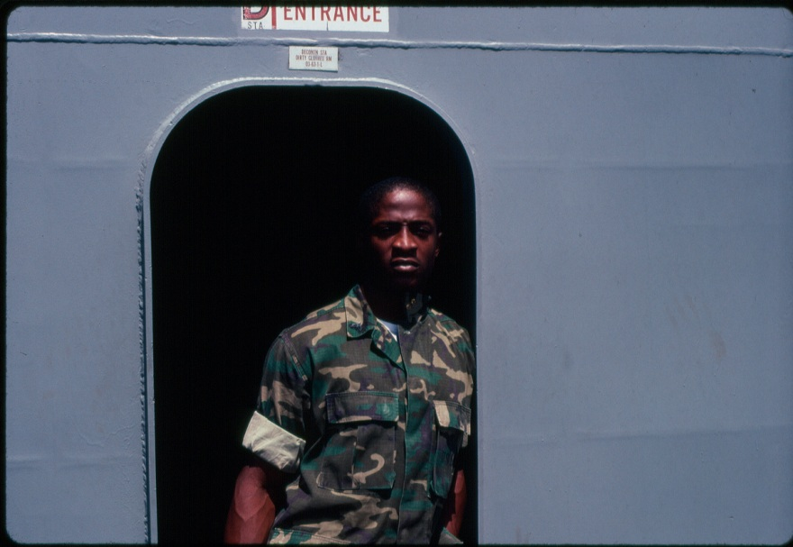
Popular squad leader 31st MAU HQ Co, Comm Plt Cpl Todd S. Black (Too Smooth – Bronx, NY) – Jade Tiger Hero
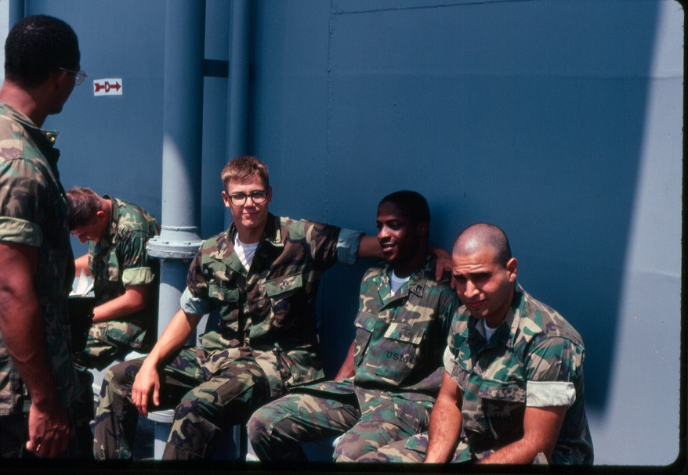
PFC C. Callahan (Ohio) with his squad leader and bro Cpl Black
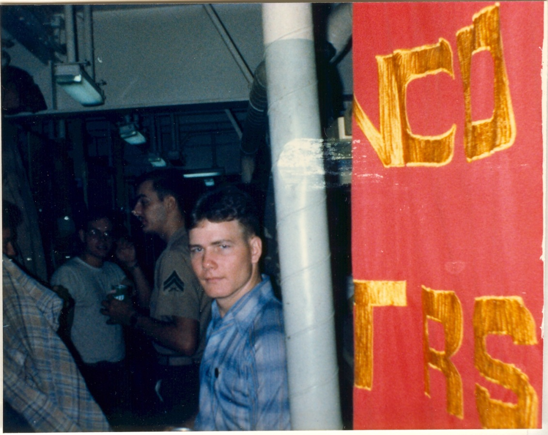
31st MAU HQ Co, Comm Plt LCpl Kelton (Kentucky) – Jade Tiger Hero
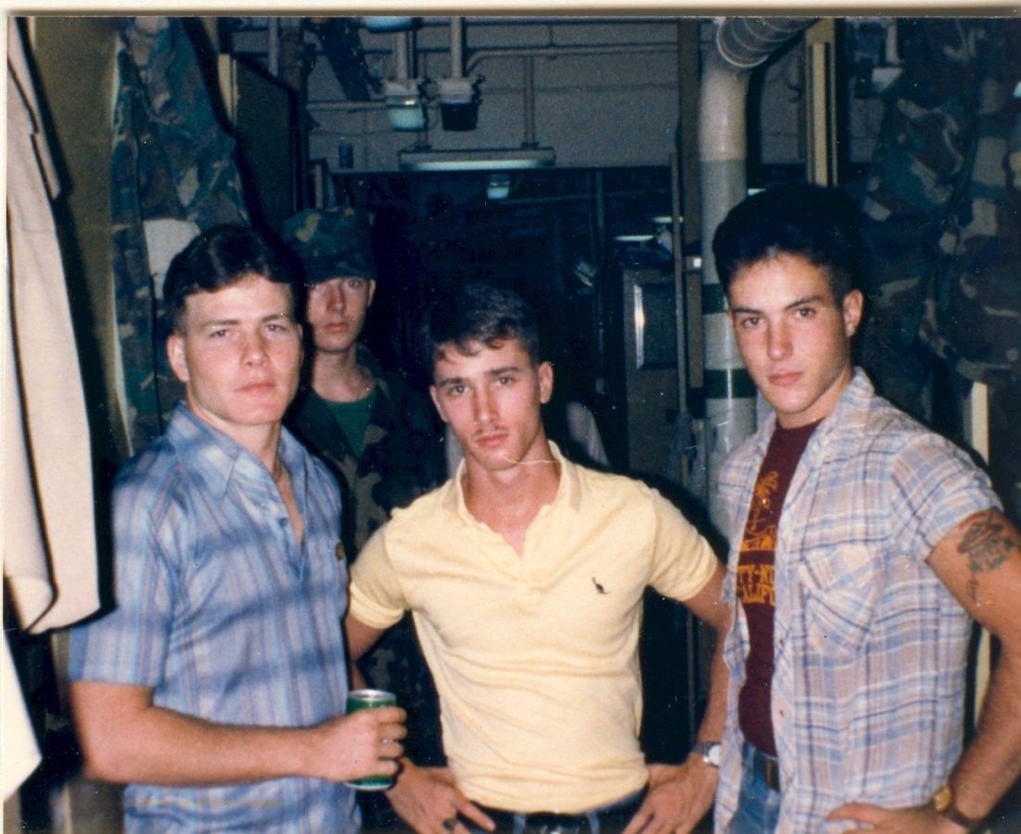
31st MAU Jade Tiger Marines

Somalia Pt 2

My first amphibious landing was with HQ 31st MAU accompanied with BLT 2/3 it was a practice landing on 10 Nov. 1982 (Marine Corps. Birthday) in the Indian Ocean at Diego Garcia, on the first wave about the 4th M-boat. The second landing (Nov. ‘82) was in Berbera, Somalia. I was a part of the advanced party and went ashore in civilian clothes on [1-1] the first wave first M-boat of three advanced party M-boats and we were all beyond fortunate to make out of there alive. We were spread out on the streets of Somalia and watched when our command staff brought the American flag and our Marine Corps colors ashore. I remained on ship as a shipboard radioman for landings in Australia, Oman, and Korea. Then in Sept. 1983 did a practice Amtrak landing for Beirut in the Philippines with A. Co 1/9, [Beirut was canceled for us then later 1/9 flew to Korea from Okinawa]. My last landing was in an M-boat while training with A Co 1/9 in Panama in June 1984 on the Panama Canal while the country was in turmoil over their May 1984 elections.

Facebook photos 2/21/2016

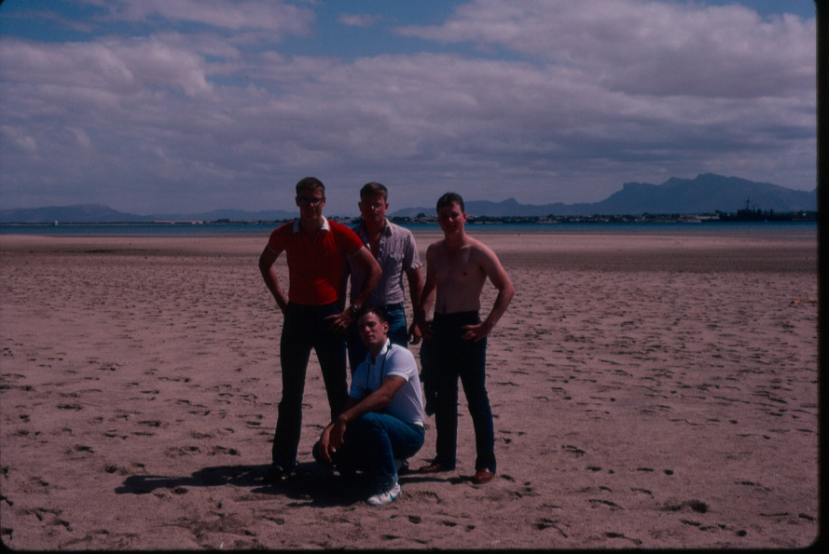

31st MAU after our [1-1] landing and on our way to our area the first full day in Berbera, Somalia. We were the north landing craft and were actually taken about 5 miles north of where we were expected to be so we had a long walk. When we finally got near our area and encountered hostile Somalis our first effort was to locate what we thought were going to be the dead bodies of m-boat [1-2] fortunately they were also late getting to the rendezvous area (that included a Somali ambush house) because of a mob of unruly Somalis. While m-boat [1-3] with Cpl Black, LCpl Williams and Pfc Kinchen, etc. was delayed launching from the ship the USS Belleau Wood (LHA-3). The ship had decided to hold off on sending the 3rd m-boat. The m-boats [1-1] and [1-2] linked up on two cross streets while Somalis were repositioning ammo and weapons in a house. I was told to stay north of the house on the street so we didn't all bunch up while the two groups linked up. I stood and somewhat saw into the house while Somalis moved piles of ammo and firearms, so much ammo and firearms that two Somalis began to complain and quit while their leader scolded them and got them back to work on their ambush. When we got dropped off in the wrong area we came into the village from a different direction then the Somalis expected. photo by David Anson Brown

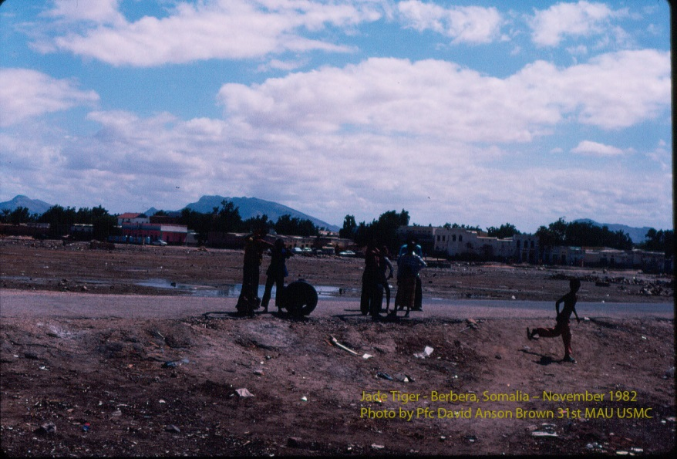

After walking about 5 miles to get to our assigned area, the buildings in the background of this photo, we neared our area and had our first encounter with Somalis. We saw the Somalis first (the children only) from a small rise so we were careful to walk down there undetected and we did walk up to them undetected but by the time we got there the adult Somalis had broken curfew and came out because the kids were arguing and fighting. The child running in the photo was a lookout from Mogadishu, Somalia (who had been fighting with the two local kids) and while we talked to him he bolted and ran to warn the Somalis in the ambush house. Our concerns about an ambush were confirmed and fortunately when he bolted and ran, he went directly to the ambush area so we knew where it was and it was where we expected it to be, there was only one good location in the buildings for an ambush to cover two directions, areas of approach from the beach. When we first saw the Somalis and watched them for a few minutes from a small rise we thought the one child wasn't from the village so when we walked up to them (they were surprised and the one seemed to indicate he was waiting for us so he could run his errand) we asked where they were from and the two Somalis told us he wasn't from the village and as the child was tense and taking steps to bolt we were frantically trying to befriend him and get him to stay with the group of Somalis. As the child was bolting (I picked up my camera and took a photo) while LCpl Kelton was offering to give him money and he looked our way considering our offer but then ran on a path towards the ambush site.

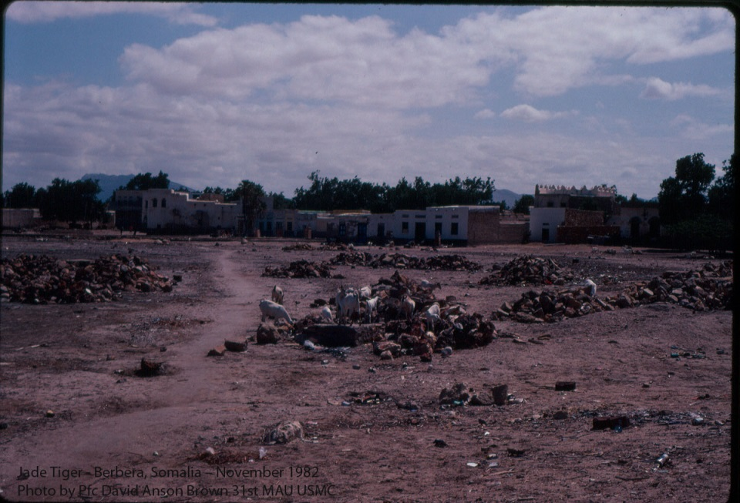

This is the [final part of the] path that the Somali child sprinted to the ambush area. Later in the first day I returned and took this photo of the area (where LCpl Kelton and later Cpl Black had their finest hour). When the Somali ran on the path we knew it wasn't mined [IED] but Kelton suspected they were watching the path so instead of walking on the path we spent about a good 20 minutes low crawling [with our shirts off] from rock pile to rock pile in this garbage dump area. The actual ambush site was up and to the left of this photo and I never did get a photo of the actual site, it was too dangerous [and it turned out that if I had taken a picture of the ambush building my film would have been confiscated back on ship]. I was the last person in our spread out squad column and as we low crawled to the buildings on the left side of the photo I was the last person and to this day I don't know what they saw up there but we all had to get up [put our shirts on] and run a ways and spread out into a street past these buildings. The Marines ahead of me were relaying a message back for me not to come past a certain house and it turned out to be the ambush site, so I stood outside the ambush site trying to count the number of Somalis in the (house) building. [one of my best memories of being a Marine is of running into the street of Somalia, one of the worst was of crawling through that dump to get there] After about 10 minutes the m-boat [1-2] linked up with LCpl Kelton down the street and the Somali ambush house really became tense, quiet and nervous and we were spreading out more and getting nervous ourselves, the other Marines thought I was going to come down and bunch up and yelled for me to stay there but I was only moving a few feet so I wouldn't be a standing target and by my occasional moving just a few feet slowly back and forth in front of house opening the Somalis couldn't easily track how many of us there were even though we were in civilian clothes the Somalis were too busy redirecting their ambush and any movement brought them some confusion. About 10 minutes after [1-1] and [1-2] linked up and it was clear we still didn't have enough Marines on the street m-boat [1-3] Marines with Cpl Black arrived just in time. When the other Marines arrived Somalis started running out of the buildings and onto the street picking up rocks and yelling and by this time the ambush site realized that we had them isolated so Somalis from the ambush site started jumping from the building through a side window and mixed into the crowd (some of the crowd was at first friendly to us but quickly unfriendly Somalis outnumbered the friendly). I had seen three Somalis in the ambush house and by hearing movement thought there were probably five Somalis in the building and I stood there stunned while about fifteen Somalis quickly jumped from the building and mixed into the crowd and departed.
The crowd grew worse and one Somali from the building tried to kill another Somali with a club for getting in his way missing his head but definitely breaking his shoulder blade. Marines from [2-2] stepped in and took away the club and the injured Somali refused medical attention. The crowd of Somalis suddenly quieted and as we looked up off in the distance we could see m-boats landing with our 31st MAU command bringing the America flag and our Marine Corps colors. - In the photo the building on the right-side with the pointed roof was the mosque, that mosque is now domed. - Photo of goats eating in a Somali dump taken by David Anson Brown.

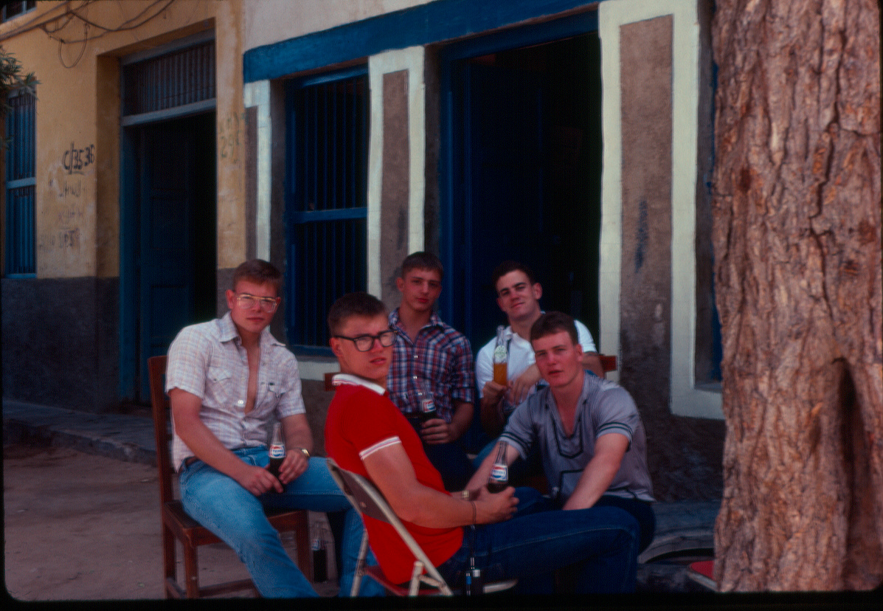

31st MAU the 1st full day at Berbera, Somalia. Marines of m-boat [1-1] after we went ashore (in the wrong location) we went to our assigned area to assess the area and be a presence on the streets when our Marine Command came ashore and Sailors had a shore party. [L-R] LCpl Walton, Pfc Callahan, Pfc Brown, Pfc Schwabach and our leader LCpl Kelton -- The C/35 36 writing on the wall is a building marked by Marine Recon and Navy SEALs who cleared the building.

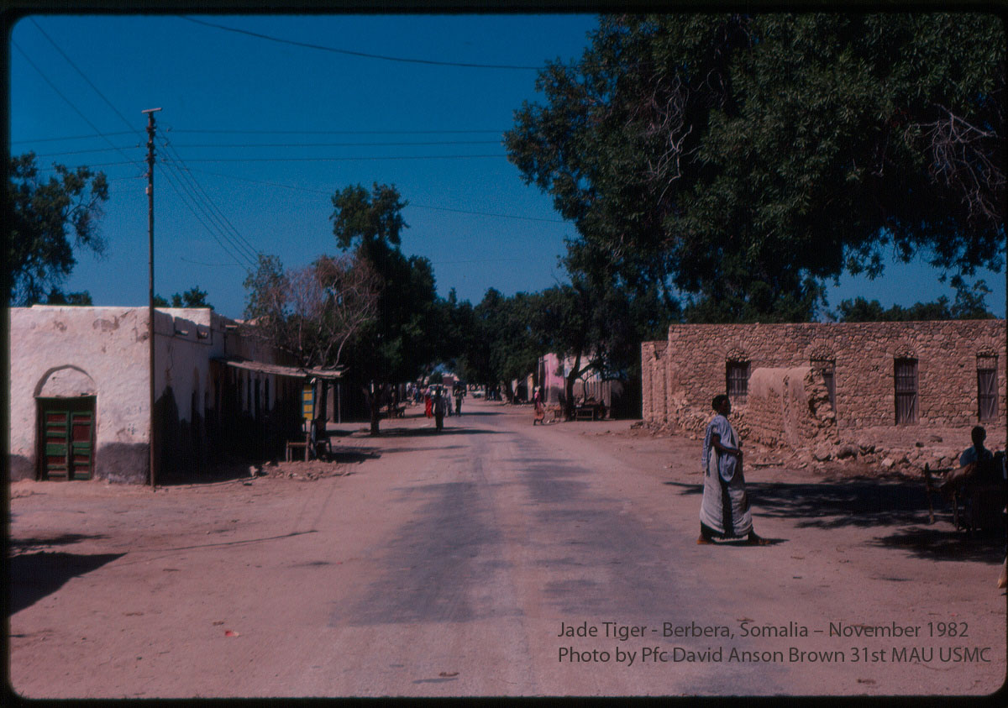

This photo was taken the last day [about day 5] we were in the city/village on my way to the hospital working party. This is the area that m-boat [1-2] moved through and encountered the angry crowd that first day the reason they were late linking up with us. The building on the right in the photo was damaged as were many buildings by previous fighting. The night before we arrived in Somalia there was fighting and a Somali was killed (by another Somali) in the street in this area and there was still blood on the street when we were there. The first day [1-2] had stepped in some blood offending the Somalis and triggering the angry crowd and the riot that delayed them. Later I almost accidently stepped in blood but a Somali woman ran out of her house and started yelling then I looked and saw blood and stepped over it. We [1-1] landed on a beach further north of the city and were late getting to our rendezvous area while [1-2] landed somewhat closer in the south of the village than we did but were later getting to the area because of angry crowds. Had [1-2] gotten to the rendezvous site first they would have certainly had casualties as that was the direction the ambush site was set up to cover. It was a good thing we came in first and from the other direction. Photo by David Anson Brown

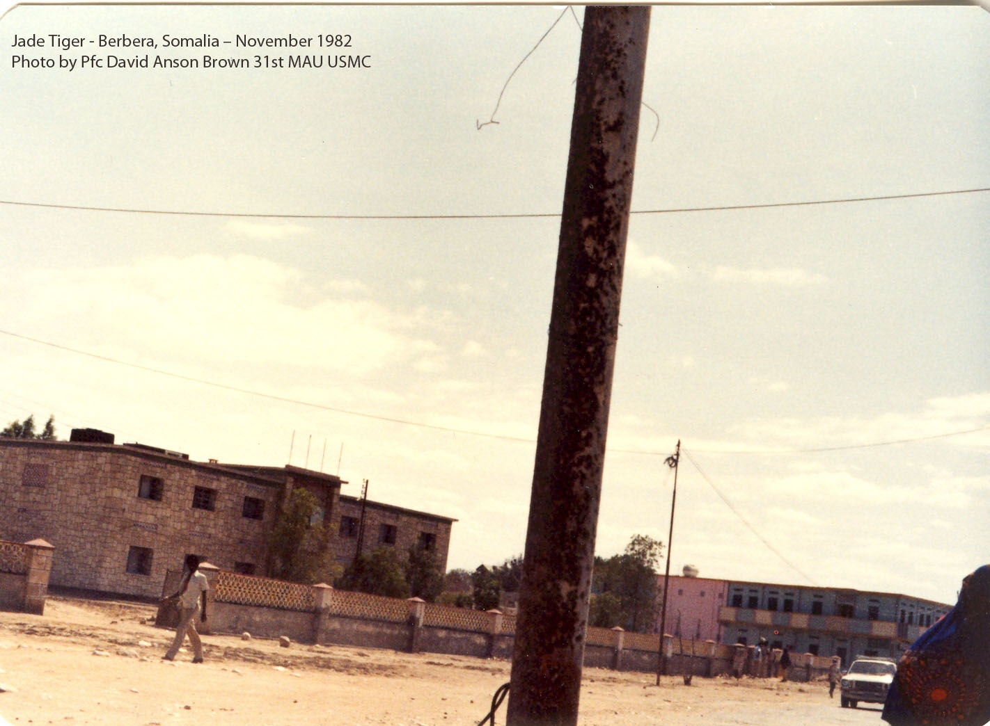

The next day the 31st MAU setup a buffer zone for a few days, outside the city (Operation Jade Tiger) I stayed on ship and did communication duty. On ship I was assigned to communicate with the artillery we had ashore and they were constantly plagued by Somalis in armed (technical) vehicles. The artillery Marine I usually talked to was later killed by a sniper while in a different unit in Beirut. Two of the 31st MAU Marines were wounded by snipers in Beirut after I had left the deployment and returned to Okinawa. - In the photo I was going to the hospital working party. The city of Berbera was under a curfew and the only people out in this area were out to cause problems. In the lower right corner of the photo is a Somali woman who wasn't supposed to be on the street and I had accidently gotten on the wrong end of the street on the way to the hospital. I had duty on ship and left later that day and all of 31st MAU Comm Plt that went ashore was already at the hospital and all the Marines I went ashore with went to a riot so I went to the hospital by myself but I didn't exactly know where it was. I had stopped when I realized I was going the wrong direction. I was standing there looking around for the hospital and trying to not be overly noticed when the well-dressed Somali woman who wasn't supposed to be out, she was trying to avoid the other Somalis and was mostly looking at the ground in front of her and didn't see me and almost walked into me. As she pretty much bumped into me then startled she turned and quickly headed back the other direction getting away as fast and as far as she could from me hoping no one would think she had been talking to me. Meanwhile there was a huge rock throwing riot taking place a few blocks to the left that these Somalis were watching from a distance. I thought it was funny when we sort of bumped into each other and I quickly tried to take a picture of her walking away. She left so fast I didn't think there was a chance she was in the picture and when my film was developed I was surprised to see her in the corner of the picture. I finally made it to the hospital that was way down this street to the left. The worst part was crossing the street to get to the hospital. Photo by David Anson Brown

HQ Company 31st MAU on route to Western Australia about October 10th 1982
Pfc David A. Brown back row center

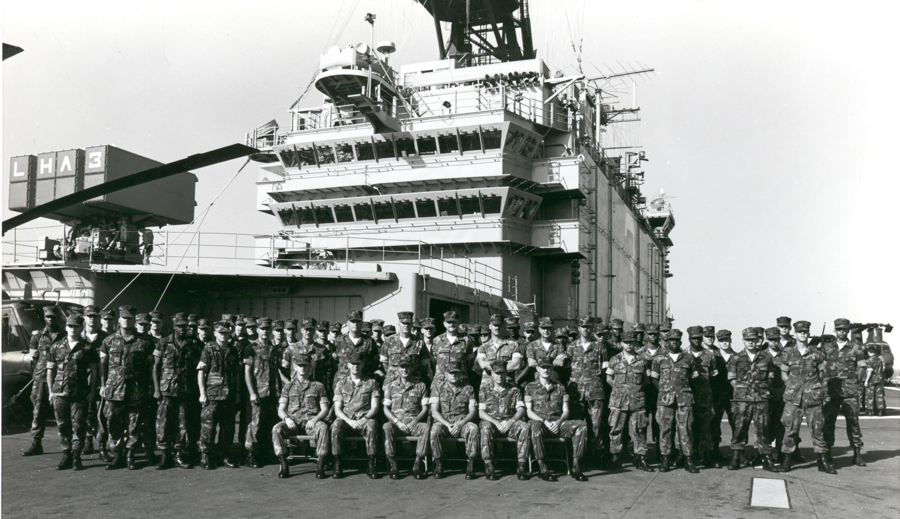

Somalia Final: prior to the photo [of us drinking Pepsi] the three advanced party landing craft my [1-1], the
[1-2] and [1-3] had all gone ashore separately and we had all linked up. After linking up and about the time of treating an injured Somali the Marines from m-boat [1-2] told us that they had also encountered a downed electrical wire that had previously fatally injured a Somali child. After the MAU Command staff came ashore we talked to them briefly. The [1-1] and [1-3] m-boats were both HQ Comm Plt Marines while [1-2] I think were Combat Engineer Marines. Being from the same Plt [1-1], and [1-3] stayed together and walked down a street and up a hill towards an area that [1-2] had already been. We came to a small area where some Somali children were playing soccer and as we walked up there we could see that there was an electrical wire on the ground that they were trying not to step on. I mistakenly started to reach and pick up the wire to move it and the Somali children looked very surprised and all the Marines shouted don’t touch the wire it was the live electrical wire that [1-2] told us about that was causing serious problems.

After the downed wire m-boat [1-1] went back more towards our original area and the beach area fairly close to where more Marines and a bunch of Sailors were coming ashore. We were sitting taking our first break when a newly arrived Marine also from our Plt came by and briefly talked to us and took the photo. I was a little shaken not that we were encountering hostility but by the sheer amount and intensity of it. I had expected some problems but it was very widespread and very intense and I was a still a little upset with myself for almost grabbing that downed wire, you just couldn’t make any mistakes over there every misstep caused problems and was potentially deadly.

After this photo Pfc Callahan and myself volunteered to do road guard duty and for the rest of that day, the next day and part of the day after that did volunteer road guard duty on an extremely busy Somali road and it is what I consider to be my finest hour in Somalia.

The deployment command had decided on sending all the Marines and Sailors ashore for a series of four beach parties lasting over four days. The first two days were assigned to groups of Sailors from all three ships and the last two days were assigned to groups of Marines from all three ships. The road that Callahan, myself, some other Marines, a few Sailors and even some special forces guarded was a dirt road that separated the Sailors at the beach party from the Somalis of the village and the city.

It was almost like a 4th of July crowd on the road and at the beach back in the USA except the beach was crowded with Sailors and the road was crowded with Somalis. The beach parties were the two beer and food parties that the military so often has overseas. The Somalis were coming out in droves to see the Americans but they weren’t allowed to be there. Many of the groups of Somalis were elderly with young children who were curious about Americans but also wanted to know what was happening on their beach. Other groups of Somalis didn’t want us there at all.

We spent the days keeping foot traffic moving along the road and keeping the groups separate though there wasn’t much interaction between the groups but what was a continual problem was that Somalis would stop for various reasons, most, especially the elderly and the children were being friendly but then as soon as a group formed and wherever a group formed other Somalis would quickly come to the group and cause problems and it was becoming very dangerous especially for the elderly and the children who only wanted to be friendly. Then the elderly in particular and even the children were soon offended because they had to move along with everyone else on the road. The entire situation became heated and extremely volatile especially the first day to the point that a special forces member [I think Delta Force though he didn’t say he only smiled when I asked] came over and offered advise [i.e. get these people unbunched and down the road for everyone’s safety – he also said the Somalis had a weapon in every window] and there was some consideration of canceling the parties. But as he was coming over we were able to talk to the elderly Somalis and thank them for letting us use their beach and come to their city and the elderly Somalis saw the angry groups and knew it was best to not stay. We did the road guard duty, armed only with a nightstick for the two days of the Sailor beach parties then we stopped by for the first day Marine beach party but they obviously didn’t need us. Then we were part of the last (4th) group to have our beach party though our beach party was moved further down the beach to a different and better location, a better beach with better swimming and we had a great beach party as did all the groups. We were already scheduled to go to Oman after Somalia so the Mau Command really made an effort to get everyone ashore and have a good time and they really succeeded.

We were so successful in doing our road guard duties that Pfc Callahan and myself were recommended for a commendation. When the MAU arrived at Somalia we received a message that the Navy was awarding the Sailors an Expeditionary medal and a Meritorious Unit ribbon and that the awards were to be recommended to the Marines as well. With Beirut in progress and the Marines in Beirut having not yet received any medals our medals put on hold and have not yet been issued.

After our [HQ 31st MAU and 2nd Bn 3rd Marines] raucous beach party, the Navy threatened to leave us out all night, they were already mad at us because on the way to Somalia we were overrunning their mid-rats every night and having our own late night social hour in their cafeteria on their time and with their food. We returned late that day to the ship sunburned and tired. The next and last day in the city we had the hospital working party. There was actually work going on in the hospital for several days but this last day was a big volunteer cleanup day.

The hospital was a big success but it was almost a complete disaster as well it was the only time in my Marine Corps service that I would see Marines somewhat panic and run. The events of every day kept taking a toll and by the time of the hospital cleanup everyone was frayed. Inside the hospital Marines were bending down as they walked past windows hoping not to be seen by Somalis outside the hospital. There was a huge rock throwing riot sort of in the area, that everyone was concerned would end up at the hospital. Each day in Somalia was getting worse with the first and last days the worst and the last quickly becoming potentially catastrophic. When we were leaving the hospital it for a short time it looked like the Fall of Saigon and briefly it was everyone for themselves. Some trucks and vehicles arrived outside the hospital and since I was late to the hospital I didn’t know who they were for so I went over and asked the lead driver who the trucks were for and he said only for certain people and grabbed his rifle to make his point more clear.

Clp Black again did an amazing job and formed up Comm Plt and took it back to the harbor marina and back to the ship. I was still trying to get a picture of our first day ambush site so I didn’t go back to the ship with Comm Plt. The riot was in our view and was moving from street to street, I saw where it was and went where I thought I could avoid it and go take a photo but the riot had shifted and I ended up walking right into it, though I was going to go there after taking a photo I never did get the photo. I was talking to the (0311) Marines at the riot about the hospital (they were sure we were all dead and were surprised we made it out) while I was trying unsuccessfully not to get hit by any rocks. I got hit by several rocks at one time a couple of big hits in the back and upper back shoulder.

Leaving the riot area I and two other Marines went to the harbor marina were lookout Marines were crouched down watching while the Marines at the harbor were waiting to be overrun by what amounted to a Blackhawk Down type of crowd of armed angry Somalis that was forming back in the buildings. When I walked past the two Marines (crouched down) doing road guard they stood up and also came into to the harbor. There was a SSgt talking to a Somali and I went up to the SSgt to tell him that we didn’t have any road guards out. While I was waiting to talk to the SSgt the Somali a Warlord was talking to the SSgt and issuing threats and violence about our being there and mostly about us (USA) not giving his clan enough material possessions. The more the Warlord talked the more enraged he became especially after the SSgt told him that he had gotten everything the USA was going to give him. The Warlord tried to threaten and intimidate the SSgt but then quickly realized that it was a bad idea because the SSgt wasn’t going to back down and I was there and other Marines were coming over all standing shoulder to shoulder with the SSgt. The Somali Warlord said “you are dead”, “you don’t it, get we hate you” and walked off promising to bring his clan from among the buildings and that it would be his greatest moment to kill us all. Twice we could see an armed mob that had formed between buildings in the distance. While we were standing there we would look out at the ocean looking for our m-boat to arrive and then look out at the buildings looking for the crowd of Somalis to arrive and wondering who was going to get there first. It was so bad and in the extreme heat and dust that the buildings actually began to look like they were moving and closing in on us and other Marines were saying it looks like the buildings are moving in on us. It was a lot like the first day when we were waiting for m-boat [1-3] to arrive in time and wondering if they would make it. Like the first day an m-boat left the USS Belleau Wood (LHA-3) and came to pick us up. The Marines still at the riot saw the m-boat coming in and all hurried over to get on it.

When we got on the m-boat to leave the m-boat wouldn’t depart because they weren’t sure they had everyone and they were running on a schedule. When we were all aboard we had three Marines that were high ranking two GySgts or higher and a SSgt on our m-boat and they told the Sailors to take the m-boat back to the ship.

Finally the m-boat departed the marina from my last trip ashore in Somalia. Also aboard the m-boat was a Sgt from my Comm Plt who was at the riots and he had come over during the riot to check on me when I was hit with rocks, several Marines had stepped in and really saved me. The Sgt and I were on different ends of the m-boat, I was in the front by the ramp door and he was towards the back. As the m-boat was slowly pulling away from Somalia I wanted to make sure he knew I was on the m-boat because everyone boarded so quickly so I was going to go back and talk to him. This is funny, just then the Marines around me were looking back and forth between the shore and the ship and the m-boat was moving slowly we were barely getting away from Somalia and one of the Marines said I can’t wait I have to go to the bathroom. I said just climb up and go over the side and he rightly said no way we are still in range and I’m not going to get shot just to take a piss so he started to pee in the bottom of the m-boat. Then all the Marines up front said that’s a great idea and everyone started to use the m-boat as a bathroom. I decided it was a good time to go talk to the Sgt and when I got to his part of the boat he saw movement up front and said “what’s going on up there” and I told him everyone is going to the bathroom and he said “oh, good idea” and he and other Marines rushed up there to go to the bathroom. So we were finally leaving Somalia but it was in an m-boat that had become a toilet. I thought it was fitting after having to crawl through the village dump the first day to now leave like that. When we got back to the ship a Sailor was about to board the m-boat and I put my arm across so he couldn’t board and he said “don’t you try to tell me I can’t board our boat” I said watch the bottom it’s a sewer and he said “we expect nothing less from you Marines” and grabbed a hose and hosed it off after we left and before he got in.

We spent the next several days conducting a buffer zone outside the city. I stayed on ship and did radio duty feeling the effects of two large bruises on my back, I didn’t tell our officers about getting hit and later when we were in the Philippines I came back to the ship [from a work day liberty that I had] after a bus ride into the country where there was some fighting on the hills taking place at one point on both sides of the road. Back on ship in the Philippines that day I was immediately told to go on the deck and see one of our officers and when I saw him he said glad you are back now hold your hands out, then he had me do a few movements I thought it was a sobriety check and I told him I didn’t drink and he said it’s not a sobriety check its making sure you are ok after what happened in Somalia and I was fine.

When our ship finally left Somalia it was like our ship became the Princess Cruise ship and was headed to the Caribbean or the Bahamas for a vacation everyone was so happy, so much so that the Captain of the ship made and 1MC announcement to the whole ship telling everyone to maintain our military discipline and bearing and then reminded us that we were headed to the Middle-East.

Years later when I heard about President Clinton sending Marines back to Somalia my parents asked me how I thought it would go and I told them it could only end badly. Then when I heard about the Black Hawk Down incident in Mogadishu on the news and talking to some citizens who had closely followed the news I was surprised and amazed that anyone lived through it. It’s a real credit to the solders that went through that ordeal that some of them made it out. Where I was in Somalia the Somalis were obsessed with a massacre of Americans it was the one word we heard the most often from Somalis. I have talked to a few Marines that served in Somalia after my time and it has always been a pleasure to meet such outstand Marines. To the Marines and Sailors that I am proud to have served with in Somalia and elsewhere they will always be in my fondest memories, occupying my greatest respect. ~ David Anson Brown

LCpl David A. Brown USMC at Moon Beach Okinawa, May 1983

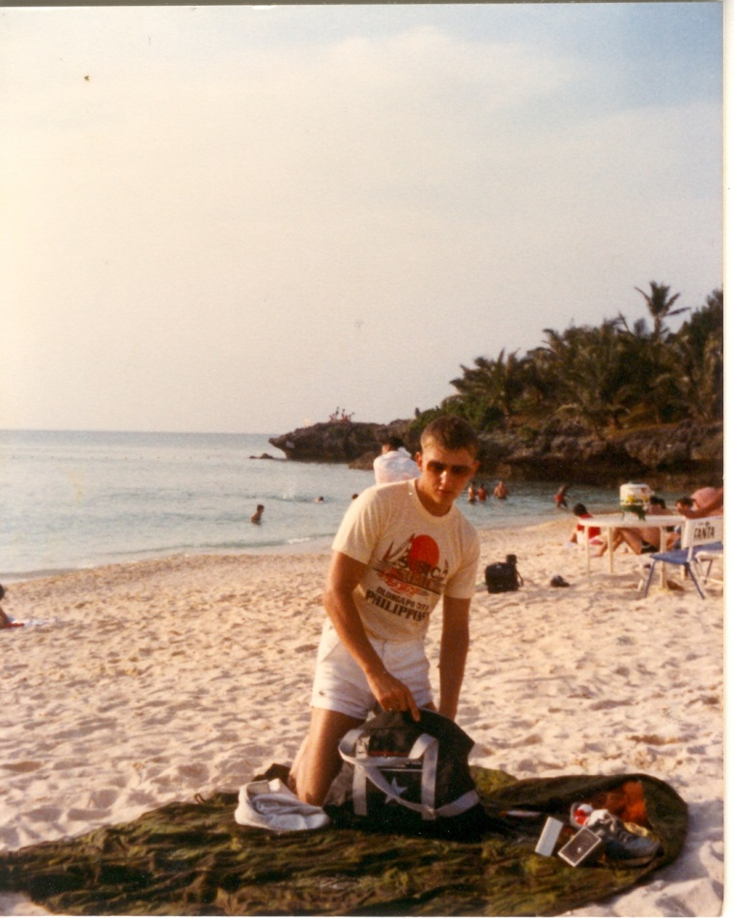

Facebook posting 2/6/2016

This was after returning to Okinawa and the 7th Comm Bn, 3rd Marine Division from the 31st MAU, 3rd Marine Division in the Philippines. At first when I returned I had orders to report to the 2nd Marine Division at Camp Lejeune, NC that were changed before I left [all west coast rotating Okinawa Marines went to Pendleton] and my new orders were to report to the 1st Marine Division at Camp Pendleton, CA. I left Okinawa within a few days of this photo. After some leave at home in June 1983 I reported to the 1st Bn, 9th Marines at Camp Horno, Camp Pendleton, CA. - This is the last of my military postings. Thanks for the support and your patience.

Exercise Golden Lion [aka Exercise Jade Tiger] – Wahabi Sands, Oman December 1982

31st MAU Oman
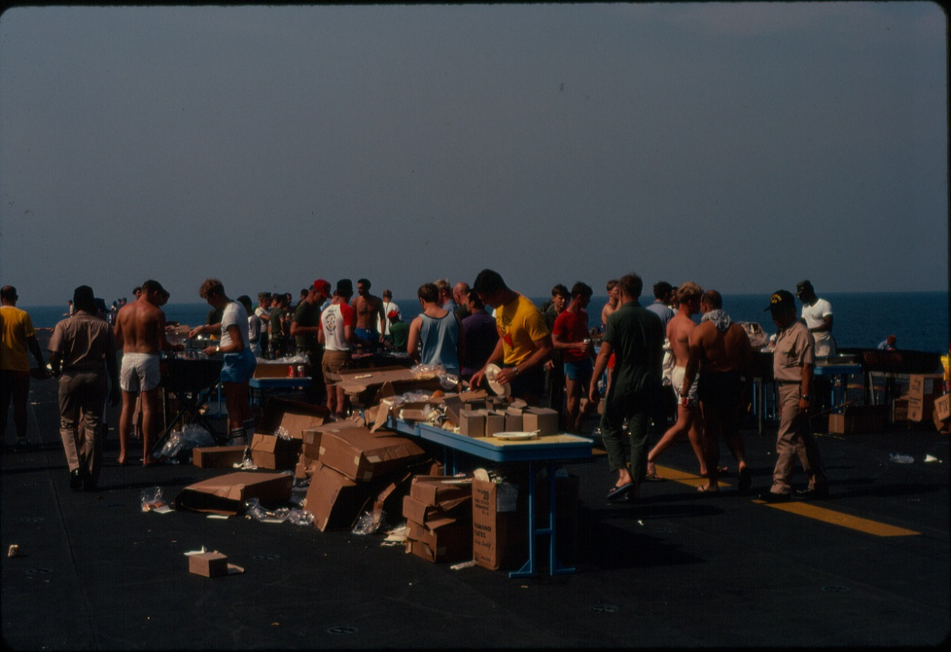
Steel Beach Party in the Arabian Sea near the coast of Oman the 31st MAU, USS Belleau Wood (LHA-3).
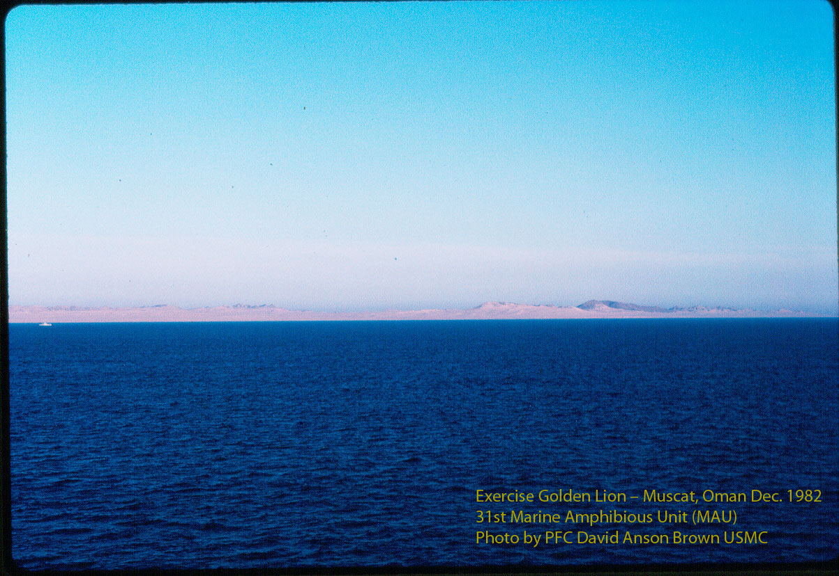
Exercise Golden Lion [aka Jade Tiger] was a two aircraft carrier group [USS Enterprise (CVN-65) and the USS Coral Sea (CV-43)]
Show of Force off the coast of Oman with a 31st MAU beach landing at Wahabi Sands, Oman in December 1982.
PFC David Anson Brown of 31st MAU (with the other shipside communication members) remained on ship for communications duty.
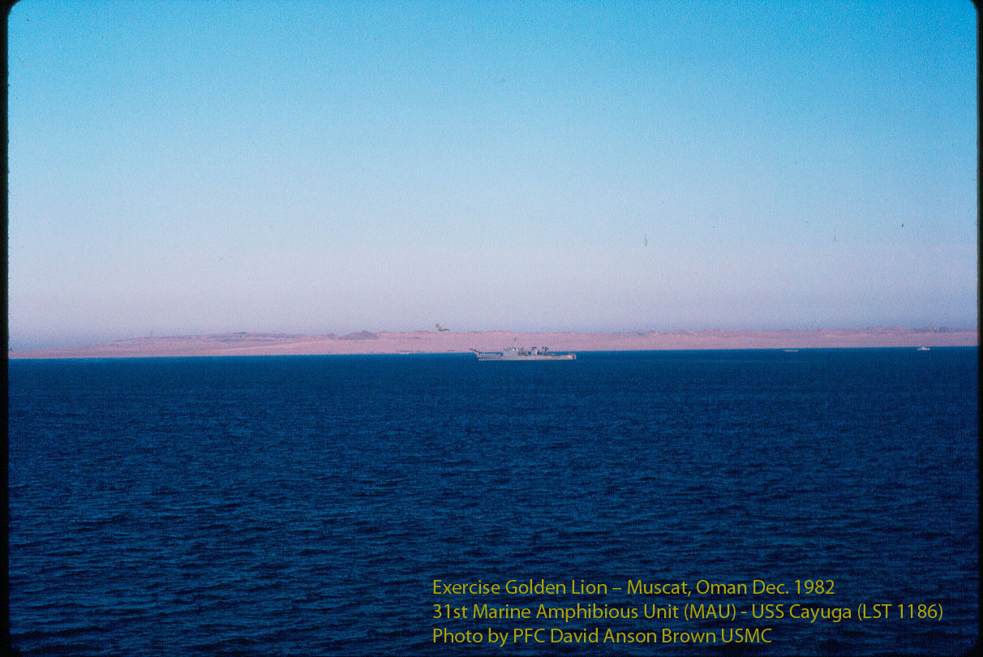
31st Marine Amphibious Unit (MAU) – Task Force B for the aircraft carrier group USS Enterprise (CVN-65)
Note: for us Jade Tiger was done in Somalia and we went to do Golden Lion in Oman but the Golden Lion name was mostly dropped and other ships went off of what we thought was a completed Jade Tiger (today both are usually called Jade Tiger) – we did have various communication, encryption and compromise problems that resulted in a shortening of the Golden Lion Exercise.
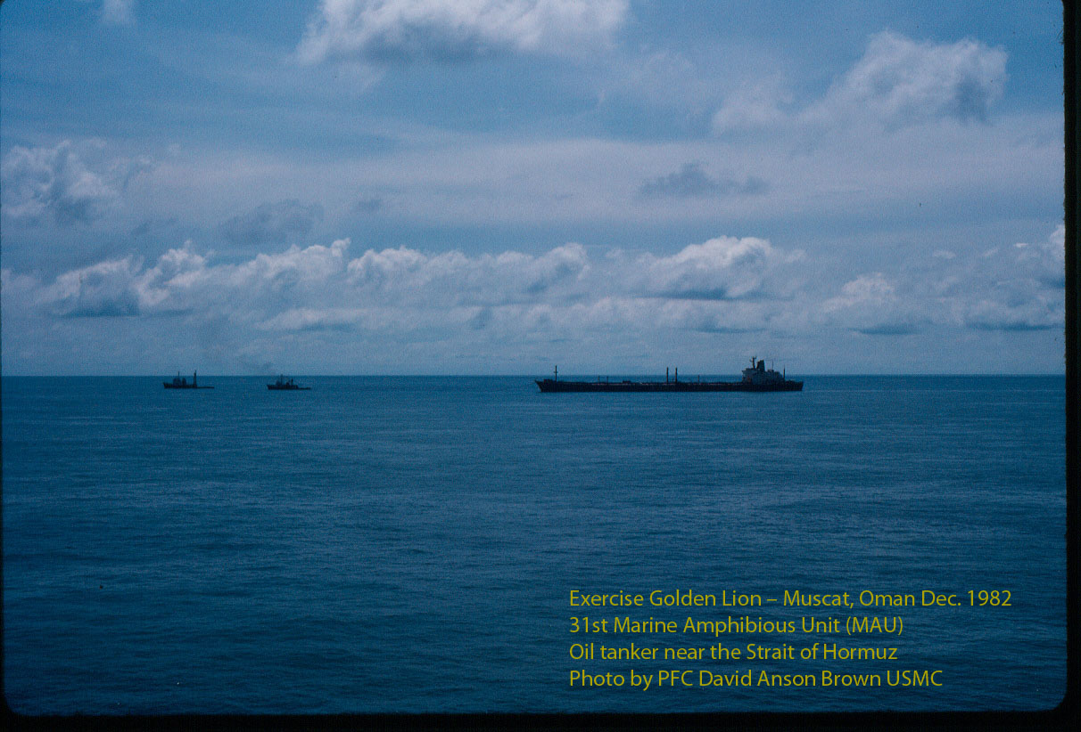
The Arabian Sea near the Strait of Hormuz, an assisted oil tanker has successfully navigated the Straight and was part of a long line of tankers coming from the Persian Gulf.
Photo taken from the USS Belleau Wood (LHA 3) by PFC David A. Brown of the 31st MAU USMC.
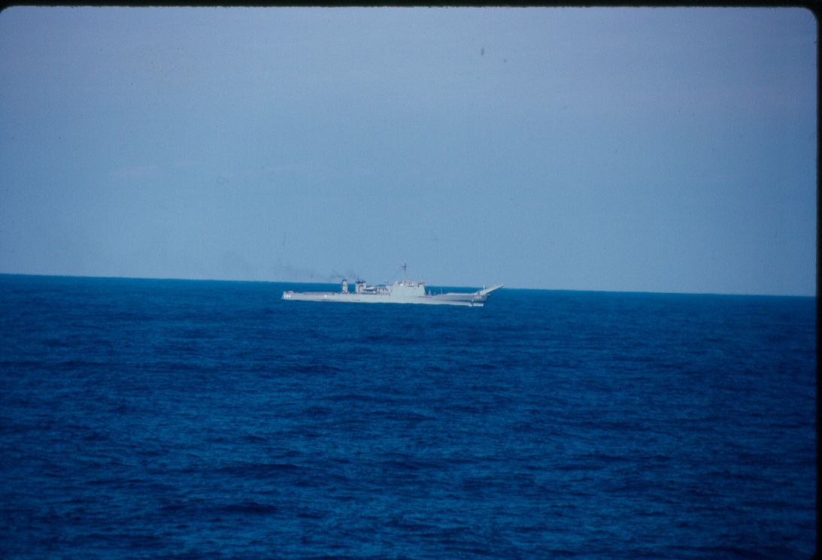
The Arabian Sea near the Strait of Hormuz the USS Cayuga (LST-1186) proceeding to the Persian Gulf.
The USS Belleau Wood (LHA-3) remained near the Strait of Hormuz and conducted surveillance off the coast of Iran during a battle in the Iran/Iraq war. Surveillance was also conducted in the Philippines in Dec. 31, 1982 until Jan. 21, 1983 during NPA battles in Luzon, Philippines.
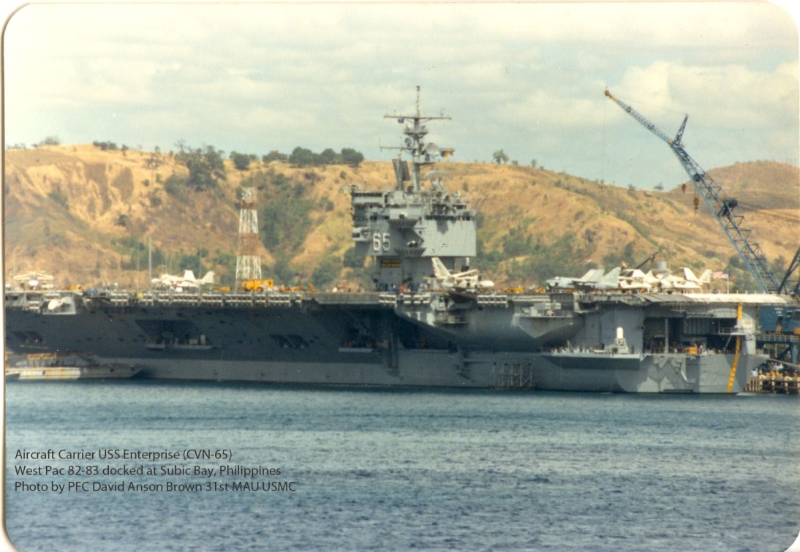
31st Marine Amphibious Unit (MAU) – Task Force B for the aircraft carrier group USS Enterprise (CVN-65)
The aircraft carrier USS Enterprise (CVN-65)
West Pac 82-83 docked at Subic Bay, Philippines
Photo by PFC David Anson Brown USMC

Wahiba Sands, Oman

U.S.S. CAYUGA (LST-1186) Deployments - Major Events
(WestPac 82-83) AUG 1982 - FEB 1983
(Location:) West Pac-Indian Ocean-Persian Gulf (Strait of Hormuz - Iran)
http://www.hullnumber.com/LST-1186

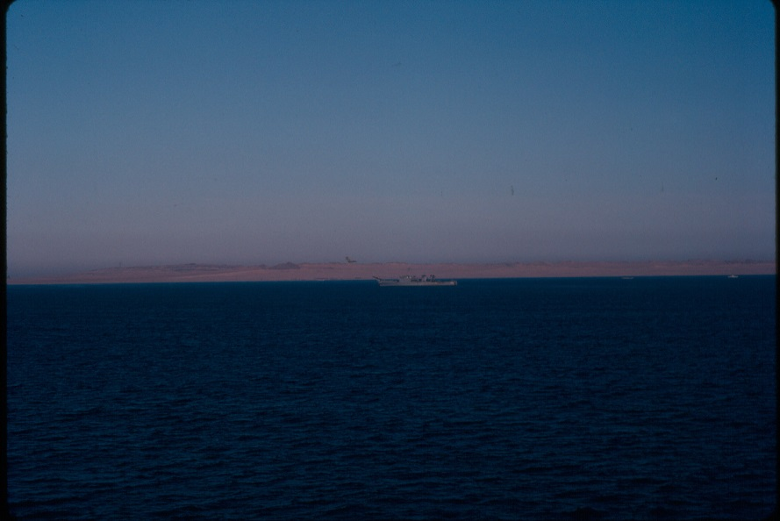
31st MAU December 1982 photos of the Wahiba Sands, Oman area USS Cayuga (LST-1186) from the USS Belleau Wood (LHA-3). Photos by Pfc David Anson Brown HQ Co Comm Plt 31st MAU

1982
-
DEC
1982
Inchon Landing (*the actual landing was in Wahiba Sands, Oman in Dec. 1982)

http://www.hullnumber.com/LST-1186

"As Central Command grew so to did the Marine Corps' involvement. In 1982 (Dec.), the RDJTF conducted a major amphibious exercise when 31st MAU landed more than 1,000 Marines in Whaibah Sands, Oman as part of Exercise Jade Tiger (originally Exercise Golden Lion)."

Source: Fortitudine Vol 29 No 4 page #11
http://issuu.com/davidansonb.../docs/fortitudine_vol_29_no_4

31st MAU December 1982 photos of the Wahiba Sands, Oman from the USS Belleau Wood (LHA-3)

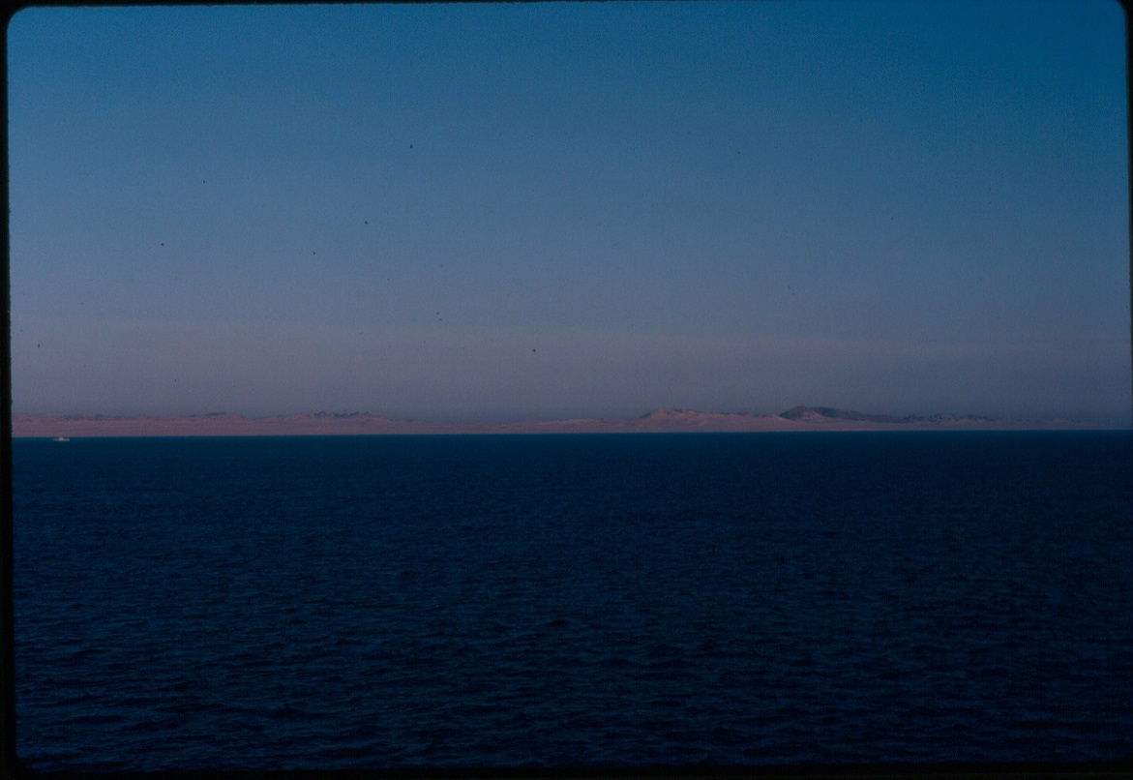

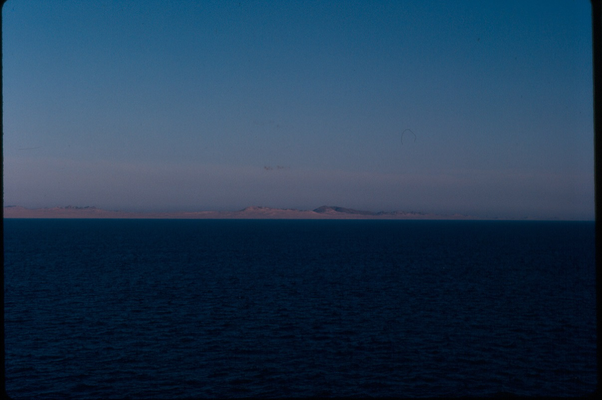

Photos by Pfc David Anson Brown HQ Co Comm Plt 31st MAU

"As Central Command grew so to did the Marine Corps' involvement. In 1982 (Dec.), the RDJTF conducted a major amphibious exercise when 31st MAU landed more than 1,000 Marines in Whaibah Sands, Oman as part of Exercise Jade Tiger (Golden Lion)."

Source: Fortitudine Vol 29 No 4 page #11
http://issuu.com/davidansonb.../docs/fortitudine_vol_29_no_4
North Arabian Sea, Strait of Hormuz
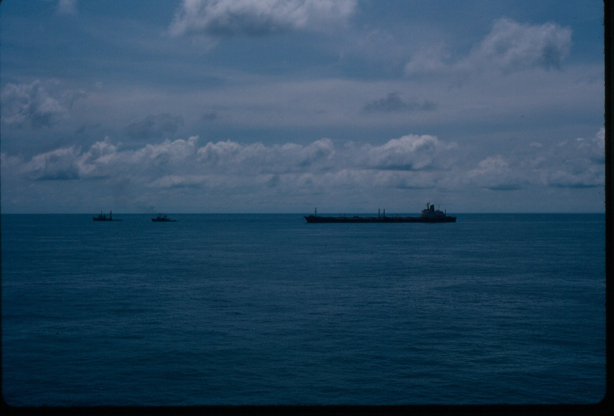
31st MAU December 1982 North Arabian Sea, Strait of Hormuz area from the USS Belleau Wood (LHA-3).
Photo by Pfc David Anson Brown 31st MAU, HQ Co, Comm Plt.
An oil tanker having just transited the Strait of Hormuz from the Persian Gulf into the Arabian Sea/Indian Ocean. During the Iran and Iraq Oil Tanker War the oil tankers and large ships had to be guided by tugboats through the Strait of Hormuz. Both Iran and Iraq were trying to sink tankers and large ships to block the Strait of Hormuz. After exiting the Strait of Hormuz the tugboats would unhook from the oil tankers and the ships would go on their way. Oil tankers came through the Strait of Hormuz lined up like busses leaving a bus station.

The couple of pictures (slides) that I took at the Strait of Hormuz were the last of my photos from the area. After I took this photo and was walking on the deck back to our berthing area there was a loudspeaker announcement that no more photos were allowed and all of our cameras had to be secured. We were mostly in "general quarters" not battles stations but we had to remain in our assigned areas this lasted until we were on our way to Singapore.

The entire Westpac 82-83 was being recorded on security cameras that were running 24/7 not just during events so taking photos on that deployment at first wasn't such a big deal. When I went ashore with my camera in Somalia the next day some of the MAU Staff questioned me and made sure I didn't take any photos of anything operational, something we were already told not to do. Actually I never felt that it was my part to take "nightly news" type of photos and only took generic photos and I still think that was the appropriate way to handle the situation.

After taking my photos at the Strait of Hormuz and the announcement about no cameras I think there was some discussion between the Navy and our MAU Staff and Officers. Our 31st MAU and Comm Plt were short a few staff personal, we didn't have a SGT Major and several of our officers left the deployment after Australia including our amazing 1st Lt from Comm Plt.

When we arrived in Okinawa from 29 Palms radio communications school several of us bought cameras and I bought a 35mm Minolta camera that I took along with a regular instamatic camera on the MAU deployments. I was using Kodak ektachrome slide film in the Minolta camera plus the iso setting was off and many of the photos are darker. It turned out when we got back to the Philippines that I couldn't develop the Kodak slide film in the Philippines or it would just take too long to get them back so my slides weren't developed while we were on the deployment.

After the 31st MAU HQ Company cross-decked to the USS New Orleans (LPH-11) for WestPac 83 the topic came up with the senior MAU Staff about my photos from Westpac 82-83 and they thought it was a good idea that I had taken the photos and wanted me to get them publically published somehow (i.e. at my next duty station or later at college) we didn't know then that I couldn't even get them developed. When I was doing my checkout paperwork to depart 31st MAU from the Philippines and return to the 7th Comm Bn in Okinawa I was told that I couldn't complete my checkout until I showed that I had the film canisters from WestPac 82-83 in a carry bag on my person because it turned out that if I were to send the film through an airport x-ray machine it could damage the undeveloped film that I had. So I carried the film in a bag through each airport until I got to Okinawa and had it developed and still carried it in a bag through the airports on my way back to the states. After all the hassle with the Minolta camera the darker photos and the undeveloped film I left the Minolta camera at my parent’s house before reporting to Camp Pendleton and going on my second deployment with the 1st Battalion 9th Marines.

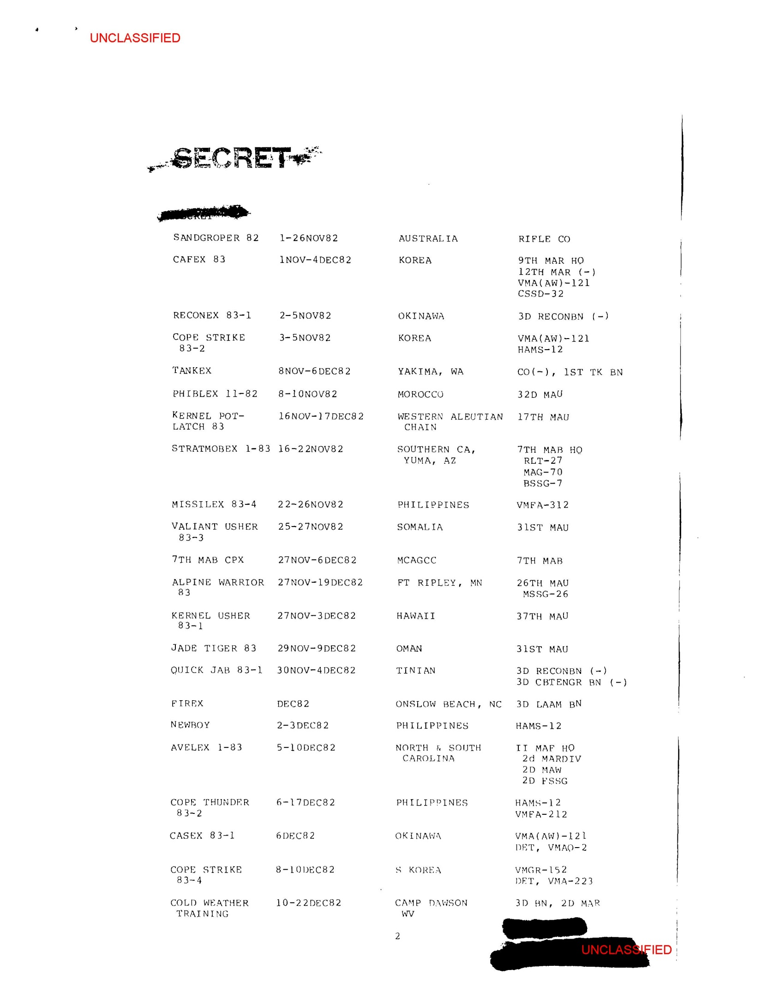

Shipboard Fire on the LHA-3

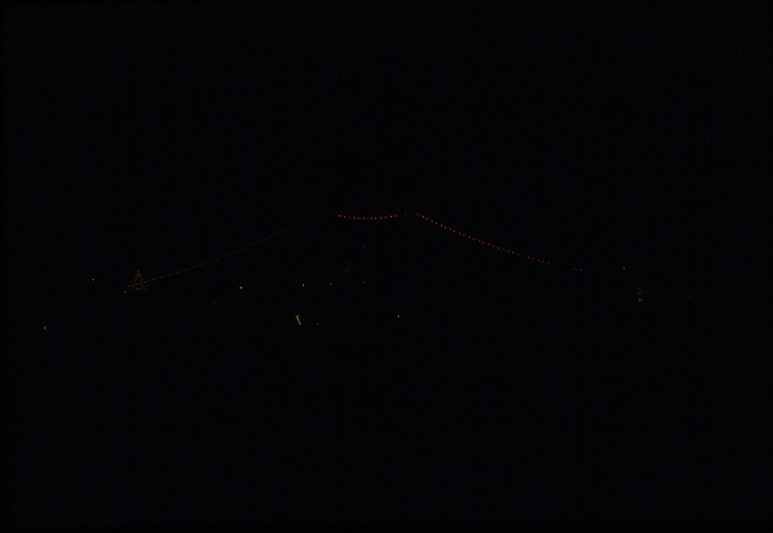
USS Belleau Wood (LHA-3) January 1983 in Hong Kong Harbor photo by David Anson Brown
Note: the LHA-3 deck light configuration is the same (without the colored friendship lights) that the ship used while in the Northern Arabian Sea.
While we were off the coast of Iran in December 1982, in the Arabian Sea near the Strait of Hormuz the USS Belleau Wood (LHA-3) suffered one of the larger shipboard fires in modern history. The heat and smoke were so intense that the fire teams were two rooms away fighting smoke and heat before they could even get to the fire.
We were called [or about to be called] to the flight deck of the ship for possible abandon ship procedures that were underway but most of us, me included were slow to go up there because it was night and we didn't want go up there and fall overboard especially if the ship exploded or shifted somehow.
When the ship's control started the abandon ship procedures that night they were calling off compartment numbers over the intercom and those compartments were to begin evacuating and going topside but we didn't know what compartment number we were in. I remember we were checking the walls of our berthing area looking for some kind of number markings on something. We didn't want to go up on deck if we weren't called but also mostly we didn't want to go up on the deck at night I know I really didn't want to and then after a while they told everyone to stay in their berthing area or work area.

I went down to the mess deck about 5:30 am that next morning as soon as I could get down there with the plausible excuse of going to the chow hall and they were using the chow hall for a staging area for the fire crews and smoke was still coming out. When I went in there they said "no way you are here looking for coffee or breakfast" and I said I was checking out the fire. After a quick look around and a few other Marines were showing up they sent us back to the berthing areas and made a 1MC announcement that the chow hall was closed for the day [opened about noon] and no one was allowed to go to the fire area.
They brought me over to the area for a quick look before I left. Someone had said if he came down to see the fire let him see it. Then some of the photos were posted and I remember it being some of what I had seen. Though definitely it was not a good plan for me to go down there, though the fire crews were glad that Marines were concerned about the situation.
The Sailor mostly in charge of the fire crews at the time I was there I think received an achievement medal for his part in overseeing the fire damage control team.

Note: there are photos of the fire damage and if I can locate any photos I’ll add them.

Arrival in Singapore "The Garden City" December 1982 – Christmas

31st MAU Singapore
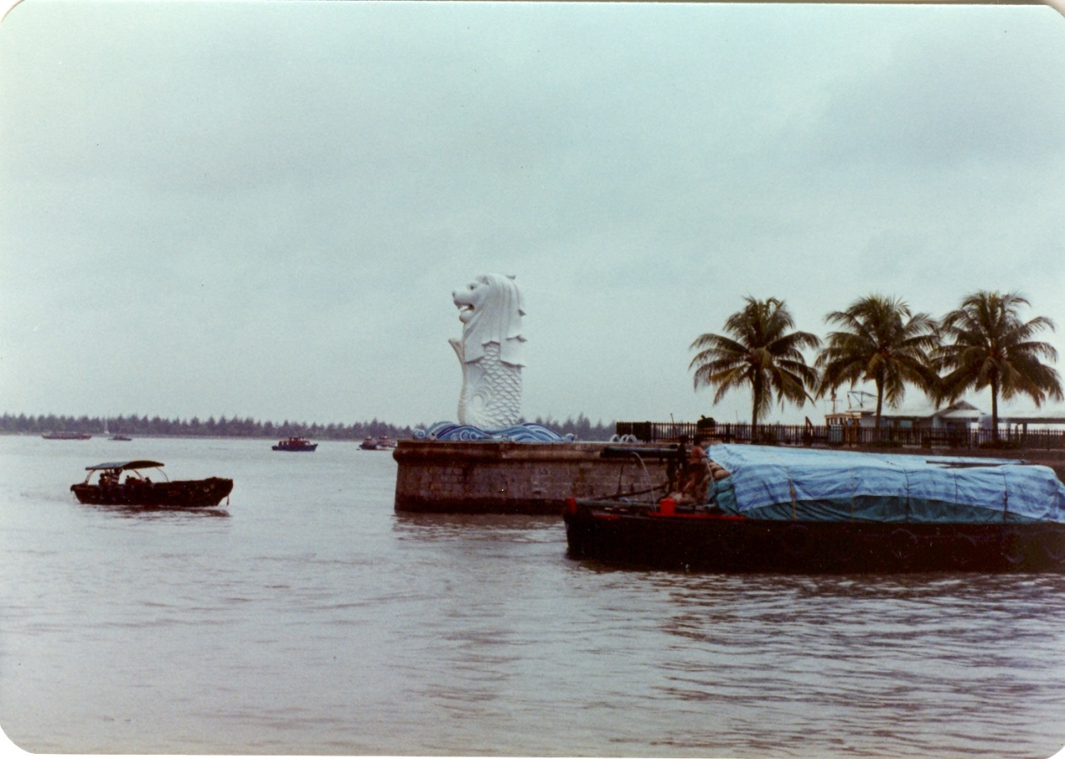

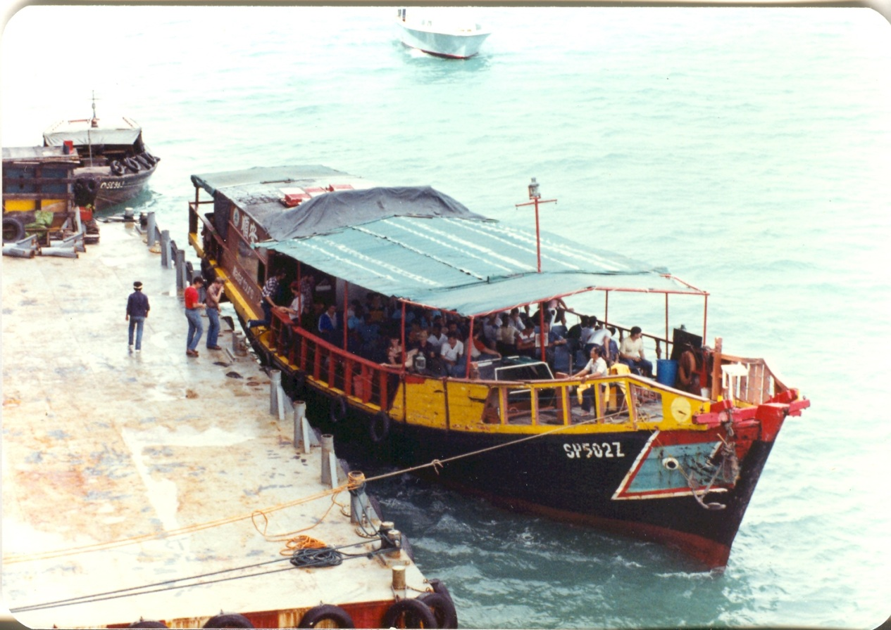
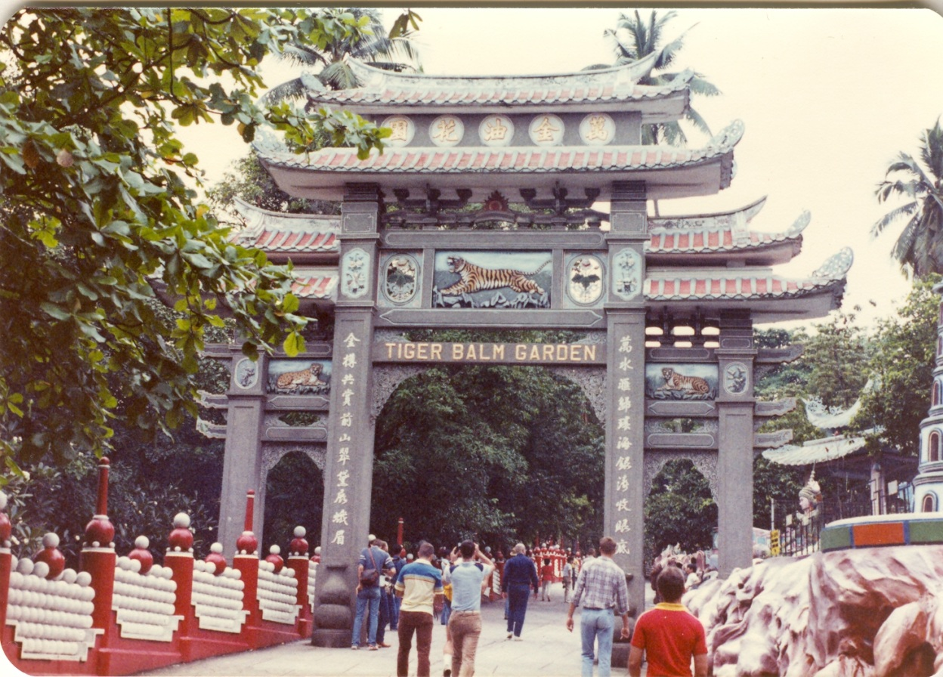
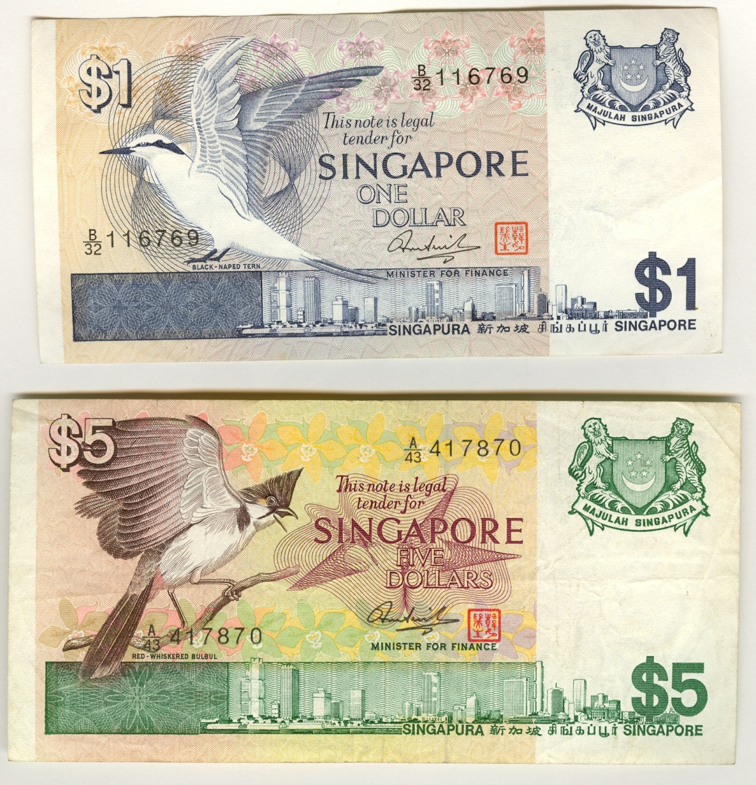

Singapore Botanic Gardens
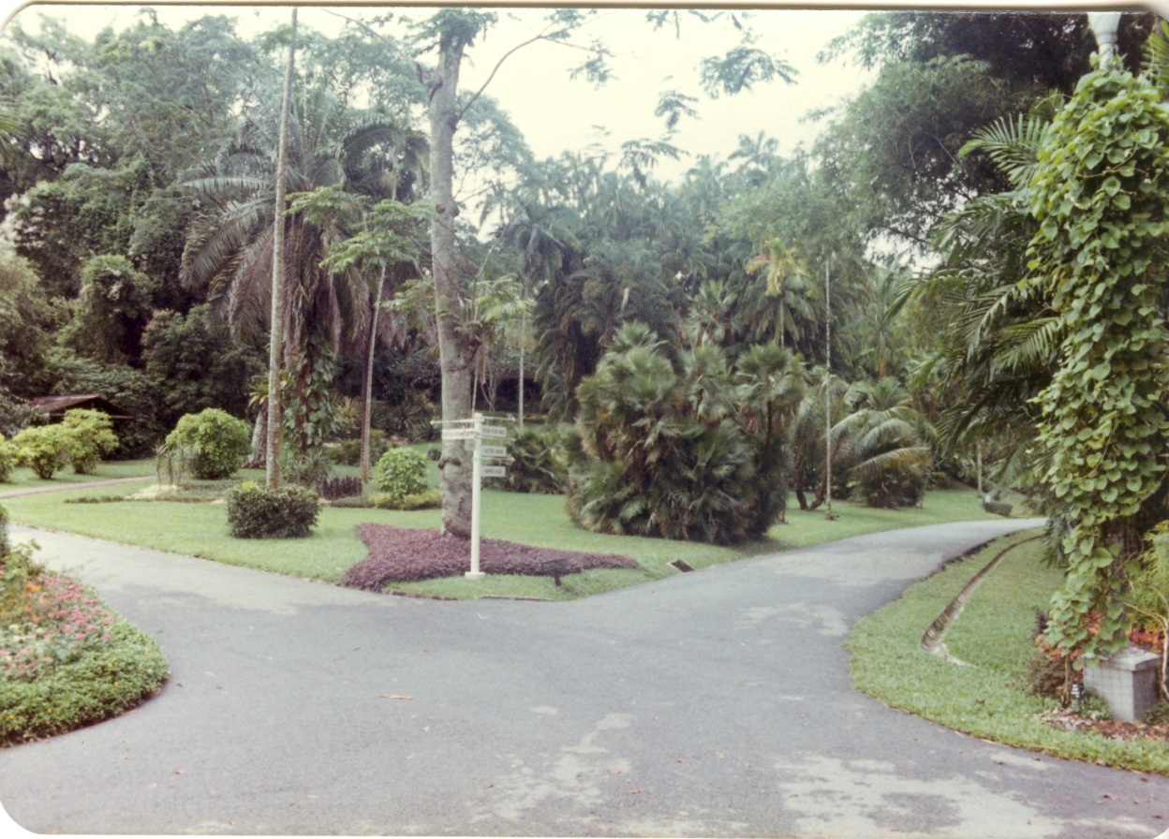
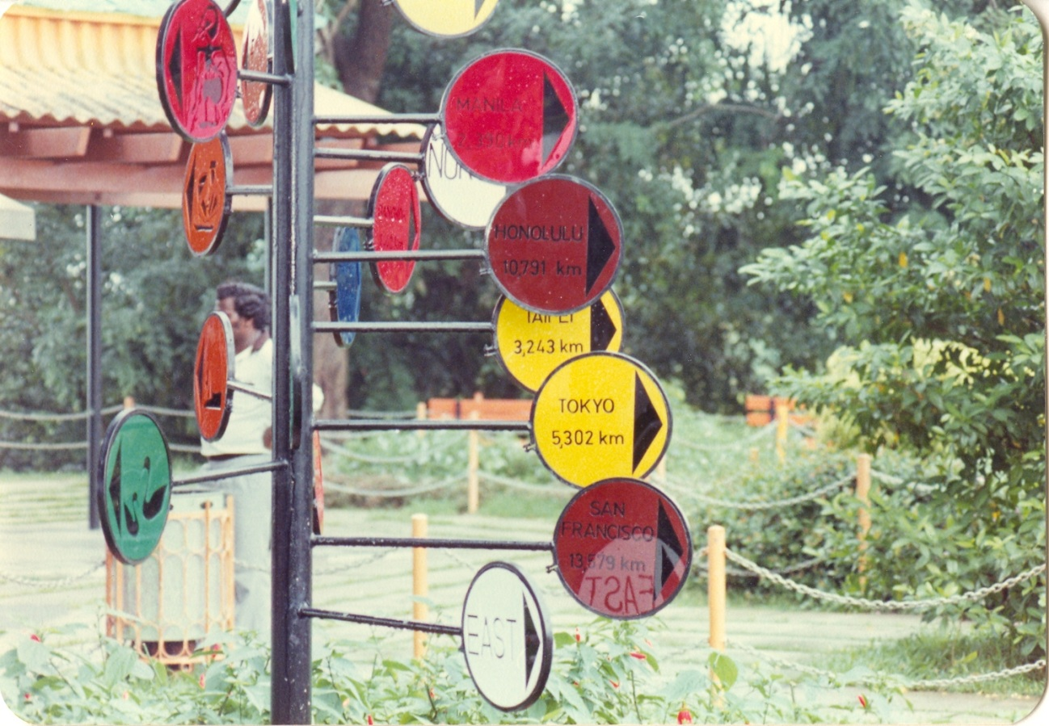
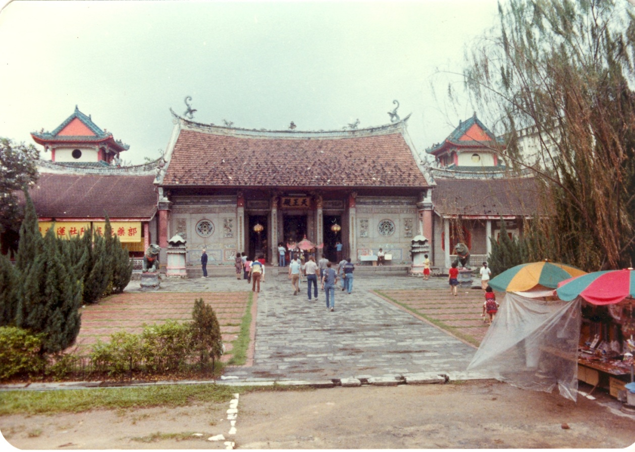
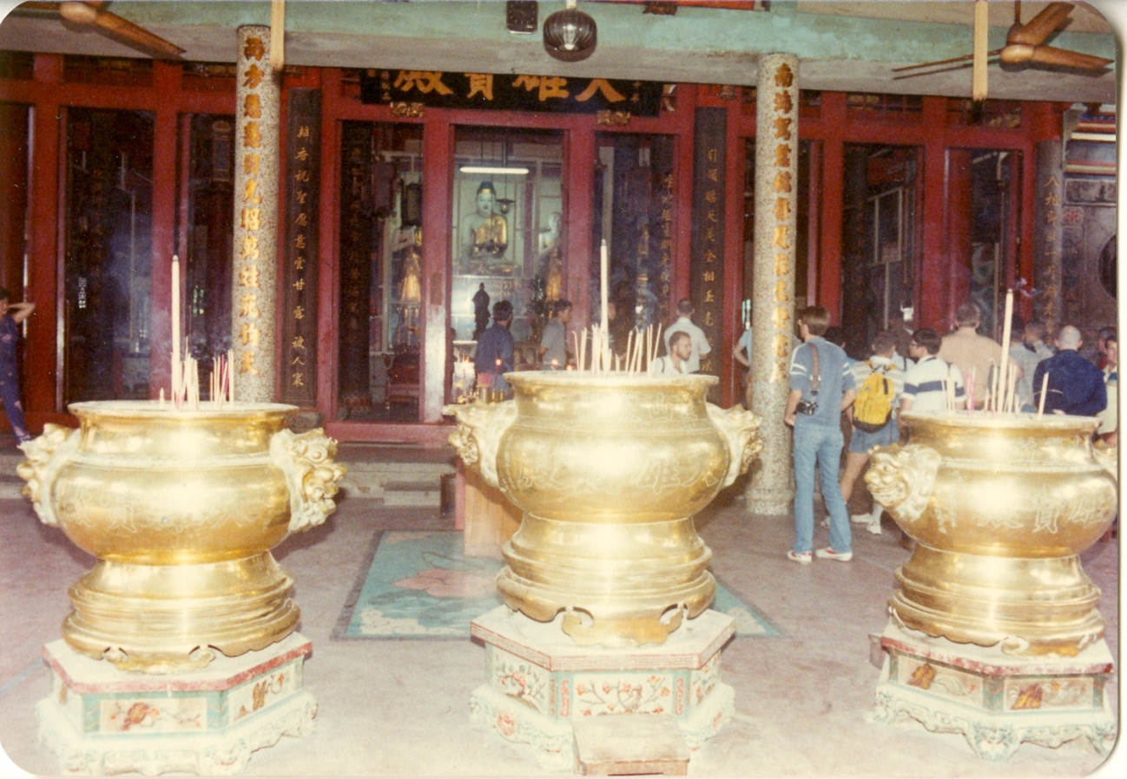
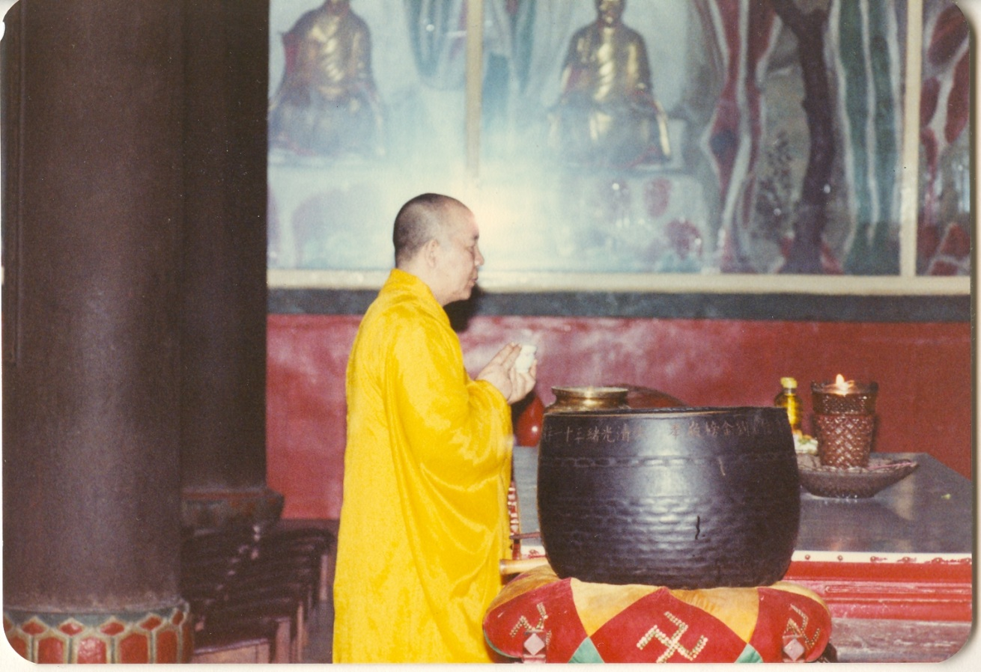

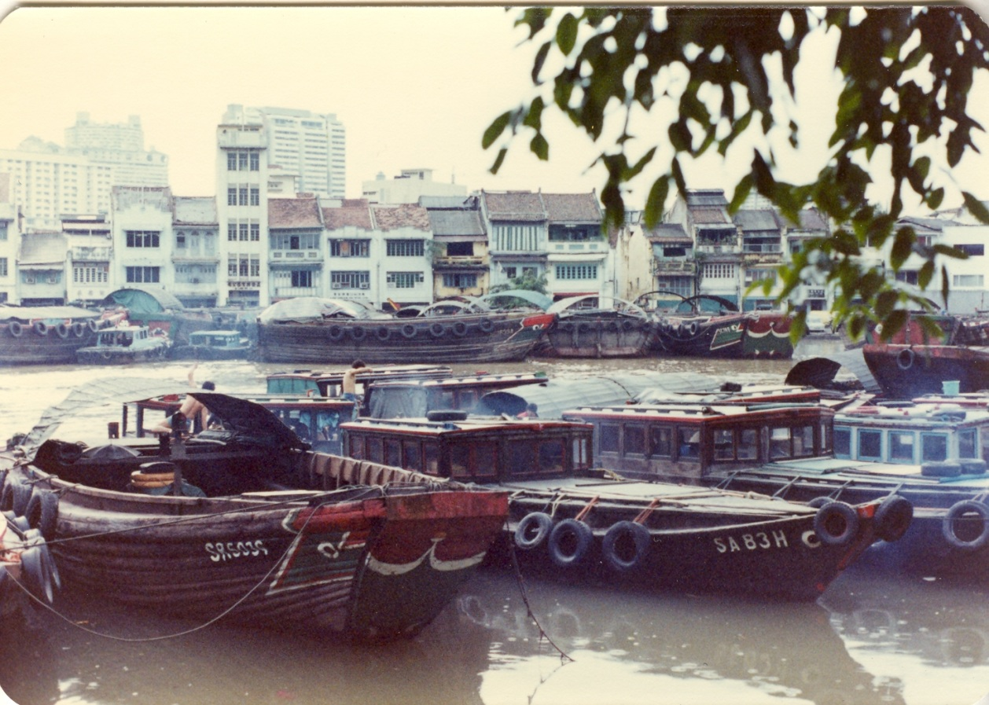

31st MAU – Back in the Philippines Dec. 31, 1982 – Jan. 21, 1983

Philippine NPA battles
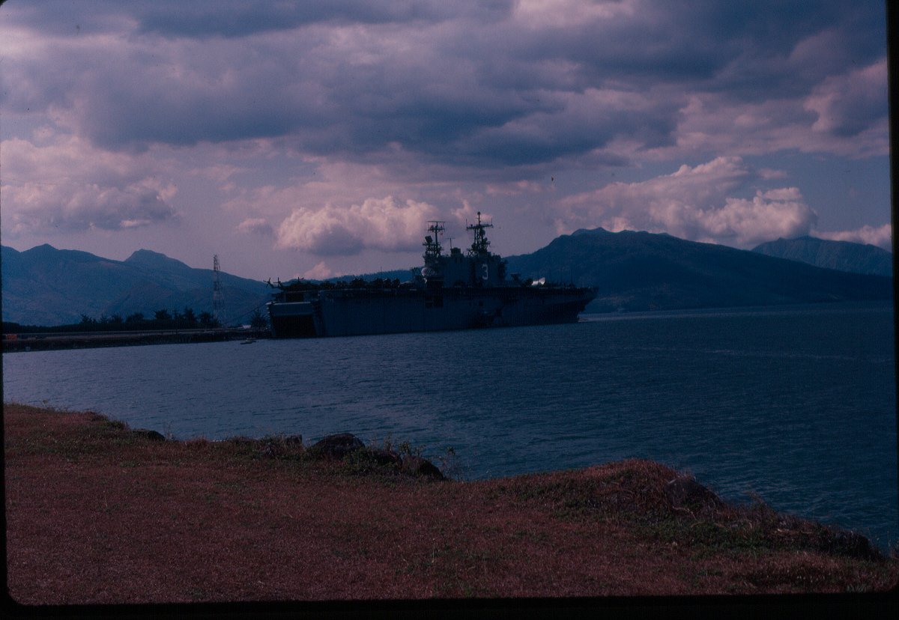
January 1983 the USS Belleau Wood (LHA-3) relocated to a safer position while conducting surveillance of ongoing fighting in the Philippines
After returning from “Jade Tiger” and conducting minimal surveillance off the coast of Iran during fighting in the Iran/Iraq war the 31st MAU, USS Belleau Wood LHA-3 returned to the Philippines and conducted surveillance during ongoing battles in the Philippines between the government and the rogue NPA.
Global Security Article 1985
''We didn't look into the NPA problem, and it almost blew up into our faces, '' Maj. Gen. Delfin Castro, head of military's southern command, says in 1981. NPA says it has guerrilla fronts in 50 of the 73 provinces.
By April 1983, NPA changes military tactics. Instead of small groups of three to nine guerrillas using hit-and-run tactics to seize arms from small bands of soldiers, NPA now operates in groups of 200 in some areas. Open, large-scale fighting gives NPA regular supply of weapons. By 1984, Western sources estimate NPA operates in 60 provinces.
www.globalsecurity.org/military/library/report/1985/ARS.htm

Note: I left the Philippines to return to Okinawa in mid-April 1983 at the height of the fighting in Luzon. It took two days of bus and plane travel; getting ammunition, leaving at 0230, making diversions, taking alternate routes and returning to where we started before we finally got back to Okinawa.
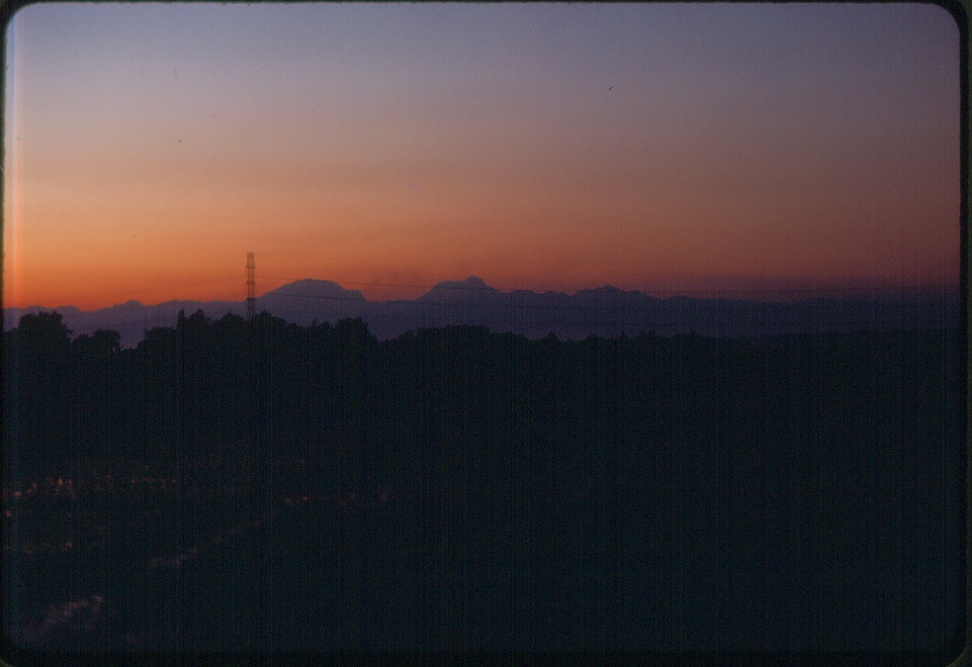
Smoke [slightly visible rising – center left of photo] from fighting in the area (Jan. 83). A few of us had a day off before we left. I was on a bus in the countryside while fighting was taking place. I left Subic Bay [another Marine correctly opted out of the trip] just before the base was closed. At one point fighting (shooting) and fires were on hills on both sides of the road. The road was about to be closed to travel by the Philippine military guarding the road so at the next bus stop I took another bus and returned to Subic Bay. Later I heard that some of the Philippine soldiers guarding the road were killed.
CS Monitor Article
Continuing peasant grievances and intense nationalism that arose during 1960s give new impetus to communist movement. NPA, which initially used Maoist ''people's war'' strategy and tactics, appeals to peasants, mainly in central Luzon. CPP appeals to newly emerging Philippine business class, which wants a smaller role for Chinese and other foreign businesses. CPP turns militant nationalism into urban demonstrations against [President] Marcos, an advocate of foreign investment. MARTIAL LAW, 1972-81: crackdown brings deceptive calm.
September 1972: Defense Ministry accuses NPA of trying to assassinate Defense Minister Juan Ponce Enrile Sept. 22. Many believe attempt was staged by government to justify martial law. The next day, Marcos announces martial-law decree (signed Sept. 21), citing need to suppress ''state of rebellion'' instigated by NPA. In next two months, some 6,100 people (including Aquino) are arrested. ...
Jan. 17, 1981: Marcos officially lifts martial law.
AFTER MARTIAL LAW, 1981-84: rebellion resurfaces
April 1983: Marcos says three-month antiguerrilla sweep in Mindanao kills 436 communists and 19 NPA leaders and that NPA has stepped up its activities.
Sept. 29, 1983: NPA kills 39 soldiers, wounds 17 in Mindanao, the highest toll in single incident in a decade.
May 14, 1984: During parliamentary elections, 91 people are killed in military-communist clashes. Filipinos essentially ignore CPP calls for election boycott.
June, 1984: Army launches largest offensive ever against NPA rebels in northern and central Luzon.
www.csmonitor.com/1984/0927/092716.html

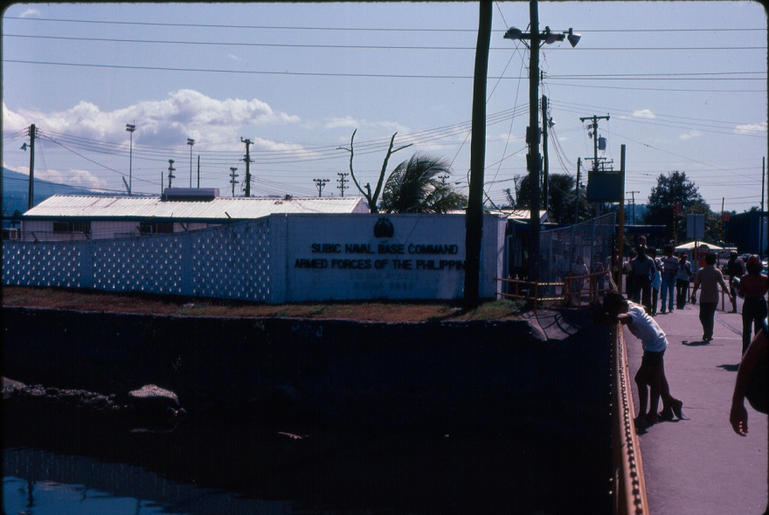
The Subic Bay Naval base Philippines approaching from Olongapo City in January 1983.
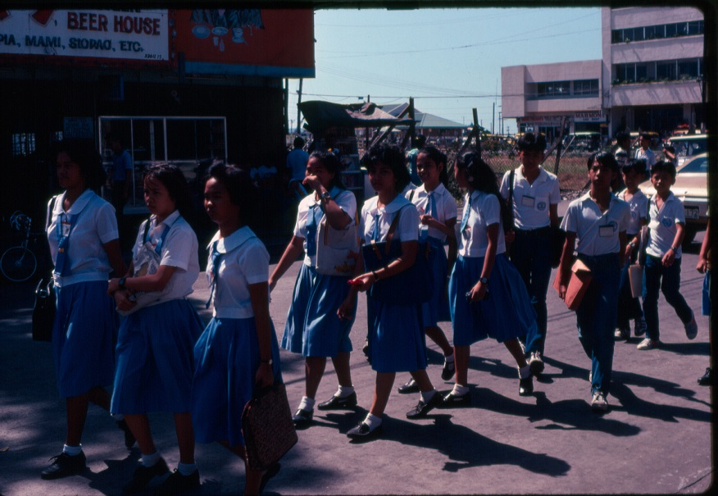
Olongapo City a group of school children just outside the Subic Bay Navy base.
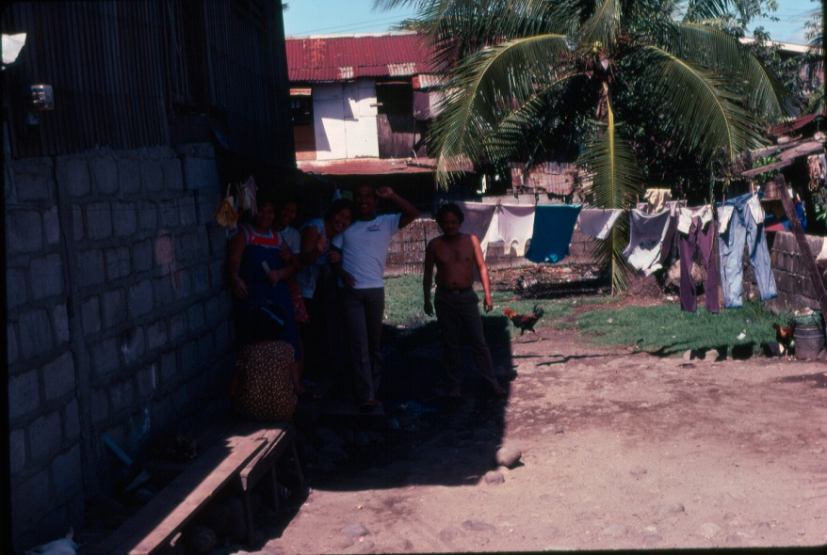
Olongapo city a family near the Subic Bay Navy base.
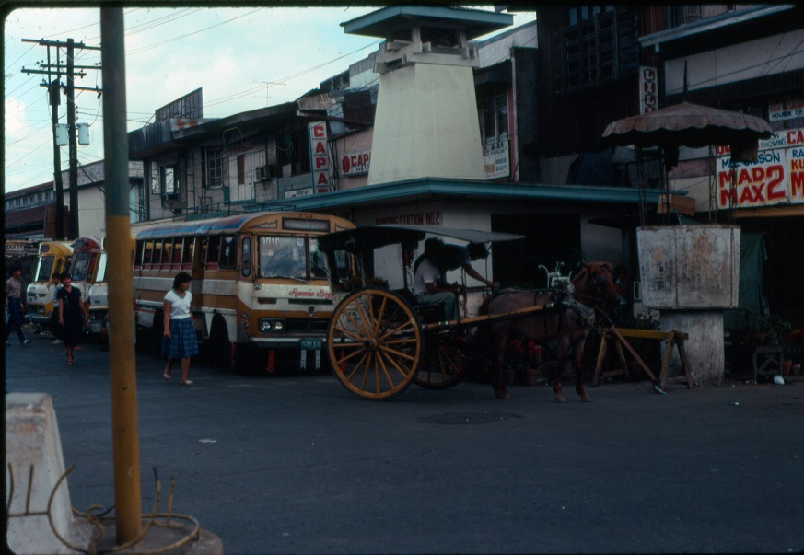
Possibly near the bus station in Olongapo City or another city in April 1983.
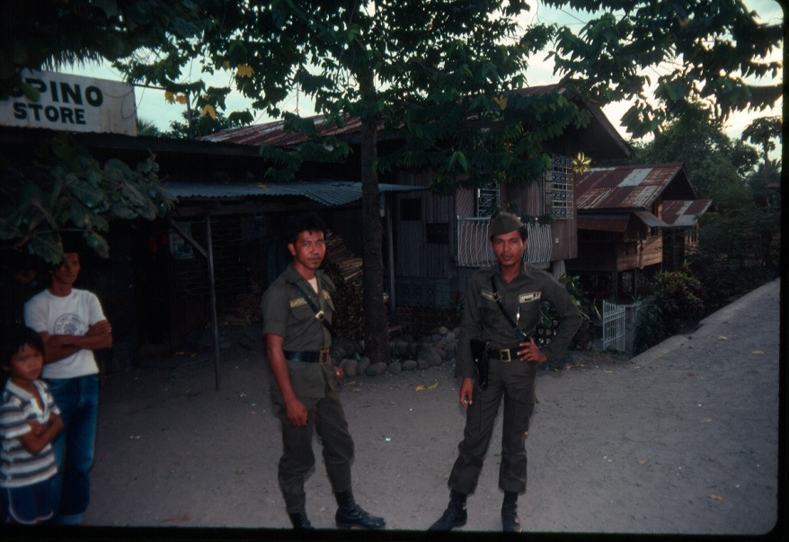
Philippine police standing guard in a small village to prevent NPA activity in April 1983.
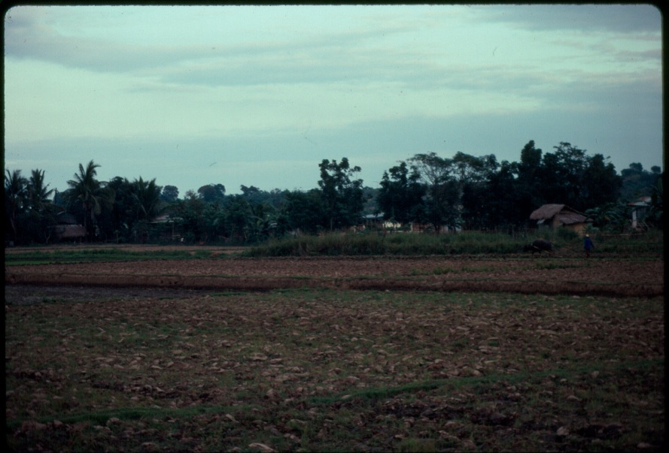
Weekend Liberty in the Philippines on route to Angeles City near Clark Air Base.
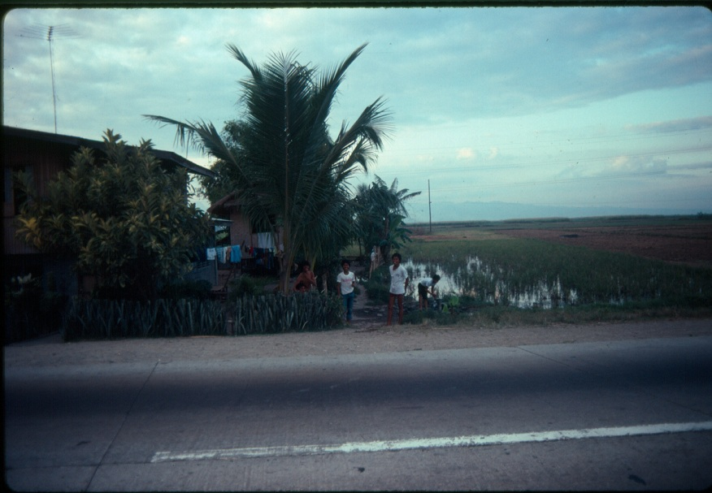
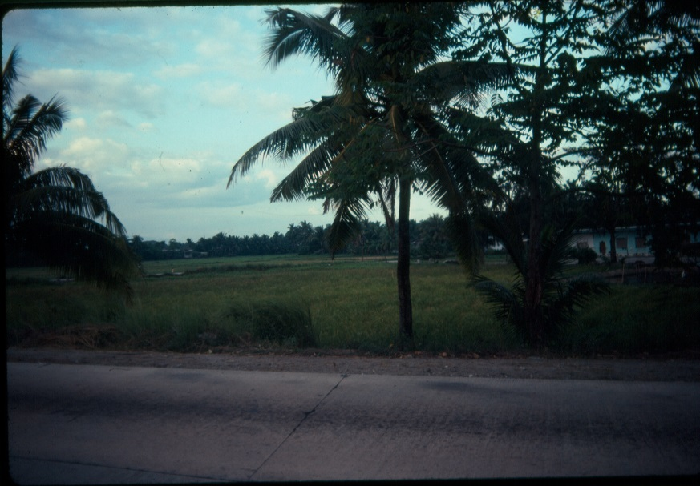
Note: this is part of the WWII Bataan Death March route. -- All photos by David Anson Brown
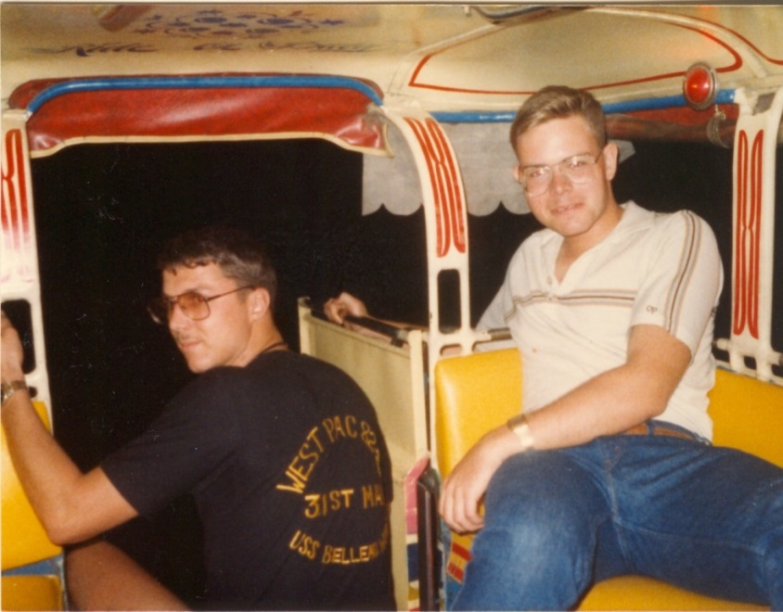
Jade Tiger Marines - Weekend Liberty on route to Angeles City, Philippines in about March or early April 1983.
Our first night out talking briefly about Somalia (grateful we made it out of there), our WestPac 82-83, current battles (Philippines, Lebanon), future wars (i.e. Somalia) while being on a part of the old WWII Bataan Death March route.
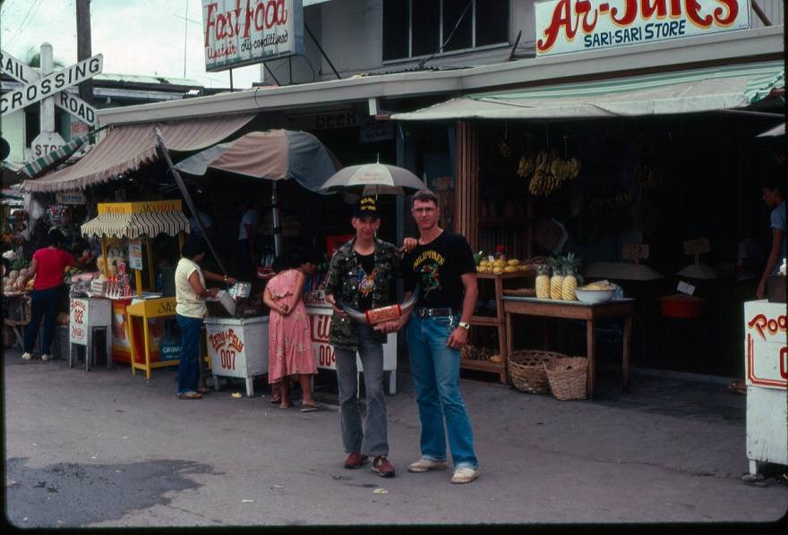
31st MAU Marines on a weekend away from Subic Bay going to Angeles City in April 1983.
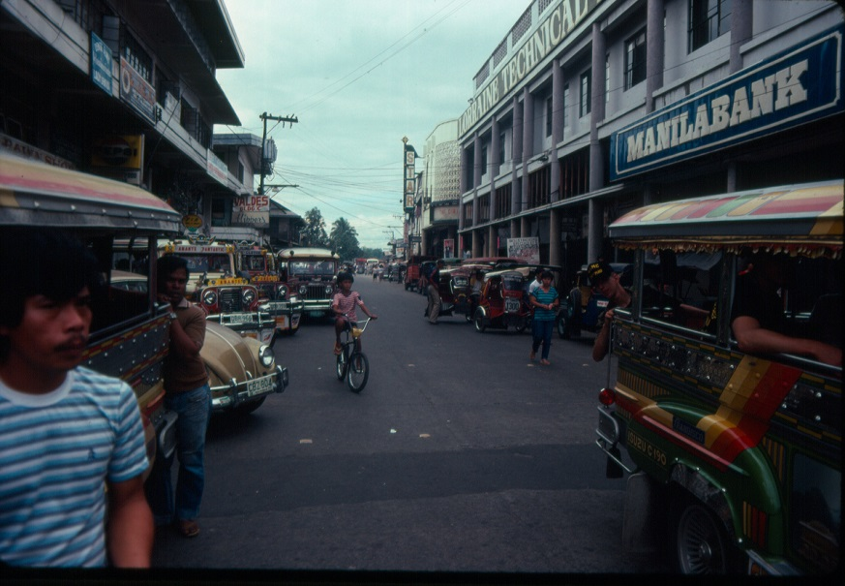
Angeles City Philippines April 1983.
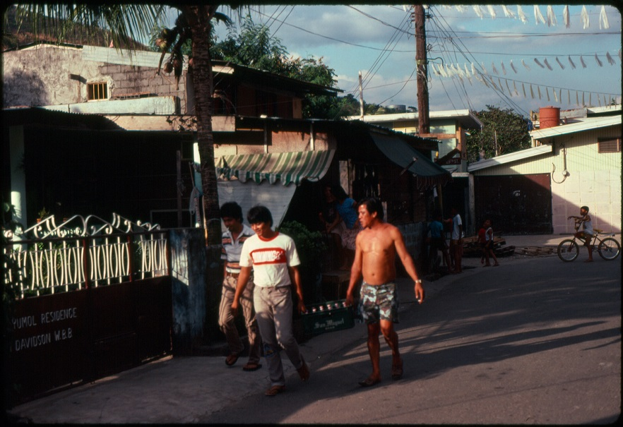
Philippine citizens going about their weekend while their country is in crisis during heightened NPA activity April 1983.
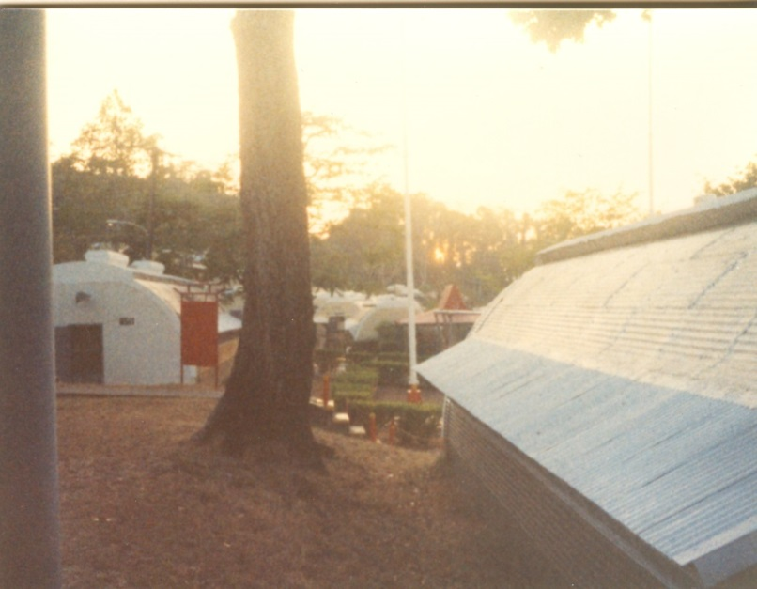
Upper MAU Camp in the Philippines in January 1983. The building on the right is my barracks.
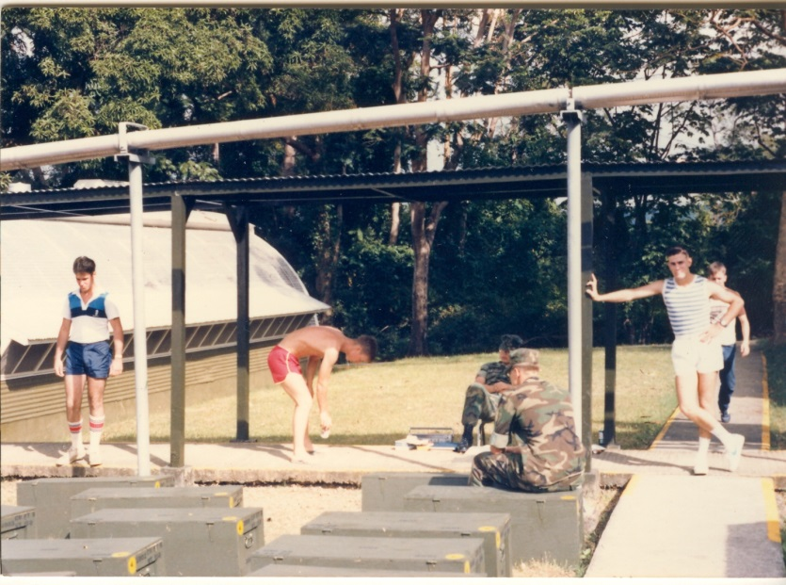
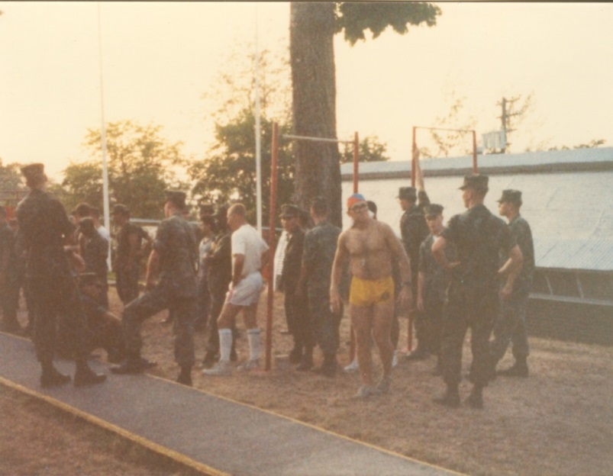
Upper MAU Camp in the Philippines Jan 1983
Physical Fitness Testing (PFT) – the Marine in the yellow (recruit 2nd Bn) PT shorts was a great motivated Marine.
Note: the Barracks were modified Quonset huts – my barracks was the one in this photo.

31st MAU – Hong Kong – January 1983
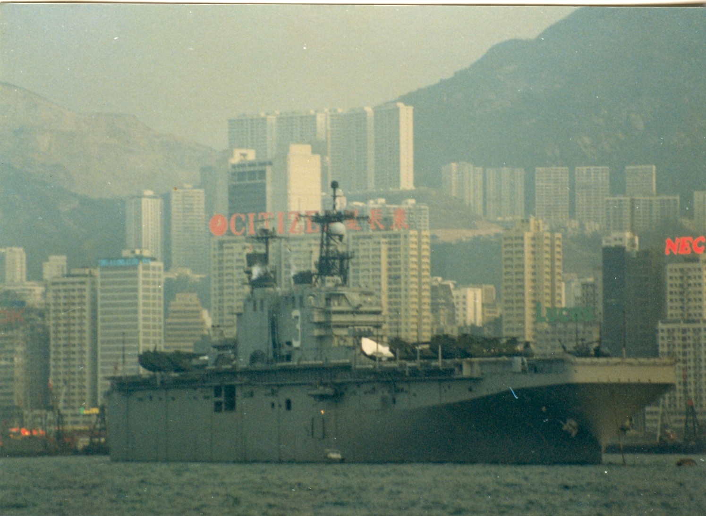
USS Belleau Wood (LHA 3) Hong Kong Harbor 1983 photos by PFC David Anson Brown 31st MAU USMC
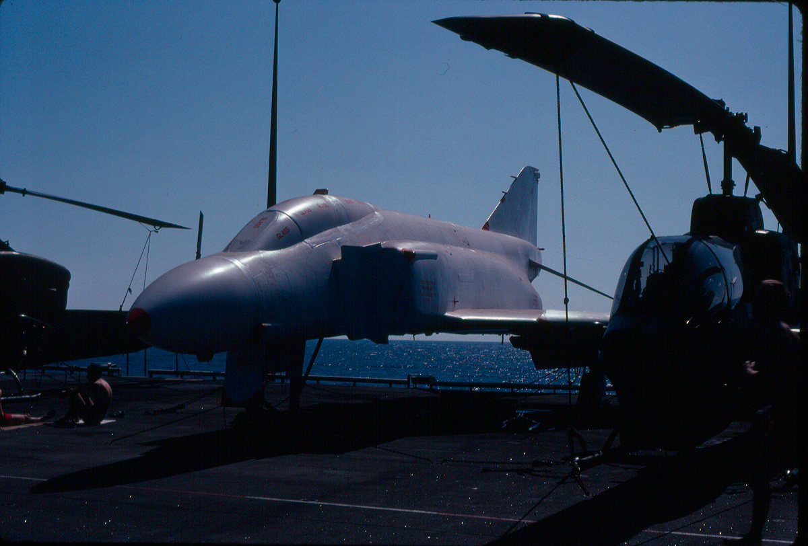
USS Belleau Wood (LHA 3) near Hawaii – a closer look at the disabled A-4 Skyhawk jet aircraft (wrapped in white protective plastic) that the ship picked up in the Philippines and was transporting for another ship. It is visible in the above photo and in other photos.
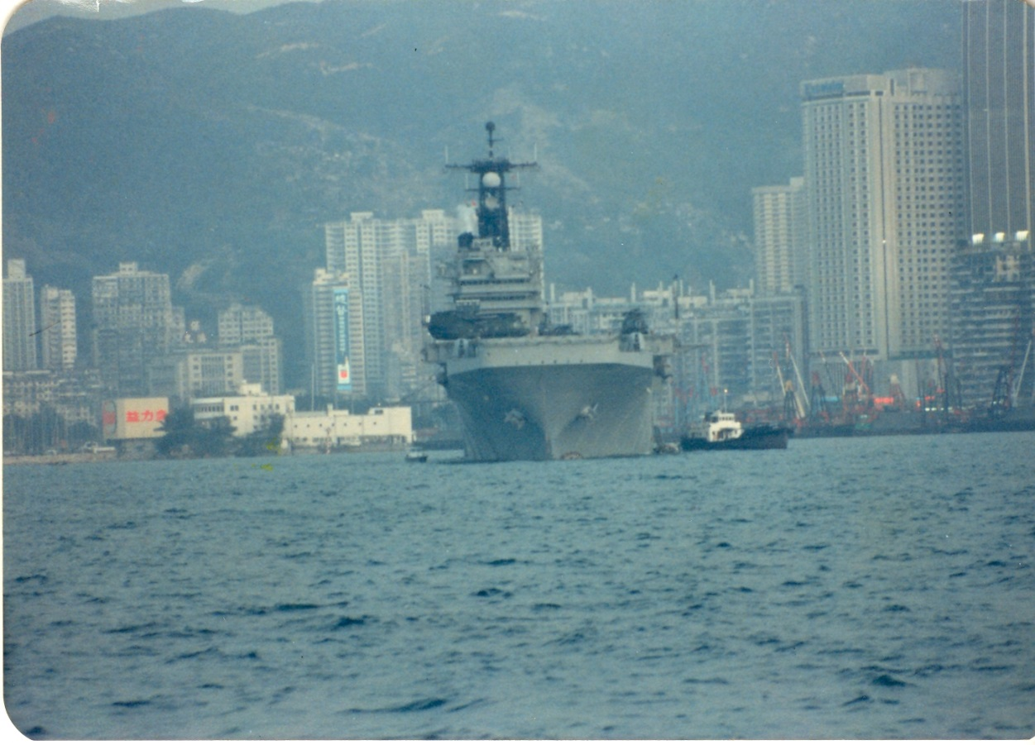
USS Belleau Wood (LHA 3) in Hong Kong January 1983

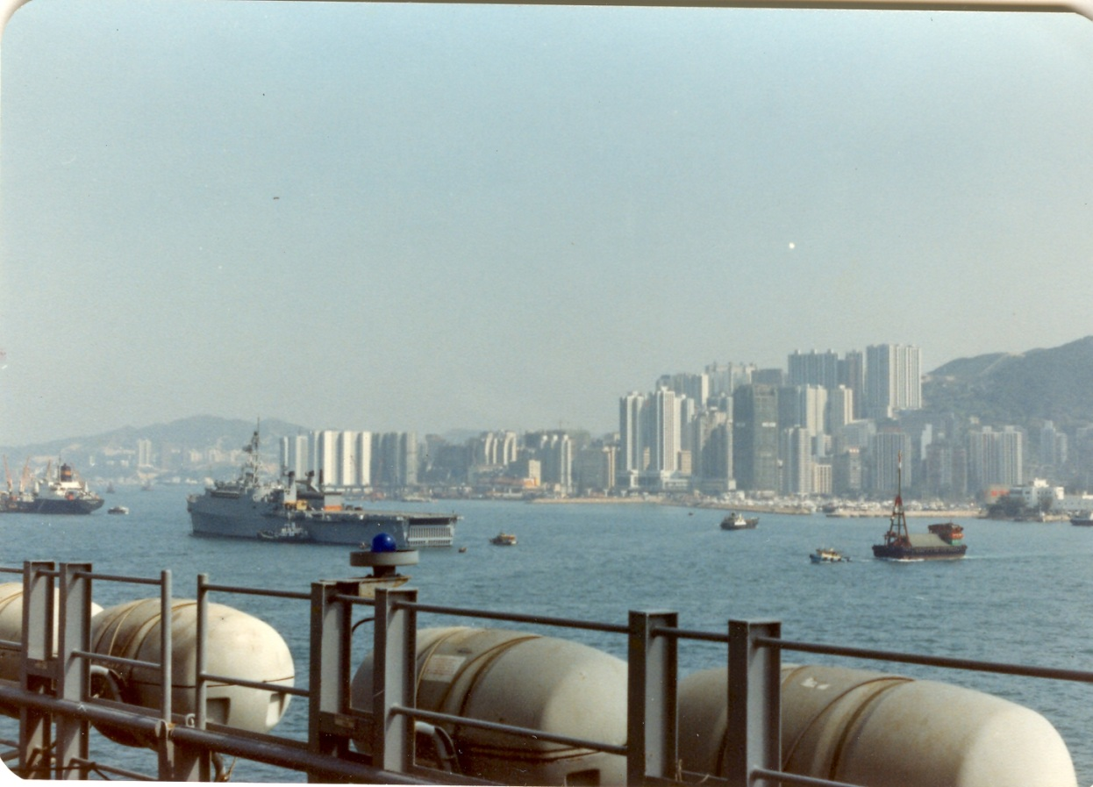
USS Belleau Wood (LHA 3) with the USS Ogden (LPD-5) in the background Hong Kong 1983

Hong Kong and China border
WestPac '83, about February 1983 Hong Kong and China border at "Lok Ma Chau" hill overlook in Hong Kong.
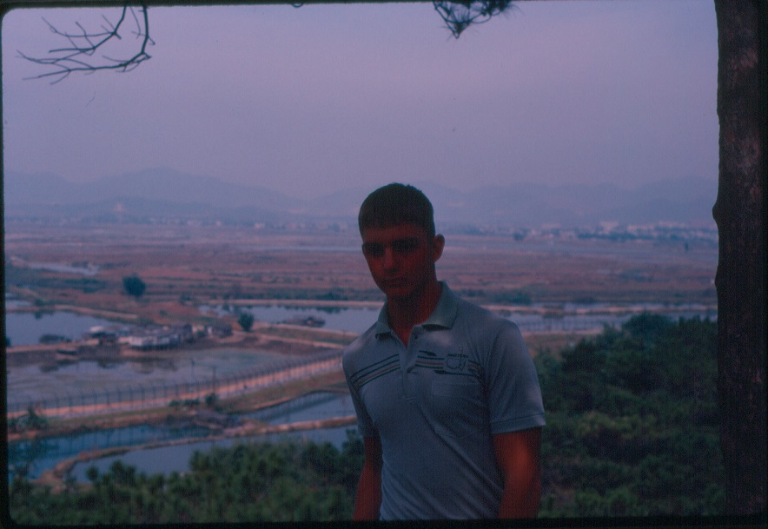
LCpl David Anson Brown HQ 31st MAU Comm Plt on a guided bus tour at at "Lok Ma Chau" in Hong Kong – views of China
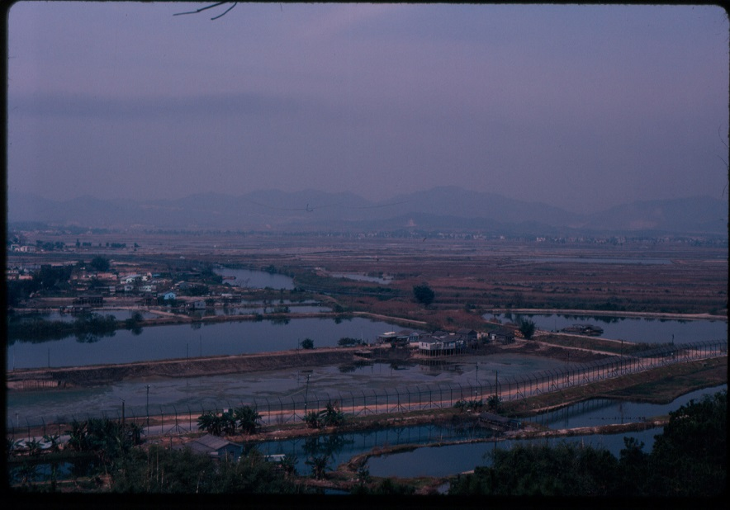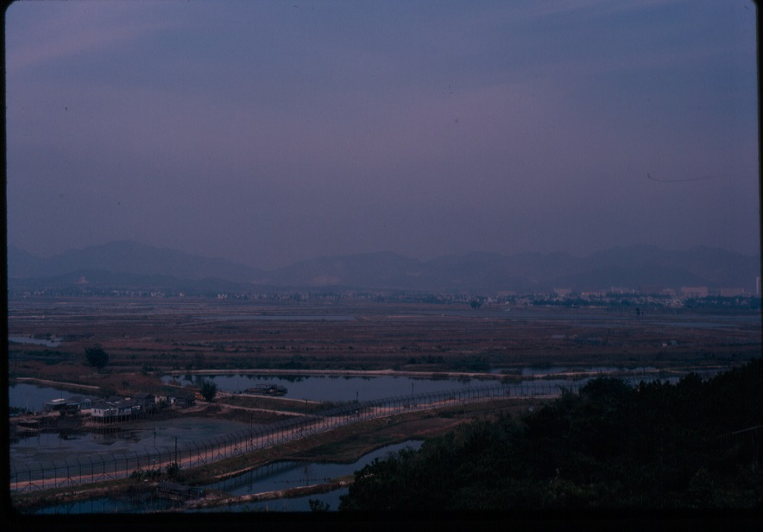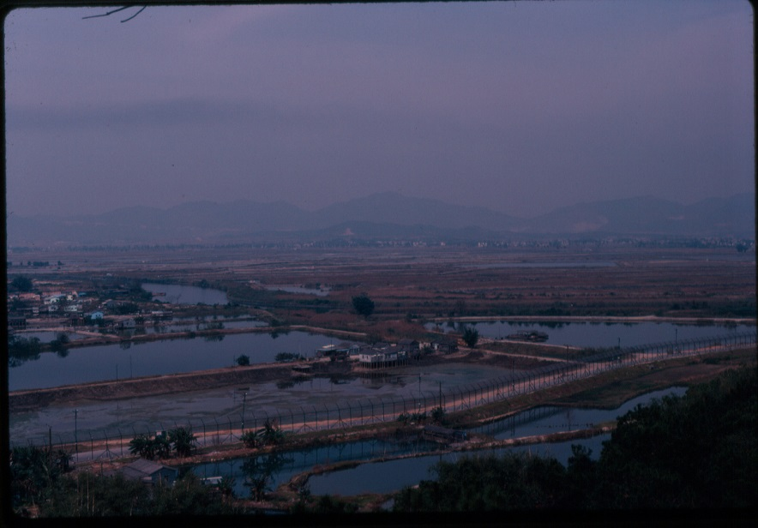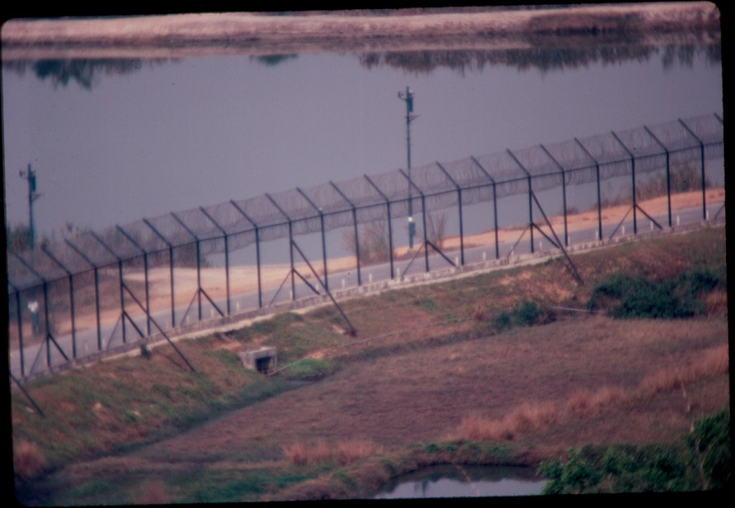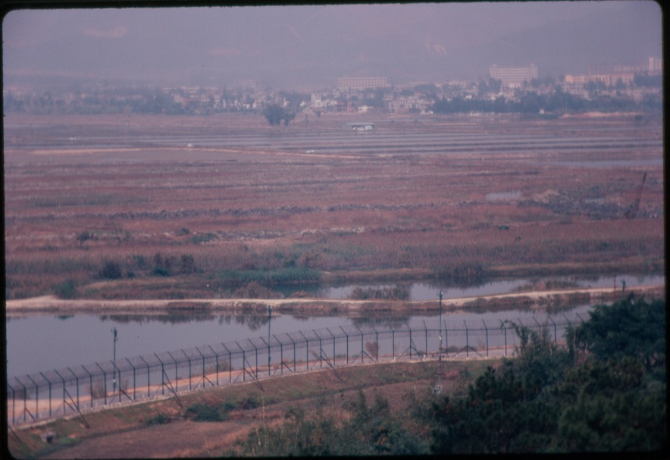
A startling event happened in China near this overlook while we were there. Just before we boarded back on the busses on the other side of the fence on the China side about six military 6x6 2½-ton trucks pulled up on the road and parked. Our tour guide had been concerned when we arrived and sometimes that location was skipped from the tour because the Chinese military was known to react when American personal were visiting that hill. But it turned out that it had nothing to do with us and our Hong Kong tour guide was infuriated as she explained to us that it was a Chinese socialist work detail and the Chinese military got out of their trucks and using megaphones started ordering Chinese civilians out of the back of the trucks and made them like forced labor go to work weeding the rice fields. This was happening in 1983.

USS New Orleans (LPH-11) – WESTPAC 83 – 31st MEU (MAU)
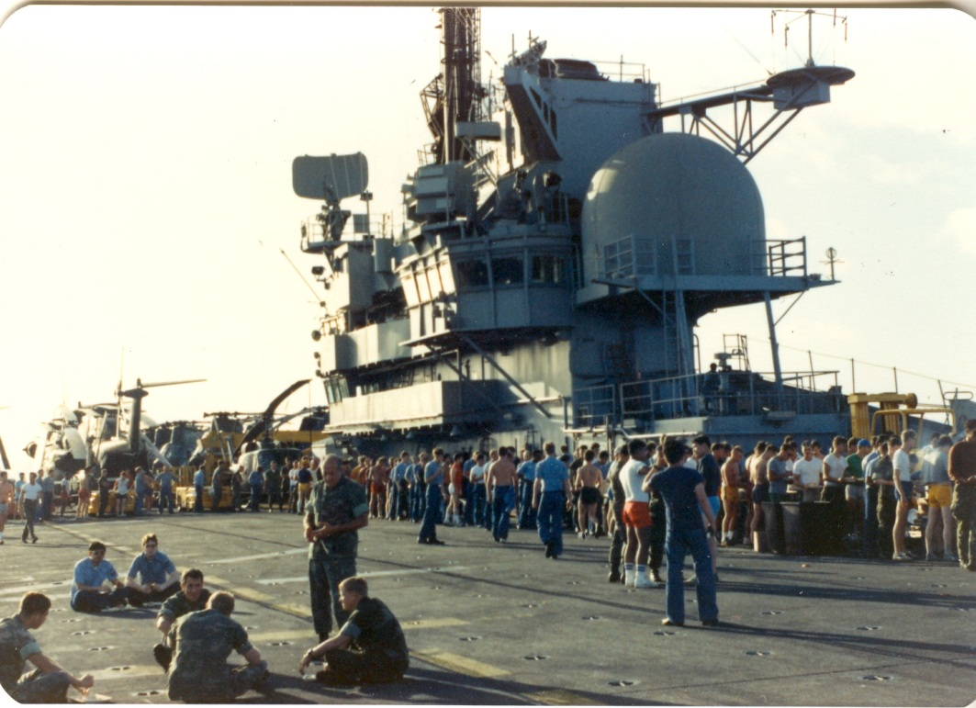
Marines of the 31st MAU – USS New Orleans (LPH-11) deck party - about February 1983 – near Hawaii.
Excellent Marine officer 31st MAU Commander Colonel Macaulay is standing, talking to members of his outstanding Command Staff.
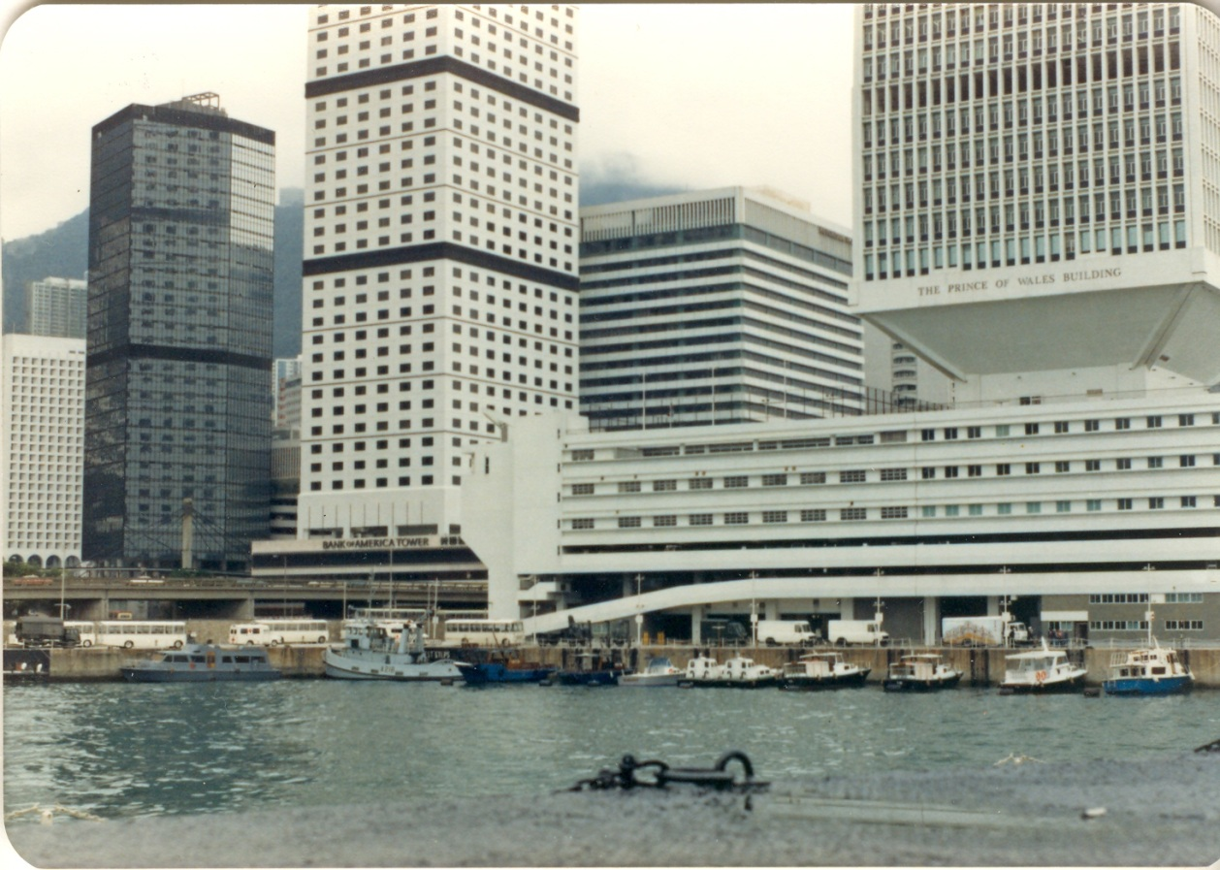
USS New Orleans (LPH-11) in Hong Kong about March of 1983.
Note: previous to Hong Kong the 31st MAU was in Southern Korea – I had been able to avoid the well-attended Philippines malaria party but I wasn’t able to avoid the Korea pneumonia party and stayed on ship in Korea sick with pneumonia.
USS New Orleans (LPH-11) in the Philippines in April of 1983
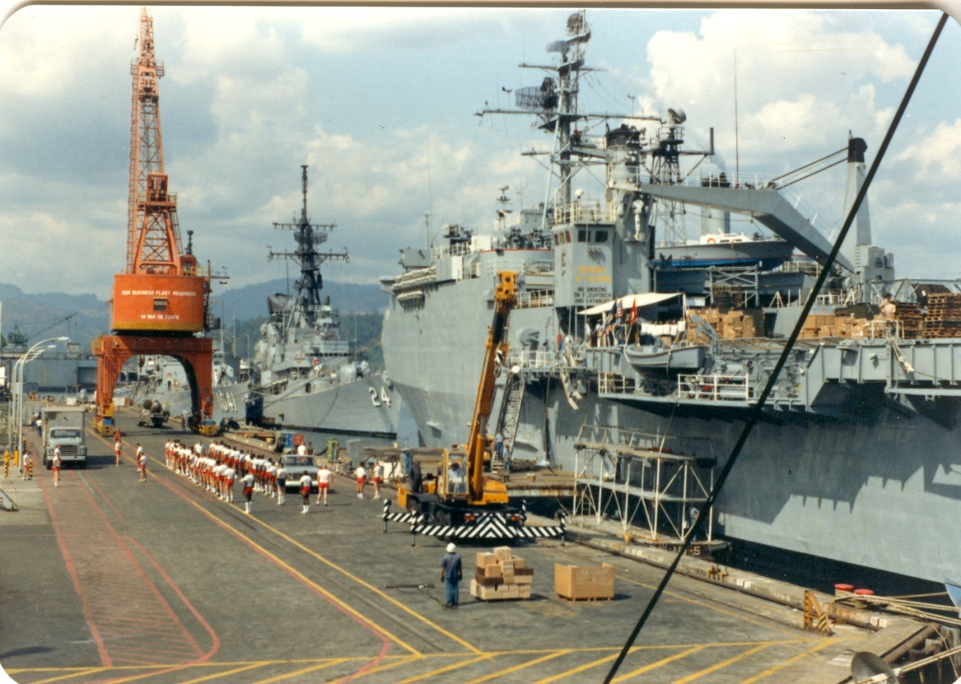

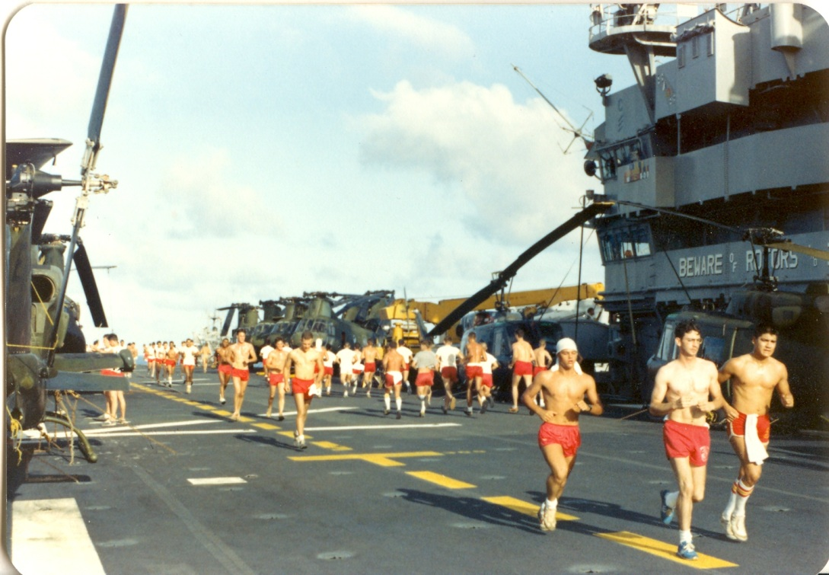
USS New Orleans - 31st (MAU) - Battalion Landing Team (BLT) 1st Battalion 3rd Marines.
7th Communication Battalion – Okinawa, Japan

USS Blue Ridge (LCC-19)
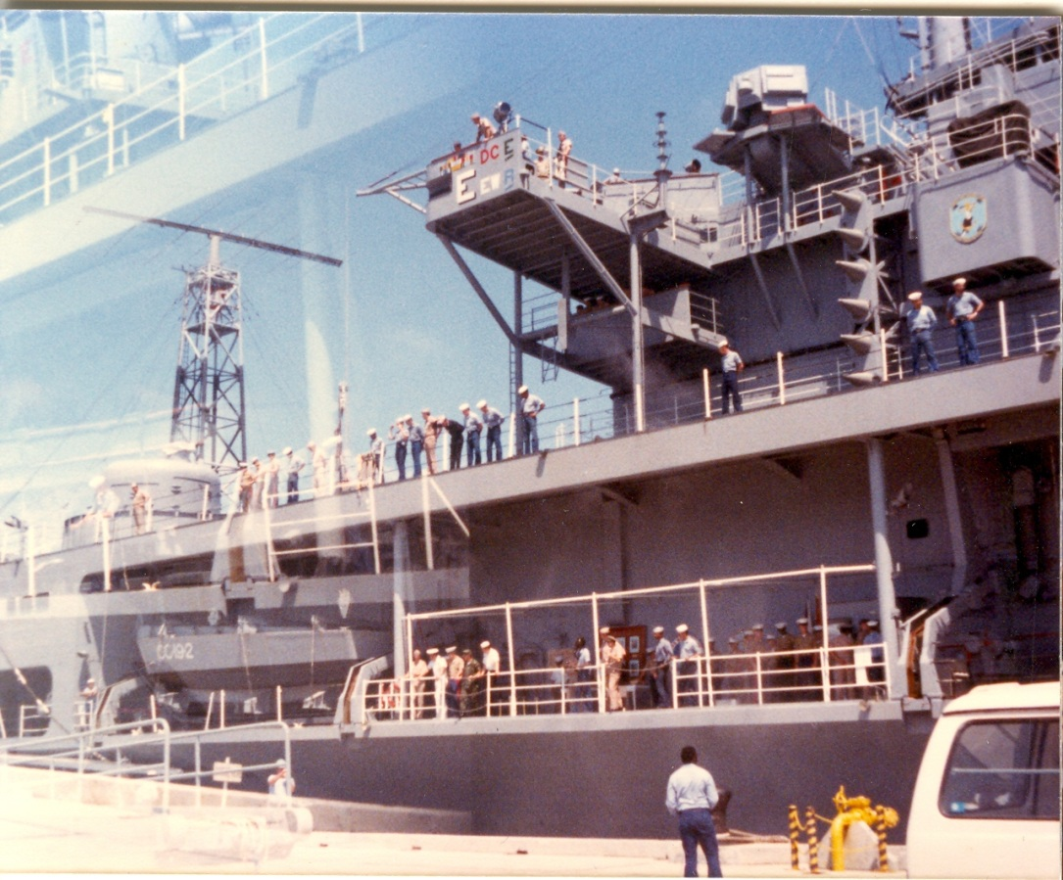
USS Blue Ridge (LCC-19) – 3 day 7th Comm Bn communications exercise off the west coast of Okinawa (Philippine Sea).

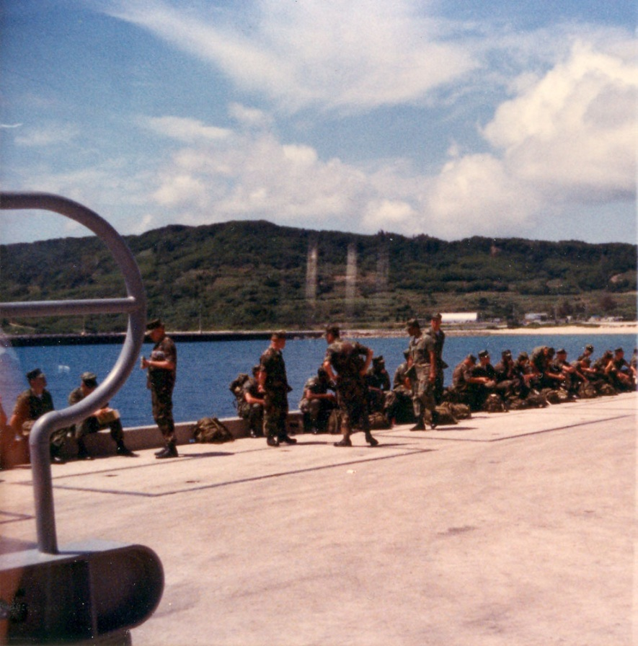
White Beach Naval Facility Okinawa, Japan – 7th Comm Bn Marines waiting to board the USS Blue Ridge – April 1983.
1st Marine Division – Camp Pendleton, California
1st Bn 9th Marines "The Walking Dead"
The title "The Walking Dead" was earned by the Marines of the 1st Bn 9th Marines during the Vietnam War through their constant valor and sacrifice while in extended combat duties in Vietnam and it has become one of the great Marine Corps traditions of today.

1st Marine Division – Camp Horno at Camp Pendleton, CA 83-84
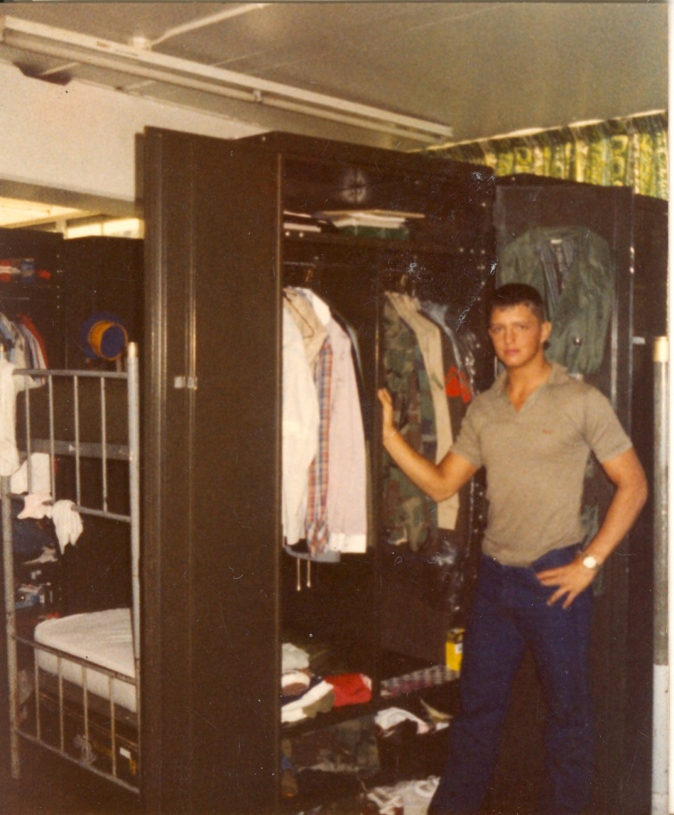
Inside the 1/9 Comm Plt Barracks at Horno, Camp Pendleton, CA – LCpl David Anson Brown - 1984
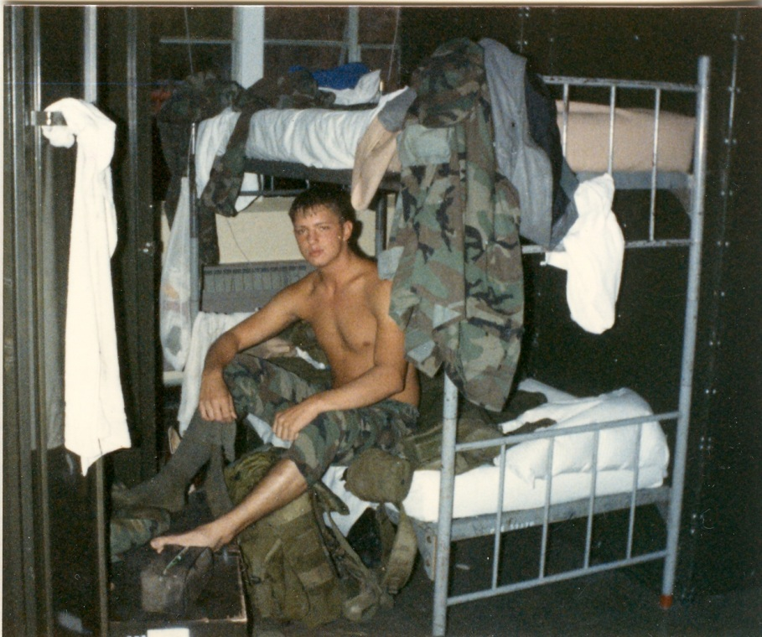
1/9 Comm Plt Barracks at Camp Horno, Camp Pendleton, CA – LCpl David Anson Brown – 1984
Camp Horno 1/9 Battalion area in 1984
Chow hall is center-left with 1/9 Comm Plt bks on the right the bldg with the two bushes on the end by the back road.
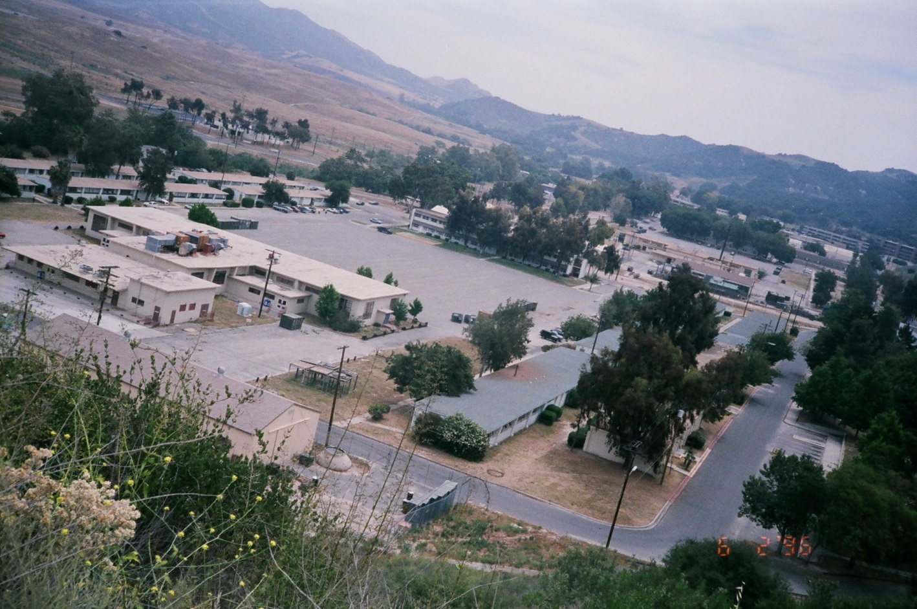

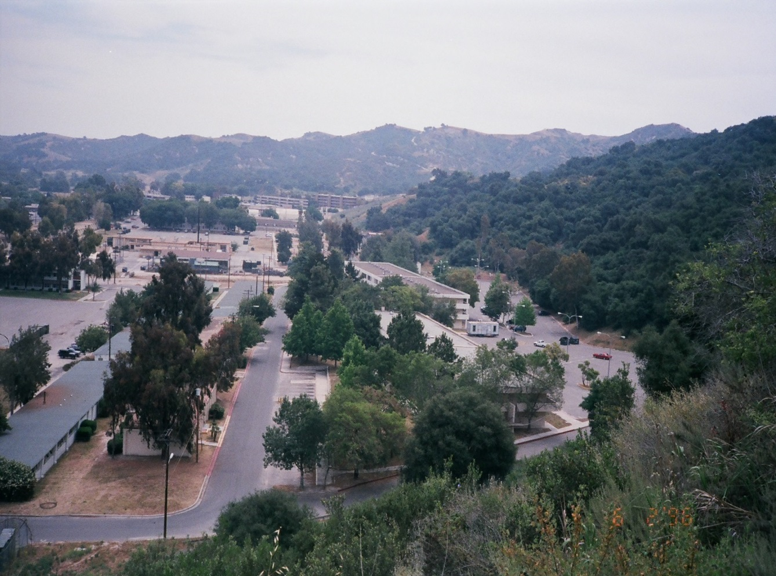
1ts Bn 9th Marines Comm Plt barracks lower left in 1984 after returning from Okinawa and WestPac 83-84.
Photos from the "Sons of Horno" Facebook page

Camp Hansen, Okinawa – West Pac 83-84

1st Bn 9th Marines, 3rd Marine Division
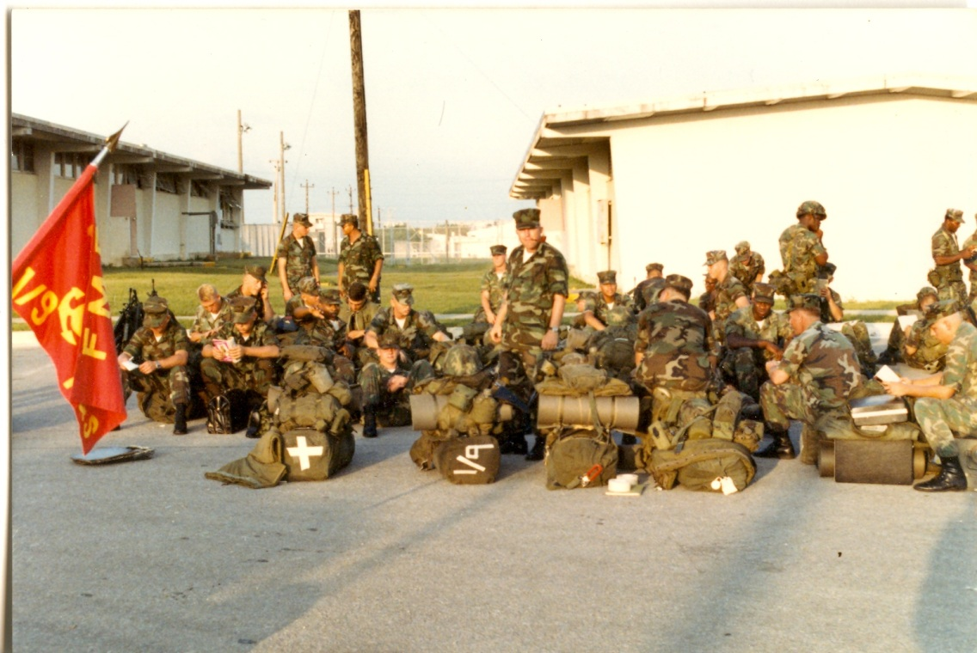
H&S Co. Communications Plt 1/9 Marines waiting to go to Korea

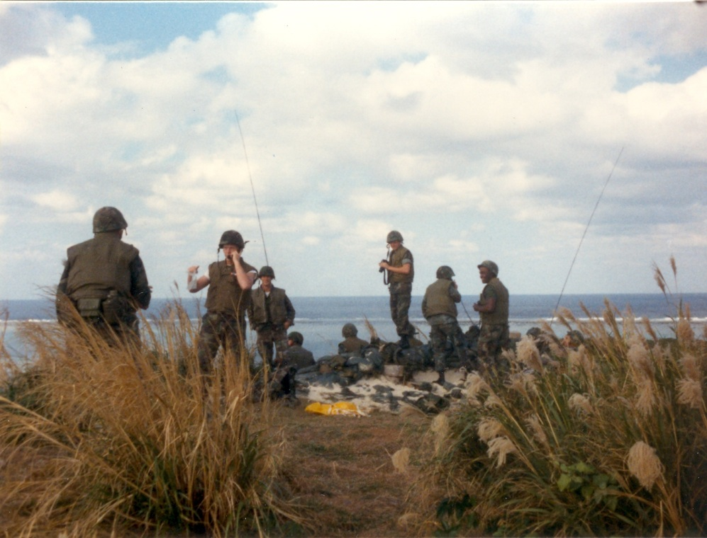
A small island live fire range about 60-90 miles away from Okinawa – LCpl T. Moudy (Illinois) directing air strikes probably off of the aircraft carrier USS Ranger (CV-61) – about January 1984.
Fort Sherman, Panama Canal - June 1984
1st Bn 9th Marines, 1st Marine Division

1/9 Panama Canal 1984
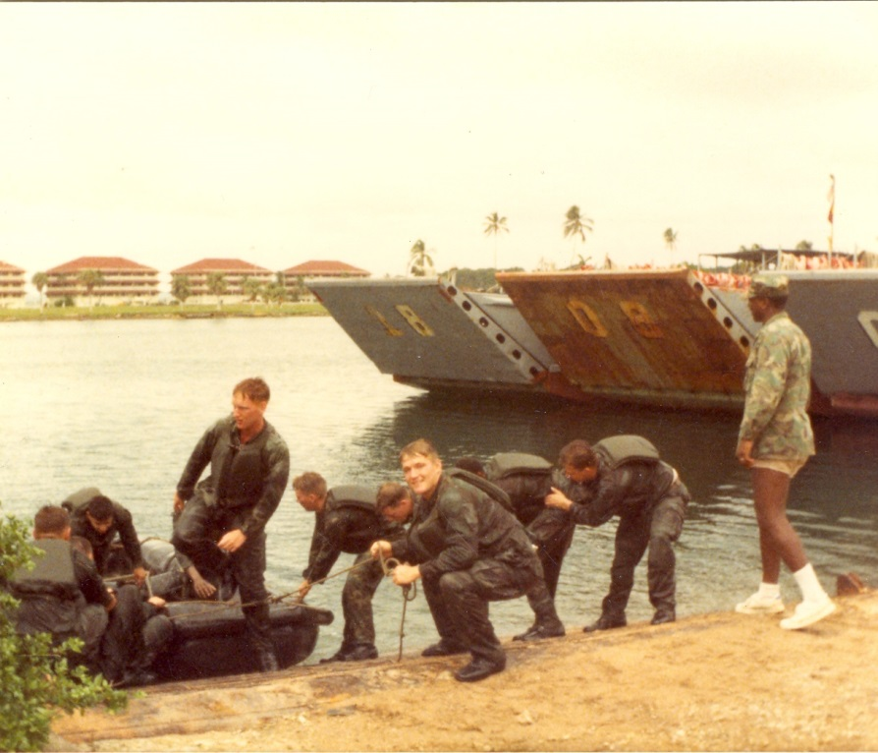
LCpl Timothy Conarton (Michigan), LCpl Steve Gibbs (Missouri) of Comm Plt with A Co. 1/9 – US Army Ranger Instructor
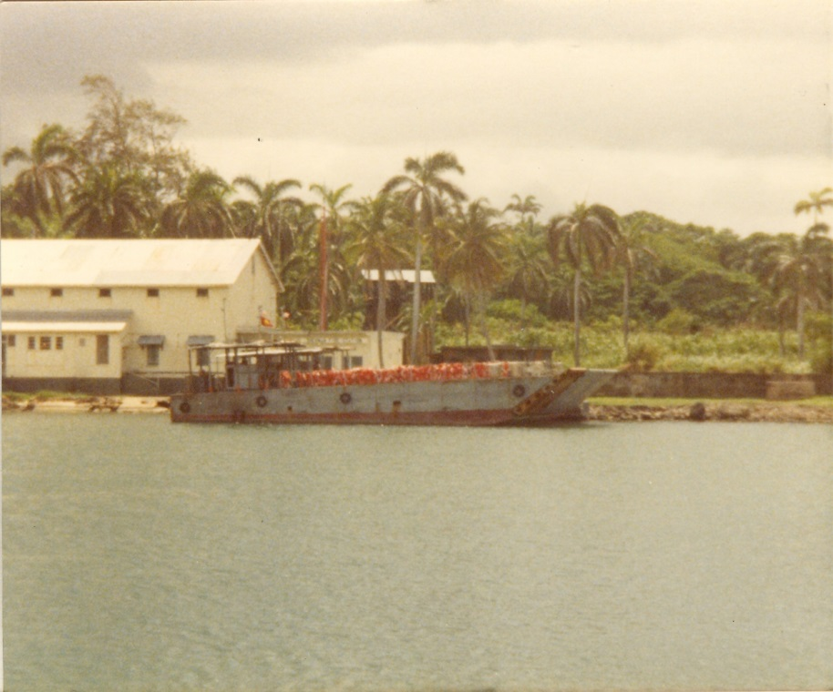
Fort Sherman, Panama Canal - June 1984, one of the landing craft after we arrived at Fort Sherman.
The 1st Bn 9th Marines flew by passenger plane to Panama City, then a bus ride across Panama to the Panama Canal and then finally some boats, landing craft, took us to Ft. Sherman.
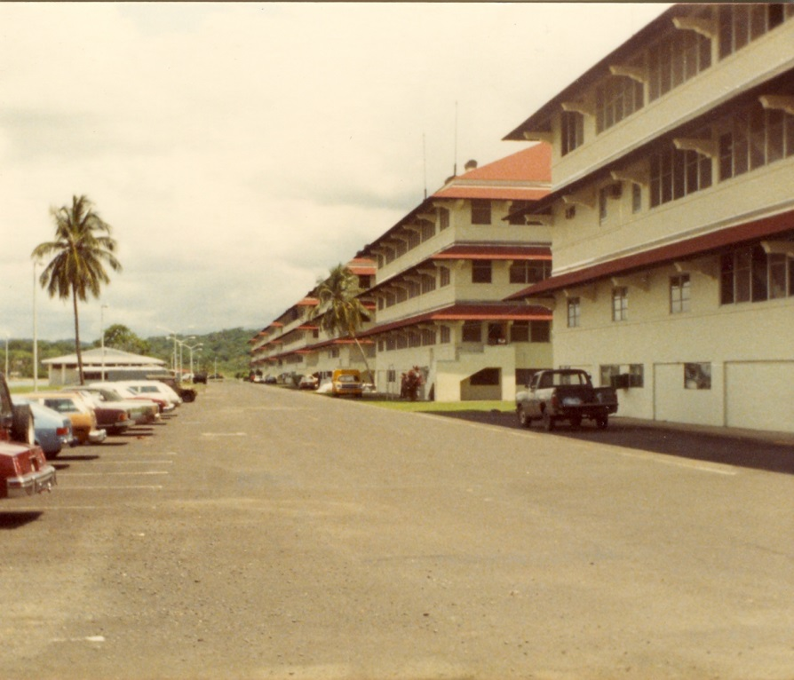
Fort Sherman, Panama Canal – the barracks
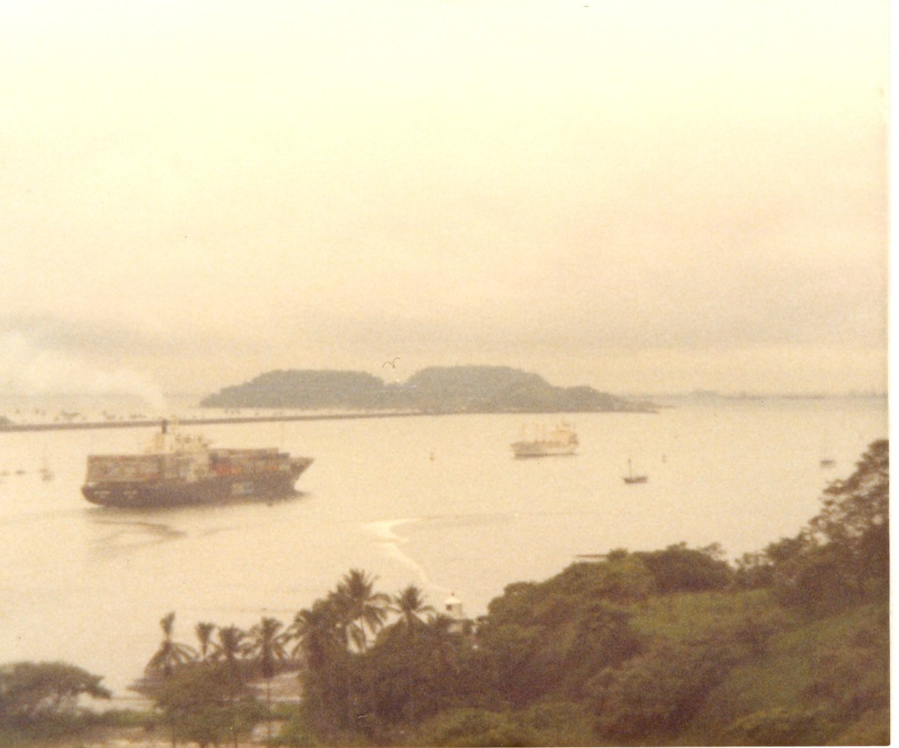
Panama Canal, Atlantic Ocean entrance - June 1984
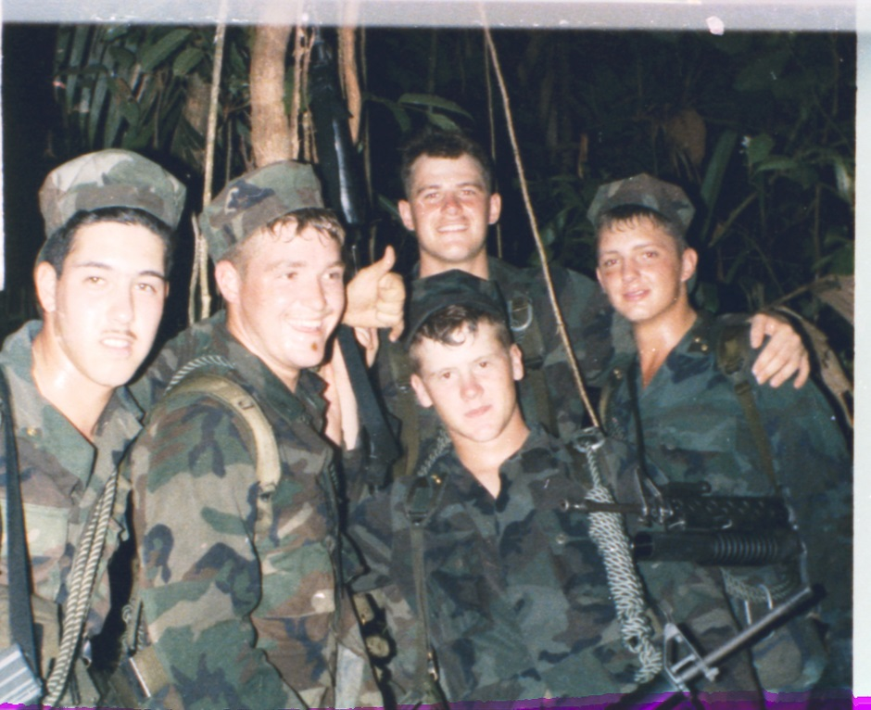
L-R front row LCpl M. Latchman, LCpl Steve Gibbs (Missouri), LCpl Timothy Moudy (Illinois)
L-R back row LCpl David Hartill (Washington), LCpl David Anson Brown
Comm Plt Marines training with A Co. 1/9

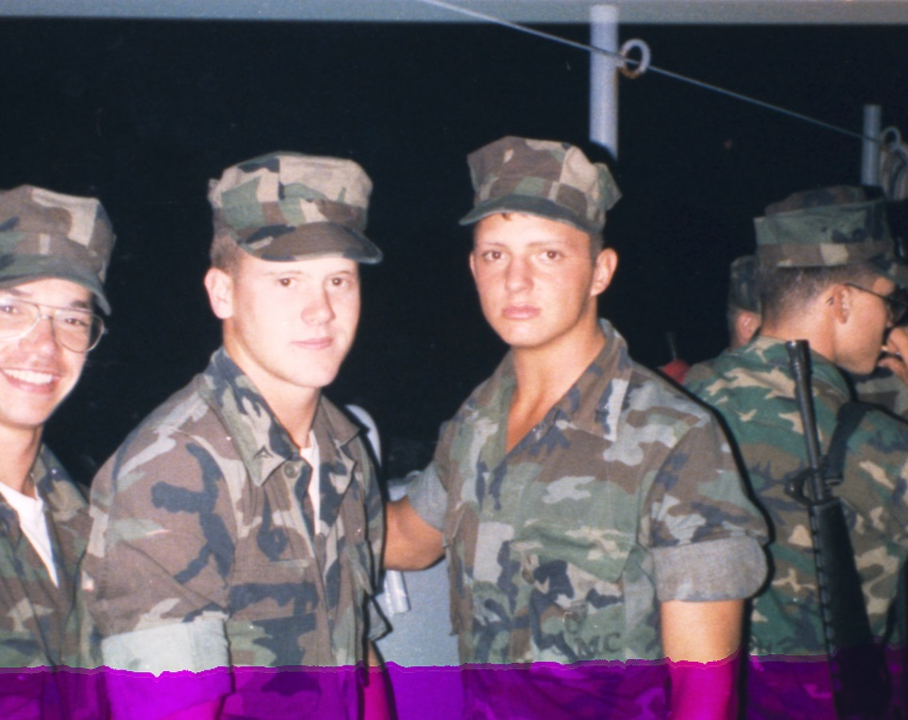
LCpl Moudy, LCpl Brown 1/9 Comm Plt. – May 31st, 1984 our 1/9 arrival via boat at Fort Sherman, Panama Canal

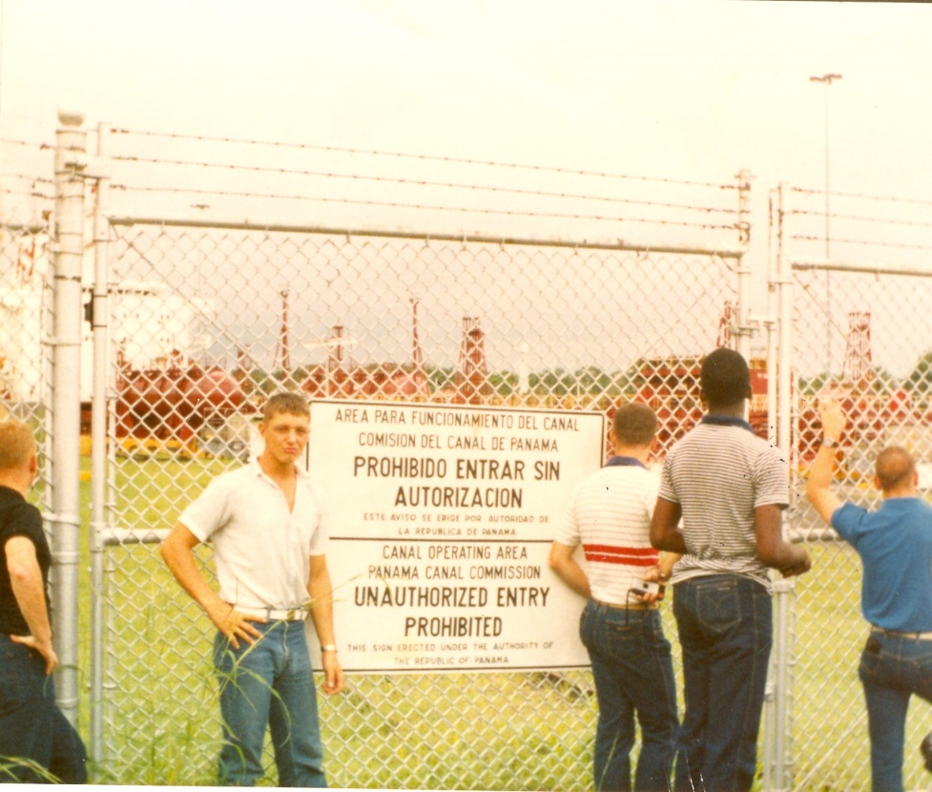
1st Battalion 9th Marines in June 1984 received about 3 hours of liberty in Panama City, Panama. The two buses we traveled on stopped about half way between Fort Sherman and Panama City giving us a chance to get out and see a lock. — Jim Borseth, David Anson Brown, Robert Lucke, John Tinsley, [?] in Panama.
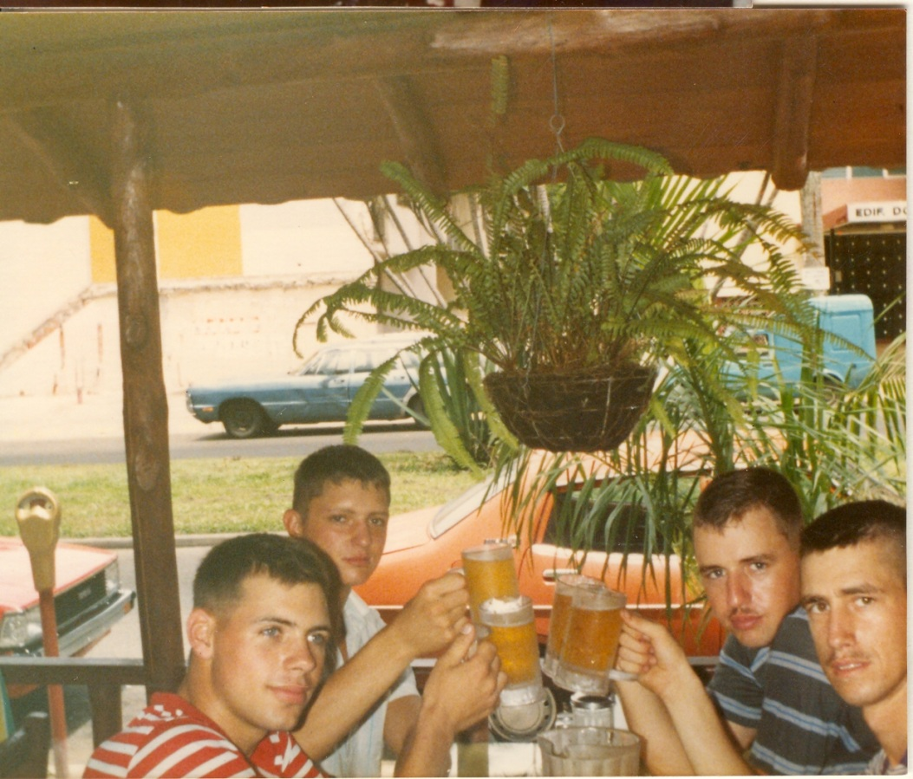
Members of 1/9 Comm Plt on Liberty in Panama City, Panama – mid June 1984

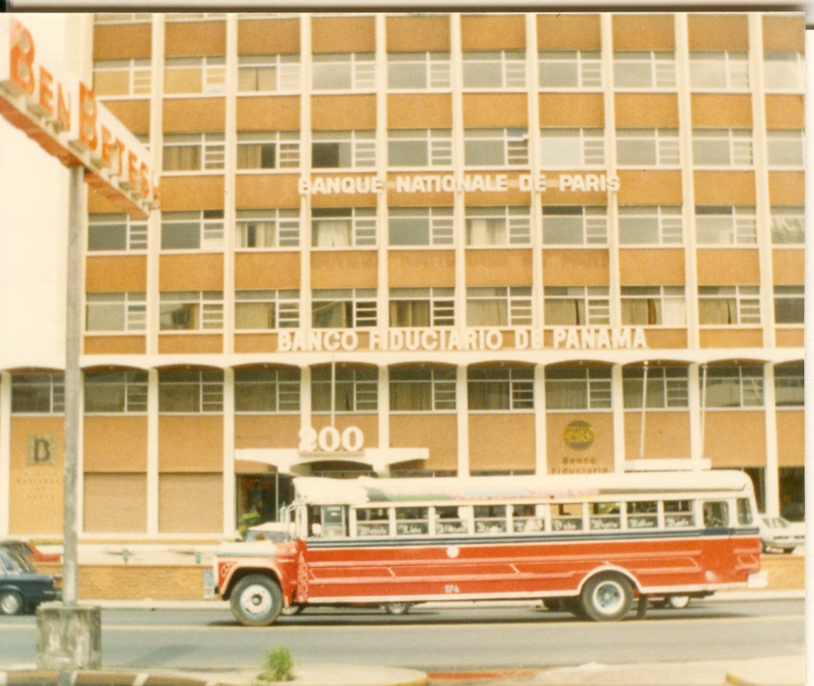
Panama City, June 1984 – Bank of Panama. Traffic was just coming back on the mostly deserted streets after about 45 days of National Martial Law (riots) and a sunset curfew from the aftermath of the May 6, 1984 Nicolás Ardito Barletta election as President of Panama a supporter of Manuel Noriega.

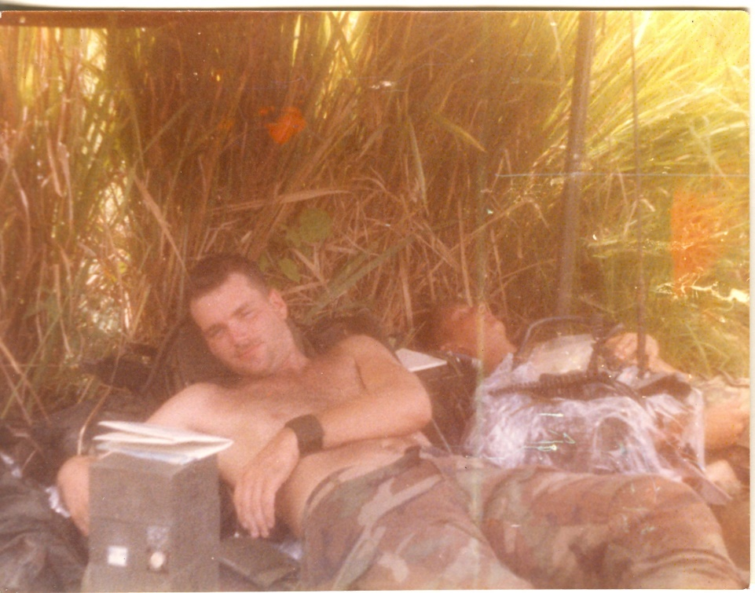
LCpl Bob Mills and LCpl David Anson Brown

1st Bn 9th Marines Fort Sherman, Panama June 1984.
At 1/9 A Company perimeter during a three day exercise the last event of training.

May 1984 Panama Election

1989 The U.S. invades Panama [History Channel]
Noriega supported U.S. initiatives in Central America and in turn was praised by the White House, even though a Senate committee concluded in 1983 that Panama was a major center for drug trafficking. In 1984, Noriega committed fraud in Panama's presidential election [6 May 1984 - 16 May 1984] in favor of Nicolás Ardito Barletta, who became a puppet president. Still, Noriega enjoyed the continued support of the Reagan administration, which valued his aid in its efforts to overthrow Nicaragua's Sandinista government.
http://www.history.com/this-day-in-history/the-u-s-invades-panama

Nicolás Ardito Barletta Vallarino
The election was the country's first after 16 years of military rule, something that had been agreed to during US negotiations that led to the signing of the Panama Canal Treaty in 1977 (Ardito Barletta was among the negotiators for Panama). The campaign proved to be bitterly contested, with both sides predicting victory. Arias and his backers claimed that Ardito Barletta was conducting the campaign unfairly. In addition, most of the media—television, radio stations, and newspapers—favored the government coalition. For example, only one of the country's five daily newspapers supported the ADO.
Voting day, 6 May 1984, was peaceful, but violence led by Arias's supporters broke out the next day in front of the Legislative Palace, where the electoral board was meeting. One person was killed. The opposition charged that there was electoral misconduct and fraud. The candidates for congress on both sides challenged the vote count at the district level, delaying the final count. Meanwhile, both sides claimed victory.
Despite this atmosphere, the initial exit polls showed Ardito Barletta with a narrow lead. On 16 May 1984, after ten days, the district results were finally tallied by the Electoral Tribunal and Ardito Barletta was declared the winner by 1,713 votes, defeating Arias. However, the results continued to be challenged. The United States and Mexico were the first to recognize the results, followed by other countries.
https://en.wikipedia.org/wiki/Nicol%C3%A1s_Ardito_Barletta_Vallarino

Panama Regime Stole Election, U.S. Finds
June 22, 1986|By Seymour M. Hersh, New York Times News Service.

WASHINGTON — The United States has assembled conclusive evidence showing that Gen. Manuel Antonio Noriega, the military strongman of Panama, ordered the Panama Defense Force to intervene and overturn the results during that country's 1984 presidential election, according to Reagan administration officials.

The officials said the CIA and secret analyses provided by the U.S. Embassy in Panama concluded that extensive vote fraud took place. A senior State Department official said there was "absolutely no question" the Defense Force's intervention came at the express order of Noriega.
A White House official with direct knowledge of the situation in Panama similarly said CIA field reports had painted a clear picture of vote-stealing and had tied it directly to Noriega. "I saw the original reports in the daily intelligence briefs," he said. "They were extremely accurate."
These U.S. officials, some of whom were serving in Panama at the time, said vote-stealing and fraudulent counting occurred after it became clear that Nicolas Ardito Barletta, the candidate supported by Noriega and the Reagan administration, was running behind Arnulfo Arias Madrid, the opposition candidate.
Noriega is the commander of the Panama Defense Force, which at the time of the election was known as the national guard, and he is widely considered the politically dominant force in the nation.
The general was unavailable for comment on the charges of election rigging.
Last month, according to first-hand sources, CIA officials told a top-secret Senate Foreign Relations subcommittee hearing on Panama that Arias actually won the election by 30,000 votes. Shortly after the election, the U.S. Embassy initially concluded that Arias won by 25,000 votes, administration officials said.
Despite the extensive information on vote fraud, American officials and diplomats said, Secretary of State George Shultz headed the U.S. delegation to Barletta's inauguration in October, 1984. While there, Shultz said Barletta's election offerred "Panamanians of all political persuasions a new opportunity for progress and national development."
Barletta was forced out of office by Noriega last fall after he agreed to establish a commission to investigate the torture and murder of Dr. Hugo Spadafora, a leading opponent of Noriega's regime. The president's successor, Eric Arturo Delvalle, is viewed a figurehead, with Noriega and the Defense Force retaining tight control.
Public charges of vote-stealing were made shortly after the election and continue to be made in Panama, but the official American Embassy position, as reported at the time of the election, was that the U.S. had received no evidence of fraud and had warned prior to the election that any attempt at rigging could result in a cutoff of American aid to Panama.
In explaining the administration's position two years ago, some officials pointed out that Washington had badly wanted an election. Panama had not held a presidential election since 1968.
Barletta, an economist who had studied at the University of Chicago under Shultz in the 1960s, was known to have no special ties to the Defense Force.
Reagan administration officials acknowledged that Barletta had been promoted and, before his official nomination, approved as a candidate by senior White House, Defense and State Department officers at meetings in Washington in late 1983 and early 1984.
http://articles.chicagotribune.com/1989-05-08/news/8904100898_1_guillermo-endara-opposition-candidate-carlos-duque

PANAMA LEADER SEEKS TO CALM ELECTION FRICTIONS
By STEPHEN KINZER
Published: May 9, 1984

PANAMA, May 8— In the wake of post-election disturbances Monday night that left one person dead and 40 injured, President Jorge Illueca appealed to Panamanians today to remain calm and refrain from further political demonstrations.
Nonetheless, supporters of both presidential candidates rallied in front of their respective headquarters this evening. The vote counting is continuing but both candidates have released unofficial tallies showing them winning the presidency.
By midevening, no clashes had been reported and demonstrators from both parties had begun to disperse. The plaza facing the Legislative Palace was empty except for soldiers guarding entrances to the building.
President Illueca said he had ordered an investigation of Monday's violence and pledged to punish those who fired on civilians. The gunmen appeared to be acting on behalf of the ruling coalition, and the dead demonstrator, Jose Angel Gutierrez Vega, 29 years old, was identified as a supporter of the opposition.
In an interview after his address to the nation, President Illueca said he had telephoned Dr. Arnulfo Arias Madrid, the 82-year-old opposition candidate, who has a history of conflict with the military, and asked him to visit the presidential palace for a meeting. But he said Dr. Arias had declined the invitation and had replied that he would be willing only to receive the President at his own residence.
Civilians Blamed for Shooting
President Illueca said he had heard reports that the violence had been provoked by armed civilians while soldiers watched without interfering. "This is not legal, this is not admissable," he said.
The Government's presidential candidate, Nicolas Ardito Barletta, an economist, said in a telephone interview this afternoon that he was making "a maximum effort to control all our groups, which is not always easy to do." He said Arias supporters had provoked violence Monday night by heckling election officials inside the Legislative Palace and by trying to jump from the spectator section into the area where votes were being counted.
"We are lacking results from some areas, but our impression is that we should win by about 8,000 votes," Mr. Barletta said.
On Monday Dr. Arias, a Harvard- educated physician, declared that his figures showed him the winner. Today, his partisans continued to insist that he was substantially ahead.
Arias Backers Planned March
Backers of Dr. Arias had called for a march this afternoon, but none developed. A campaign spokesman, Louis Martinez, said after President Illueca's address that demonstrators would not be led toward the Legislative Palace.

"We're going to keep our people out here," he said. "Since we were accused of provocations yesterday, we would like them to stick around here for the time being. In case the other guys come to bother us, we can say we were provoked this time."
Mr. Barletta said he had directed his supporters, who had also planned a march, to stay away from the Legislative Palace and to avoid any contact with opposition marchers.
The slow pace of vote counting has been frustrating for both candidates and for President Illueca. The President directed the electoral tribunal Monday to finish counting presidential votes as soon as possible, leaving votes for members of the legislature for later. He said he hoped an official winner would be proclaimed by Wednesday.
Dr. Arias has charged that the military-backed Government is trying to impose a fraud that would deprive him of the presidency. The military previously deposed him from the presidency three times, most recently in 1968.
Panamanian television stations, all of which are controlled by the Government, gave only sketchy versions of the violence that shook downtown Panama Monday night. As a result of the lack of information, the city was alive with rumors of imminent coups.
At least three of those injured were reported in serious condition, and President Illueca said one would probably remain paralyzed.
http://www.nytimes.com/1984/05/09/world/panama-leader-seeks-to-calm-election-frictions.html
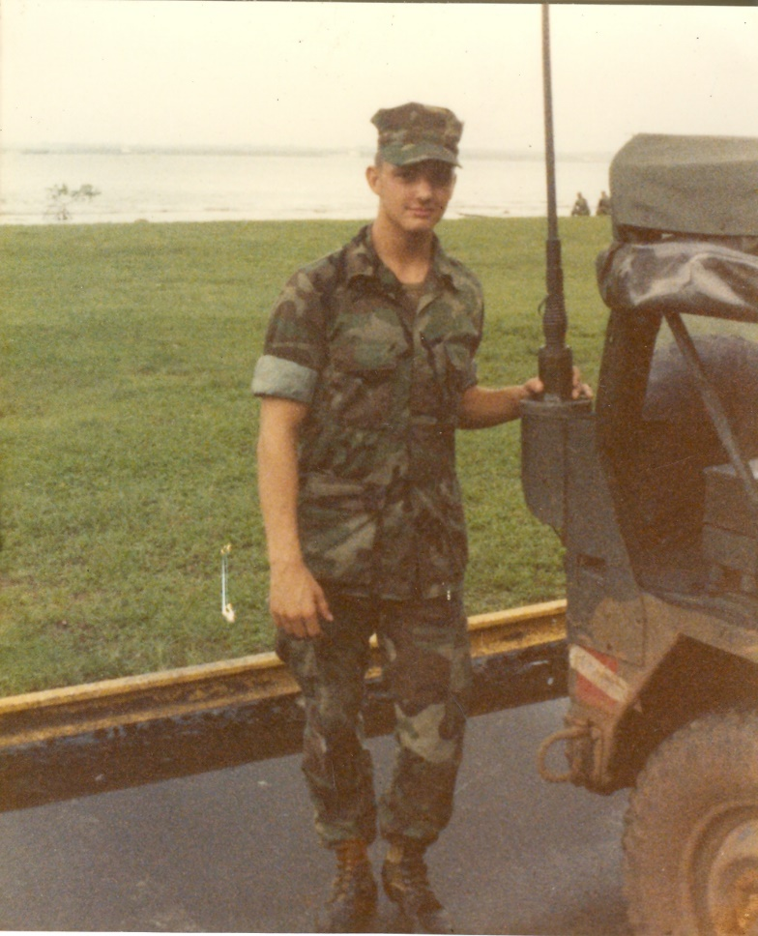

Fort Sherman, Panama June 1984 LCpl David Anson Brown in the area in front of the barracks by the Panama canal. A few Marines are behind me sitting on the canal bank looking over towards Colon. When we first got there a lot of us spent some time standing and sitting out there at night looking at the fires over in Colon across the canal. - Most nights we averaged just a few hours of sleep. We were in the field training every day and cleaning our gear at night then up early.
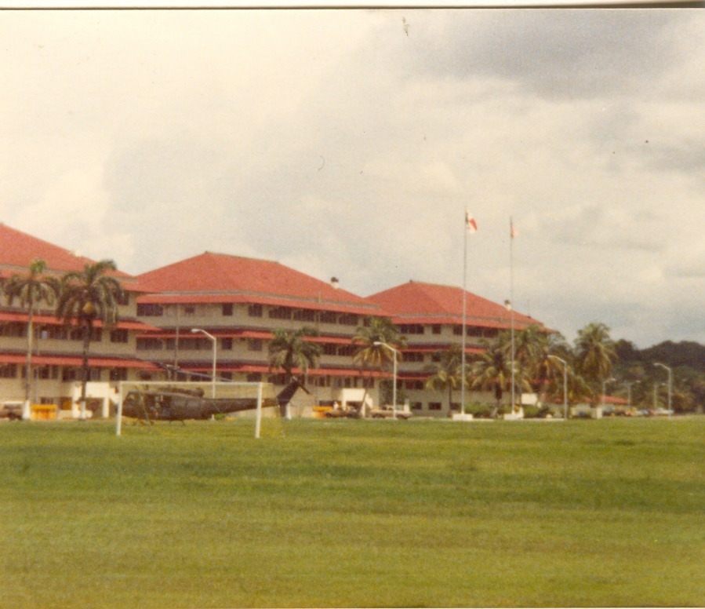
Fort Sherman, Panama – June 1984

When the 1st Bn 9th Marines returned to Camp Pendleton from our Okinawa deployment we were told we were going to Panama. The elections were being held in Panama and the JEST school cycled three Battalions of Marines through to be in the area before, during and after the May 1984 elections - the elections that would eventually end in the 1989 Panama Invasion. We arrived at the end of May and left at the beginning of July.

When we first arrived in Panama we landed at Panama City during post-election riots and martial law. We finally arrived at Fort Sherman late at night after a long bus ride ending in a LCM boat ride down part of the canal and into Fort Sherman.

The next few nights we stood in front of the barracks watching the effects of the riot across the canal in the city of Colon. As we stood on the bank of the canal in front of the barracks we could see fires burning and hear the crowds riot with loudspeakers and gunshots being fired. The fires were both street fire bonfires and a few larger buildings on fire. The light from the fires would bounce off the jungle and it looked like scene from a horror movie. – An official USMC photographer filmed us standing there watching the events in Colon across the canal from us.

The posted photo is from the back of the barracks buildings and was taken in late June maybe even early July within about a week of us leaving Panama. The grass field area [on the left] is where we held our Battalion Graduation formation ceremony on 6/28/1984 my 21st birthday, soon after we left a still tense Panama and returned to Camp Pendleton, CA.

A Personal Note: when I first read in the Bible's Old Testament [Deuteronomy 1:1] about Moses holding the great assembly and formation in the desert mountains with the Nation of Israel the Children of God just before they entered into their Promise Land of Israel, myself having stood in many great assembled formations as a Marine Corps Veteran I really admired and understood what it is to be a part of something great.

Looking at these pictures of Panama and remembering our great 1st Battalion 9th Marines graduation ceremony on that field and remembering our formation back in Okinawa where Lt-Col Hering talked to us about the possibility of going to Beirut and our end of deployment formation in the base theater at Camp Hansen, Okinawa. I also think about the great formations I stood in with the 31st MAU in the Philippines at a time during their guerrilla war and riots and of our formations in Berbera, Somalia down on the beach before our two beer beach party and on the hill at the hospital in Berbera, Somalia. I just as fondly think of our great 3rd Bn M Co formations at MCRD-SD and how proud and fortunate I felt just to be a part of something really great.

As much as I appreciated standing in great formations as a Marine I most often think of Moses and his great OT assembly and of Jesus Christ and the greatest of all assemblies the coming assembly of the gathered immortal, eternal, heavenly generations. It's my biggest hope that one day we will all be in that one really great assembled formation the formation of the Christian Saints in Heaven.

1/9 CAX 29 Palms 1984

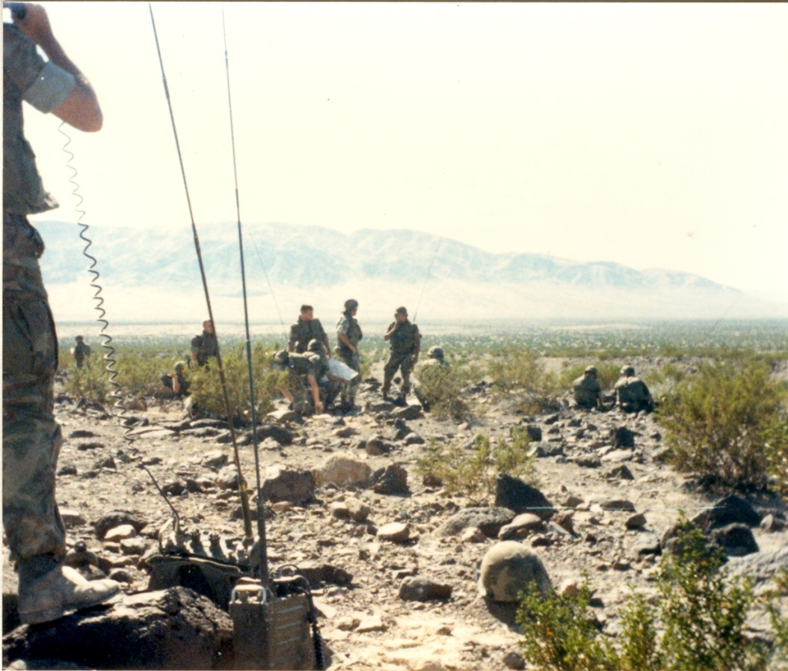
Oct-84 – 1st Bn 9th Marines, 1st Marine Division- CAX (Combined Arms – Artillery and Air Strikes) Exercise 29 Palms, CA
A Co. 1/9 (Comm Plt FAC Marine on the radio) looking over to C Co 1/9 (Artillery F.O. is on the radio).
Photo by LCpl David Anson Brown

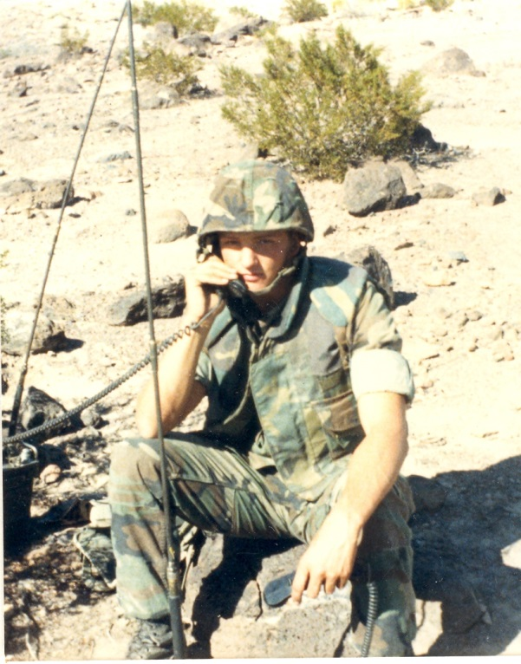
1st Bn 9th Marines, 1st Marine Division – Oct. 1984 – CAX at 29 Palms CA – LCpl David Anson Brown

Extra Photos and Documents
31st Marine Amphibious Unit (MAU) on route to Perth, Australia Oct. 1982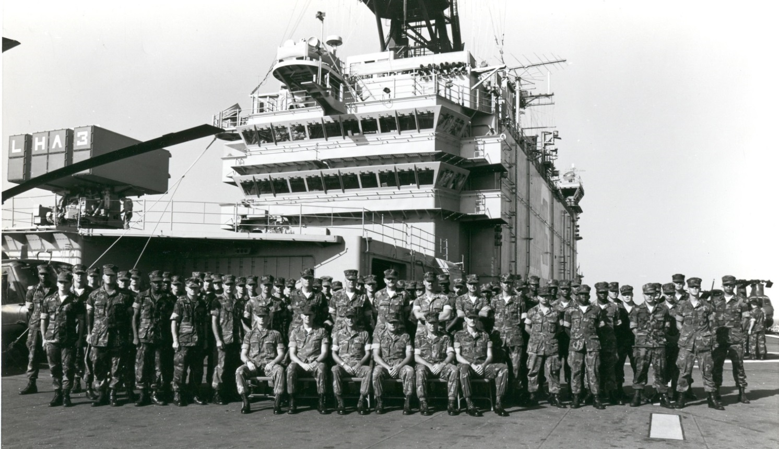
HQ Co 31st MAU on route to Australia before Diego Garcia, northern Somalia and later Oman and the Arabian Sea.
I’m in the middle-right [looking at the picture] of the back row. Oct.-Nov. 1982. — 31st Marine Amphibious Unit.
USS Belleau Wood (LHA-3)
MCRD San Diego, CA Nov. 81 – Jan. 82, Plt. 3101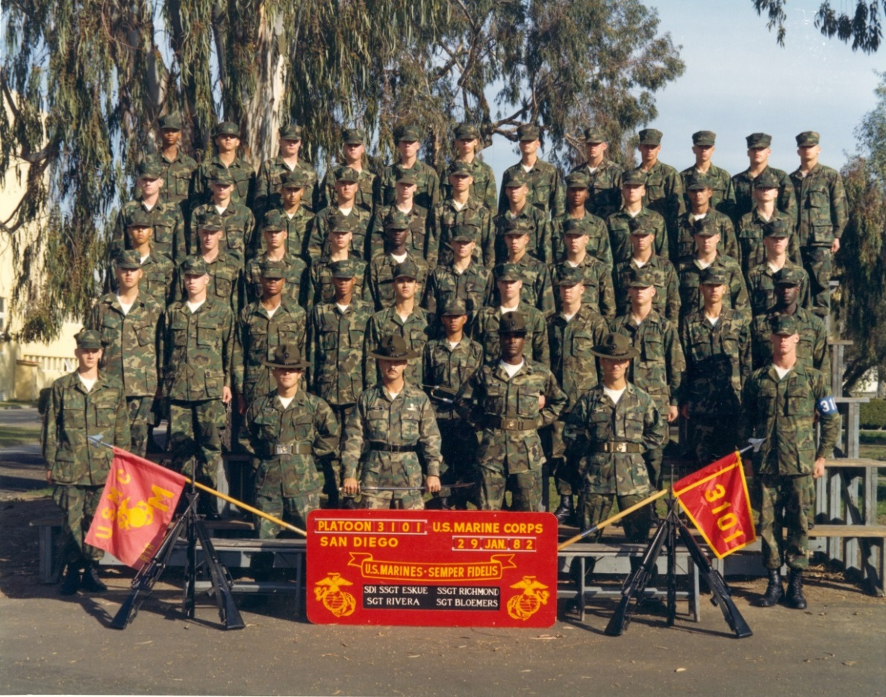
I’m on the 3rd row from the top and the 3rd recruit from the right.
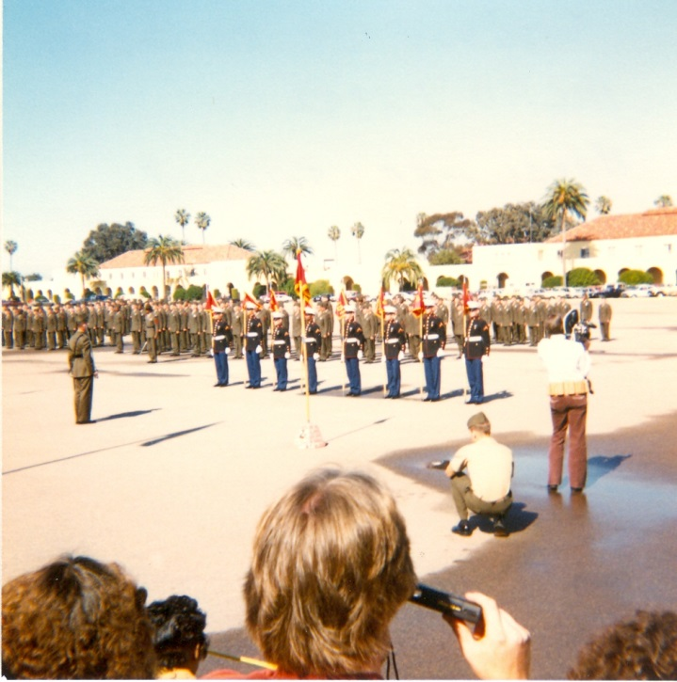
MCRD M Co. Series 3101 Graduation Day – my partents made the trip to graduation.
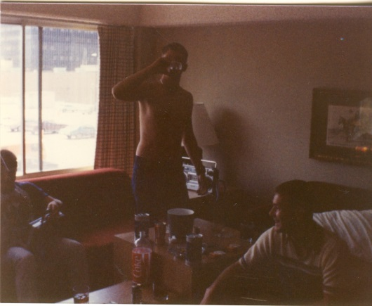
Me and other Marines from 29 Palms, CA - Field Radio Operator (FROC) School. At the old Renaissance Hotel on Hollywood Boulevard in Hollywood, California. Partying for a couple days before we went overseas to the 3rd Marine Division.
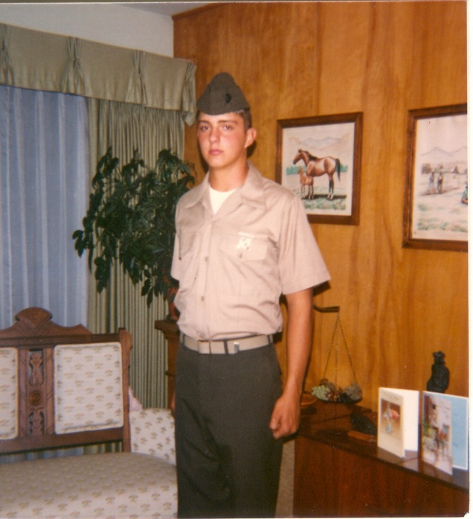On leave May 1982 in Bismarck ND about to go to Okinawa, 3rd Marine Div. Note: my Drill Instructor SDI SSGT Eskue gave me his rifle expert badge on graduation day in boot camp.
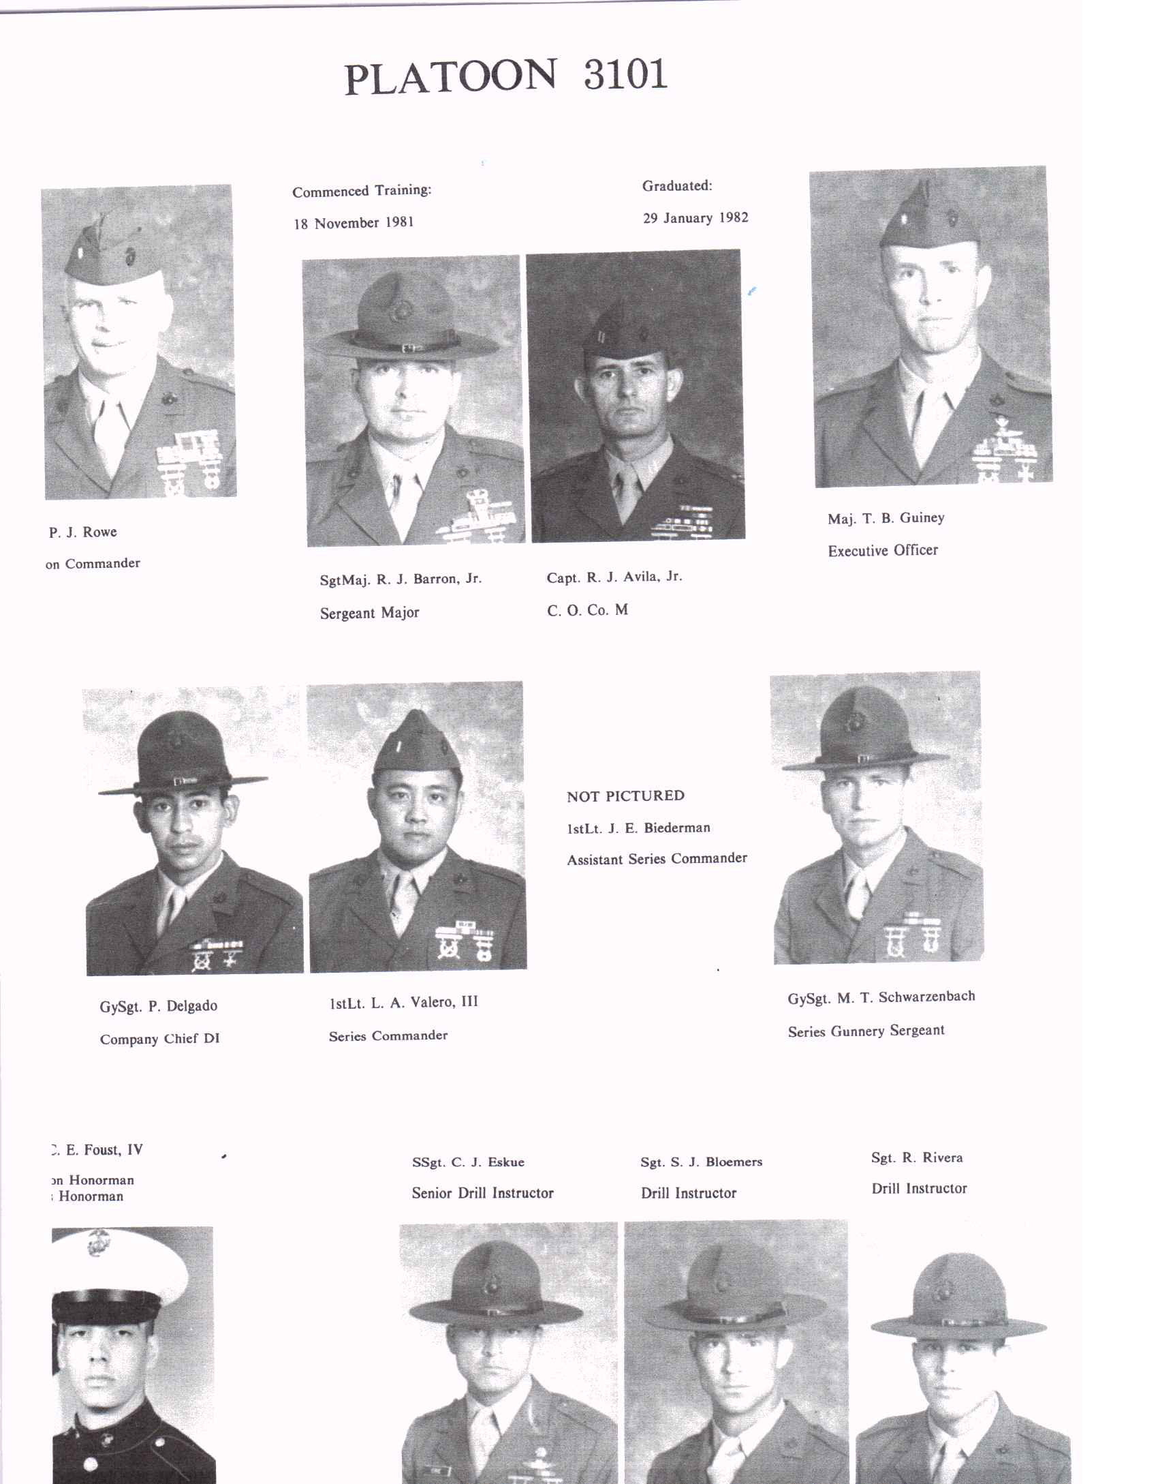
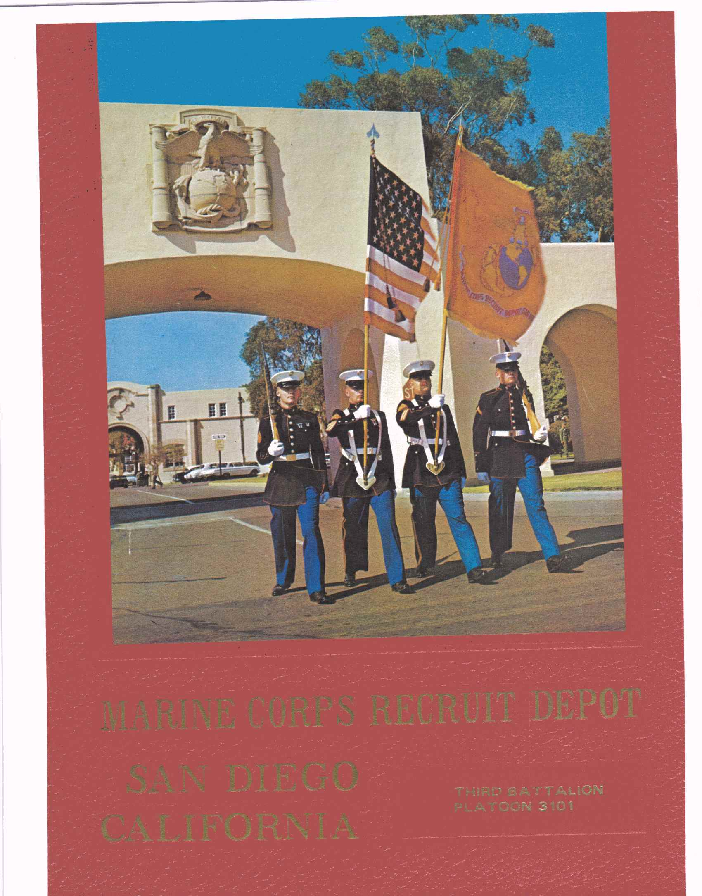

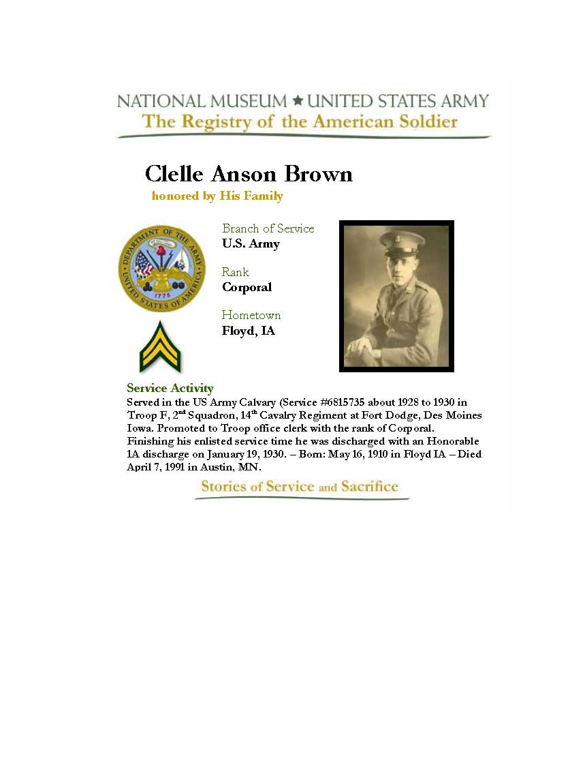
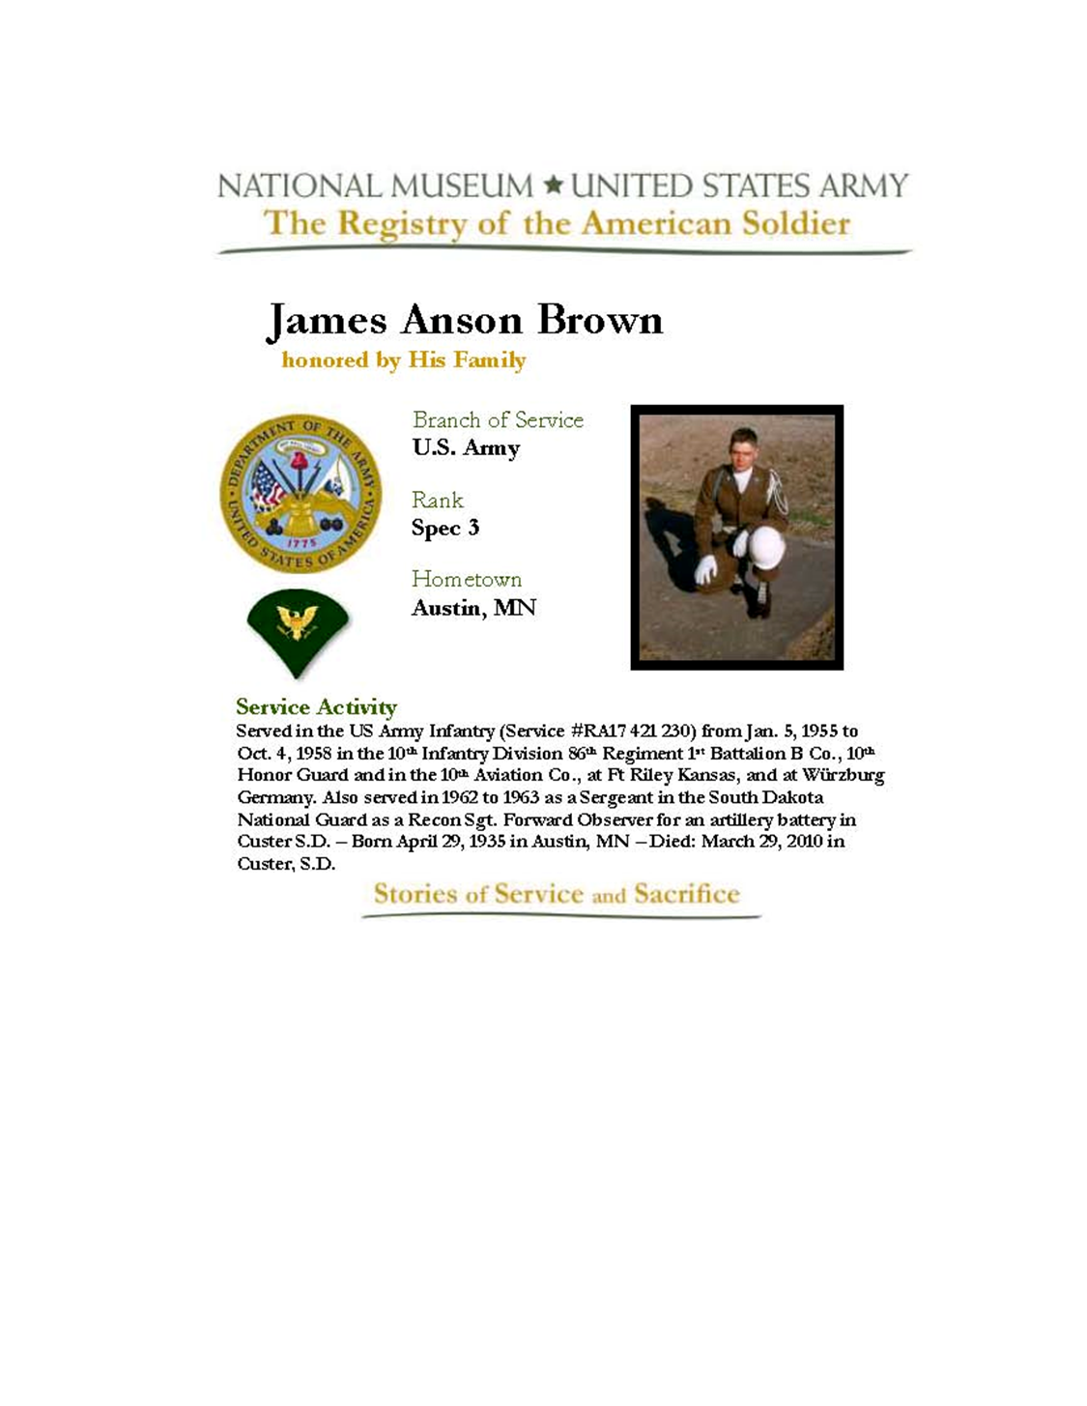

Memorial Day 2005
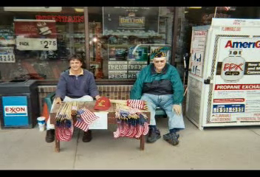

David Anson Brown and James Anson Brown receiving donations on Memorial Day 2005 for the American Legion in Custer, SD.

James Anson Brown
(April 29, 1935 - March 29, 2010)
Memorial Service near Custer, SD – Spring 2010

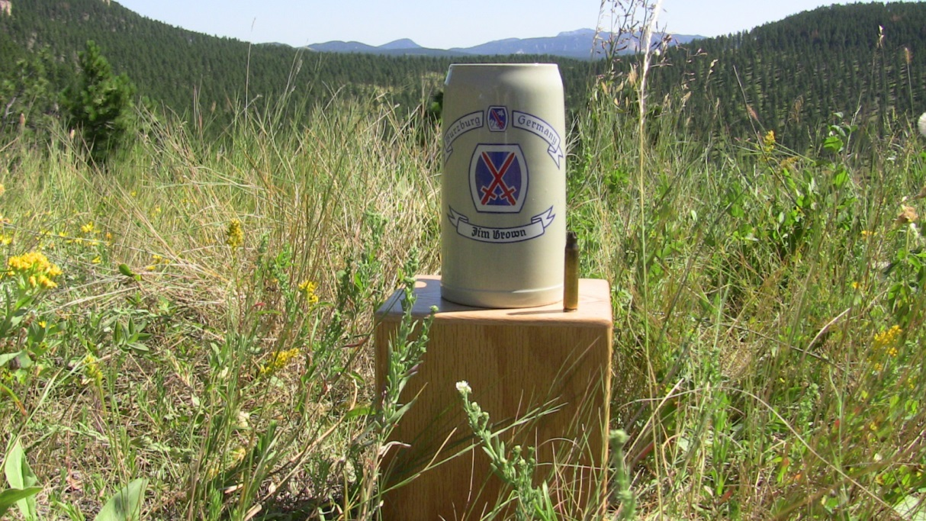

School of Ministry (SoM) Class of 1998 at Calvary Chapel of Costa Mesa, CA

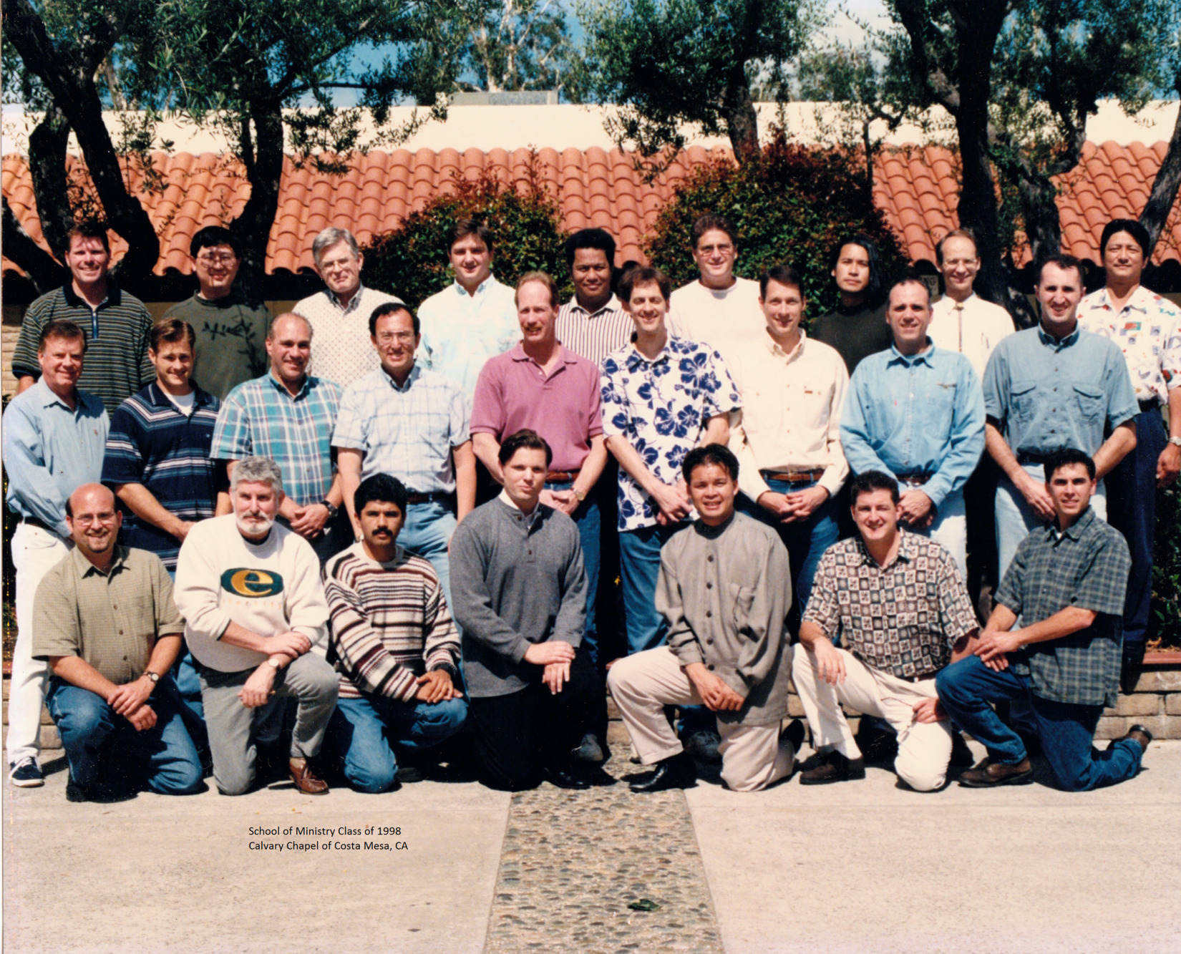

David Anson Brown (back row 4th from the left) May 1998
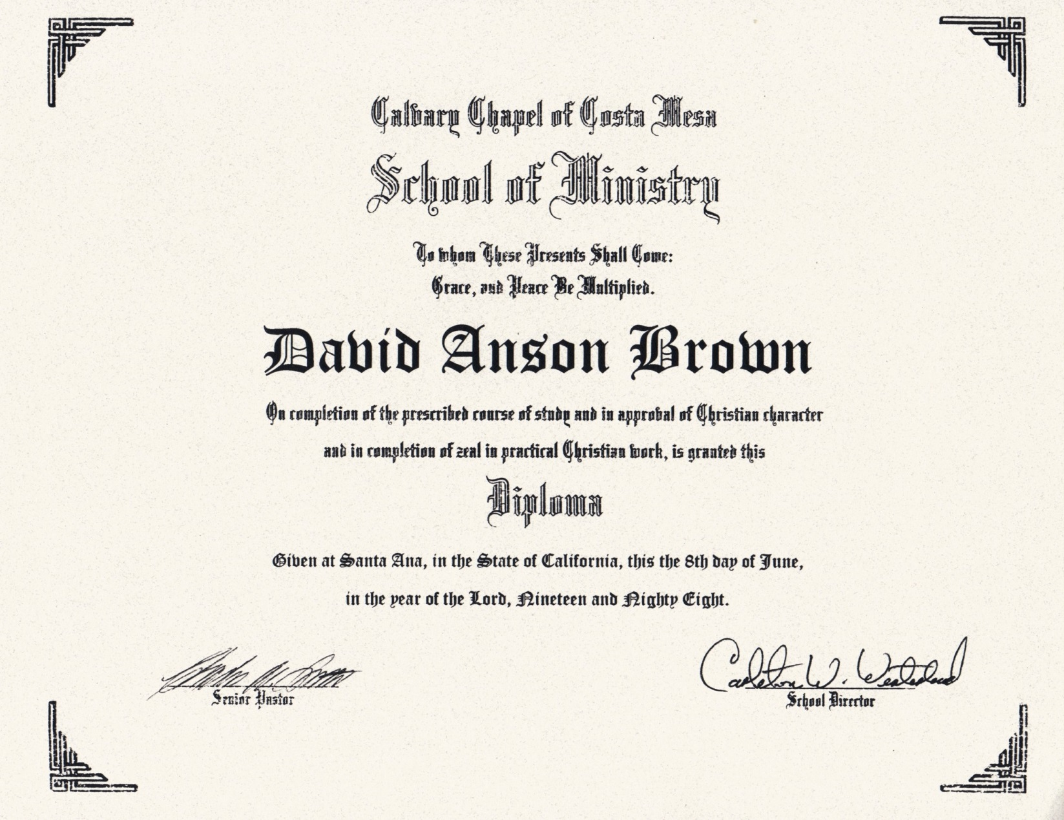
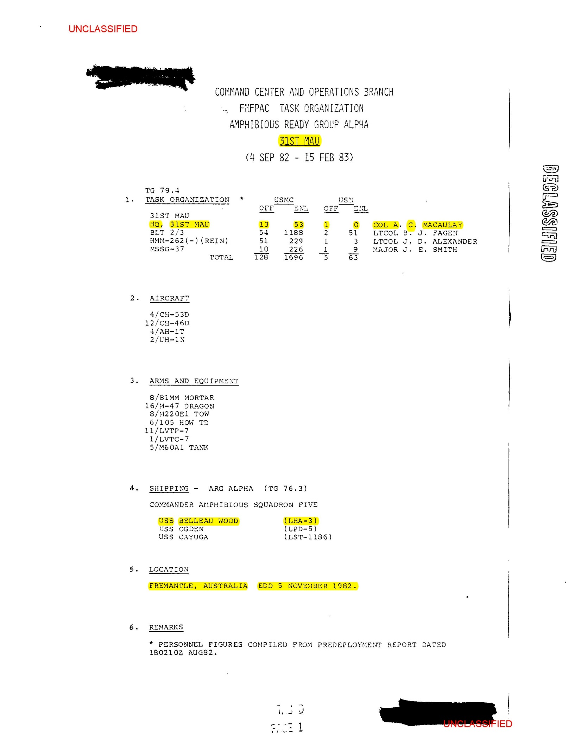
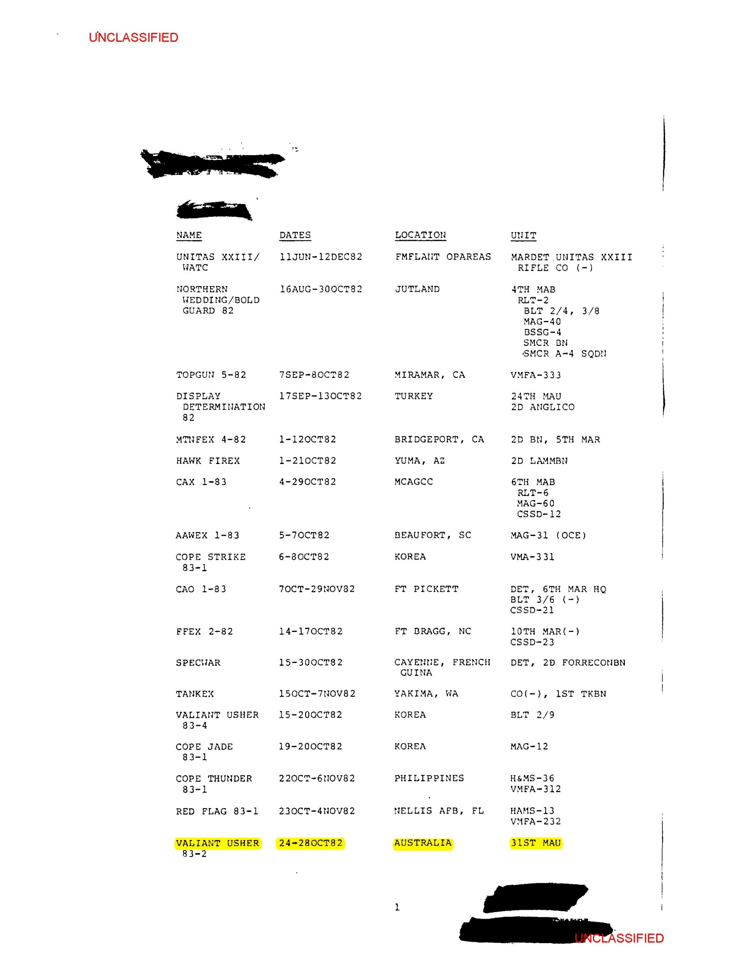
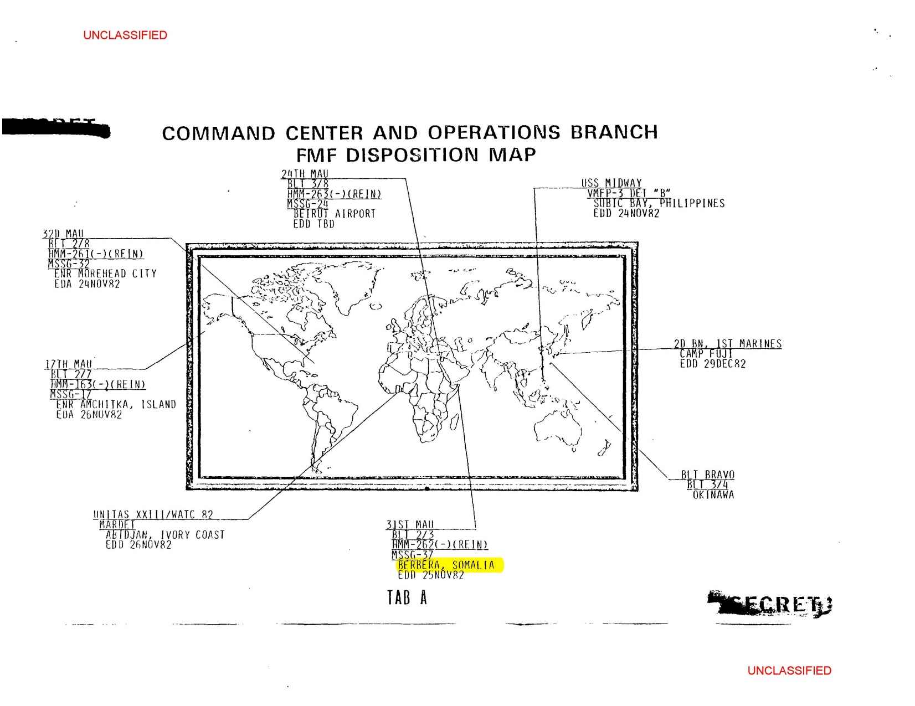

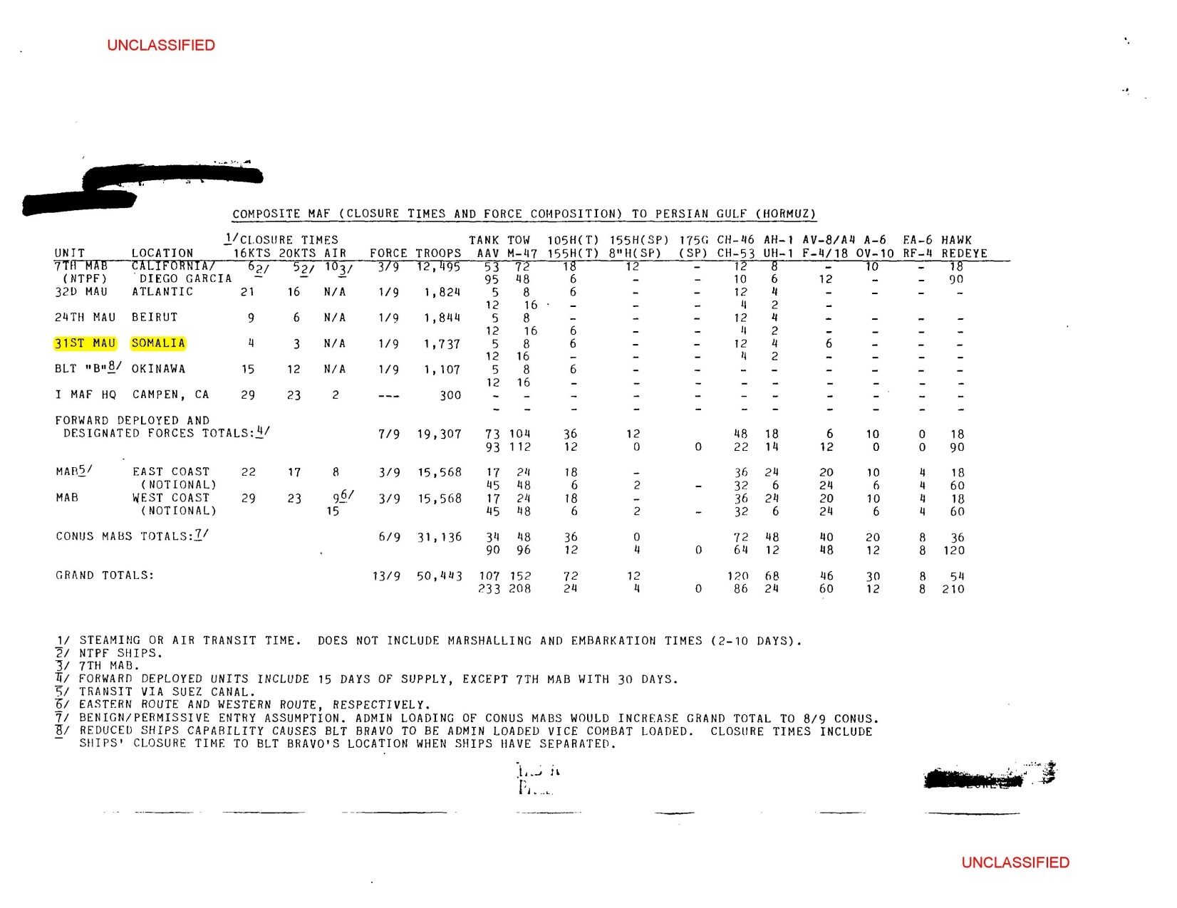

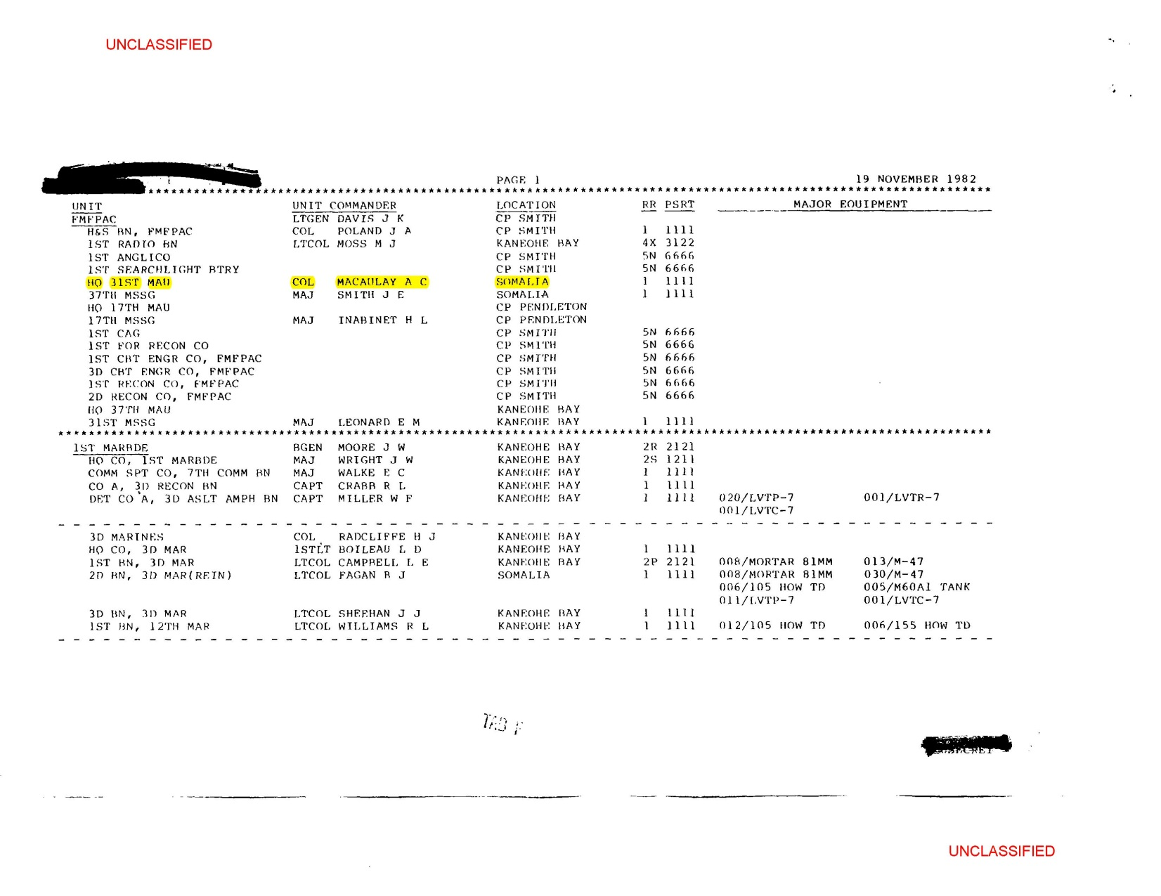

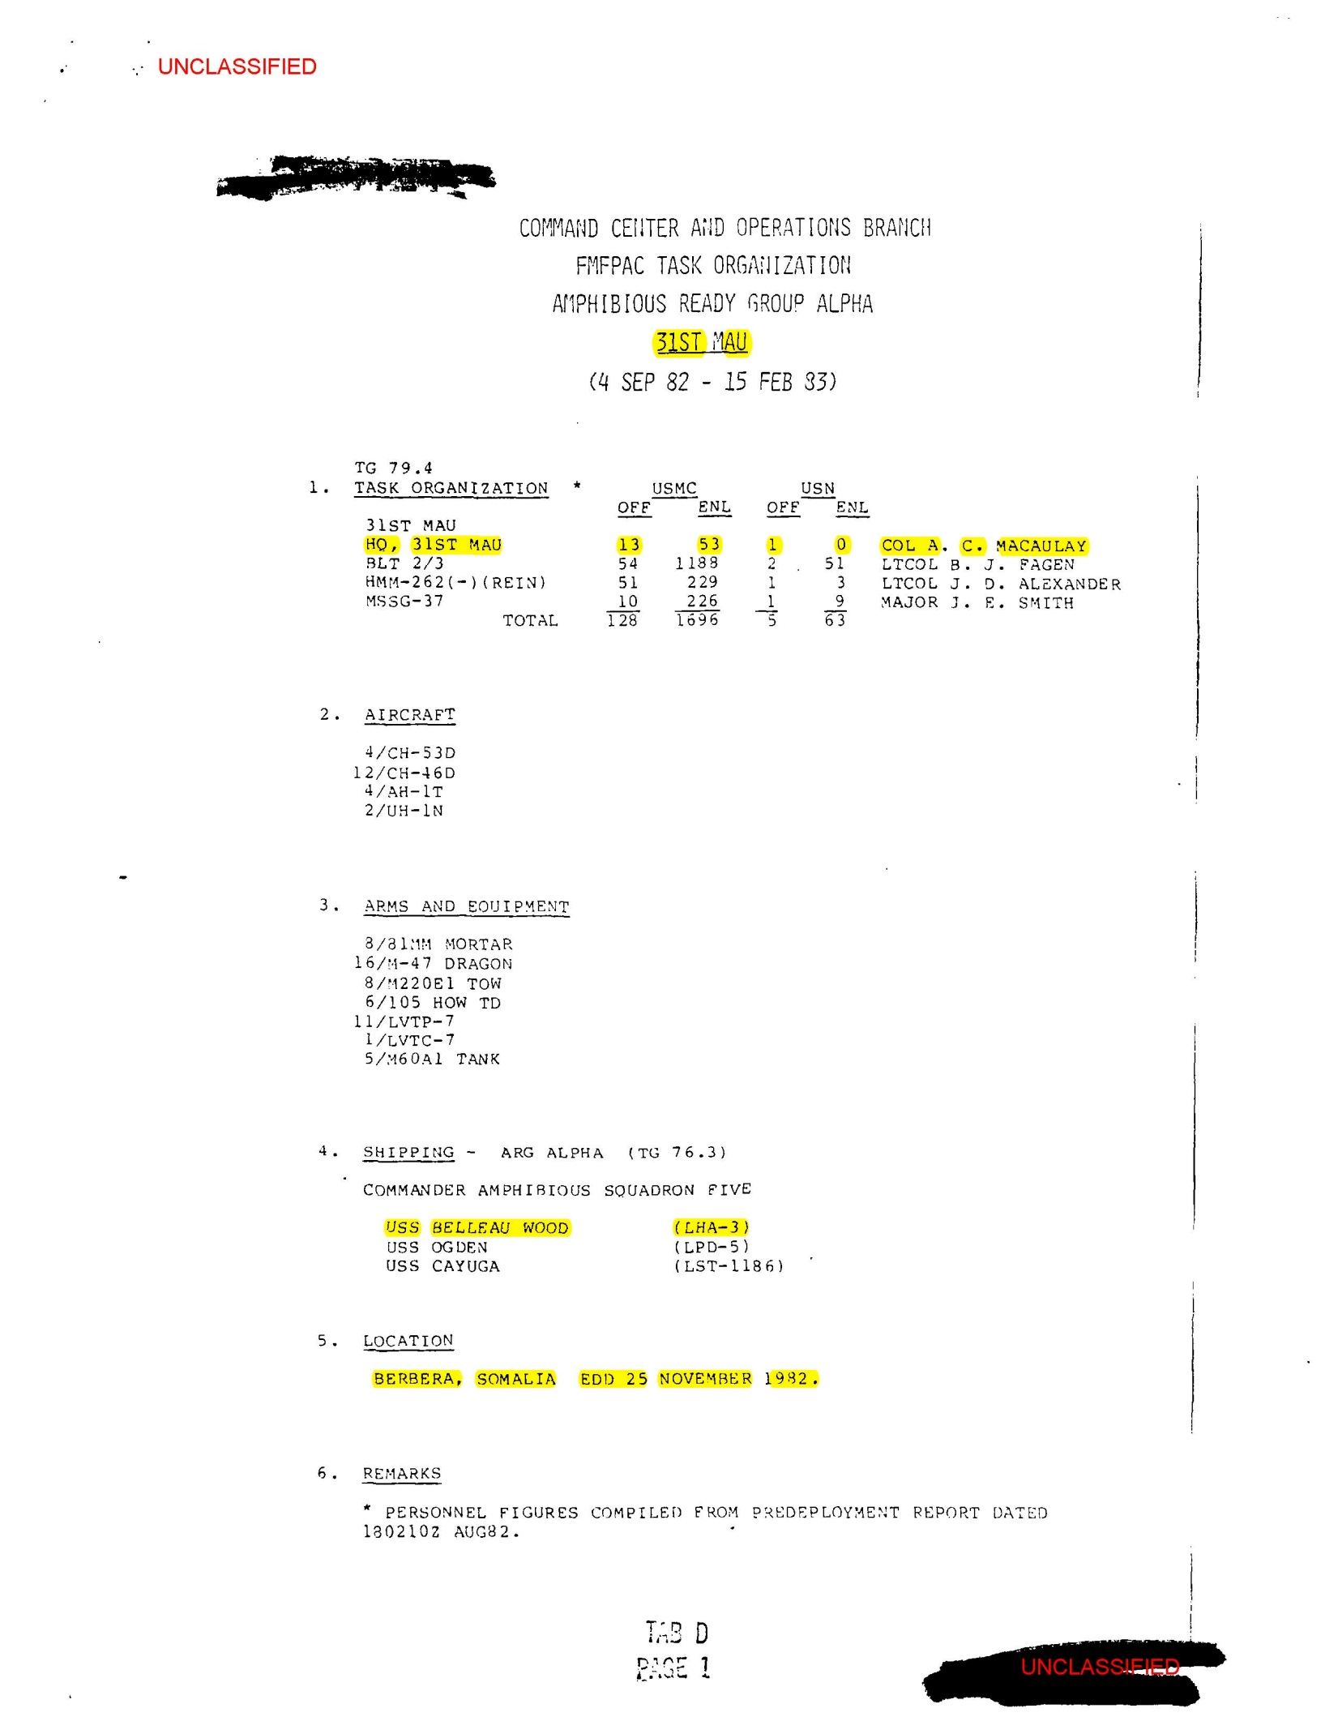
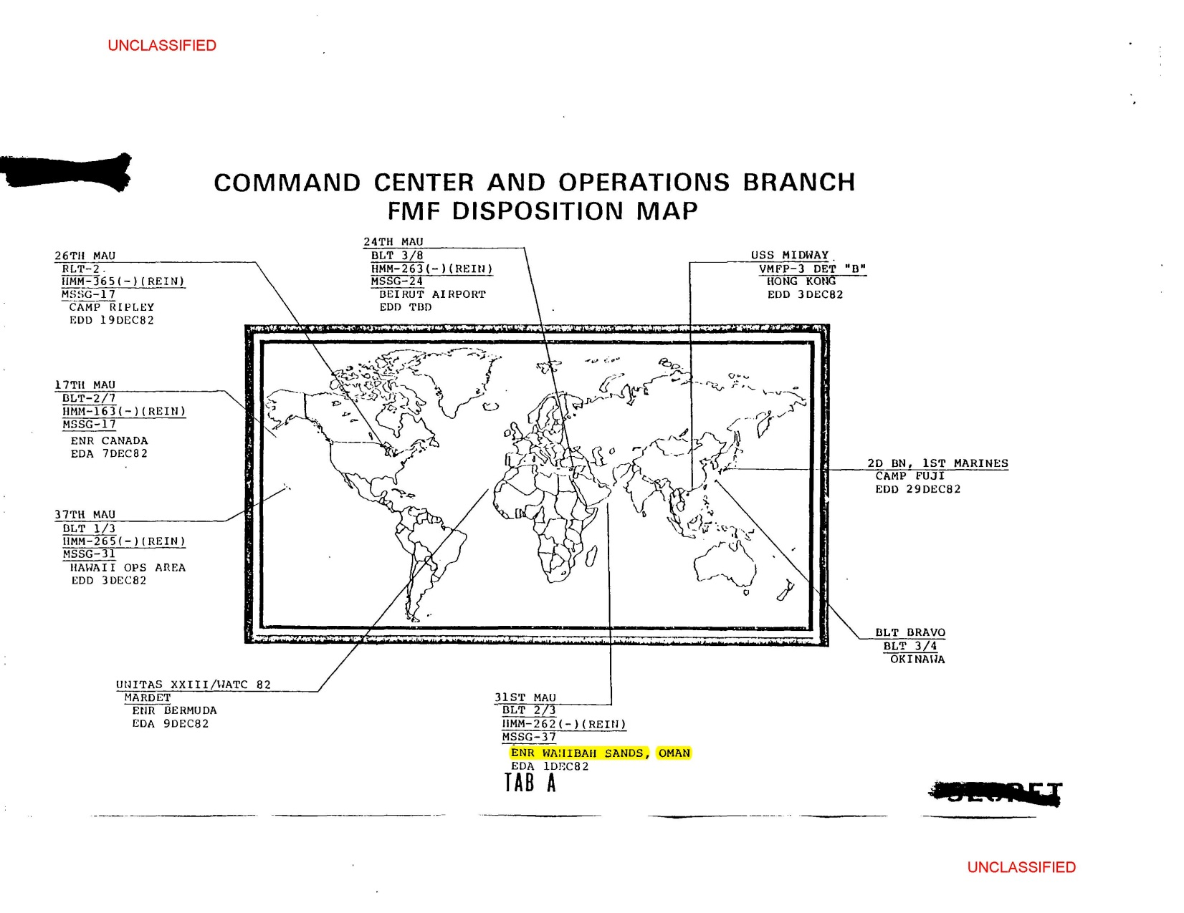

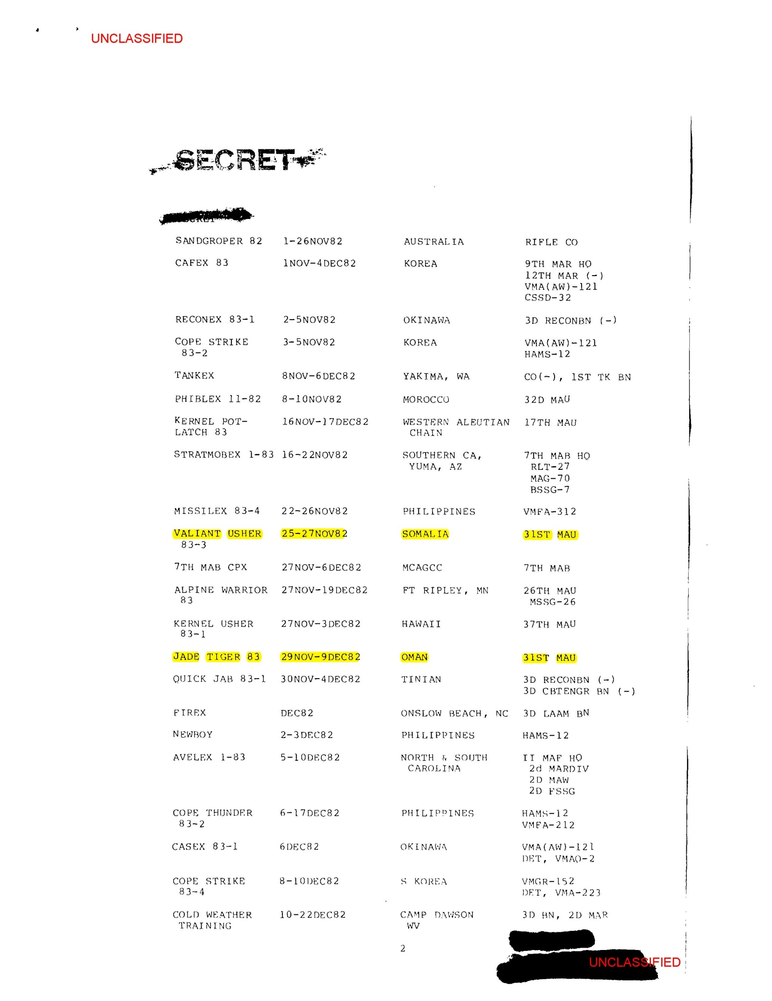
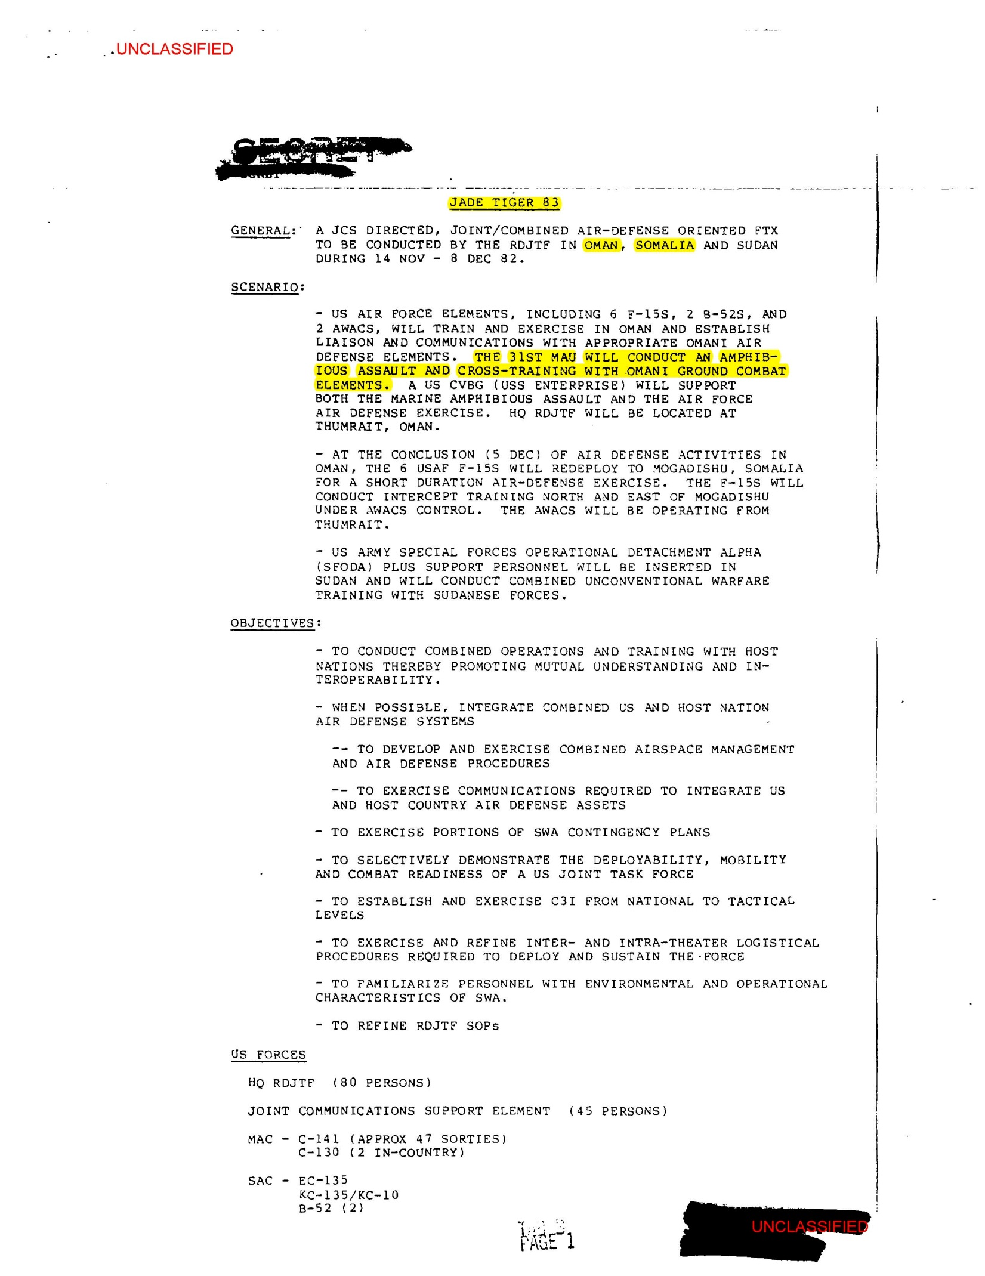
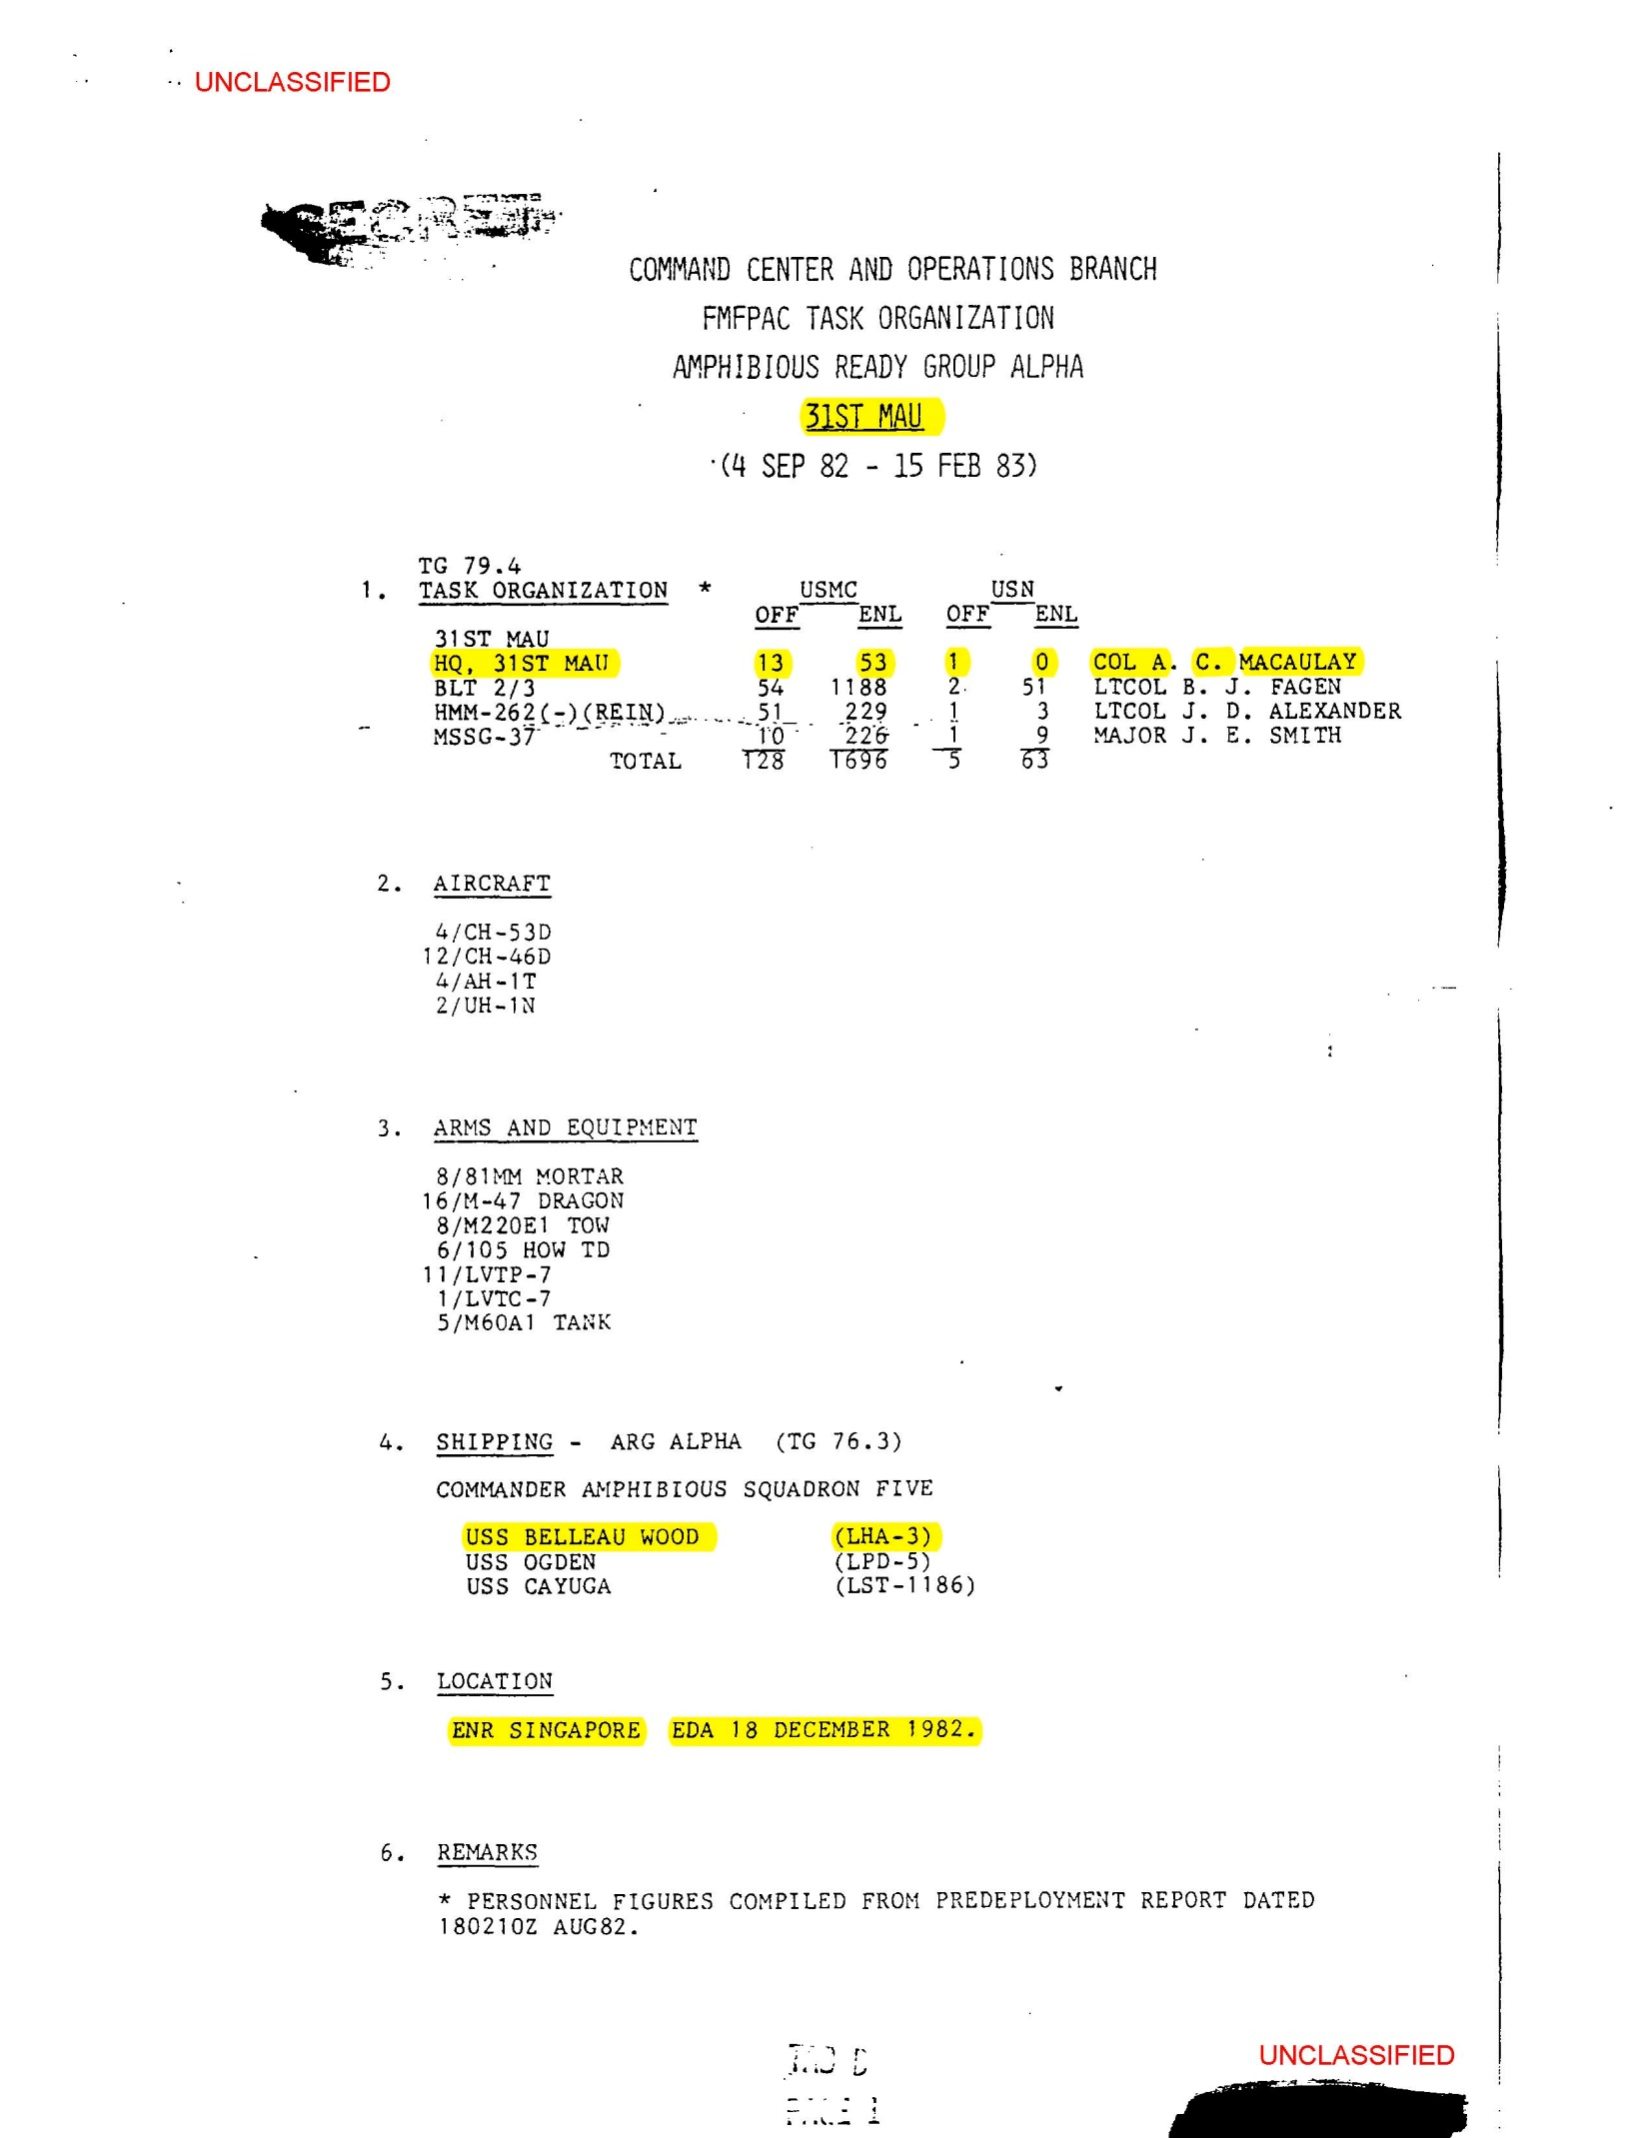
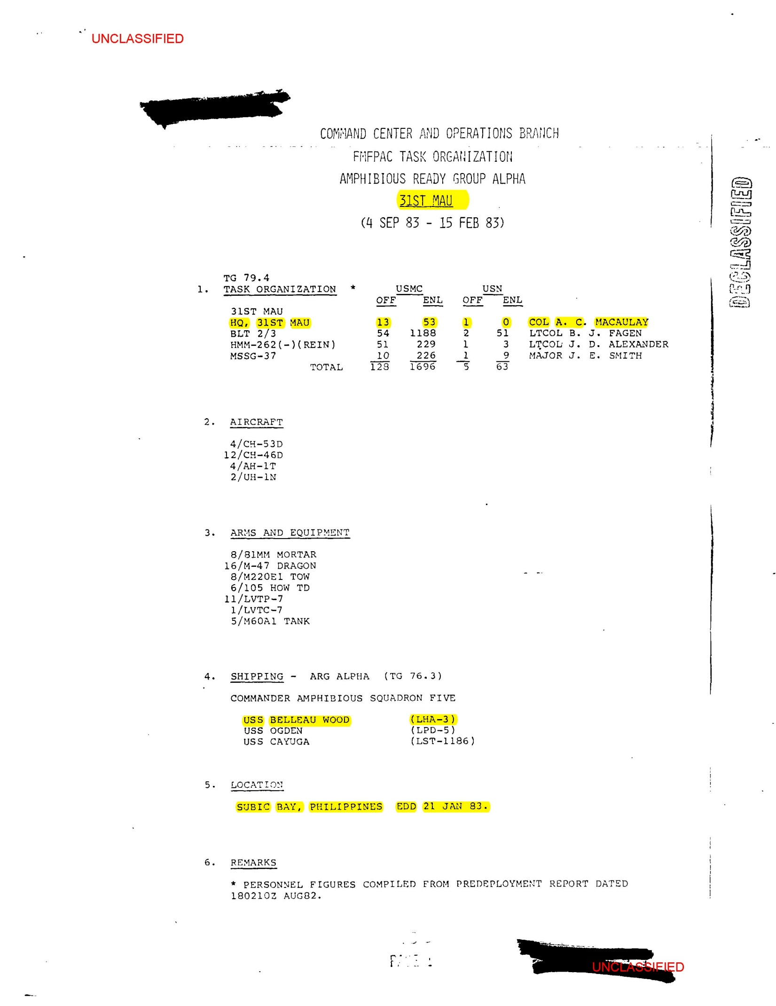
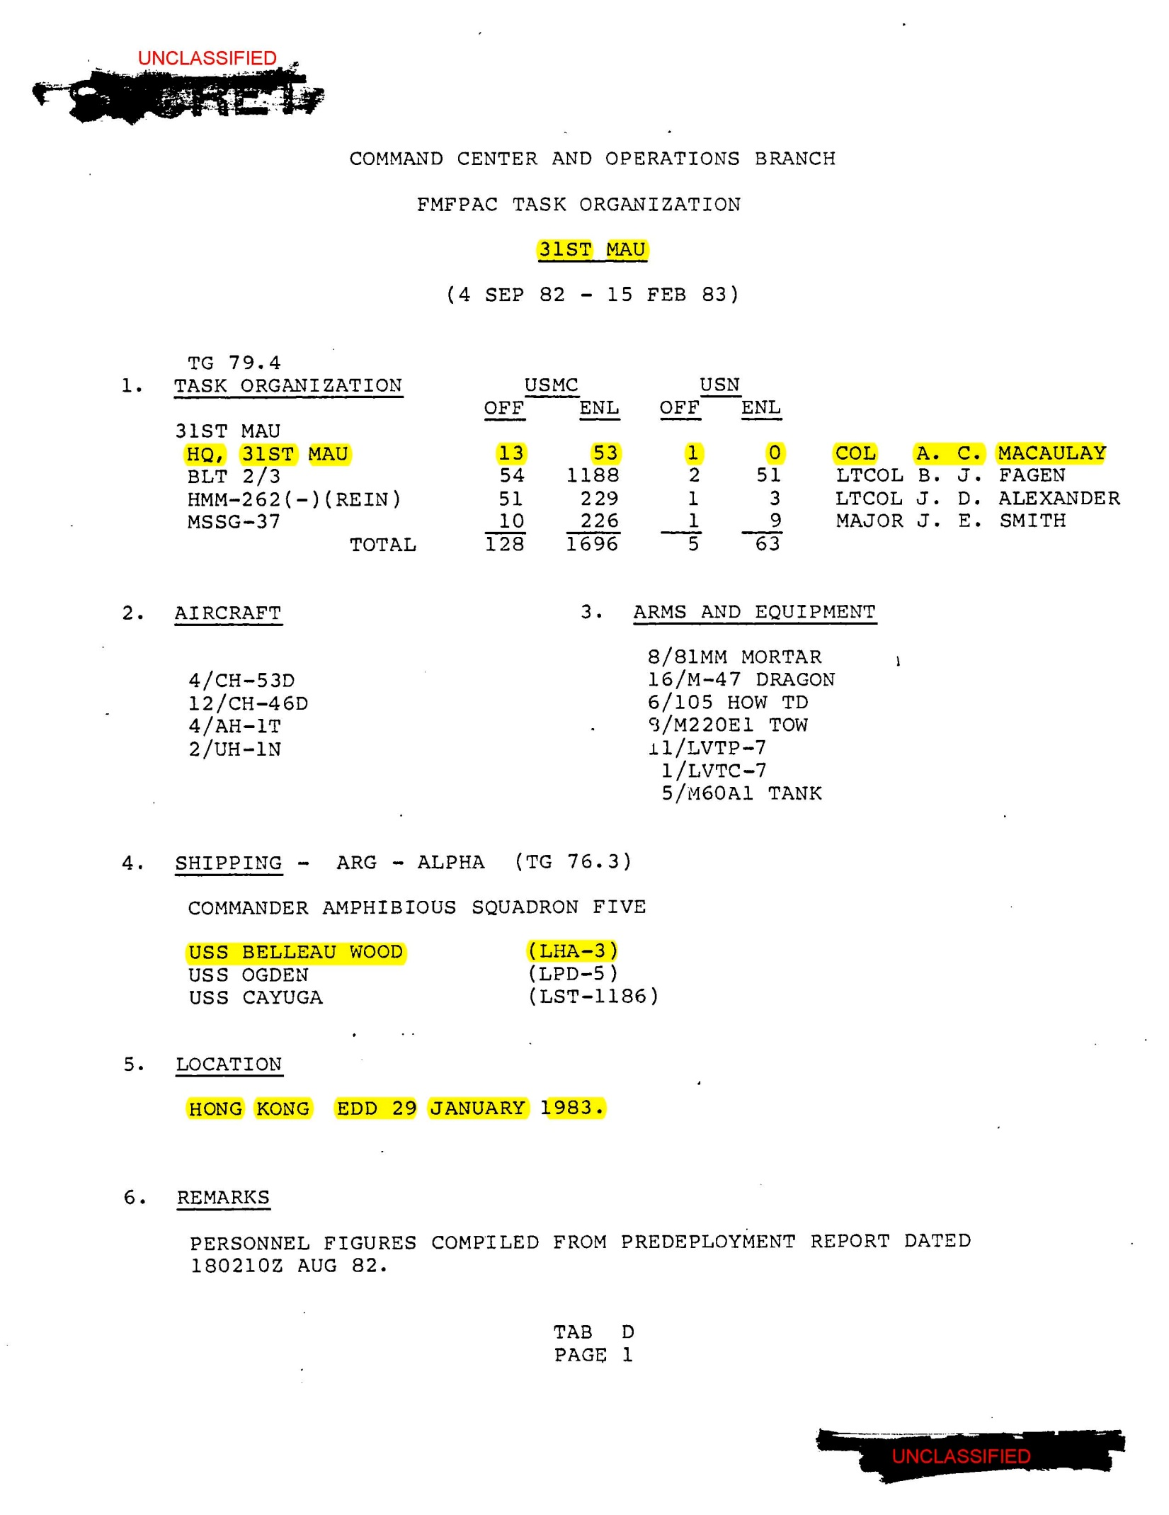
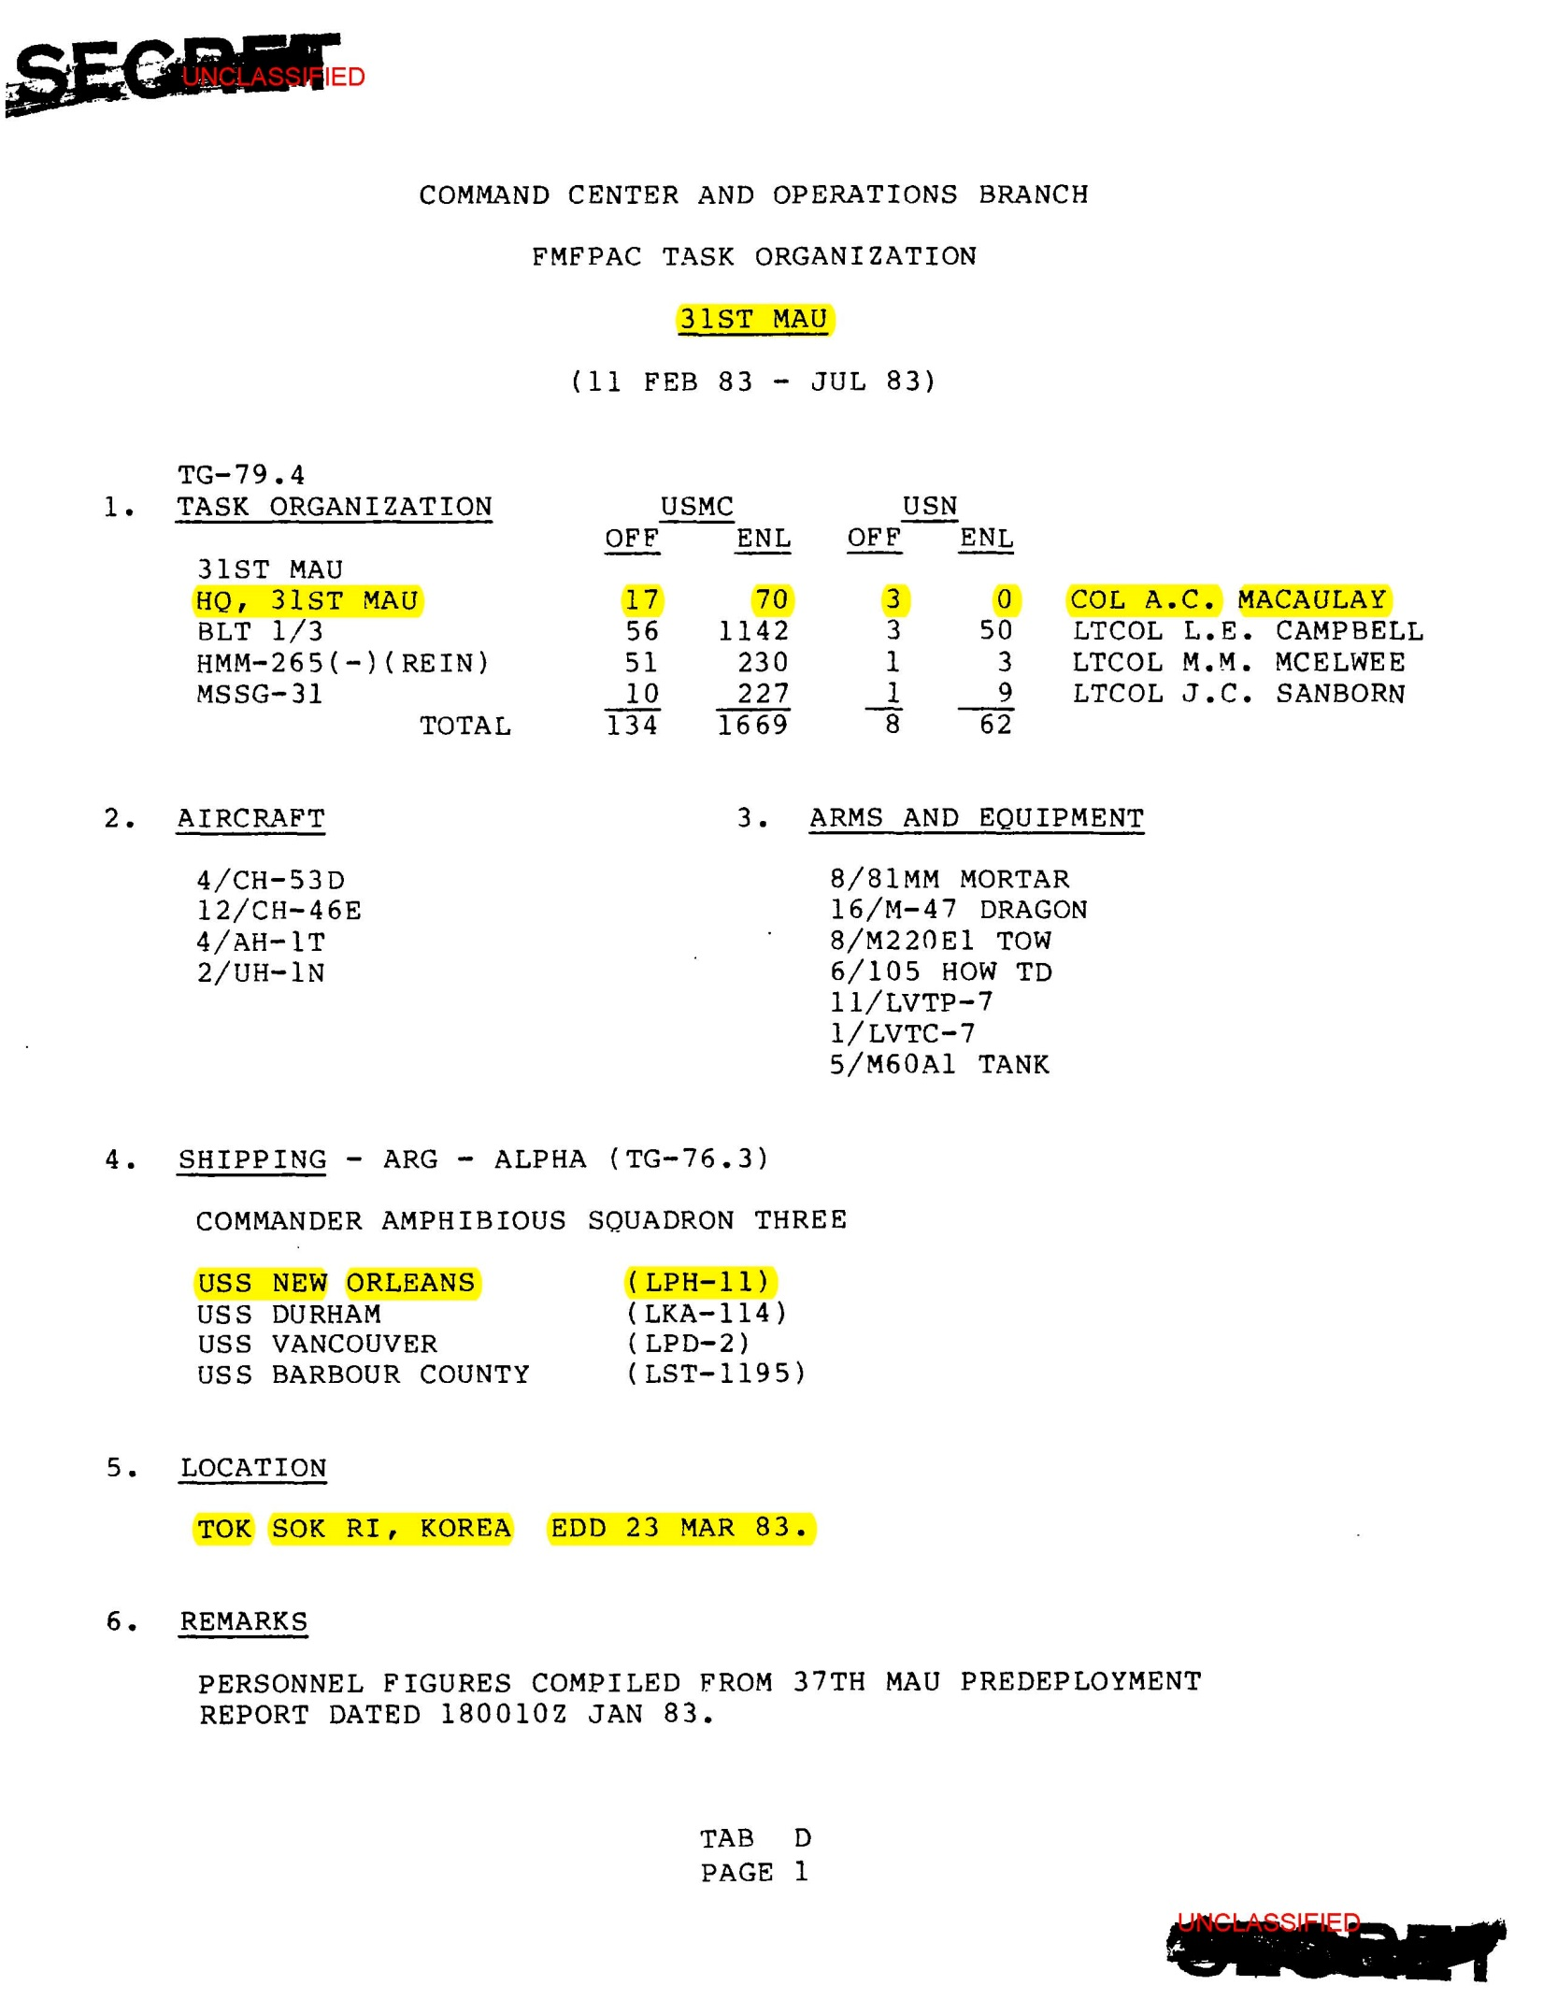
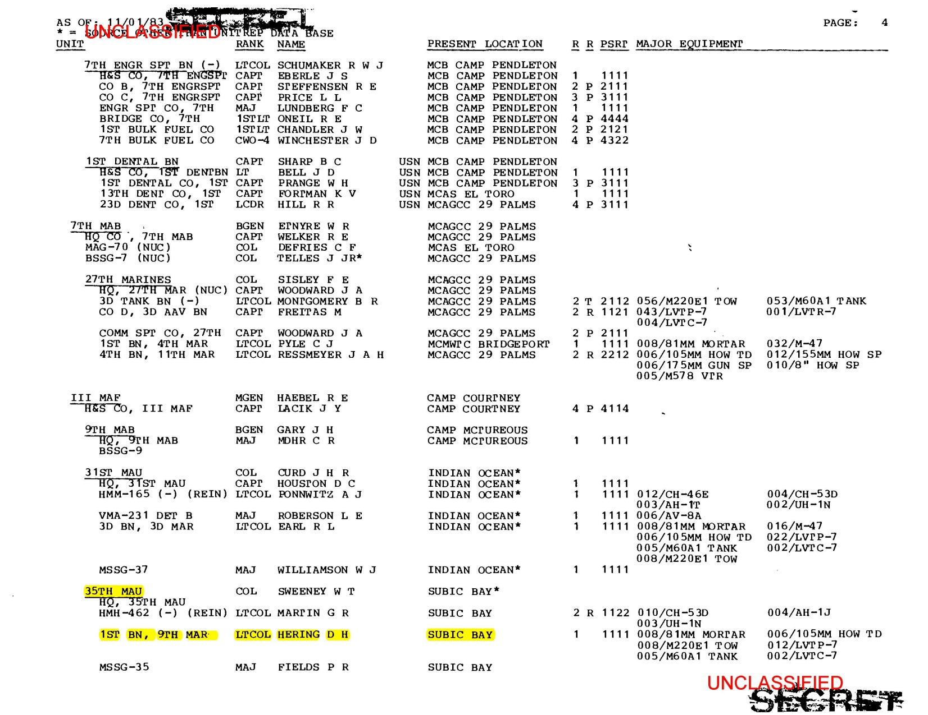

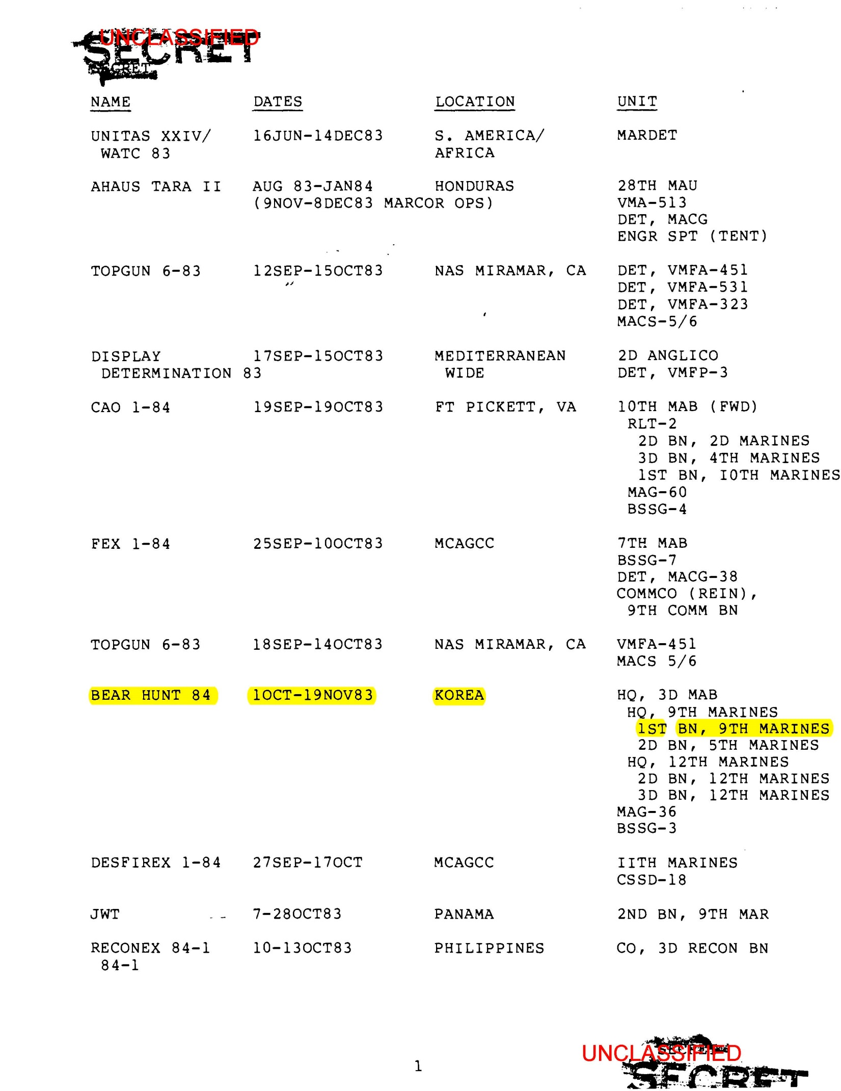
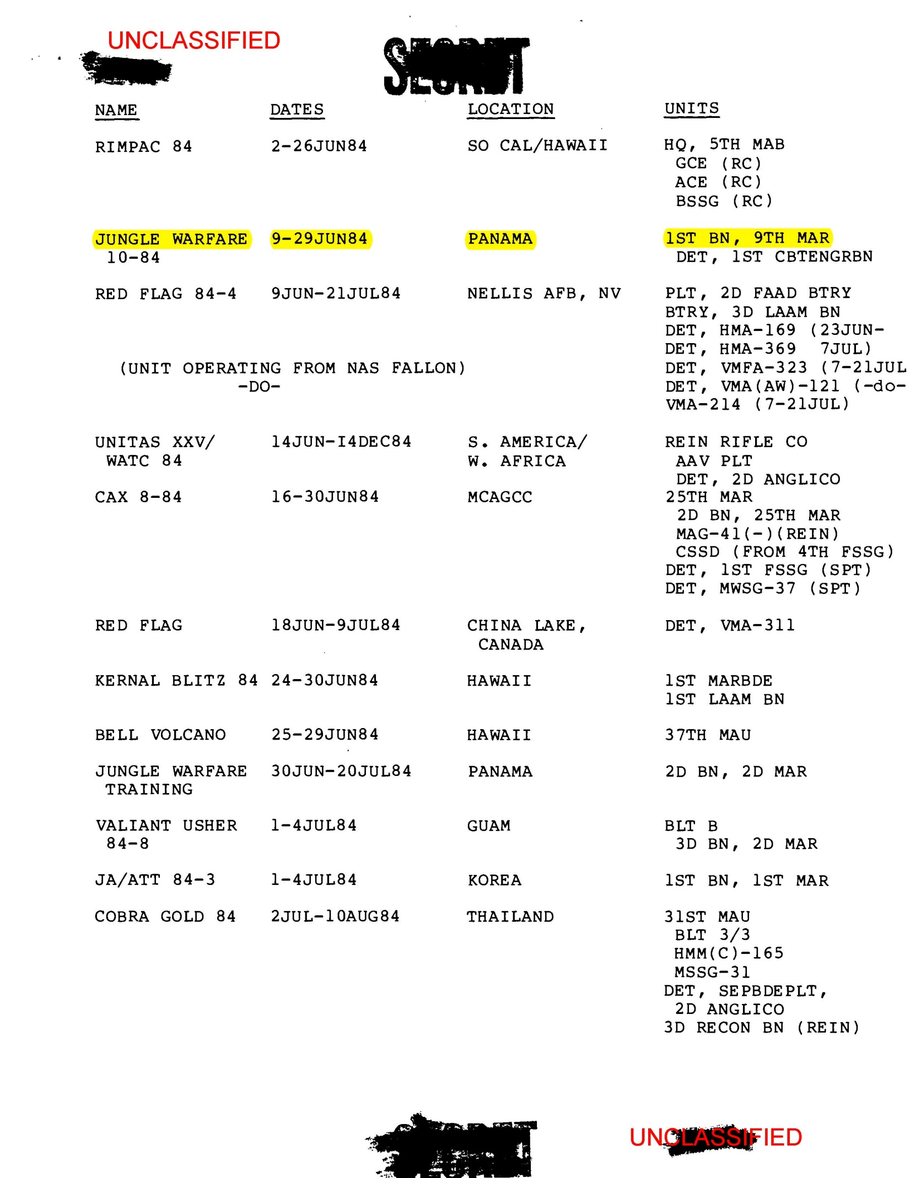
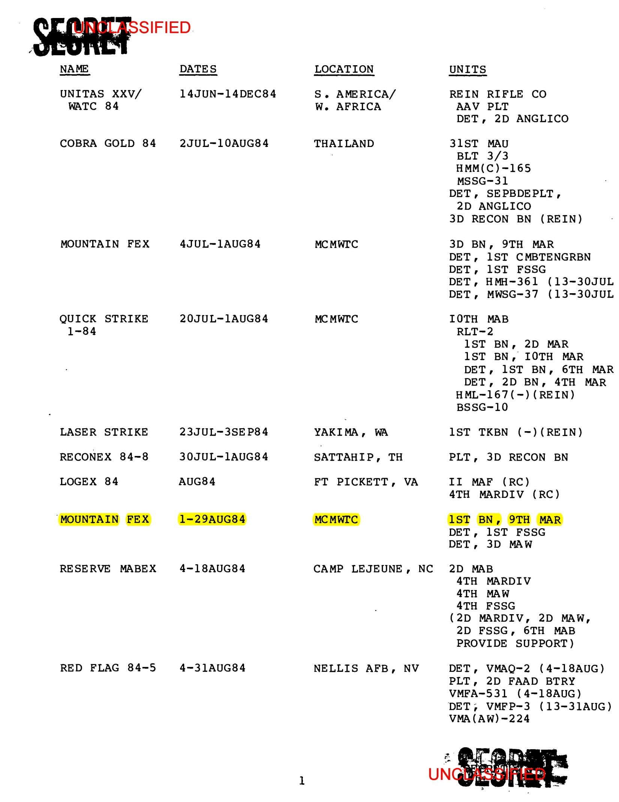
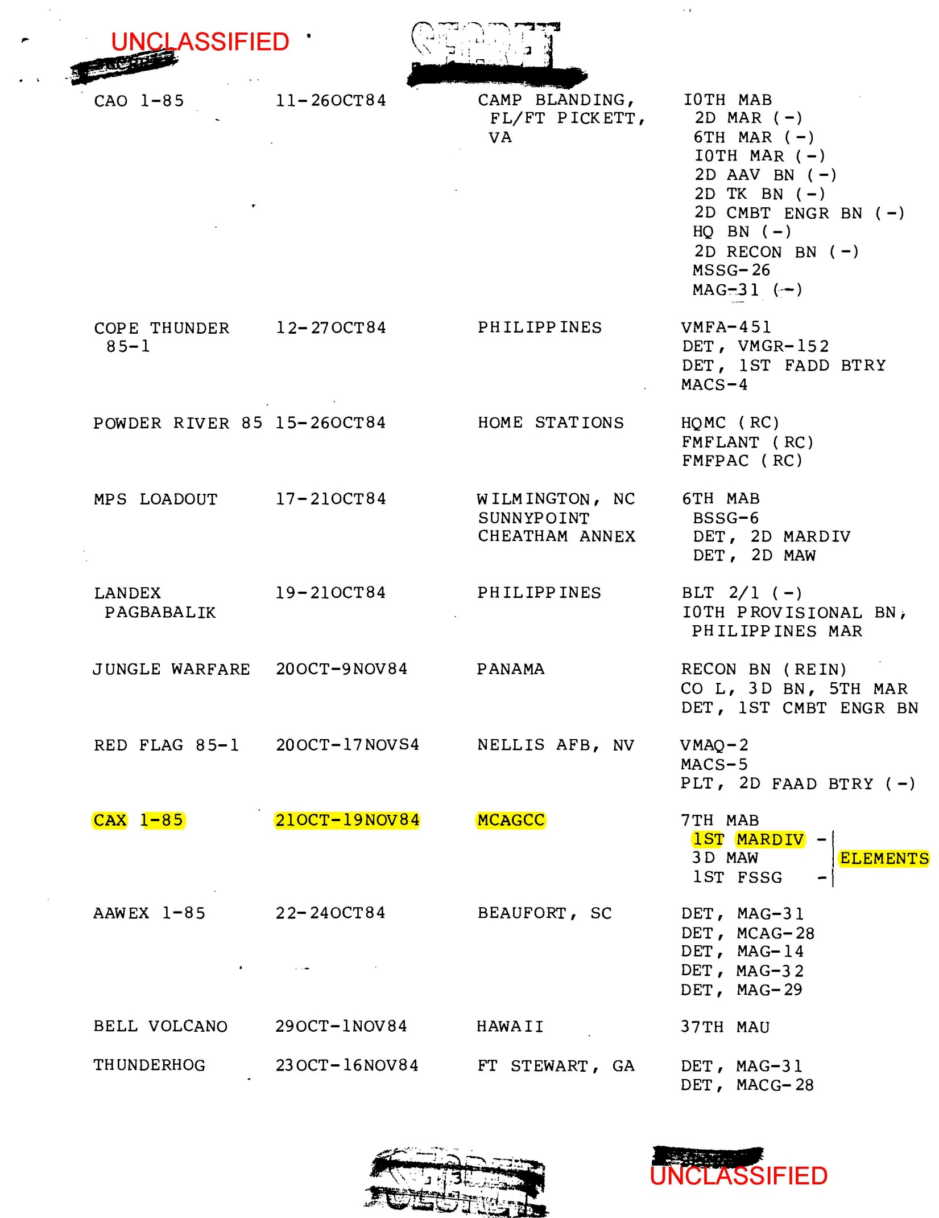
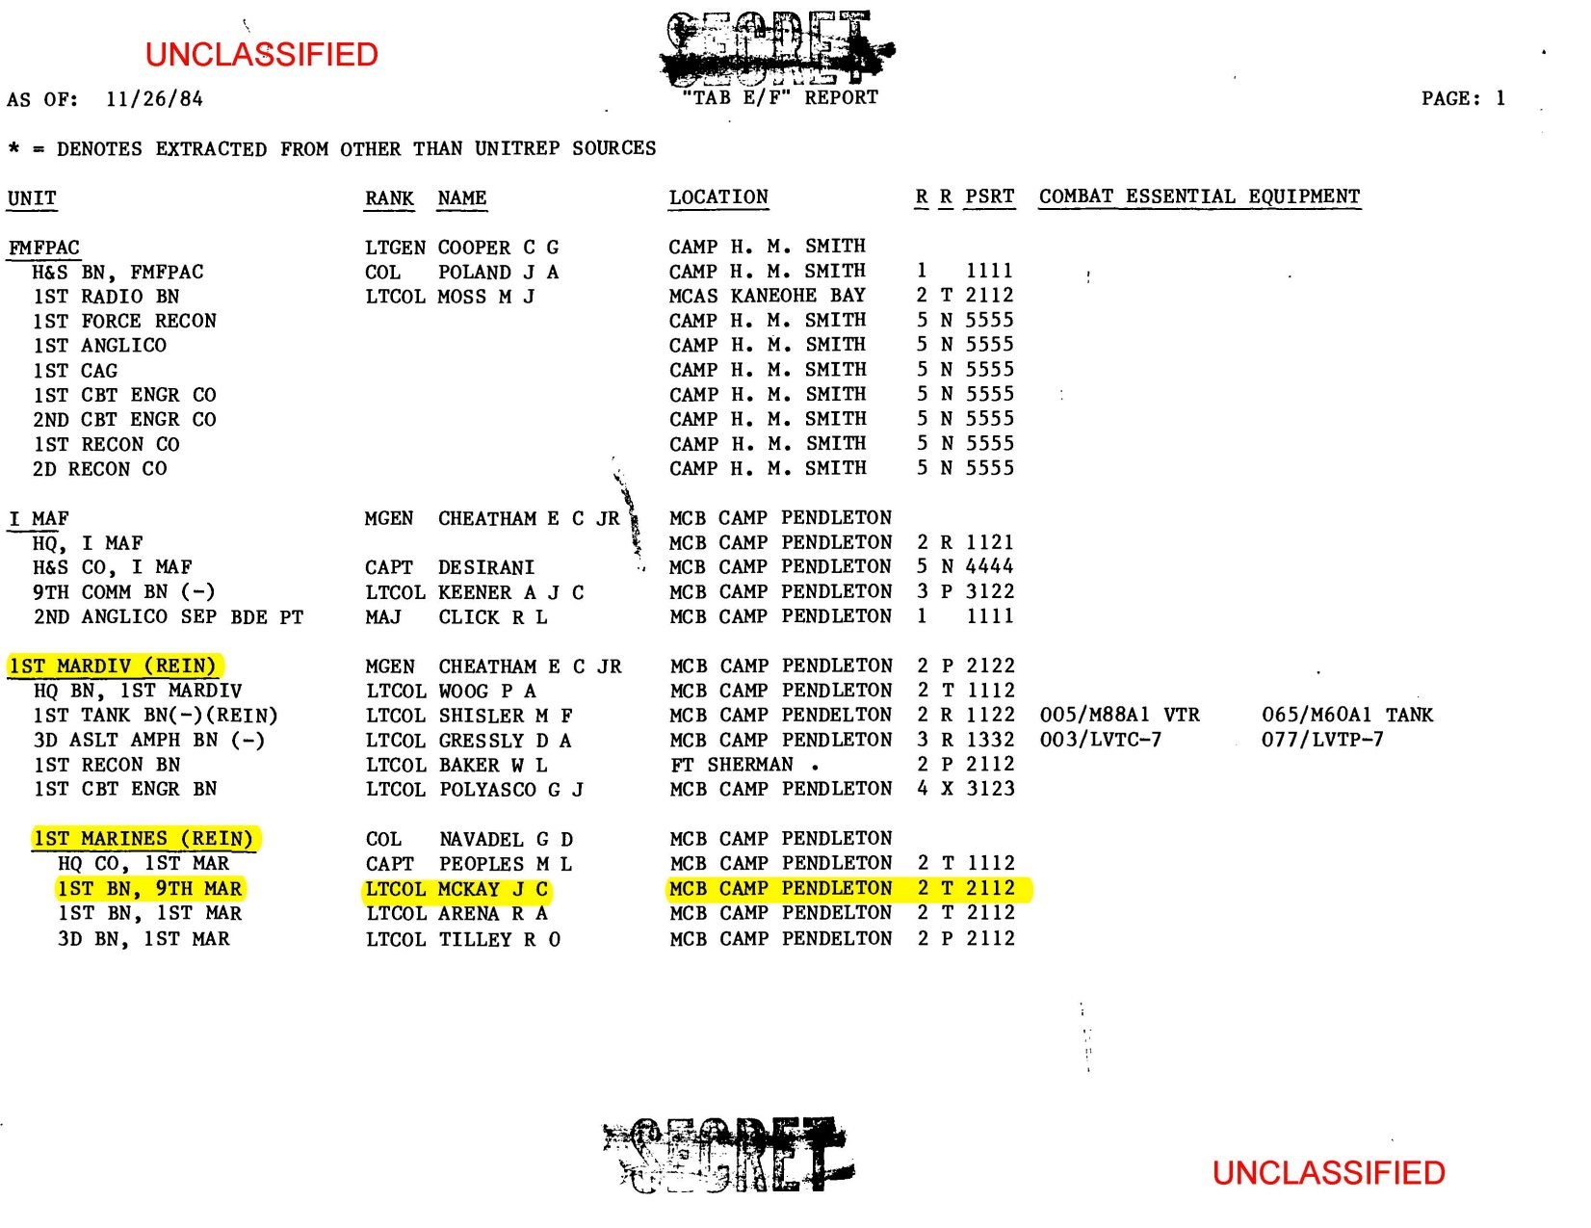

Veterans Educational Assistance Program (VEAP)

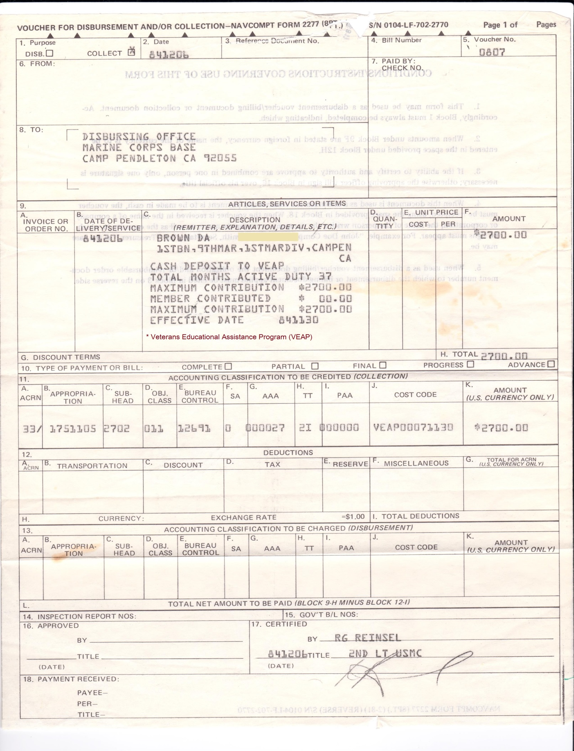
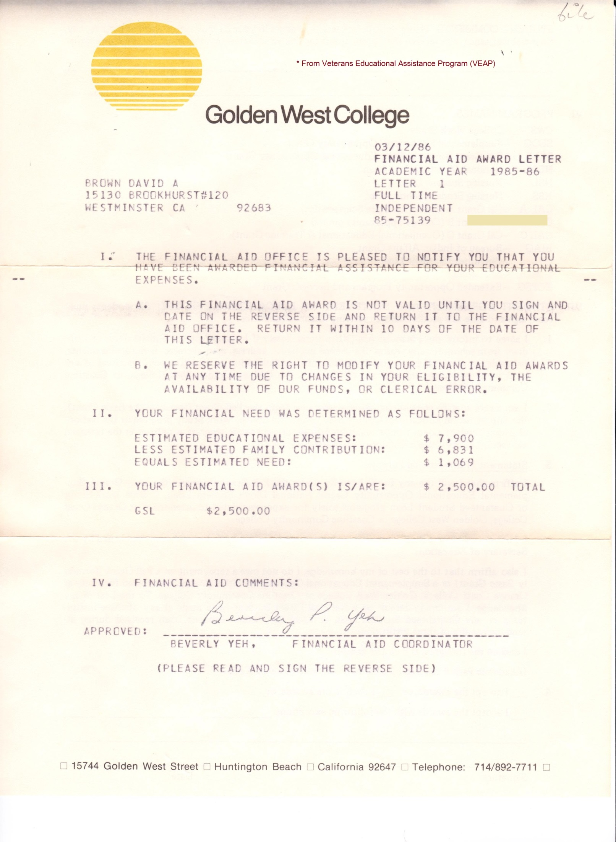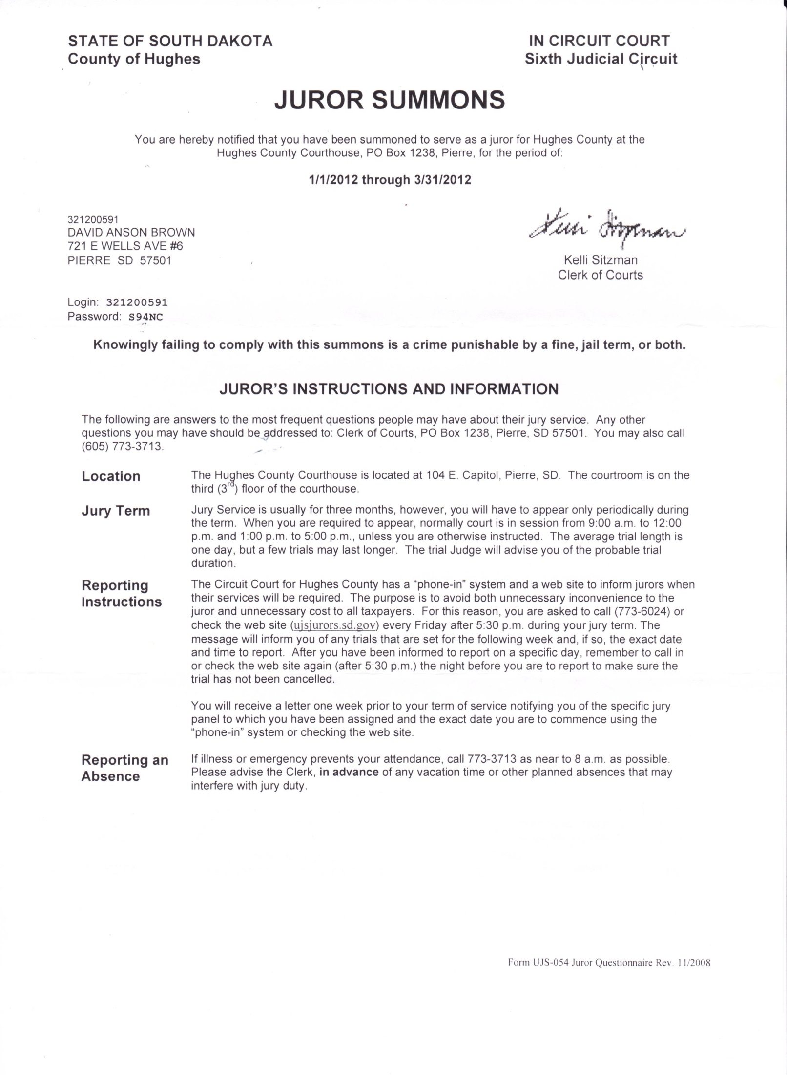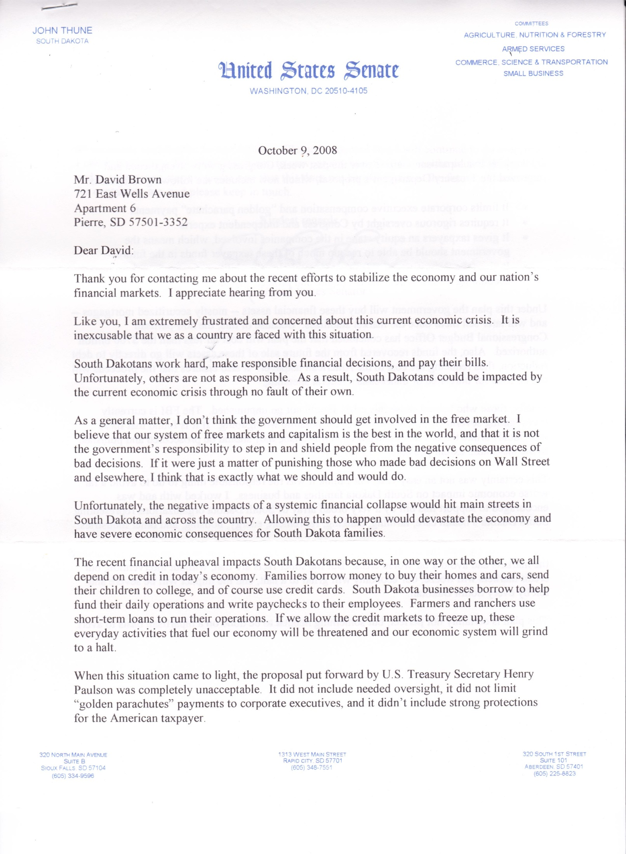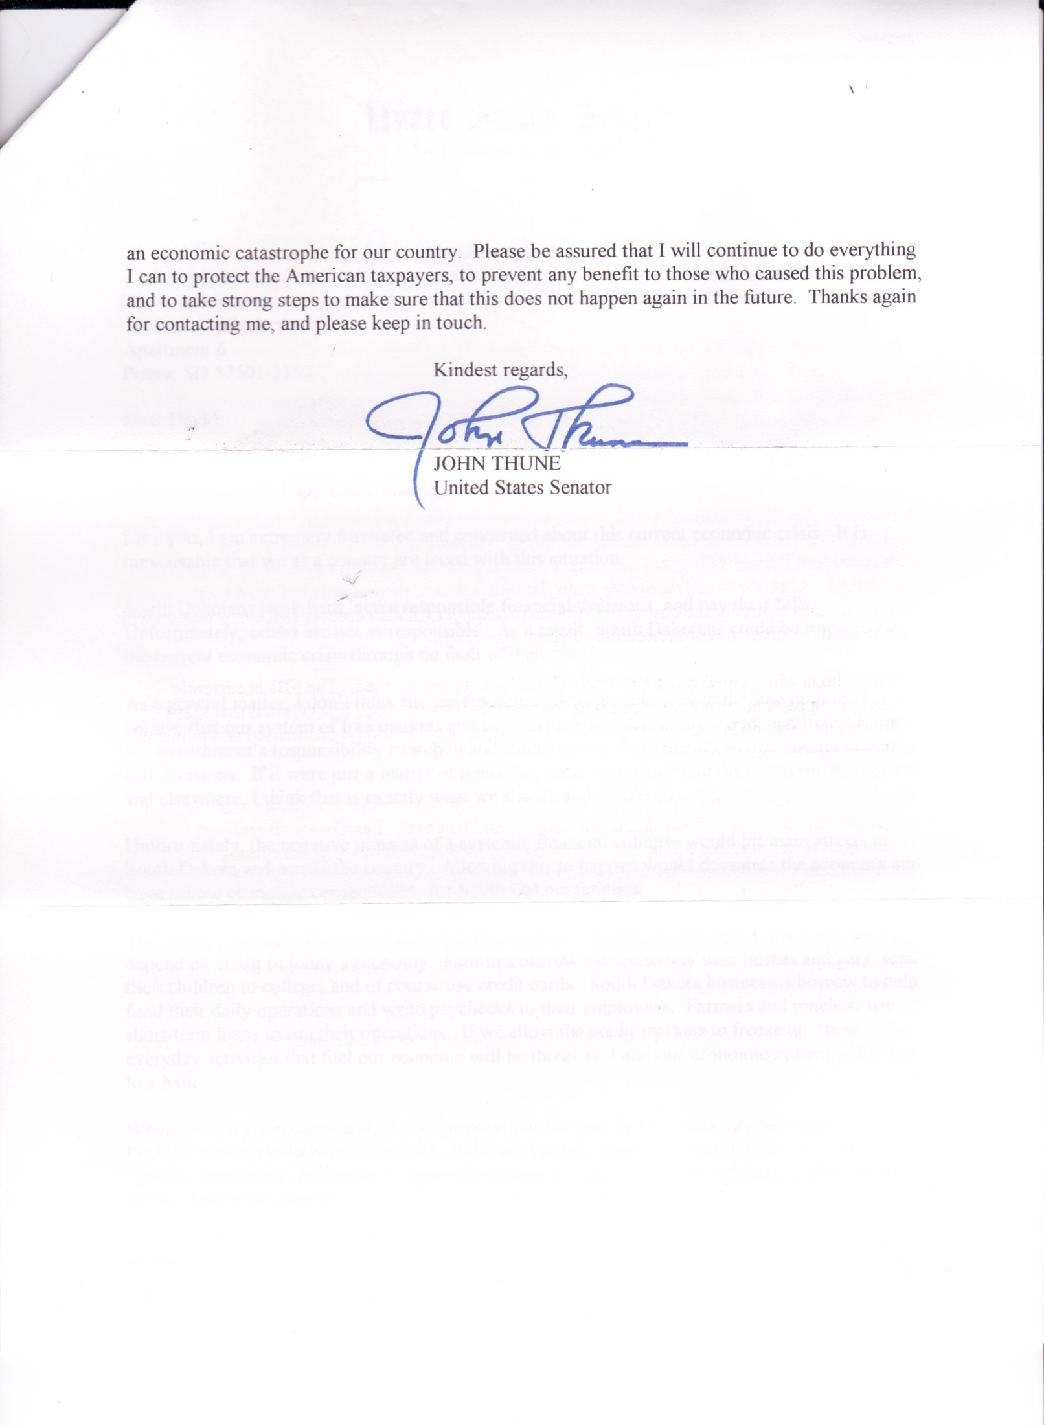
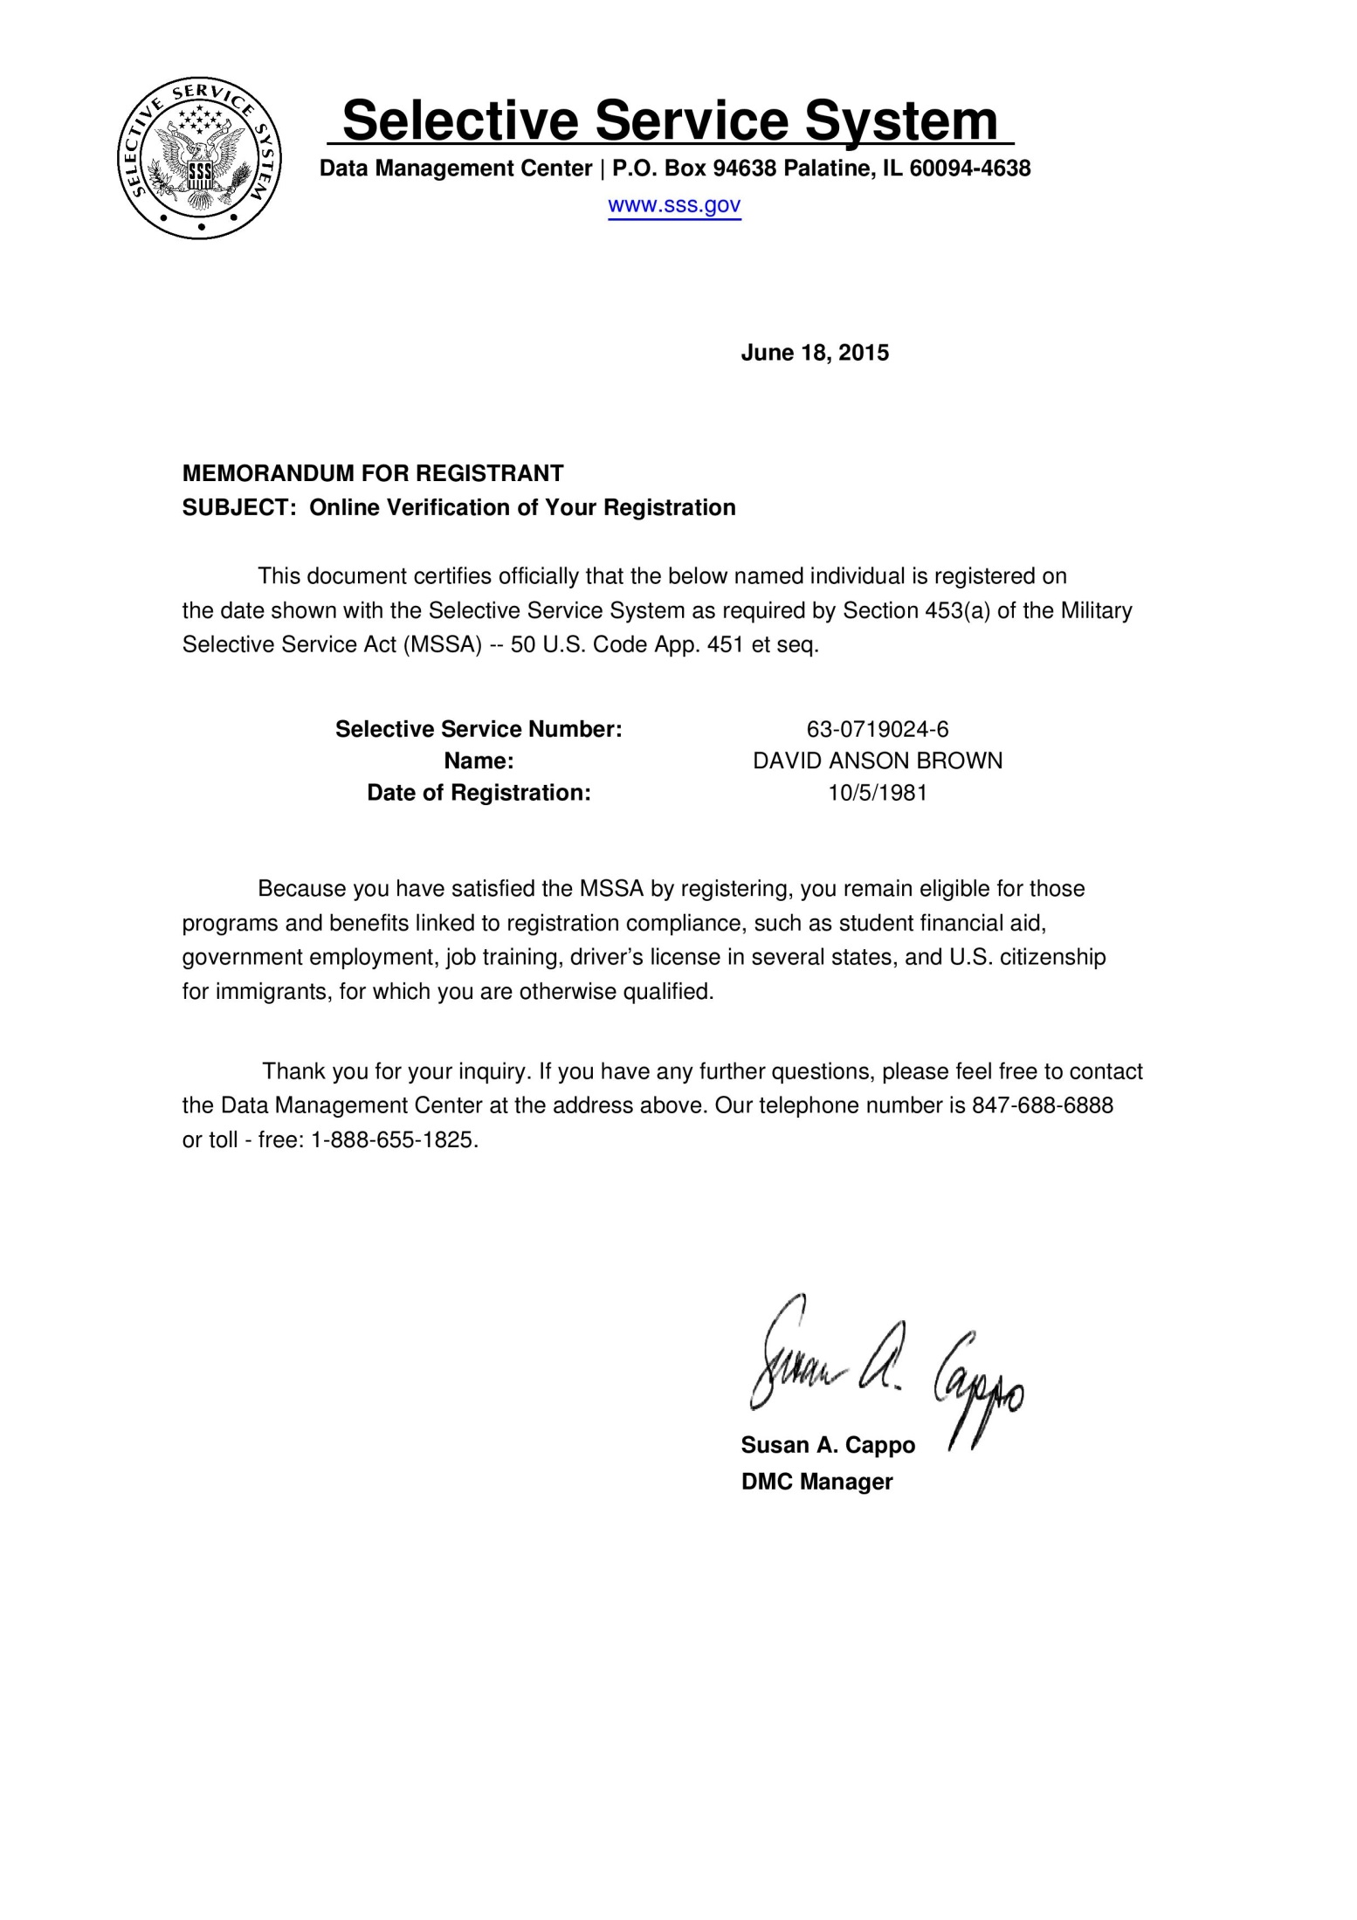

LCpl David A. Brown USMC 1983

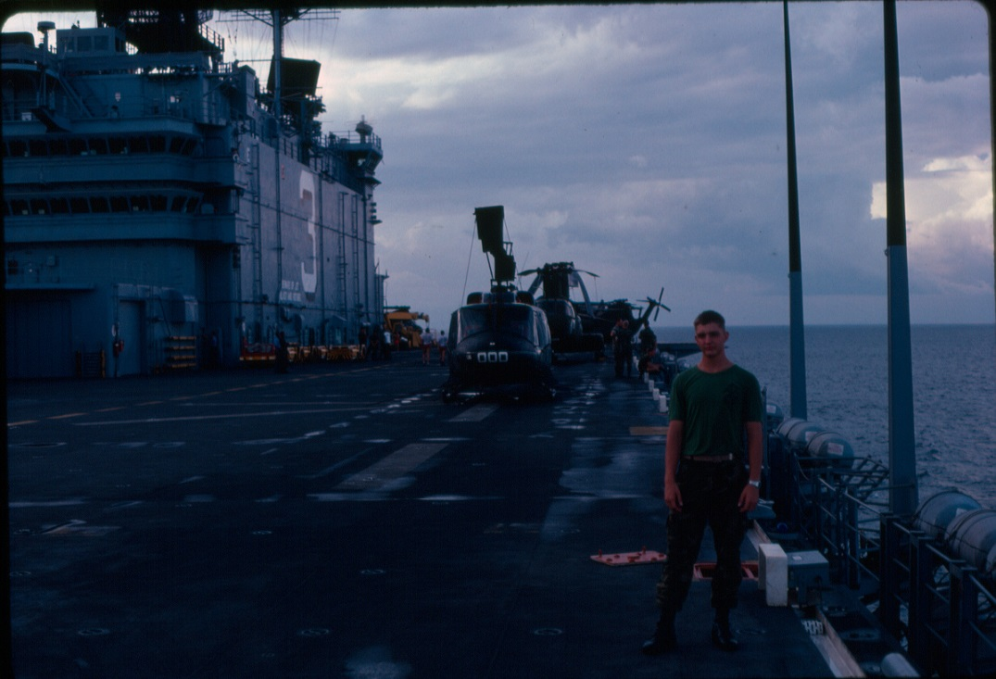

Cold War Certificate
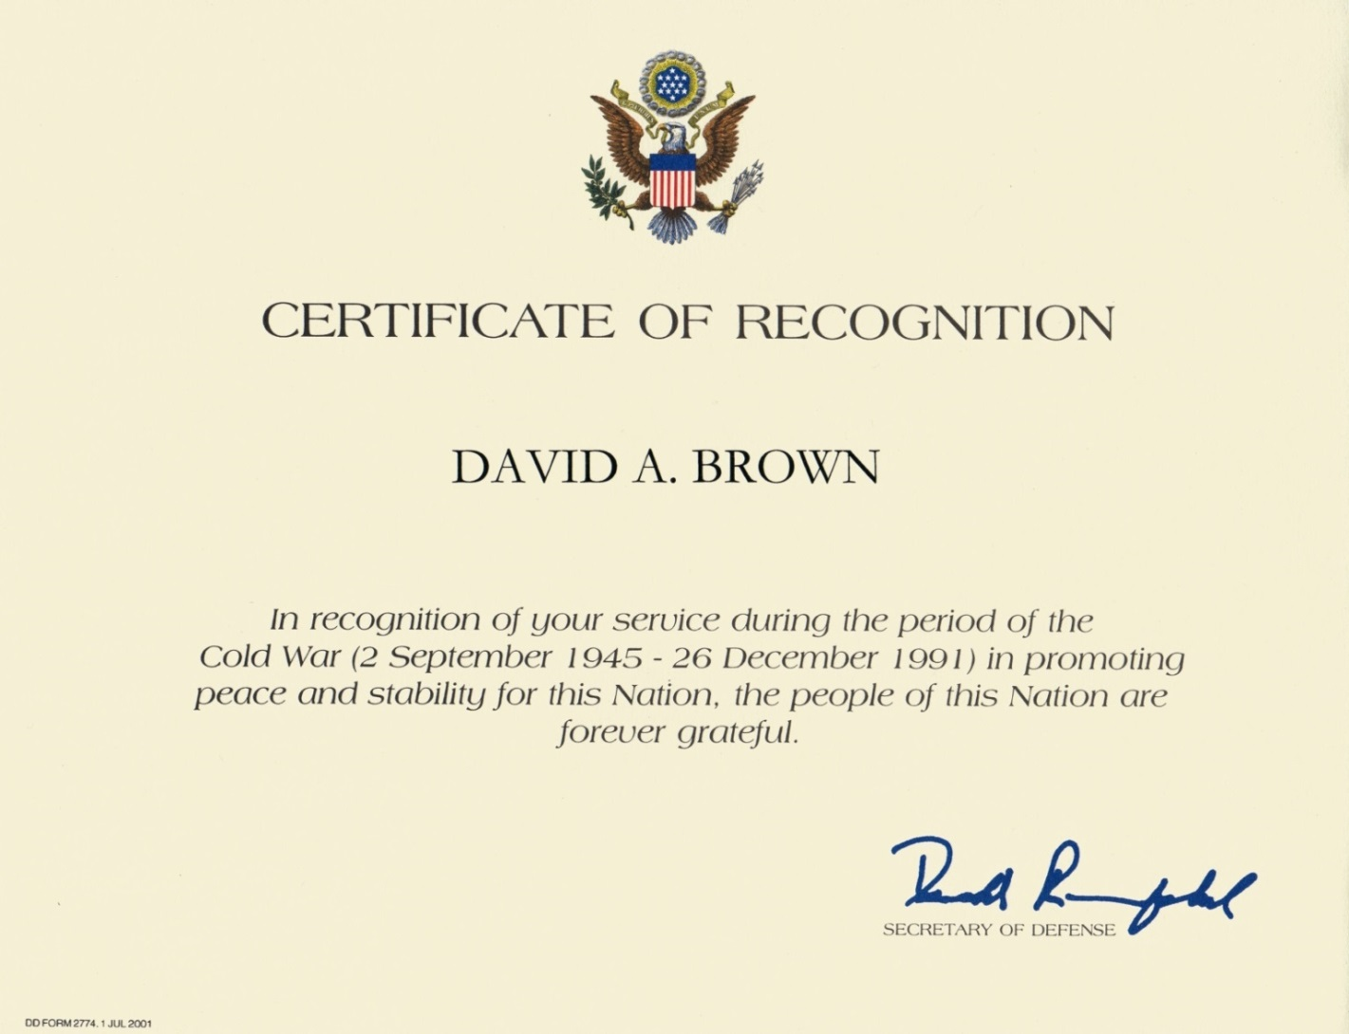

The American Forces Network (AFN) Television (FEN) Philippines signoff early 80's

https://youtu.be/vd909AYJ9p8

The Philippines I think ended their broadcast earlier at 10:00 pm if I remember correctly. We didn't have a tv in the Philippines usually when we saw this it was when we were in a shop out in town or in a restaurant or something and it was on their tv. The Philippines people watched this channel as much or more than the Americans. Also with the Hawaii like palm tree and sunset at the beginning we considered this to be more of a Hawaii signoff than a Philippines and when they started naming the broadcast locations you knew you were in a foreign country and felt a long way from home.

Okinawa, Japan AFN television sign off at midnight early '80s

We saw this a lot in Okinawa and liked it it's very good it was usually if you had midnight fire watch (barracks guard duty) someone always had a TV on at 7th Comm Bn.

https://youtu.be/3BI8jR-Ps20

AFN DJ Charlie Tuna

Armed Forces Radio and Television '80s memories wouldn't be complete without a tribute to Charlie Tuna. Armed Forces TV compiled most of its TV from the three major USA TV Network shows. Armed Forces Radio Pacific was compiled mostly from Los Angeles AM radio. After the Marine Corps and while living in and going to college in Southern California at times I would turn on the early morning KRLA 870 AM radio station and listen to Charlie Tuna for a few Okinawa memories.

https://youtu.be/KGZkgHo3Vfk

Updated: April 30, 2017

